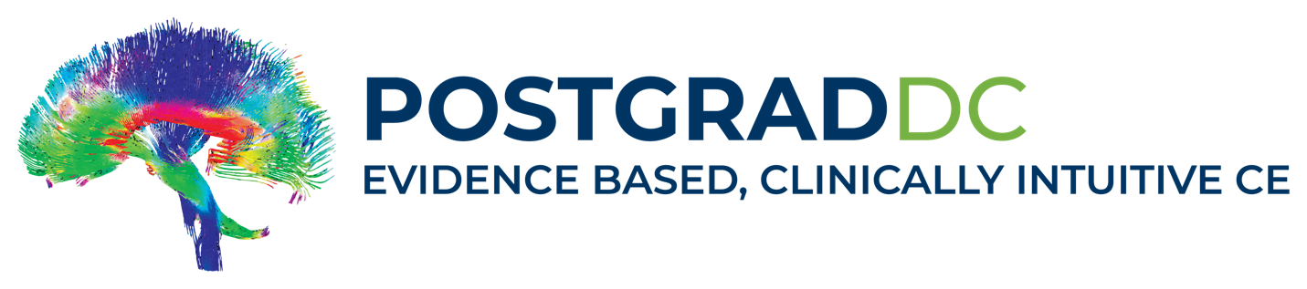
Dear Doctor,
You are registered to attend “Chiropractic Update: Advanced Imaging / Decompression / Cervical Artery Dissection / Informed Consent.”
When:
- Saturday, November 16, 2024 from 7:30 AM – 1 PM EST
- Sunday, November 17, 2024 from 7:30 AM – 1 PM EST
Classes will start promptly at 8 AM EST.
To attain license renewal credits, you must follow the following instructions carefully.
To get the Zoom meeting link, click on the following before the event:
Click Here for Room Meeting Link
You will then receive a confirmation email containing information about joining the meeting, including a blue meeting link button, "Join Meeting." Click that button to enter the webinar.
Course Handouts will be available on Friday, November 15, in the respective course in your account at: PostGradDC.com.
Lecture and Break schedule:
- 7:30 AM EST - Log into Zoom via the meeting link provided.
- 8:00 AM – 9:40 AM - Lecture/QA/Polling Questions
- 9:40 AM – 10:00 AM - Break Time (20 Minutes)
- 10:00 AM – 11:40 AM - Lecture/QA/Polling Questions
- 11:40 AM – 12 Noon - Break Time (20 Minutes)
- 12 Noon – 12:50 PM - Lecture/QA/Polling Questions
Attendance is Mandatory:
- Respective Boards of Chiropractic Examiners require STRICT compliance related to live webinar attendance.
- All attendees must be individually logged on with a computer or device.
- By taking this coursework, you attest that you will remain in attendance during ALL hours of lectures.
- Our course administrator will monitor attendance periodically throughout the presentation.
Mandatory Poll Questions
- You must answer three (3) polling questions each day during the lectures to assure attendance compliance. Your responses are recorded by ZOOM. If you do not answer all of the polling questions, you will not receive license renewal credit for those lecture segments. This is your responsibility.
Complete the Course Survey to Generate your Certificate of Completion
- At the end of the lecture on Sunday, you must complete our Course Survey to attain your certificate of completion. Once you’ve done so, your certificate will be available under your account. This is your responsibility.
Interactive Class
- During the lecture, your microphones will be muted. You can raise your virtual hand and ask questions in the Chat Box. During Q&A, we will answer chat box questions and your microphones will be unmuted so you may ask questions directly.
- Please exercise discretion while your mic and camera are on.
You must Self Report your CE hours to your respective state and CE Broker (in NC, SC, TN, NH):
- To assure your license renewal, please self-report your hours to your respective boards of examiners and CEBroker.
If you have any problems, or lose connectivity, please call Robert: (910) 297-0912.

