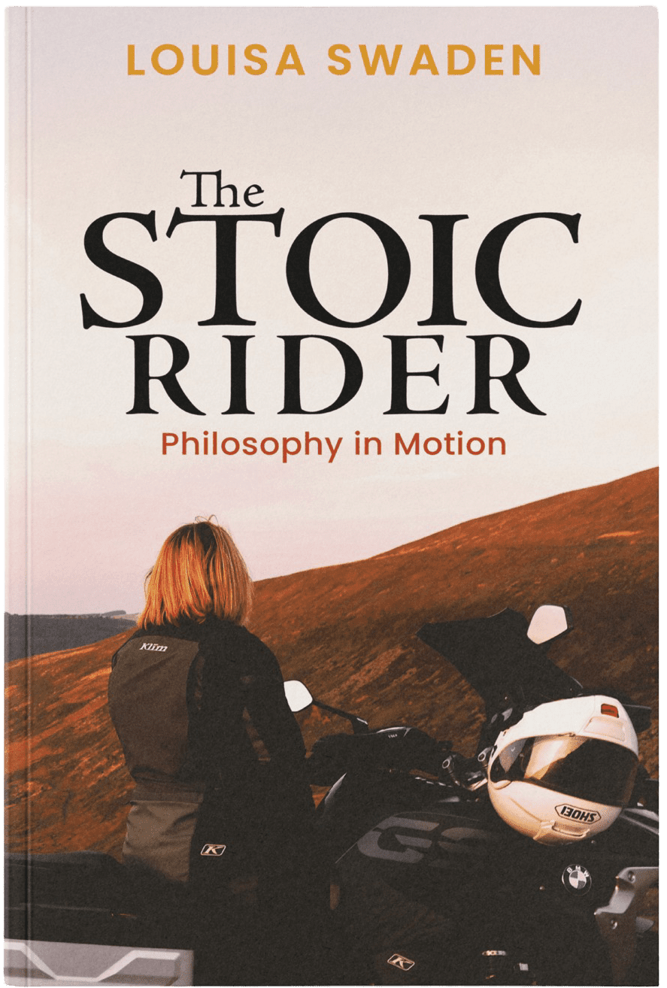
THE STOIC RIDER
LOUISA SWADEN

9 August 2025, Throttle & Thought Press
257 pages, Philosophy, Non-Fiction Motorcycle Memoir, Available in print, eBook and audio

- ISBN (Paperback): 978-1-0682107-0-9
- ISBN (Kindle eBook) 978-1-0682107-1-6

Available for pre-order pricing of £15.49 UK list price and US $19.99 list price
For media inquiries contact media@existentialbiker.com

High-Res Media Gallery: https://existentialbiker.com/media-kit/

TABLE OF CONTENTS:
The Stoic Rider…………………………………………………………………………………………….. 1
Description………………………………………………………………………………………………….. 2
Pitches & Blurbs……………………………………………………………………………………………. 3
Praise for The Stoic Rider………………………………………………………………………………… 3
About the Author………………………………………………………………………............................. 4
For Motorcycle Enthusiasts………………………………………………………………………………. 5
The Stoic Rider Q&A……………………………………………………………………………………… 6

DESCRIPTION

Philosophy for the open road. Stillness in motion. Strength in surrender.
In The Stoic Rider, Louisa Swaden blends the raw experience of motorcycling with the timeless insights of Stoic philosophy. Part memoir, part field guide, this is a book for anyone who’s ever felt the fear before the ride, the stillness within the speed, or the pull to keep going when the world says stop.
This is not a how-to manual or a collection of lessons from the saddle. It’s a philosophical companion for anyone navigating uncertainty—on the bike or in life. With clarity, honesty, and wry defiance, Louisa reflects on what it means to move forward through fear, and how the open road mirrors the inner one.
The Stoic Rider is her invitation to meet life, and yourself, at full throttle—a call to stop waiting, start living, and remember that time doesn’t hand out second chances.
“You’re not too old. It’s not too late. The only thing in the way is the story you keep telling yourself.”

PITCHES & BLURBS

Land Speed Record Holder, Louisa Swaden debuts her first book—The Stoic Rider.
At 50, Louisa Swaden’s return to motorcycling inspired her to set records and write her first book—The Stoic Rider, a powerful meditation on mindset, resilience, and choosing your line—on two wheels and beyond.
At 50, Louisa Swaden returned to motorcycling after decades away—buying a second-hand bike off eBay for less than the price of a mobile phone and eventually becoming the fastest woman to ride on sand and a member of the coveted 200mph club. But The Stoic Rider isn’t about speed; it’s about learning to live with clarity, courage, and purpose. Drawing on ancient philosophy and modern psychology, Louisa weaves stories of self-doubt, transformation, and the open road into a powerful reflection on what it means to ride through life awake. A grandmother of three and powerlifting record holder, she now speaks and writes on mindset, mortality, and what two wheels can teach us about meaning.
Key Words: Record-Setting, Philosophy, Motorcyling, Inspiring Women, Women over 50 200mph club, Motorcycle Mindset, Women who Ride, Adventure Motorcycling

PRAISE FOR LOUISA & THE STOIC RIDER

Beautifully written, with enthralling descriptions, humour and razor-sharp thought processes, The Stoic Rider could well change the way you think. Louisa Swaden has created a book of revelation and inspiration that absolutely everyone needs to read.
- Sam Manicom, Motorcycle Travel Author

In The Stoic Rider, Louisa Swaden has created an intriguing, original book that effortlessly blends the thrills of a wide open throttle with life lessons from the great minds our our time. Honest and thought-provoking, it will inspire you to hit the road - and squeeze the most out of life.

- Lois Pryce - Author of The Revolutionary Ride

ABOUT THE AUTHOR
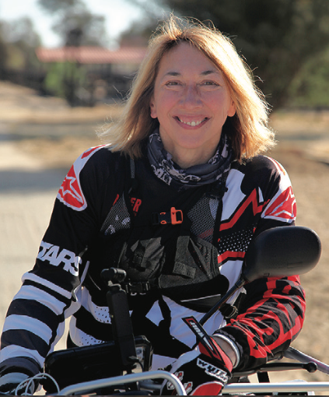
Louisa Swaden is living proof that the second half of life can be the start of something extraordinary. After turning 50, she began saying yes to things that once felt impossible—setting land speed records on sand, racing at the legendary Bonneville Salt Flats, and riding across Namibia as part of a conservation effort with Rally for Rangers. She became a UK Ambassador for the global Women Riders World Relay, a movement that united thousands of women through the shared freedom of motorcycling and also earned a Welsh Powerlifting record along the way. Most recently, she’s turned author, weaving together mindset, motorcycles, and philosophy in her debut book.
Under the name The Existential Biker, Louisa shares raw, reflective insights drawn from the road, exploring what it means to live bravely, age boldly, and lean into life’s unknowns. When she’s not writing or exploring on two wheels, she can be found reading sci-fi, musing on the universe, or laughing with her grandchildren. Her story reminds us that life doesn’t have to shrink with age—it can expand in thrilling, unexpected directions. As she says: Where you look is where you go.

Short Bio: Louisa Swaden began saying yes to things that once felt impossible after turning 50—setting motorcycle land speed records on sand, racing at the legendary Bonneville Salt Flats, and riding across Namibia as part of a conservation effort with Rally for Rangers. She became a UK Ambassador for the global Women Riders World Relay, a movement that united thousands of women through the shared freedom of motorcycling and also earned a Welsh Powerlifting record along the way. Most recently, she’s turned author, weaving together mindset, motorcycles, and philosophy in her debut book, The Stoic Rider.

FOR MOTORCYCLE ENTHUSIASTS

Louisa Swaden is a speed-record-holding rider, moto adventurer, and author who returned to motorcycling later in life—and hit the throttle hard. After decades away from bikes, she bought an Indian Scout for a trip to the Harz mountains in Germany, and hasn’t looked back. She rode a Gen II Hayabusa at Bonneville and a Kawasaki ZX6R on the iconic Pendine Sands in Wales, where she is believed to have become the fastest woman ever recorded on sand—clocking 145.334 mph—being awarded the title Lady of Speed on Sand in 2019 and becoming a member of the famous 200+ mph club.
Her passion for two wheels has taken her across continents and into causes that matter. In Namibia, she rode with Rally for Rangers and donated a motorcycle to wildlife rangers working on the front lines of conservation. As the UK Ambassador for the Women Riders World Relay, she helped unite a global community of women bikers, and she’s guided motorcycle tours through wild landscapes and mountain passes alike.
Now writing and posting as The Existential Biker, Louisa blends throttle with thought—fusing philosophy, riding, and raw experience in everything she creates. Her debut book, The Stoic Rider, explores how the road can teach us about life itself. She currently rides a BMW GS 1250 but still has her trusty ZX6R, and continues to speak, write, and ride with boldness, humour, and a deep curiosity for the journey ahead.

THE STOIC RIDER Q&A

What inspired you to write this book? Why now?
I’ve always believed that time is the most precious thing we have—and yet we often live as if it’s limitless. But it’s not just that we don’t have much time; it’s that we often lack the courage to spend it on the things that would truly enrich our lives. I’ve seen too many people reach the end of their lives having never taken the trip, started the project, or pursued the dream—simply because they didn’t have the right mindset.
Stoic philosophy has helped me make sense of the world and my place in it for years. It’s a practical, honest framework that reminds us we’re not in control of much—but we are in control of how we respond. As I returned to motorcycling, I started seeing all these parallels between the road and the ancient Stoics: focus, presence, momentum, acceptance, purpose. Riding became both a physical and a philosophical practice. The Stoic Rider is my attempt to share that connection—to help others find clarity, courage, and meaning, whether they ride or not.

Starting motorbiking again at 50 years old is quite the feat. What made you take the leap? I didn’t know it would change my life—I just knew I wanted something more. My children had left home, and for the first time in decades, there was space to ask myself: What have I always yearned for? Adventure had always been quietly waiting in the wings, but life—especially one centred on raising a family—doesn’t always leave room for it.
So, I made a list of things I’d always wanted to do: sail across an ocean, witness the Panama Canal being widened, ride across America on a motorcycle. I bought an Indian Scout and signed up for a tour across the U.S.—thinking it would be just one experience among many. But it had a far deeper impact than I expected. Riding didn’t just open up the road—it opened up my sense of self, my friendships, and the direction of my life.

How did philosophy become part of the story?
I’ve been drawn to philosophy for as long as I can remember—ever since watching Kung Fu on TV and hearing those quiet, powerful lessons from Taoist thought. I was the kid who always asked “why” five times in a row—curious, relentless, probably a bit annoying! But that need to understand never left me.
Over time, I came to see how the way we think shapes the way we see the world—and that perception guides every choice we make. A single quote or idea can lift a veil and shift how we live. For me, philosophy—especially Stoicism—offered comfort, not by sugar-coating life, but by

helping me see things as they truly are. There’s a quiet strength in accepting reality and learning to live in harmony with it. That’s what I wanted to bring into the book.

For someone who isn’t perhaps a biker, but wants to take on a new challenge, how does your book help them do that?
You don’t need to ride a motorcycle to relate to The Stoic Rider. The bike is just a metaphor—it could just as easily be a paintbrush, a paddleboard, or a new career. Stoic thought can be applied to almost anything, but I find it works especially well when paired with movement, because both the body and the mind are involved.
When we take on something new, we’re guaranteed to face uncertainty, discomfort, and self-doubt. Stoicism offers tools to meet those moments with resilience. It reminds us that we can ask for help, that our attitude matters more than the outcome, and that progress—not perfection—is the point. The simple act of choosing to grow puts you on the right path. This book is here to help you stay on it, especially when the road gets rough.

As an avid biker, any advice for those who are considering taking up motorcycling?
Absolutely—never stop learning. Passing your test is just the beginning. I’d encourage anyone to go straight into advanced training. It doesn’t just make you a better rider—it can quite literally keep you alive.
Be prepared for your world to expand. Motorcycling connects you to the environment and to people in a way that driving never will. You’re no longer in a box—you’re in the world. And your circle of friends? That’ll grow too. Riders look out for each other. Oh—and one last thing: make space in your garage. Most motorcyclists I know don’t stop at one bike!

Favorite bike? Favorite ride?
It has to be my ZX6R. It’s old, but it has so much heart. I bought it blind off eBay and somehow it ended up looking after me on Pendine Beach, where I set my land speed record. It’s got character—and a bit of a story behind it.
As for my favourite ride, anywhere in Scotland wins. There’s something about riding through those vast, open landscapes with the mountains all around you. It feels like freedom with a soundtrack.

