For Immediate Release

Name
Title
Contact Information

Marnie Russ
Founder & Ceo, National Kitten College
Email: marnie@kittencollege.org

KITTEN SEASON IS COMING: [YOUR ORGANIZATION] CALLS ON COMMUNITY TO BECOME A KITTEN FOSTER

[City, State] - Kitten season is just around the corner, and [Organization Name] is preparing for an influx of vulnerable neonatal kittens in need of foster care. As a National Kitten College (NKC) Partner, [Organization Name] is calling on community members to join its foster network and help give more kittens the chance to survive, grow and find loving homes.

Every spring and summer, animal shelters and rescues across the country see an increase in the number of kittens entering their care. Neonatal kittens — especially those who are too young to eat on their own — require specialized care, frequent feedings and a safe place to grow. Without enough foster caregivers, shelters can quickly become overwhelmed.
Many people are interested in fostering kittens, but hesitate because they worry they don't have the experience or knowledge needed to care for them. [Organization Name] wants potential fosters to know: you don't have to be an expert to become a kitten lifesaver.
Through its partnership with National Kitten College, [Organization Name] has access to training, resources and proven strategies designed to help foster caregivers feel confident caring for neonatal kittens.
“[Insert quote about kitten season and the need for fosters],” said [Name, Title]. “[Inset message about how your community can help].”
Foster caregivers also don't necessarily need to make a long-term commitment. [Organization Name] may offer short-term foster opportunities, with some commitments lasting as little as two weeks, depending on the kittens' needs. This flexibility can make fostering possible for people who travel, have busy schedules or simply can't commit to fostering year-round.
National Kitten College is built around the idea that communities can save more kittens when they have the knowledge, resources and foster caregivers to care for them. Neonatal kittens remain the highest euthanized population in shelters, where healthy kittens remain the most adoptable population. [Organization Name] has joined their nationwide network with a commitment of saving more of these tiny lives.
[Organization Name] encourages community members interested in learning more about fostering neonatal kittens to [call to action - website sign up, call, come to a training, etc].

About Your Organization
Your mission statement, website, etc. here.

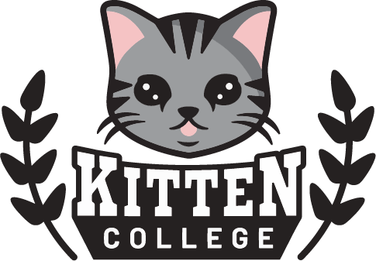 | About National Kitten College
National Kitten College is a nonprofit organization dedicated to advancing the care and survival of neonatal and underage kittens in shelters and rescues. Through training, consultation, data collection, resource development, and a growing national network of partner organizations, NKC works to build sustainable kitten lifesaving programs and advance evidence-based practices in neonatal kitten care.

