For Immediate Release

Name
Title
Contact Information

Marnie Russ
Founder & Ceo, National Kitten College
Email: marnie@kittencollege.org

[YOUR ORGANIZATION] JOINS NATIONAL KITTEN COLLEGE NETWORK TO HELP SAVE THE LIVES OF NEONATAL KITTENS

[City, State] - [Your Organization] is proud to announce that it has joined the National Kitten College (NKC) network as a partner campus, bringing new training, resources and support to its community to help more neonatal kittens survive and find loving homes.

Neonatal kittens are among the most vulnerable animals in shelters and are one of the populations most at risk of euthanasia. Yet with the right care, these tiny kittens can become healthy, social and highly adoptable cats. Through its partnership with National Kitten College, [Organization Name] is working to make that lifesaving care more accessible to its staff, volunteers and foster caregivers.

As an NKC Partner, [Organization Name] will have access to training, resources and proven strategies designed to help caregivers feel confident caring for neonatal kittens — including bottle feeding, foster care, socialization and other essential aspects of kitten care.

“[Quote about why you became a Kitten College Partner],” said [Name, Title]. “[Quote about something specific to your community, and state your goals of being a partner].”

For many potential foster caregivers, the thought of caring for a newborn kitten can feel overwhelming. National Kitten College helps take the fear out of neonatal kitten care by providing practical education, resources and support that make it easier for more people to say yes to fostering.

[Organization Name] hopes to use these resources to expand its foster network and make neonatal kitten fostering accessible to more members of the community — including people who may not have considered fostering before.

National Kitten College is built on a proven model for expanding neonatal kitten care and foster capacity, with over 180 nationwide partners already on board. When the program launched at the Animal Welfare League of Arlington in 2017, the organization cared for approximately 92 neonatal kittens per year. With the development of the Kitten College program, that number grew to more than 1,500 neonatal kittens per year.

[Organization Name] encourages community members interested in learning more about fostering neonatal kittens to [call to action].

About Your Organization
Your mission statement, website, etc. here.

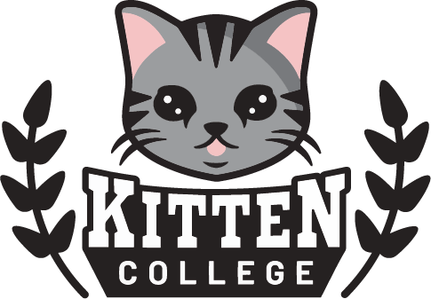 | About National Kitten College
National Kitten College is a nonprofit organization dedicated to advancing the care and survival of neonatal and underage kittens in shelters and rescues. Through training, consultation, data collection, resource development, and a growing national network of partner organizations, NKC works to build sustainable kitten lifesaving programs and advance evidence-based practices in neonatal kitten care.

