JanBros 2-stroke 1.0
Table of content : 1 General info p 2
2 Data p 5
3 Exhaust p 8
4 Transfer p 12
- Head p 14
6 FOS pipe p 15
7 Example p 19
8 Print p 21
9 Input
Everything in the excel is not my knowledge, it is based on the knowledge of many 2-stroke enthusiasts on the Kiwibiker.co.nz and Pit-lane.biz, with special thanks to Frits Overmars, Jan Thiel and Wayne Wright aka Wobbly for sharing all their knowledge. Without them this spreadsheet would not exist.
Everybody is free to do whatever they want to do with it, as long as it is not for commercial use and they honor the people that need to be honored. It is “open source”, so if you add a nice feature to it, please couple it back to me via one of the fora (preferably, I don’t want my mailbox to pile out) or by mail (jjanbros@gmail.com) so it can be available to everyone.
People might think it’s some sort of Bimotion copy, and in a way it is, but only as a concept. I’d seen it and read the manual online and thought : “I can do that to” . And so I did.
The spreadsheet’s are password protected, so you can’t mess up formula’s by accident. The password is a simple x in case you’d want to find out how it all works . If you want to change it for whatever reason , you also have to change it in the Visual Basic code of the AutoAdjust button’s, as the password needs to be lifted temporarily for them to work.
If you have lifted the protection for whatever reason, pushing any of the AutoAdjust-buttons puts it back in place automatically. On the Data-sheet, I’ve placed a “Protect” button that does the same.
It’s been great fun creating this, and enhanced my knowledge quite a lot. But it has also been a lot of work. A whole lot of work … If by some magic people have too much money and feel like this is worth something… anything … you can always donate something on my paypall address, which is the same as my email.
1 General info
I’ve made this with Excel 2010, keep that in mind if something ain’t working properly.
I have done my best (and it is pretty close) to use the Aprilia RSA125 GP engine’s data as an example, so all the OLD pages are filled with that as an example. On the NEW pages, I’ve created a 250cc upscaled version of it, more about that in 7/ Example.
All yellow cell’s are calculated data and you should not change them.
All green cell’s are for entering data. On some pages there are darker and lighter green cell’s, their differences will be explained in their chapter’s.
The concept is that you enter all your current engine’s data under “old” . Than you copy them to the new page (-or enter different data if for example you are going to use a different cylinder or longer stroke or …), set your goal by chosing the BMEP you are after and change the ports/… so that the STA numbers of your ports match those of the target.
You need to make a portmap of your cylinder and draw a BDC-line on your portmap at the correct height. That line is the zero height for entering heights in the portmaps.
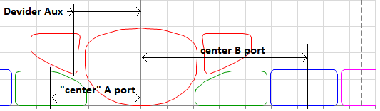
For each symmetrical transferport, you will need to determine the distance of it’s center to the centerline of the cylinder (center main exh or center between double exh port) and enter this as the “center location” on the transfer pages. For each a-symmetrical port (Aux exhaust and A-port like in the example), you also must chose a vertical line through it (where the port’s height is biggest, this does not have to be the actual center of the port) , and enter that as the Aux divider location or A-port “center” location, as we will be entering separate width’s for the inside and outside part of the ports (inside = part closest to centerline through cylinder, outside = furthest away).
Than you measure for each port for a certain “height” it’s “width” and enter that data as height and width into it’s portmap on it’s appropriate sheet, where bottom of port is bottom of table. For Width, you enter the distance from the centerline to the port’s edge (so for example : on symmetrical ports only half the width !). Again : height “zero” must correspond to the BDC line on your OLD portmap ! You enter the actual (not chordal) port width from from the portmap (only for the a-symmetrical ports, you enter the width from
You can take height steps as small as 0.1mm . Entering more decimals than 1 has no point as they are automatically rounded to the first decimal. The height steps intervals can be anything you like (up to a maximum port height of 50mm for exhaust and 30mm for transfer), as all corresponding width’s for each intermediate 0.1 step will automatically be calculated.
To smoothen the curve of your ports, you can put your mouse-pointer on the curve in the graph, and it will show you the coordinates of that point, so you know at which height (the second coordinate, here 19.10) you have to change the width a bit. Sadly, if for example you’ve put a spacer under the cylinder, you might have to subtract that number from the coordinate.
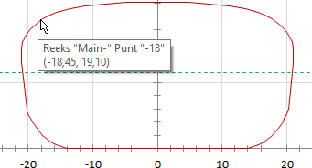
If when working on your ports, you decide that you need to lift all your ports , you can enter for example a higher number for the base gasket under new if you only need a very small raise, or decide to use a spacer (and an extra gasket), … All the changes you enter between old and new are all automatically calculated and distributed over the sheet. So using a spacer under the cylinder will automatically adjust timing, all STA calculations, pipe dimensions, adjust all the data under Port Data on the Data sheet etc…
Unfortunately it would have been too complicated to rename the transfer port’s to what we normally use. For example if a cylinder has 3 ports , we would call the 2 ports next to the exhaust the A port’s and the central port opposite the exhaust the B port. In the sheet, only the last port (D port) has the option of being a single central transfer port, so you will have to use that one as the B port in case of a 3-port lay out. So on the sheet it will be A-D ports and not A-B. The A-port is the only transfer port which has the option of being a-symmetrical like in the RSA , so the ports used in the RSA example are A-B-D. The Kawasaki KR1S does not have an a-symmetrical A-port, so it is easier to use B-C-D.
You can have up to 3 Exhaust and up to 8 transfer ports.
In many cell’s around the sheet’s, there are remark’s explaining what they are for.
Simply scrolling down on each page, there are empty tables in which you can store alternative data – of all the green cell’s - (you will find the Aprilia RSA data and my beloved Kawasaki KR1S), simply copy an entire column and paste it in there :
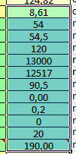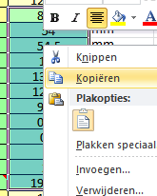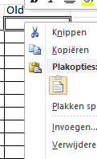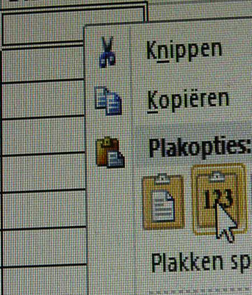
go to empty column
Select column right click select top and select “paste values”
Copy right click “123”
This was very valuable to me as I could easily swap between portmaps/data when building the sheets. Now it’s most useful feature is that you can swiftly erase everything by copying empty tables from below into the green cell’s, so you don’t have to delete all green cell’s manually.
But be careful, only copy boxed cell’s back to green cell’s ! This applies for example to the light green cell’s on the transfer sheets : you can copy the light green cell’s as numbers to the tables below to save them, but you can not copy them back (that’s why they are not boxed).
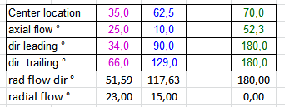
If you have the password protection of and you’d copy them back, you’d write over the formula’s. You have to manually get the numbers back by using the sliders.
The AutoAdjust buttons on all graph’s automatically adjust the graph’s to the size of the engine or ports. Normally you only need to push them once when you changed some engine parameter considerably (like bigger bore or longer stroke). Just click on it if not all is shown or it is shown to small.
If you only want to have a play with ports and not be bothered about gaskett’s under cylinders, deck to port heights etc , you can. Just enter the same data under new and old in all green cell’s. As their will be no difference between them, no change will occur due to them, and as zero height on portmap is always BDC (this is true if all data of the engine between new and old is the same, if you change for example the stroke of new, than BDC of new will change) you are good to go .
2 Data
All “darker” cell’s (green and yellow) are for the New ports/engine, all “lighter” cell’s for the old one.
If you leave all the cell’s blank in the Portmap Data on the exhaust/transfer sheets (or enter zero’s in all of them) : all yellow cell’s will also be blank . As you enter data in ports, all the corresponding data will automatically be calculated. As you can see in the RSA example : no data is given for the C-ports. If in yellow cell’s a “#xxx! error is displayed it means either not all needed data is entered or impossible data is entered (ports higher than stroke for example).
About :
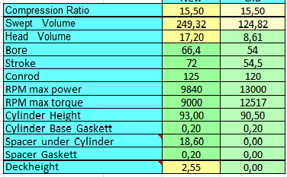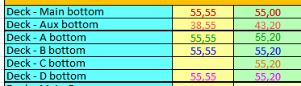
There is a big difference between “old” and “new” when entering data.
Under “Old”, you enter the data as your engine currently is, and you are not supposed to play with it (for this reason, there is no “offset” on the old pages) , because it is just a “snapshot” of the current situation and some of the entered data are linked together (like deckheight and deck to bottom-ports). For example : lifting the “old” cylinder by 10mm by using a spacer under it, you will see that nothing changes in the calculations for “old”. On the contrary, you will see that only the calculations of “new” change. This is because for the “new”, all changes between “old” and “new” are taken into account. So you must leave “old” as is so that all entered data is correct. If you change anything under “old”, all “new” calculations will be done on bad data. If you do want to change something under “Old”, make sure to change all the corresponding data to (use spacer -> change deckeight, change “Deck to bottom port’s” and change height’s in portmap data on “Old pages”
About the head volume :
The head volume is needed for the STA calculations. If you do not want to use the Head sheet, you leave the little box unchecked and fill in the head volume at the left. If you do check the box, the entered volume left of it is meaningless and you will have to design the head to what you want it to be.
About the piston:
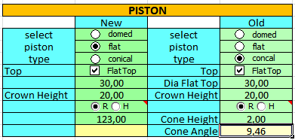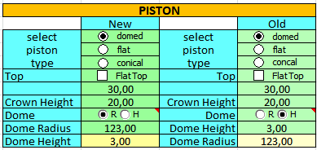
First, you chose the type of your piston : domed, flat or conical top. If it has a flat top (for domed or conical), you tick the box “flat” and in all the blue cell’s below will be displayed what data you need to enter in the green cell’s. If nothing is displayed in the blue cell, it doesn’t matter if anything is entered or not in it’s green cell. When a domed piston is selected, you need to chose wheter you are going to use the height (H) or radius (R) of the dome as data to enter, the other will automaticaly be calculated (example on the right).
In the example left, you see that the old piston has a flat top, while on the right both piston’s do not : on the right “Flat top” is not displayed and nothing is done with the “30” value . When “conical” is selected, nothing is displayed next to R / H so selecting either of them doesn’t matter. If you would chose a Flat piston, all blue cell’s except Crown Height will be blank.
In fact : this all matter’s for the Head calculation’s, and that only uses the new piston, so for now, everything you enter under “Old Piston” (EXCEPT CROWN HEIGHT ! this has to be entered correct !) has no meaning. Still left it in the sheet as it might become useful in the future.
About the “Portmap Baseline” :
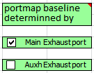
The AutoAdjust buttons on the Portmap’s on the Transfer pages need to know which exhaust port is the main exhaust port, so you must check the corresponding box here. Checking 2 boxes or no box will cause an error.
As everywhere else in the sheet’s : when you have a double exhaust port, you use only the Auxiliary ports and have to check the “Aux exh” box. In all other cases, you check the “Main exh” box.
About the “rescaling an engine” :
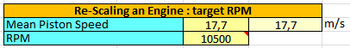
If you want to downsize or upscale an engine, their mean piston speed’s has to be the same. For example : you can not make a 250cc version of the RSA and expect it to rev as high- you will see that the Mean Piston Speed for the larger stroke is higher. This box tells you after you have entered the new stroke for the new engine the target rpm at which the new engine should make it’s max BHP, as that’s the rpm at which both engine’s have the same mean piston speed. If you then enter this RPM in the RPM for max BHP cell, you will see that “Mean Piston Speed” for both engines are the same again.

About minimal Bridge width’s :
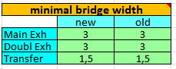
Here you can enter the minimal bridge width’s. If a bridge becomes thinner than these values, the appropriate box on the sheet will turn red.
For now , these are only horizontal ! So a “diagonal bridge” between Aux and first transfer port can be thinner, keep that in mind ! Need to have a think about how to get the diagonal width’s calculated.

3 Exhaust
When you have a double (or T) exhaust port, you only use the Auxiliary part of the sheet, leave the Main blank or put zero’s in all Main cell’s.
It doesn’t matter where you start in the column or where you put zero height.
Remember : zero height is your BDC on the OLD page ! On the new page it is best to do the same (most certainly if no basic data of the engine changes) although it isn’t 100% nescesary.
But when you do an upscale like in the example, for the STA numbers, it doesn’t matter as you can compensate with spacers, deckheights etc …. But your goal should always be that bottom’s of transferports are even with the piston at BDC, so zero height should still be BDC.
If your Main exhaust port comes lower than BDC, you still need to enter the width that corresponds to BDC at height zero, and for the width’s below BDC, you enter a “minus height”. In the columns below, there is an example called “Sky” (a Honda 50cc moped), just copy the columns into the portmap and you can see the example. If you do not see the actual port’s below BDC in the graph’s, just click the AutoAdjust button’s.
Best is to always end (bottom end top) with a zero width (repeat the height above/below) and fill the remaining cell’s in the columns all the way down/up with that height and zero width or there will be a line drawn through the center of the port on the graph. It will not show for the main port as it interacts with the Y-axis, but for all other’s it will show. This has no effect on calculations though if for example you fill up with zero’s as width and height.
So best do this when all is done.
You can not have a higher height in the column than for which there is actualy a port width!!!! That higher height would be used for timing calculations !!!! Always check !!!
You start by entering your current engine on the “old exhaust” page. After you have entered the ports, you need to enter these data :
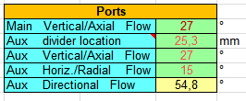

Vertical/Axial flow is the angle the exhaust duct makes to the line perpendicular to the stroke :
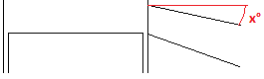
Horizontal/Radial flow is the angle at which gases flow through the ports, compared to line from the center of the port to the center of the cylinder :
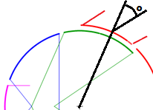
Aux directional flow is the angle the flow into the port makes to the centerline through the cylinder :
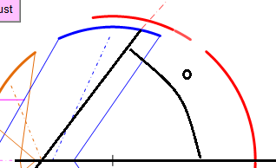

About :
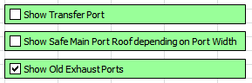
Ticking the “Show transfer port” box shows you where the first transfer port sits when re-shaping your exhausts. For this to work, you must have selected the first transfer port’s box in the “Actual Ports” graph on the “New Transfer” sheet !
Ticking the “show safe main …” shows a line that corresponds with a safe main roof calculated from the width of the port. It’s safe because it is easy on the rings as it guides them back into the piston. This is calculated by a formula given by Frits Overmars.
If you tick “show old exh ports” , they will also be shown so you can see the difference :
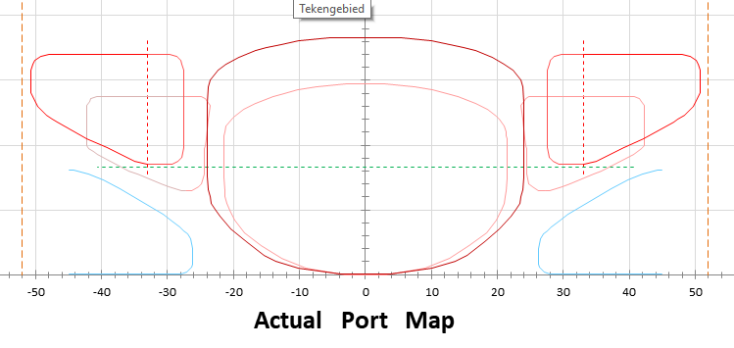
The vertical dotted red lines in the Aux Port’s show their divider’s location.
The horizontal green dotted line shows where the Blowdown ends and the transfer port with the highest timing opens.
The vertical red dotted lines on the sides show the half-cylinder-circumference mark. They are important as your auxiliary or double exhaust ports should not exceed them, as that is bad for power according to Jan Thiel.

Now that you have defined all your exhaust ports (and your transfer ports, see separate chapter), you adjust the BMEP value on the “Exhaust Old” page until the calculated STA numbers match the Target values as close as possible (targets change as you change the BMEP). When you’re done, you can read above the BMEP value what your current ports might be able to produce as max BHP/kW . This depends largely if everything else is also designed adequately (firstly and mostly if the transfer ducts will flow as much as the ports).

After you have entered the data on “transfer old”, you are ready to move on to the “New pages”. Firstly : if you are going to change something to the basic’s of the engine, do this on the “Data” sheet.
Now you need ports on the “new page” . you could do it the hard way designing them from scratch, or you can simple copy the entire “old” tables to the “new” pages like explained in the general info, and change the numbers when re-designing your ports.

On the “New Exhaust” page, you enter the BMEP value you want to aim for and start changing the ports. A quick way of doing this is using the “Offset” cell’s under each column : if you enter a 2 for example, it means that to each entered value in the column above 2 is added. For width, this widens the port, for height this raises (or lowers when entering a negative value) the entire port, it does not make the port higher. So you can quickly see it’s effects, but you best change it in the “portmap data” itself afterwards when satisfied with the result to compensate for the lost Angle.Area at the bottom by raising the port (and you probably must do this with the transfers to make sure the bottom of the port again sits at BDC as this is important for piston cooling).
It is possible that when changing port-shapes, you also must change the divider/center location of some of the ports to keep them all separated.

When it is impossible to reach your new target’s with your STA numbers, you might have raised the bar too high and you will have to lower your target BMEP.

4 Transfer
First you enter the port’s data similar to the exhaust sheets. The A-port is special as it has separate in- and outside width’s, so this port can be a-symmetrical. The D-port is also special as it has the option of being a single port opposite of the exhaust.
For a single D-port, tick the box top right of the portmap-data.
After you have entered the ports, you need to fill in their location and all the angles :
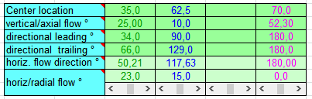
In the lighter green cell’s, you do not enter the numbers (you couldn’t if you tried, unless you have the protection off). Both light green cell’s above each slider are automatically adjusted by the slider. I still gave them a green color so it is obvious that they are for entering data but you have to adjust them by using the slider underneath them.
It would be good if you have read Frits Overmars’ article “The leaning tower of Pisa” to understand all these angles. Copy this link, paste it into a browser and you’ll find it somewhere in the middle (all is listed alphabetical) : https://drive.google.com/drive/folders/1JXzzjE_Ol6LGs-yEMuy2DbpjdH-2R0fs .
Otherwise, in the remarks on the sheets is a short explanation what they are. Change the numbers and you will see on the circular graph what changes, so you know what they are.
There are 3 ways to change the slider :
Super-super-fast : you click on the “grey box” between the arrows and drag it along Simple clicks either left or right between the “grey box” and an arrow makes the values go op or down by units. Hold your “click” and they will continue to go up/down. A click on an arrow makes them go up or down by 0.1 . Same with “hold click”.
You will have to make an educated guess by carefully studying the cylinder’s transfer ducts and port-entrances into the cylinder as to what the horizontal flow direction actualy is. It’s the bottom ones that are used for further Angle.Area calculations . On the circular graph, you can tick the “Show flow lines” to help you determine how the actual horizontal flow through the ports is.
If you have chosen a “single D” port, it does not matter what center location you enter or it’s leading and trailing angles : it will automatically be placed in the center of the cylinder opposite of the exhausts, and 180° leading and trailing angles will be used. You will also notice that the slider for the horizontal flow no longer works, as that flow is also automatically 180°.
As said in Exhausts : when all is entered, and you have set your goal by choosing a new BMEP value on the “exhaust new” sheet, you start reshaping your ports. A guide that can help you here is :
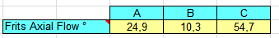
These are “guidelines” for the Vertical/Axial flow out of the ports (given by Frits Overmars). They are dependent on the bore-stroke ratio of the engine. An over-square engine needs different angles than a square or under-square engine. THESE ARE ONLY TRUE FOR A TRADITIONAL 5-PORT ENGINE !!!

About :
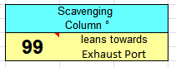
This is the angle the scavenging column makes (when all the flow from all the ports has come together) with the center line through the cylinder . It’s the direction of the resultant of the final upwards flow. More than 90° means the column is hanging towards the exhaust side of the cylinder, less than 90° means it’s hanging towards the backside of the cylinder. More explanation on this, also see “the leaning tower of Pisa”.
About :
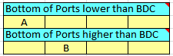
This will tell you if the bottom of your transfer ports are flat with the piston at BDC. It will show when the difference is 0.1mm or more.

5 Head
Ticking this box :
will make all the light green input cell’s meaningless, as all those parameters will be taken from the DATA sheet.
Simply :
- enter the head-gasket diameter and thickness if used, sparkplug diameter, height and volume
- choose your squish height and area
- choose whether you want your squish to be parallel to the piston or tangent.
And then chose the right radius for the bowl to get the compression ratio/head volume/squish velocity you want. You can add a height H3 if necessary.

Leaving the box blank, you can use this sheet as a stand-alone, simply enter your data in all the green cell’s.
The tangent-squish option I only put in because some people swear by it. For power it most certainly is not the way to go.
Squish velocity should be “as high as possible” which in practice means close to 40m/s according to the people who know. The calculations are 100% correct with those of Professor Blair, most you find on the internet are not.
The spark plug is marked on top of the roof of the chamber so you know where it is.
About :
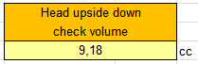
This corresponds to the volume of the head when placed upside down for checking.

- FOS pipe

The pipes dimensions are calculated through Frits Overmars’s FOS concept:
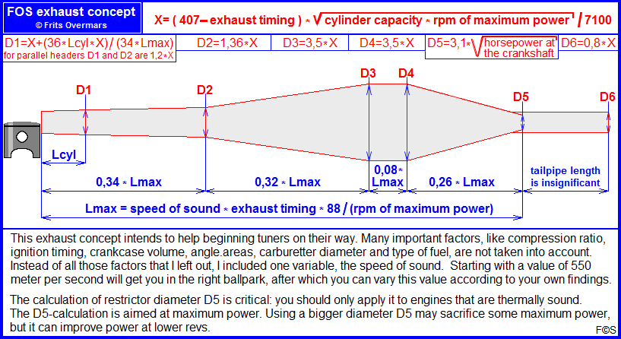

There are also tick-boxes that give you the possibility to select a “Wobbly Exhaust duct” as by the drawing below :

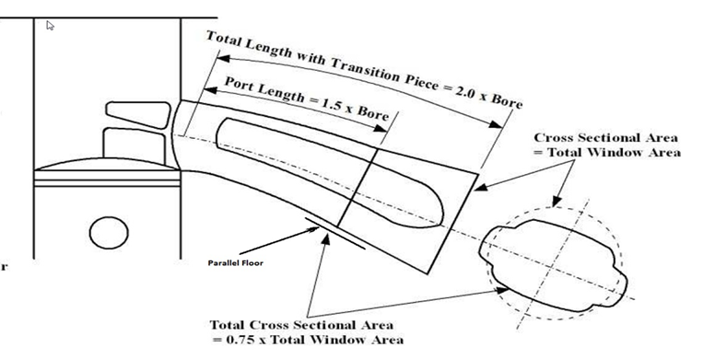

When you downloaded my excel, it has a +/- version of an Aprilia RSA125 GP engine. The green pipe shown is the Aprilia tubo102 factory pipe (well almost, because of some limitations of the sheet, but not more than 1mm of anywhere), and without the last bafflecone, but with the Wobbly-duct ticked on. You can see Wobbly’s duct is an almost perfect match with Aprilia’s duct (just the end Aprilia’s duct sit’s halfway between Wobbly’s duct and spigot) and the rest of the FOS pipe’s dimensions corresponds very well with those of the tubo102 which are free to find on the net).
The red pipe is a standard FOS pipe calculated on the RSA data in the sheet’s, and as you can see it is a straight forward simple pipe, but still very VERY well matched in shape with the factory pipe. I have built a couple of pipes with this sheet, and I can tell you : get the speed of sound spot on and they work very well !
About this box :
When this box is ticked, it means the sheet uses all the light green data from the previous sheets and you only have to enter the length of the exhaust duct and the speed of sound, all the data in the light green cells is then meaningless and not used. If you leave the box unticked, you can use this sheet as a stand-alone to calculate a pipe without all the previous sheets, just enter data in all the cells.
In the beginning you will have to make an educated guess about the speed of sound. If you have no clue, about 550m/s is a good place to start, at least for high BMEP engines. For my air cooled low BMEP MX moped for example , the last pipes I’ve only used 500m/s and I know from someone else in a similar situation that he only uses 487m/s. If the pipe gives it’s max power sooner than the max rpm entered on the DATA sheet, it means the pipe is too long and you should use a lower speed of sound and vice versa.
An even better way to find the correct speed of sound, is when you have a known pipe that works well :
• Measure the total length of the pipe from where the port opens to where the stinger begins
• Fill in all the data
• Change the speed of sound until the calculated total length corresponds to the length of your pipe
• Use that speed of sound as a starting point
As an example : I did this with the Tubo102 and the result was the speed of sound is 587m/s to get the length correct.
In the original FOS PIPE, you have the possibility to integrate a Wobbly Exhaust Duct/Spigot.
This greatly improves performance. Single port needs 90% cross sectional area of the effective total exhaust port area and multiple exhaust ports 75%, at 1,5 times bore distance, see picture.
Until that point, you do not "round of" the duct much, the transition to fully round is done in the spigot (from 1,5 to 2* bore), with an end-diameter-area that equals the total effective exhaust port area.
Multiple headers/diffusers/baffles ain’t worth the trouble when you can built a straight pipe, according to Frits.
However most people need to make curves in their pipes, so than it can be worth the trouble. In those situations, you can use the 2 Stage or 3 Stage pipes.
Both 2 and 3 stage are also calculated according to FOS-pipe, but you can change the dimensions using the slider/buttons. I've made it this way as it is easier to make changes than to have to enter numbers all the time. And you can immediately see the changes to the pipe on the graph. And remember : if it looks silly, you probably did something silly ;-)
With the 3 buttons on the right of the graph, you can show/hide the 3 pipes. The Graph is to scale, and when you make a new pipe that's a lot smaller/bigger than the previous (or if the changes in dimensions require it), you can use the "Auto Adjust" button to rescale the graph.

With the slider-buttons you change the green cells to the right of them. So for "D Header 1/2" and "D Diffuser 1/2" you change the angle of the cones and therefore the end-diameter of that section. You have to keep in mind that :
- Diameters are linked, so you best change first the header diameter and then work your way to the stinger.
- Changing a length also can change diameters , so always check.
The diameters of baffle2/stinger and belly (= D of last diffuser , and = D max) are changed by percentage of the original calculated FOS pipe. So 100% equals original FOS pipe. The end diameter of Baffle 1 is also calculated as a percentage of D max.
A bigger D max increases the volume of the pipe and shifts the optimal cylinder filling to lower rpm's. But the available energy is limited : a bigger D max uses more of the available energy for suction, meaning there is less energy left for pushing back the fresh charge that is already present in the header, back into the cylinder. A solution could be to use a steeper baffle cone (shorter length) to give back some amplitude .
Total header length should be about 31-33% of total length (and includes the exhaust duct). Diffuser is about 62-68%, best compromise is about 66%.
Each section of the pipe is also best made in that 66/34% range : header1/diffuser1 66% and header2/diffuser2 34% (for 2-stage). For the baffle this is more free : a steeper section returns a stronger pulse, so making a 2-stage Baffle gives you the option of having a higher return pulse in the lower rev-range giving up some top-end power.
Cone angles = to centerline of the pipe.
The yellow cells in the % columns represent the total % of the section above, so if the yellow cel under the L header % is 100, it means the total length of the header corresponds exactly to the original FOS header length.
If you want a single baffle in the 2/3 stage pipes, simply set the length of baffle 2 to 100%, baffle 1 to 0% and D baffle 1 = D max.
What I find usefull on diagram, is that you can learn a lot by just changing 1 parameter of the engine (like rpm or timings or …) and see how that influences the shape of the pipe.

- Example

In the downloaded example, under Old you have a replica of the Aprilia RSA125. Under new I’ve tried to convert it into a 250cc version with mostly used MX 250cc single bore/stroke ratio’s, to see what power theoretically could be made out of “modern” 250cc 2stroke cylinder if we would try to use it for road-race and if we could manage to distract 16.5 BMEP from it.
It’s just an exercise in getting the STA-numbers .
You can try this yourself by copying everything from old to new. There is a copy of the “re-scaled RSA” in the columns below so you can always put it back or check with what I came up with.
Enter the re-calculated target rpm for max power. This already gives an indication of what the RPM of max torque will +/- be. Do an estimated guess (like 8800) . Design a head on the HEAD sheet to get the same compression ratio as we need a new head-volume. Lift the cylinder with a spacer because of the longer stroke so that the bottom of the ports are back at BDC (on the DATA page under “Port Data” you find the distance of the port’s bottom to BDC distance, add a spacer with that distance and your ports are even again (if you’d have to lower a cylinder, enter a minus distance for “spacer”, it would represent the amount of material you’d have to remove from the bottom of the cylinder) and change the axial flow angles of the transfer ports due to the changed bore/stroke.
Start changing the ports to try to match the STA numbers. Pretty soon it’s obvious you have too much blowdown (because of the lower bore/stroke ratio) if you try to keep the same timings, so first get the transfer timings/ports in the right ball-park, and then drop the exhaust timings so that they come closer to the target.
Now you’ll have 2 “RPM of out of breath” and if you were very lucky you had chosen correctly but probably not , so take the average and enter that in RPM of max torque and adjust the ports again. And maybe another tweak to the RPM and so on, and in the end they will end up close enough (at least, I find 8996 and 9001 close enough ;-) ).
So we were able to match the target numbers, so we can conclude that in theory it would be possible to have a 250cc upscale version with 16.5 BMEP and 82.6BHP at the crank (see above BMEP on exhaust new). If we were unable to match the target, we would have to lower the BMEP so that the target’s match the best STA we could get and we would have lower HP.
If you’ve entered on the FOS sheet all the data for the RSA125, and we presume that the duct length and temperature remain the same, by clicking on the “input from data” box, you can compare the pipes for the 125 and 250cc version.

As you can now see from the data, the cylinder height of both is still the same, while the 72 stroke would require a longer cylinder. This is because in all calculations, the base of the cylinder remains the same. The difference in cylinder height is added on/taken from the top. If you delete the spacer and add it’s length to the cylinder, you’ll see that all your ports drop as much as the height of the spacer. Also if you look at these on the DATA page :
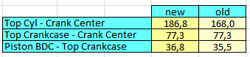
you see it does not correspond with the real world. This is because the “cylinder height” was originaly added because sometimes cylinders for the same engine differ slightly in height straight from the factory (like my beloved Kawasaki KR1S), or cylinders have already been skimmed. It is not in the spreadsheet to replicate the real world, and you can still “up/downscale” an engine, you just have to ignore those weird numbers. It requires a lot of work to have this “problem” out of the way and to make everything match the real engines, maybe something for the future.

When making big changes to basic engine data, you have to think like you would do it to a real engine and have a think of the consequences.
When someone who occasionaly tested my spreadsheet reported back that “changing the stroke to 37.8” gave an error , I thought of how that could be as I wasn’t at home and couldn’t test it directly.
So when I came home I entered 37.8 as stroke in the upscaled 250cc version, and indeed this gives an error . The error comes from the fact that in the formula’s of “exhaust port open” column J on the DATA sheet, an ARC COSINUS of a number bigger than 1 is calculated, which is impossible.
If you do this and take a quick look at the Exhaust new page, you also see immediately why : the exhaust ports are higher than the stroke. This engine in real life would also not work. So when making changes, always keep the real world in the back of your head and consider what else needs to be done for this one change to work. Ditching the spacer under the cylinder would be a start, and doing that, the error is gone, but the ports are still way too high for that stroke.
- Print

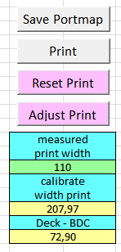

“Save Portmap” = it saves the Portmap on the “Print” sheet as a *.png image. A dialogue box opens so you can give it a name. It stores the image in the same map as the excel itself.
“Print Portmap” prints it, you are given a preview first, but all the options you normaly have are blocked, as they are all set correctly in the code of the macro (edit : apparently this depends on the printer, but if they are available, you shouldn’t change any of them. Print will use black ink).
“Reset” does just that : it reset’s the chart to it’s original dimensions
“Adjust Print” = to alter the size of the portmap
“Measured print width” = after you’ve printed a test version, here you enter the measured width of the print
“Calibrate width print” = the width the print should have, it corresponds to the circumference of the cylinder.

Printing a portmap to scale isn’t straight-forward. Several steps need to be taken , wich I solved with the help of https://www.helpmij.nl/forum/ .
Firstly, we need to make sure that the X and Y axes are to scale, so that for example 5cm wide is the same as 5cm high. This may vary depending on your screen resolution. Mine is 1920x1080 . First you make the Portmap about as big as your screen. You can do this by entering a lower number that the “calibrate width print” (for my screen in this example,I entered 110) and than click the “Adjust Print” button, and click “yes” in the dialogue box.

Than you go to the “Print” sheet and measure as much squares as possible in the height-direction .
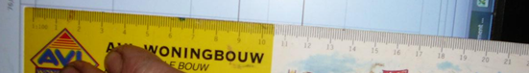
Here there were 5 and their height was 17cm.
Next you measure 5 squares width-direction and stretch the chart by grabbing the middle of it’s side , and play with it until the 5 squares measure exactly the same.
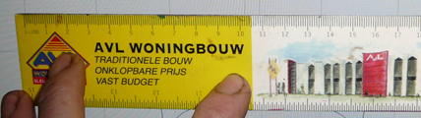
Now as long as you do not touch the chart, this will remain. You can not change the zoom after this !
Next : push the Reset button to get the chart back to it’s original size and print it by clicking on Print Portmap . Before printing, you must chose the correct printer by clicking on “file -> Print” top left of the ribbon.

The top line corresponds with the deck, the sidelines are where the cylinder-circumferrence meets up, and the distance from topline(deck) to bottomline (covered by my ruler) should be exactly half of the width, you can mesure this. If so, Height and width are correctly setup.
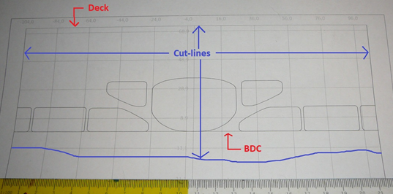
Next you measure the total width between the “cut-lines” (here 214mm), and enter this number in the “measured print width” cell, and click on “adjust print”, chosing “yes” if you want to proceed in the dialogue box. Now print it again and measure the width again. It should match the “calibrate width print”.
If it doesn’t and you are a bit of (which is very possible as the measuring ain’t perfect), do not directly re-enter a new number, as than you will make changes based on an already changed number. First you need to “Reset”, and than enter you slightly different number and print it again.
When the width-size is correc, you can always measure the distance from the BDC-line to the Deck-line, and it should be the same as on under “Deck – BDC”.
Now cut out the ports, cut the Portmap out of the sheet, make a cylinder of it and place it in your cylinder and you can see where you need to enlarge your ports .

9 Input

Just a page you can print to take into your shed/whatever to note all the needed data.
Simply push the print button.

