From: Rojhano and Johny
To: Beginners Group
Subj: Lesson 7 | PRESENT SIMPLE Part 2

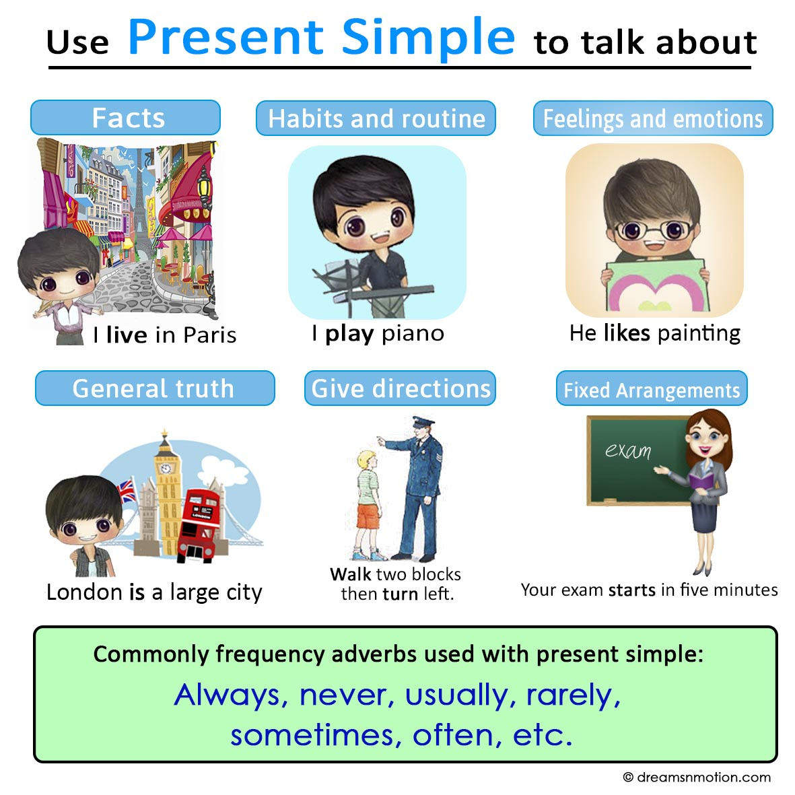
Simple Present tense uses:
1. To express habits, general truths, repeated actions or unchanging situations, emotions and wishes:

- I smoke (habit);
- I work in London (unchanging situation);
- London is a large city (general truth)

2. To give instructions or directions:
- Walk for two hundred meters, then turn left.

3. to express fixed arrangements, present or future. When talking about schedules, timetables and itineraries, the present simple tense is used to refer to a future event that is planned and is not likely to change:

- Your exam starts at 09.00
- I have a meeting on Friday, but I'm free on Saturday.
- What time is your flight?
- The last train to Moscow leaves at 8.30.
- On day 4, we visit the waterfalls.
- My father retires in two months.

4. To express future time, after some conjunctions: after, when, before, as soon as, until:
- He'll give it to you when you come next Saturday.

Be careful! The simple present is not used to express actions happening now.

Present tense habitual activities are frequently signaled by time expressions such as the following:

all the time  every class  every day  every holiday  every hour  once a week  twice a month | every month  every semester  every week  every year  most of the time  every now and then | always  often  rarely  sometimes  usually  never

Examples
For habits
- He drinks tea at breakfast.
- She only eats fish.
- They watch television regularly.

For repeated actions or events
- We catch the bus every morning.
- It rains every afternoon in the hot season.
- They drive to Monaco every summer.

For general truths
- Water freezes at zero degrees.
- The Earth revolves around the Sun.
- Her mother is Peruvian.

For instructions or directions
- Open the packet and pour the contents into hot water.
- You take the No.6 bus to Watney and then the No.10 to Bedford.

For fixed arrangements
- His mother arrives tomorrow.
- Our holiday starts on the 26th March

With future constructions
- She'll see you before she leaves.
- We'll give it to her when she arrives.

Forming the simple present tense: TO THINK

Affirmative | Interrogative | Negative
I think | Do I think? | I do not think
You think | Do you think? | You do not think
He thinks | Does he think? | He does not think
She thinks | Does she think? | She does not think
It thinks | Does it think? | It does not think
We think | Do we think? | We do not think.
They think | Do they think? | They do not think.

Notes on the simple present, third person singular:

1. in the third person singular the verb always ends in -s:
He wants, she needs, he gives, she thinks.

2. We use do/does to make questions or negative sentences.
He wants ice cream. Does he want strawberry? No, He does not want Strawberry, he wants vanilla.

3. Verbs ending in -y : the third person changes the -y to -ies:
fly = flies Cry = cries

Exception: if there is a vowel before the -y:
Play = plays pray = prays

4. Add -es to verbs ending in:-ss, -x, -sh, -ch, -o:
He passes, she catches, he fixes, it pushes, He goes

We use the simple present we say how often we do things:
- He goes to school every morning.
- She understands English.
- It mixes the sand and the water.
- He tries very hard.
- She enjoys playing the piano.

