Second Dimension – Christianity Experienced
Segment IV – Jesus, the Author and Perfecter of our Faith Progressive Bible Concepts - #36 “The Gravity of Jesus – Part II” Incarnation and Virgin Birth
Segment IV – The Author and Perfecter of Our Faith (Concepts 33-43)
- Concept 33 – “Fixing Our Eyes Upon Jesus”
- Concept 34 – “Eyes Upon the Lord”
- Concept 35 – “The Gravity of Jesus” Part I
- Concept 36 – “The Gravity of Jesus” Part II
Primary Imperative
“Therefore, since we have so great a cloud of witnesses surrounding us, let us also lay aside every encumbrance and the sin which so easily entangles us, and let us run with endurance the race that is set before us, f__________ our e______ on J________, the author and perfecter of faith, who for the joy set before Him endured the cross, despising the shame, and has sat down at the right hand of the throne of God.” Heb 12:1,2
The Gravity of Jesus is rooted in the following aspects of His Personhood:
- His P__________________________
- His P__________________________
- His I______________________
- His V____________ B________
- His C______________________
- His R______________________
- His A__________________
- His S__________ C_________
C. Incarnation of Christ
- God becomes man:
  - Ways God can make man (Anselm)
    - Without the agency of man or woman – A______
    - A man without a woman – E____
    - By the law of n____________ generation – a man (Adam) and a woman (Eve) – C______ and A______
    - Through the divine empowering of a man and a woman
      - Abraham, Sarah and I________
      - Zacharias and Elizabeth – J______ the Baptist
    - Born of a woman without a man – J________

Scripture
- “The Word became f________ and dwelt among us…” John 1:14
- “…although He existed in the form of God, He did not regard equality with God as a thing to be g__________ (h______ o______), but emptied Himself, taking the form of a bondservant, and being made in the likeness of men. And being found in the appearance of man…” Phil 2:6-8a
- “For in Him all the fullness of Deity dwells in b__________ form…” Col 2:9
- “For there is one God, and mediator also between God and men, the m____ Christ Jesus…” I Tim 2:5
Testimony of His Enemies
- “The Jews therefore gathered around Him, and were saying to Him, “How long will You keep us in suspense? If You are the Christ, tell us plainly.”
- Jesus answered them, “I told you, and you do not believe; the works that I do in My Father’s name, these testify of Me. But you do not believe because you are not of My sheep. My sheep hear My voice, and I know them, and they follow Me; and I give eternal life to them, and they will never perish; and no one will snatch them out of My hand. I and the Father are one.”
- The Jews took up stones to throw at Him. Jesus answered them, “I showed you many good works from the father; for which of them are you stoning me?” The Jews answered Him, “For a good work we do not stone You but for blasphemy; and because You being a m____, make yourself out to be G____.” John 10:25-33
Testimony of His Disciples
- So when it was evening on that day, the first day of the week, and when the doors were shut where the disciples were, for fear of the Jews, Jesus came and stood in their midst and said to them, “Peace be with you.
- But Thomas, one of the twelve, called Didymus, was not with them when Jesus came. So the other disciples were saying to him, “We have seen the Lord!” But he said to them, “Unless I see in His hands the imprint of the nails, and put my finger into the place of the nails, and put my hand into His side, I will not believe.”
- After eight days His disciples were again inside, and Thomas with them. Jesus came, the doors having been shut, and stood in their midst and said, “Peace be with you.” Then He *said to Thomas, “Reach here with your finger, and see My hands; and reach here your hand and put it into My side; and do not be unbelieving, but believing.” Thomas answered and said to Him, “My L______ and my G____!” John 20:19, 24-29

God becomes man – What it means
- His birth in Bethlehem was not His o__________, only His i_____________________. Of no other person in history is it possible to distinguish between their origin and their birth, or to say that his life did not begin at his birth.
- At His incarnation, Jesus enters the state of h____________________ by laying aside His heavenly Majesty and assuming human nature in the role of a suffering servant.
- The Incarnation represents a profound mystery of u__________ proportions – divinity assuming humanity has no precedent nor replica.
- God, the supreme being, became a member of the human race and assumed the l________ form of His created beings.
- He did not clutch onto His heavenly privilege, but laid it aside in a profound act of self-deprecation establishing the supreme s______________ of humility for all to follow.
D. Virgin Birth
- “Therefore the Lord Himself will give you a sign: Behold a v__________ will be with child and bear a son, and she will call His name Immanuel (God with us).” Isaiah 7:14
- “And the angel said to her, “…behold you will conceive in your womb and bear a son and you shall name Him Jesus.” And Mary said to the angel, “How can this be, since I am a v__________?” The angel answered and said to her, “The Holy Spirit will c______ u______ you, and the power of the Most High will o____________________ you; and for that reason the holy offspring will be called the S____ of G____.” Luke 1:30-35 (selected portions).
- “ Now the birth of Jesus Christ was as follows: when His mother Mary had been betrothed to Joseph, b__________ they came together she was found to be with child by the Holy Spirit. And Joseph her husband, being a righteous man and not wanting to disgrace her, planned to send her away secretly. But when he had considered this, behold, an angel of the Lord appeared to him in a dream, saying, “Joseph, son of David, do not be afraid to take Mary as your wife; for the Child who has been c__________________ in her is of the H______ S__________.”
- “ She will bear a Son; and you shall call His name Jesus, for He will save His people from their sins.” Now all this took place to fulfill what was spoken by the Lord through the prophet: “Behold, the virgin shall be with child and shall bear a Son, and they shall call His name Immanuel,” which translated means, “G____ w______ u__.” And Joseph awoke from his sleep and did as the angel of the Lord commanded him, and took Mary as his wife, but k______ her a v__________ until she gave birth to a Son; and he called His name Jesus.” Matthew 1:18-25

Insight:
- The h____ of the virgin birth becomes believable when the w____ of the birth is taken into account.
- The ordinary transmission of original sin from one generation to another was i______________________ by the miraculous conception.
- While belief in the virgin birth is not essential to salvation, the integrity of the doctrine is essential to the integrity of J________.
Implications:
- If false, the gospel narratives are f________ and the authority of the scripture is u____________________.
- If false, Mary, instead of being blessed among women, is branded an u______________, u________ mother of the Lord Jesus.
- If false, Jesus is the n____________ child of s__________ parents, this precludes his preexistence, n______________ the incarnation.
- If false, we are deprived of any adequate explanation of Jesus s____________ character.
- If false, Jesus is not God and is powerless to f____________ sin.
The bottom line question for any virgin birth skeptics, is ‘Are you willing to accept the s__________________________________ claims of Scripture or not?’
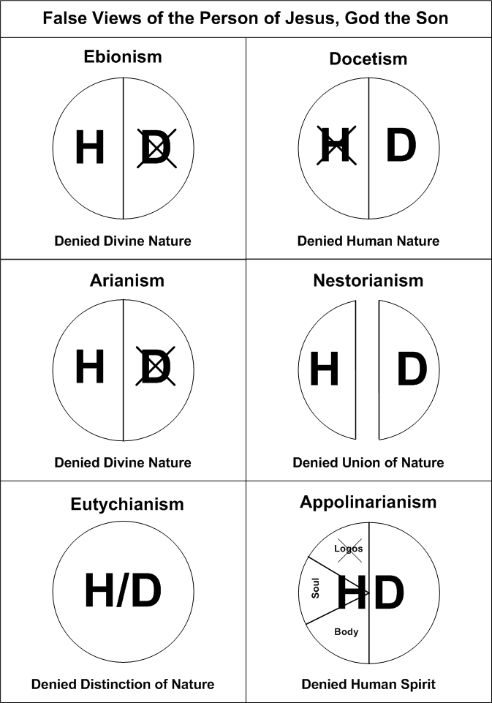

The Gravity of Jesus is Rooted in the Following:
Quote:
“The Son of G____ became the Son of M_____ that the sons of m______ could become the sons of G______.”
Summary - Concept 36 - Through the Incarnation Jesus assumes humanity and the Virgin Birth sustains His divinity.
Next Week – Concept 37
- The Gravity of Jesus – Part III – The Crucifixion and the Resurrection

