Name:_______________

Understanding Your eGauge Energy Monitor
As you may know, your school received an eGauge electricity monitor because you are participating in the ReNew Our Schools Competition. This monitor will show your school’s electricity use during the competition so that you can see how much electricity you are saving! Even better, you get to keep this monitor when the competition ends so your building and district staff can make sure you continue to conserve energy.

An eGauge monitor is an electricity monitor that can measure the electricity use of an entire building. It measures the electricity load of your school in real-time. The display is continually updated to show any change in electricity.
Here is a snapshot of an eGauge screen. The eGauge screen at your school will be updated with new data by the second.
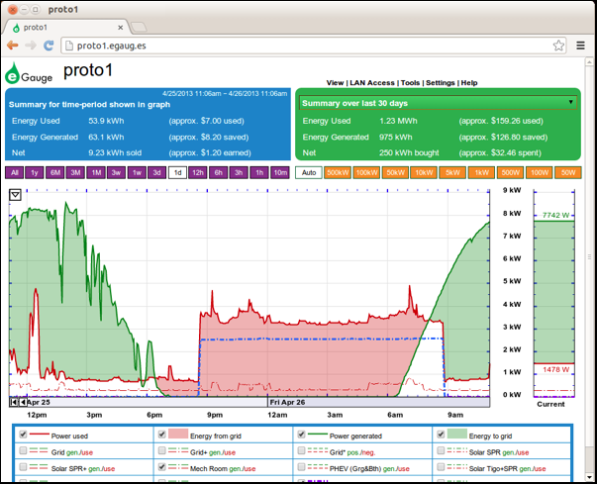g
Understanding the eGauge screen: The left (or main) portion of the screen is a graph of recent data (in this picture, the most recent 24 hours), whereas the right part of the screen is a gauge that is updated every second and displays current electricity use. The area above the graph is a summary showing how much electricity is being used, produced, and the NET electricity (the difference between the amount being used and produced). The area in purple can be changed so that the graph shows electricity use over different time periods. In this case, the graph is set to show the last 24 hours. The area in green above the graph shows the same information over the last 30 days.
Please answer the following questions using the graph above.
1) For the 24 hour time period shown in this graph, the energy used by this building is __________________.

2) The red shaded area displays the amount of energy used by this building. What is the largest amount of energy use (the highest peak) in this 24 hour period?____________________________________

3) This building has a solar array that produces energy for the school. The green shaded area on the graph shows how much energy the solar array was producing.
How much production is taking place when this snapshot was taken? ________________

Analyzing Results
- What do you think could be causing the spikes in the ‘power used’ portion of the graph?

- On the graph below, draw what you think a perfectly sunny day in Colorado would look like:

- On the graph below, draw what you think a sunny day with intermittent clouds would look like:

4) Now, using your school’s eGauge, write down 4 observations of your school’s electricity consumption. This may be most beneficial as a class exercise.
a.

b.

c.

d.

The area in red on your eGauge graph is the base electricity load of your school. The peaks are important, but the large solid red area is the area that a district should look at to save money.
6. What is the average base load of your school during school hours? _________________

7. What is the average base load of your school at night when the building is empty?

8. Looking around your school, what recommendations can you make to save energy?
a.

b.

