Second Dimension – Christianity Experienced
Segment VI – The Culmination (Concepts 54-60) Progressive Bible Concepts - #57 “The Sacraments”
Historical Overview - Theological Development
C_____________
C_____________
C_____________
Creeds:
- A______________ Creed (required confession for early church membership) – 180A.D.?
- N__________ Creed (arose out of the first ecumenical council). 325 A.D.
- A__________________ – formed later probably from the notes of Athanasius who served as the scribe for Alexander, the leading spokesman for orthodoxy in opposition to Arianism. 450A.D.

Councils
Ecumenical councils – 7 in number:
- 4 Prominent Ecumenical Councils:
- 325 - Council of N_______ – settled the doctrine of Christ’s divinity, condemning Arianism (the heresy that taught that Jesus was begotten therefore, unlike the Father).
- 381 – Council of C____________ – affirmed Nicea, also clarified the divine essence of the Holy Spirit – attention was given to the divinity of the Holy Spirit.
- 431 – Council of E___________ - settled the doctrine of Christ’s unity, condemning Nestorianism (that Christ was two persons)
- 451 – Council of C______________ – affirmed the two natures of Christ – condemned Eutychianism (that Christ had only one nature)

Confessions:
- 39 A__________ of Religion – Drawn up by the church of England, in hopes of clarifying the theological position of the C__________ of E____________ during a time of revolution and theological controversy.
- Westminster Confession of Faith – 1642-46. Not a church council but an a______________ c____________ summoned by Parliament to give advice and guidance to the civil authorities for the promotion of unity and uniformity in the work of the Reformation.

Sacraments – Definitions:
- S__________________ – holy signs and seals of the covenant of grace
- S________ – to make sacred
- M________________ – something unknown until revealed, known only to the initiated
- S______ – something by means of which something else is made known
- S______ – something that authenticates or confirms that to which it is affixed or appended

WCF – Chapter 27 Of the Sacraments
- Sacraments are holy signs and seals of the covenant of grace, immediately instituted by God:
  - to r____________ Christ and His benefits;
  - and to c__________ our interest in Him:
  - as also, to put a v___________ difference between those that belong unto the Church and the rest of the world;
  - and solemnly to engage them to the s_________ of God in Christ, according to His Word. Rom 4:11

- There is, in every sacrament, a spiritual relation, or s_____________________ u________, between the sign and the thing signified: whence it comes to pass, that the names and effects of the one are attributed to the other. I Cor 10:16, Rom 6:3

- The grace which is exhibited in or by the sacraments rightly used,
- is not conferred by any power in t______; neither does the efficacy of a sacrament depend
- upon the p________ or i________________ of him that does administer it:
- but upon the work of the S__________,
- and the w______ of institution, which contains, together with a precept authorizing the use thereof, a promise of benefit to worthy receivers. Rom 2:28,29

- There are only t____ sacraments ordained by Christ our Lord in the Gospel; that is to say, B____________, and the S__________ of the Lord: neither of which may be dispensed by any, but by a minister of the Word lawfully ordained. Matt 28:19, I Cor 11:20

- The sacraments of the Old Testament in regard to the spiritual things thereby signified and exhibited, were, for substance, the s______ with those of the new. Col 2:11,12

Roman Catholic Sacraments:
- Baptism
- Holy Communion
- Confession
- Confirmation
- Ordination
- Marriage
- Extreme Unction

The Sacrament of Baptism - Westminster Confession of Faith – Chapter 28

Of Baptism:
- Baptism is a sacrament of the New Testament, ordained by Jesus Christ, not only for
  - the solemn a___________ of the party baptized into the visible Church;
  - but also to be unto him a sign and seal of the c__________ of grace,
  - of his i_____________ into Christ,
  - of r________________
  - of r_________________ of sins,
  - and of his g__________ up unto God, through Jesus Christ, to walk in the newness of life.
Which sacrament is, by Christ's own appointment, to be continued in His Church until the end of the world. Acts 2:38

- The outward element to be used in this sacrament is w________, wherewith the party is to be baptized, in the name of the Father, and of the Son, and of the Holy Ghost, by a minister of the Gospel, lawfully called thereunto. Matt 28:19, Luke 3:16 - baptizo – “to c_______________”

- Dipping of the person into the water is not n________________; but Baptism is rightly administered by p____________, or s__________________ water upon the person. I Peter 1:2

- Not only those that do actually profess faith in and obedience unto Christ, but also the i____________ of one, or both, b________________ parents, are to be baptized. Acts 16:33

- Although it is a great sin to contemn or neglect this ordinance, yet grace and salvation are not so inseparably a____________ unto it, as that no person can be regenerated, or saved, without it: or, that a____ that are baptized are undoubtedly regenerated. Luke 23:43

- The efficacy of Baptism is not tied to that m__________ of t______ wherein it is administered; yet, notwithstanding, by the right use of this ordinance, the grace promised is not only offered, but really exhibited, and conferred, by the Holy Ghost, to such (whether of age or infants) as that grace belongs unto, according to the counsel of God's own will, in H____ a________________ t______. John 3:8

- The sacrament of Baptism is but o______ to be administered unto any person. Titus 3:5

Four Views on Water Baptism:
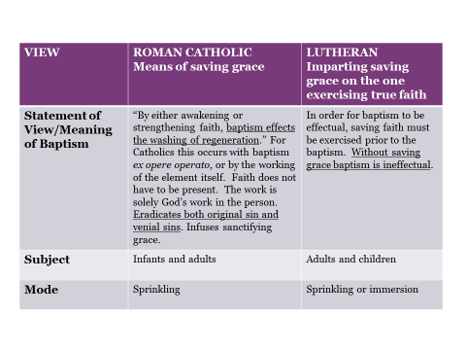
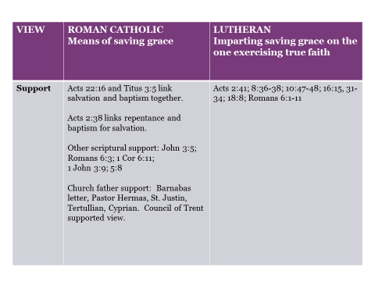

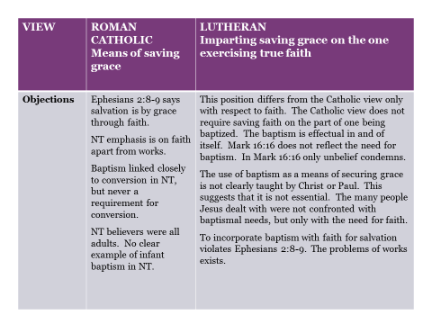

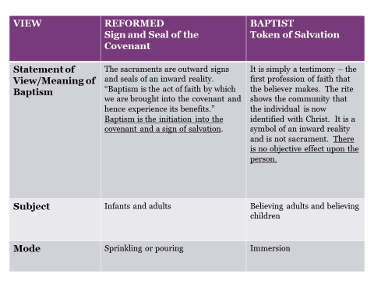

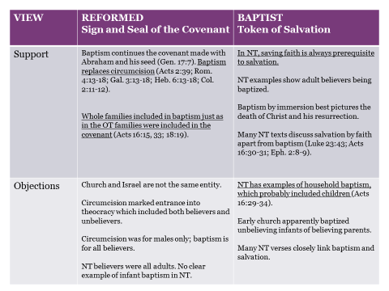

The Sacrament of Communion:

New Testament Guidelines:
- “Therefore when you meet together, it is not to eat the Lord’s Supper, for in your eating each one takes his own supper first; and one is hungry and another is drunk. What! Do you not have houses in which to eat and drink? Or do you despise the church of God and shame those who have nothing? What shall I say to you? Shall I praise you? In this I will not praise you. For I received from the Lord that which I also delivered to you, that the Lord Jesus in the night in which He was betrayed took bread; and when He had given thanks, He broke it and said, “This is My body, which is for you; do this in remembrance of Me.” In the same way He took the cup also after supper, saying, “This cup is the new covenant in My blood; do this, as often as you drink it, in remembrance of Me.” For as often as you eat this bread and drink the cup, you proclaim the Lord’s death until He comes. Therefore whoever eats the bread or drinks the cup of the Lord in an unworthy manner, shall be guilty of the body and the blood of the Lord. But a man must examine himself, and in so doing he is to eat of the bread and drink of the cup. For he who eats and drinks, eats and drinks judgment to himself if he does not judge the body rightly. For this reason many among you are weak and sick, and a number sleep. But if we judged ourselves rightly, we would not be judged. But when we are judged, we are disciplined by the Lord so that we will not be condemned along with the world. So then, my brethren, when you come together to eat, wait for one another. If anyone is hungry, let him eat at home, so that you will not come together for judgment. The remaining matters I will arrange when I come.” I Corinthians 11:22-34

WCF - Chapter 29 Of the Lord’s Supper:
- Our Lord Jesus, in the night wherein He was betrayed, instituted the sacrament of His body and blood, called the Lord's Supper, to be observed in His Church, unto the end of the world,
  - for the p________________ remembrance of the sacrifice of Himself in His death;
  - the sealing all b______________ thereof unto true believers,
  - their spiritual n____________________ and growth in Him,
  - their further engagement in and to all d__________ which they owe unto Him; and,
  - to be a bond and pledge of their c________________ with Him, and with each other, as members of His mystical body. I Cor 11:23ff

- In this sacrament, Christ is not offered up to His Father; nor any real sacrifice made at all, for remission of sins of the quick or dead; but only a c________________________ of that one offering up of Himself, by Himself, upon the cross, once for all: and a spiritual oblation of all possible praise unto God, for the same: so that the popish sacrifice of the mass (as they call it) is most abominably i________________ to Christ's one, only sacrifice, the alone propitiation for all the sins of His elect. I Cor 11:24a

- The Lord Jesus has, in this ordinance, appointed His ministers
  - to d____________ His word of institution to the people,
  - to p______, and
  - b________ the elements of bread and wine, and thereby
  - to set them apart from a common to an h______ use; and
  - to t______ and b________ the bread, to t______ the cup, and (they communicating also themselves)
  - to g______ both to the communicants;
  - but to none who are not then p____________ in the congregation. I Cor 11:26

- P____________ masses, or receiving this sacrament by a priest, or any other alone; as likewise,
  - the d__________ of the cup to the people,
  - w____________________ the elements, the lifting them up, or carrying them about, for adoration,
  - and the r________________ them for any pretended religious use;
  - all c______________ to the nature of this sacrament, and to the institution of Christ. I Cor 5:20

- The outward elements in this sacrament, duly set apart to the uses ordained by Christ, have such relation to Him crucified, as that, truly, yet s________________________ only, they are sometimes called by the name of the things they represent, to wit, the body and blood of Christ; albeit, in s______________ and n__________, they still remain truly and only bread and wine, as they were before. I Cor 11:28

- That doctrine which maintains a change of the substance of bread and wine, into the substance of Christ's body and blood (commonly called t__________________________________) by consecration of a priest, or by any other way, i__ r________________, not to Scripture alone, but even to common sense, and reason; overthrows the nature of the sacrament, and has been, and is, the cause of manifold superstitions; yes, of gross idolatries. I Cor 11:29 - – “rightly discern”

- Worthy receivers, outwardly partaking of the visible elements, in this sacrament, do then also, inwardly by faith, really and indeed, yet not carnally and corporally but spiritually, r_____________and f______ upon, Christ crucified, and all benefits of His death: the body and blood of Christ being then, not corporally or carnally, in, with, or under the bread and wine; yet, as really, but s____________________, p____________ to the faith of believers in that ordinance, as the elements themselves are to their outward senses. I Cor 11:29

- Although ignorant and wicked men receive the outward elements in this sacrament; yet, they receive not the thing s________________ thereby; but, by their unworthy coming thereunto, are g__________ of the body and blood of the Lord, to their own damnation. Wherefore, all ignorant and ungodly persons, as they are unfit to enjoy communion with Him, so are they unworthy of the Lord's table; and cannot, without g________ sin against Christ, while they remain such, partake of these holy mysteries, or be admitted thereunto. I Cor 11:29

Four Views on the Lord’s Supper:
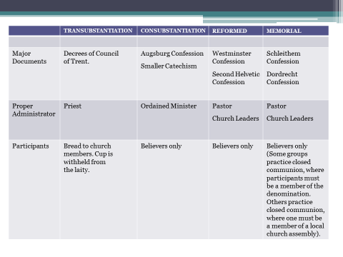
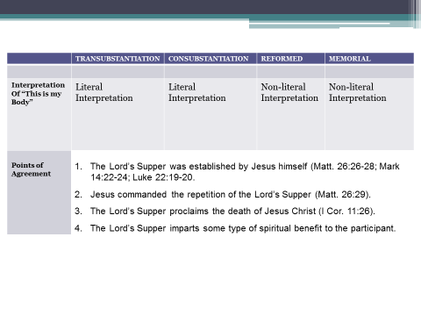
Concept 57 Summary:
Jesus instituted two rites or sacraments to be observed perpetually, faithfully, and reverently in his absence to commemorate His redemptive work in the hearts of His followers for their spiritual identification, edification, and nurture.

Next Week – Concept 58
- Death

