*From: Rojhano*

*To: Beginners Group*

*Subj: Lesson 10*

**Lesson Objective**

The student shall be able to use correct pronunciation in speaking English.

First Portion

**Pronunciation**

**Pronunciation of Final -S**

**Plural Nouns and Verbs in Third Person**

The pronunciation of S at the end of plural nouns, verbs in third person and as a part of the [possessive case](http://www.grammar.cl/rules/genitive-case.htm) sometimes causes problems for non-native speakers because it can be pronounced in three different ways: / ɪz /, / s / or / z /.

(Note: whenever you see letters or symbols between two slash marks (/ /), it refers to the pronunciation of that letter or sound)

The pronunciation depends on the last sound of the verb or noun which is usually a consonant. Before we learn the difference ways to pronounce the final S, we must first know what voiced and voiceless consonants are as well as sibilant sounds:

**Voiced Consonants vs. Voiceless Consonants**

A **voiced** consonant (or sound) means that it uses the vocal cords and they produce a vibration or humming sound in the throat when they are said. Put your finger on your throat and then pronounce the letter L. You will notice a slight vibration in your neck / throat. That is because it is a **voiced** sound.

A **voiceless** sound (sometimes called unvoiced sound) is when there is no vibration in your throat and the sound comes from the mouth area. Pronounce the letter P. You will notice how it comes from your mouth (in fact near your lips at the front of your mouth). The P sound doesn't come from your throat.

Try this with the other letters and you will "feel" the difference between a voiced and a voiceless consonant (or sound).

On any IPA table the voiceless consonants are on the left, the voiced on the right.

**Voiceless:** p, t, k, f, θ, s, ʃ(sh), h, ʍ(wh), tʃ(ch)

**Voiced:** b, d, g, m, n, ŋ(ng), v, ð(th), z, ʒ(zh), ɹ, l, j, w, dʒ (dzh)

Sibilant Sounds

Another sound which is relevant to this is the **sibilant sound** which is produced by forcing air out toward your teeth. Is is characterized by a hissing sound (sssss), a buzzing sound (zzzzz) or the sound teachers make when they want you to be quiet (shhhh!).

* Z like the sound a bee makes... zzzzzz
* S like the sound a snake makes... sssssss
* SH like the sound a teacher makes when they want you to be quiet... shhhhh

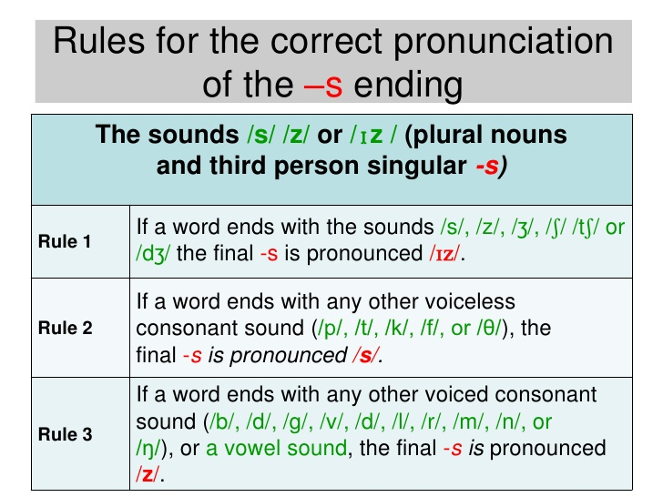

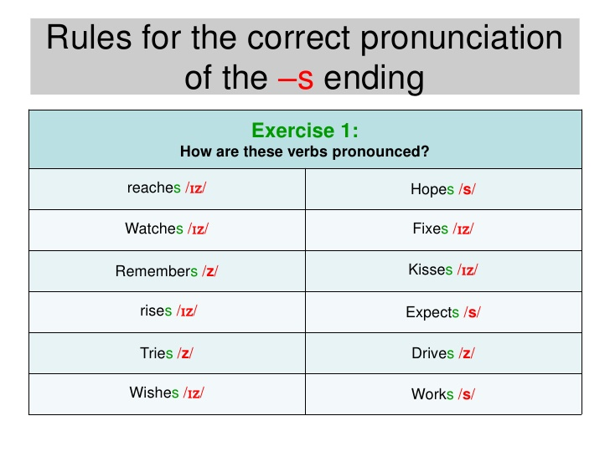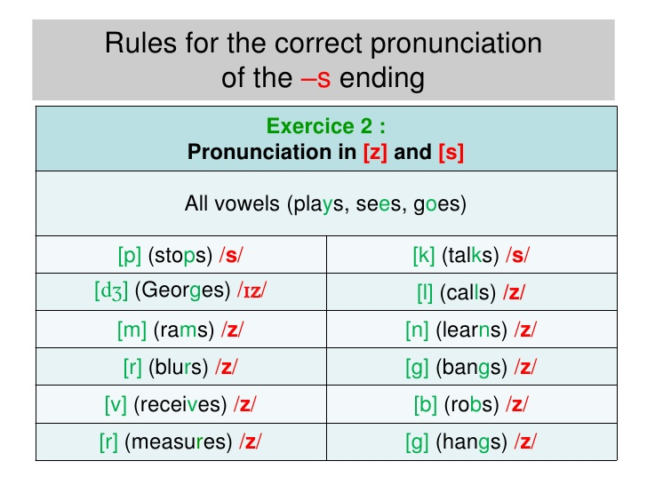

**Pronunciation of ED**

**Past Tense, Past Participles and Adjectives**

ED appears at the end of regular verbs in the past tense (e.g. wanted, helped, lived) sometimes in adjectives ending in ED (e.g. tired, embarrassed, relaxed) as well as in some Past Participles.

However the pronunciation of ED sometimes causes problems for non-native speakers because it can be pronounced in three different ways: as / id /, as / t / or as / d /

To make the past form of regular verbs, add **–ed**. Here are the pronunciation rules:

