DESIGNING A 10” CO2 CAR

To open the template drawing

- Copy the CarTemplate.mcx file to your Mastercam \My documents directory.

- Start MASTERCAM

- From the menu bar select File then Open

- In the dialog box, find and click on CarTemplate.mcx.

- Click on the open button.

An isometric view of the car drawing is on the screen. The co2 car blank is in the color red.
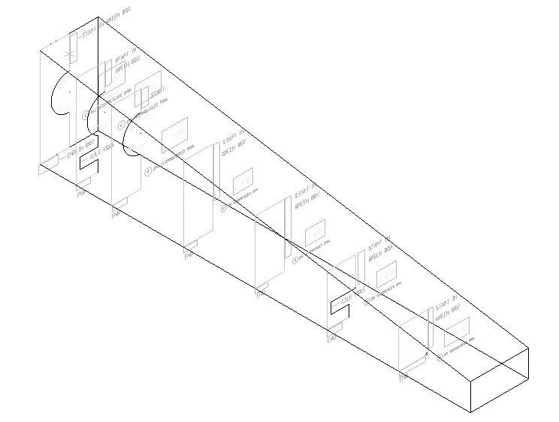You will be designing your car by drawing shapes in 7 different positions along the length of the blank. You will be using drawing templates to assist you in the design of your car.

Drawing Splines

To draw the first spline

- In the status bar , select LEVEL:

- In the list levels section click on the used or named radio button.

- Select the first spline level (level #30 at Z = 0”). This is the active level. What you
Draw will be stored on this level. Right click level #30 and select Make Main.

- In the visible levels section, click on the All OFF button. (All the levels should not be checked indicating that they are off.)

- Click on level 20: TEMPLATE of crossection for FIRST spline at Z = 0"to turn it on.

Level 20 should now have a red check mark.

6. Only levels 20 and 30 should have a red check mark (on) the rest should be (off).
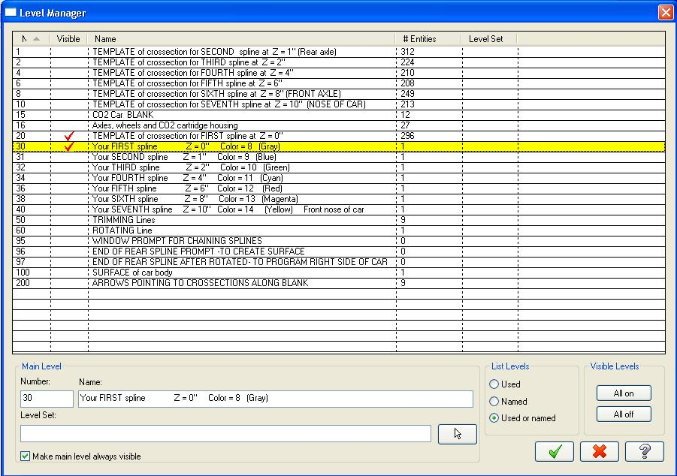
7. Click on the the green check mark.

7. In the toolbar at the top of the screen, click on the Gview side icon.

8. In the toolbar, click on the Fit icon. 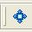
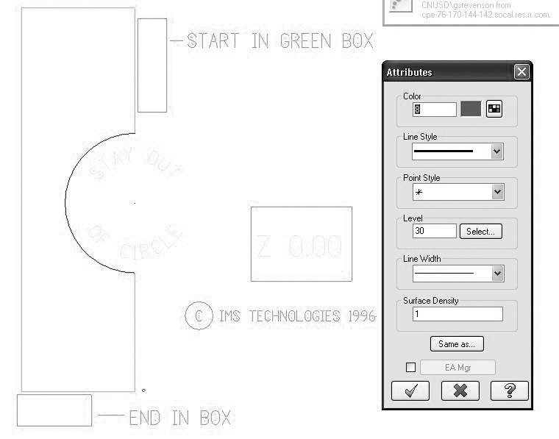

- In the status bar area, click on attributes, and choose color 8 (gray)
Select the green check mark.

- In the status bar area, click on Z:, and then select a corner of the white box labeled Z 0.00.
- In the menu bar, select Create – Spline -Create Manual Spline.
- Move the mouse into the drawing area and into the green box at the upper right.
- Click 1 time in the green box to draw your first point.
- Move to the left and down into the cyan enclosed area.
- Click to draw another point, making sure it is not above the last point. (do not draw in the red circle)
- Continue to move down and click to draw points, and draw your last point in the end box at the bottom.
- When you are finished, press the Enter Key.

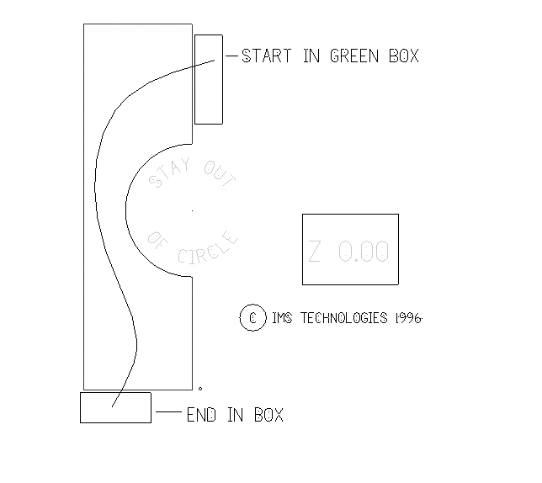

- Check that your spline is acceptable.

Does any part of the spline cross into a red zone,
or did you draw a point above the previously drawn point,
Then the spline is unacceptable and you must do steps 21 – 23.

If your spline is ok then move on to the next section: To draw your second spline.

- If your spline is unacceptable, Select.
- Click on the bad spline to delete it, and then select the green end selection button.
- Go back to step 13 and try it again.

To draw the Second spline

1. In the status bar, select LEVEL:

2. Select the second spline level (level #31 at Z = 1”). This is the active level. What
You draw will be stored on this level. Right click level #31 and select Make Main.

- On the visible levels section, click on the All OFF button. (All the levels except level 31 should not be checked indicating that they are off.)

- Click on level 1: TEMPLATE of crossection for SECOND spline at Z = 1"to turn it on.

Levels 31 and 1 should now have a red check mark.

5. Only levels 31 and 1 should have a red check mark (on) the rest should be (off).
Click on the Green check mark.

6. in the toolbar, click on the Fit icon.
7. In the status bar area, click on attributes, and choose color 9

8. In the Status bar area, click on Z, and then select a corner of the white box labeled Z 1.00.
- In the menu bar area, select Create – Spline - Create Manual Spline
- Move the mouse into the drawing area and into the green box at the upper right.
- Click 1 time in the green box to draw your first point.
- Move to the left and down into the cyan enclosed area.
- Click to draw another point, making sure it is not above the last point. (do not draw in the red circle and stay to the left of the red axle holeline)
- Continue to move down and click to draw points, and draw your last point in the end box at the bottom.
- When you are finished, press the Enter key.

16. Check that your spline is acceptable.
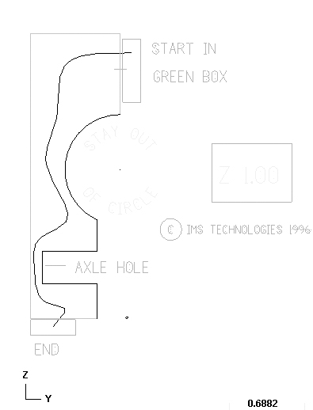

To draw the Third spline

1. In the status bar, select LEVEL:

2. Select the second spline level (level #32 at Z = 2”). This is the active level. What
You draw will be stored on this level. Right click level #32 and select Make Main.

3 On the visible levels section, click on the All OFF button. (All the levels except level 32 should not be checked indicating that they are off.)

4Click on level 2: TEMPLATE of crossection for THIRD spline at Z = 2"to turn it on.

Levels 32 and 2 should now have a red check mark.

5. Only levels 32 and 2 should have a red check mark (on) the rest should be (off).
Click on the Green check mark.

6. In the toolbar, click on the Fit icon.
7 In the status bar area, click on attributes, and choose color 10

8. In the Status bar area, click on Z, and then select a corner of the white box labeled Z 2.00.
- In the menu bar area, select Create – Spline - Create Manual Spline
- Move the mouse into the drawing area and into the green box at the upper right.
- Click 1 time in the green box to draw your first point.
- Move to the left and down into the cyan enclosed area.
- Click to draw another point, making sure it is not above the last point. (do not draw in the red circle)
- Continue to move down and click to draw points, and draw your last point in the end box at the bottom.
- When you are finished, press the Enter key.

16. Check that your spline is acceptable.
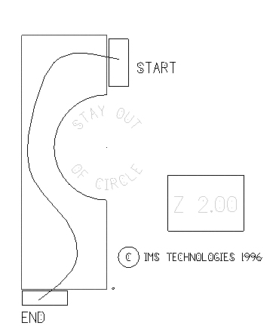

To draw the fourth spline

1. In the status bar, select LEVEL:

2. Select the second spline level (level #34 at Z = 4”). This is the active level. What
You draw will be stored on this level. Right click level #34 and select Make Main.

- On the visible levels section, click on the All OFF button. (All the levels except level 34 should not be checked indicating that they are off.)

- Click on level 4: TEMPLATE of crossection for FOURTH spline at Z = 4"to turn it on.

Levels 34 and 4 should now have a red check mark.

5. Only levels 34 and 4 should have a red check mark (on) the rest should be (off).
Click on the Green check mark.

6. in the toolbar, click on the Fit icon.

7. In the status bar area, click on attributes, and choose color 11

- In the Status bar area, click on Z, and then select a corner of the white box labeled Z 4.00.
- In the menu bar area, select Create – Spline - Create Manual Spline
- Move the mouse into the drawing area and into the green box at the upper right.
- Click 1 time in the green box to draw your first point.
- Move to the left and down into the cyan enclosed area.
- Click to draw another point, making sure it is not above the last point. (do not draw in the red circle)
- Continue to move down and click to draw points, and draw your last point in the end box at the bottom.
- When you are finished, press the Enter key.

16. Check that your spline is acceptable.
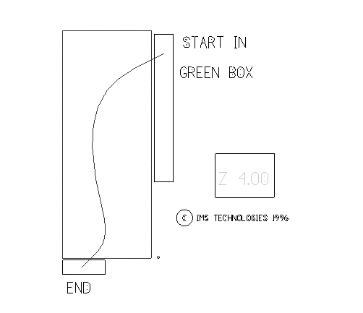

To draw the fifth spline

1. In the status bar, select LEVEL:

2. Select the second spline level (level #36 at Z = 6”). This is the active level. What
You draw will be stored on this level. Right click level #36 and select Make Main.

- On the visible levels section, click on the All OFF button. (All the levels except level 36 should not be checked indicating that they are off.)

- Click on level 6: TEMPLATE of crossection for FIFTH spline at Z = 6"to turn it on.

Levels 36 and 6 should now have a red check mark.

5. Only levels 36 and 6 should have a red check mark (on) the rest should be (off).
Click on the Green check mark.

6. in the toolbar, click on the Fit icon.
7. In the status bar area, click on attributes, and choose color 12

- In the Status bar area, click on Z, and then select a corner of the white box labeled Z 6.00.
- In the menu bar area, select Create – Spline - Create Manual Spline
- Move the mouse into the drawing area and into the green box at the upper right.
- Click 1 time in the green box to draw your first point.
- Move to the left and down into the cyan enclosed area.
- Click to draw another point, making sure it is not above the last point. (do not draw in the red circle)
- Continue to move down and click to draw points, and draw your last point in the end box at the bottom.
- When you are finished, press the Enter key.

16. Check that your spline is acceptable.
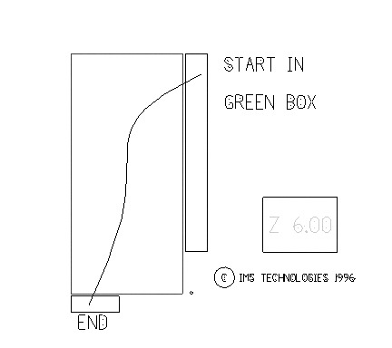

To draw the sixth spline

1. In the status bar, select LEVEL:

2. Select the second spline level (level #38 at Z = 8”). This is the active level. What
You draw will be stored on this level. Right click level #38 and select Make Main.

3 On the visible levels section, click on the All OFF button. (All the levels except level 38 should not be checked indicating that they are off.)

4. Click on level 8: TEMPLATE of crossection for THIRD spline at Z = 8"to turn it on.

Levels 38 and 8 should now have a red check mark.

5. Only levels 38 and 8 should have a red check mark (on) the rest should be (off).
Click on the Green check mark.

6. in the toolbar, click on the Fit icon.

7. In the status bar area, click on attributes, and choose color 13

- In the Status bar area, click on Z, and then select a corner of the white box labeled Z 8.00.
- In the menu bar area, select Create – Spline - Create Manual Spline
- Move the mouse into the drawing area and into the green box at the upper right.
- Click 1 time in the green box to draw your first point.
- Move to the left and down into the cyan enclosed area.
- Click to draw another point, making sure it is not above the last point. (do not draw in the red circle and stay to the left of the red axle holeline)
- Continue to move down and click to draw points, and draw your last point in the end box at the bottom.
- When you are finished, press the Enter key.

16. Check that your spline is acceptable.
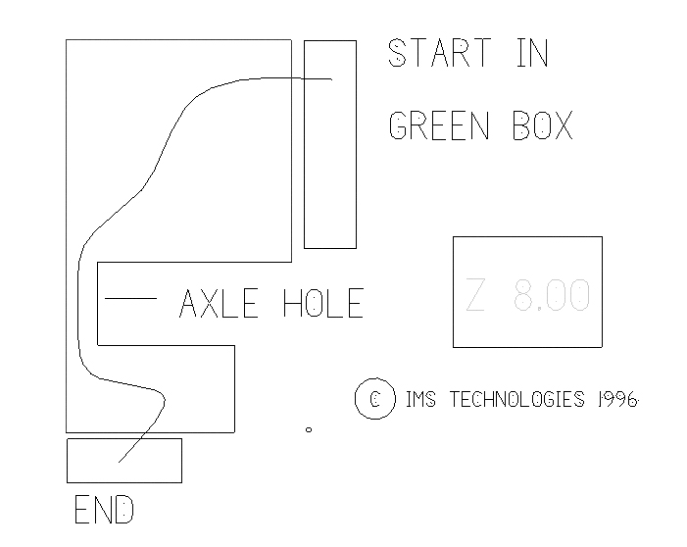

To draw the seventh spline
1. In the status bar, select LEVEL:

2. Select the second spline level (level #40 at Z = 10”). This is the active level. What
You draw will be stored on this level. Right click level #40 and select Make Main.

- On the visible levels section, click on the All OFF button. (All the levels except level 40 should not be checked indicating that they are off.)

- Click on level 10: TEMPLATE of crossection for THIRD spline at Z = 10"to turn it on.

Levels 40 and 10 should now have a red check mark.

5. Only levels 40 and 10 should have a red check mark (on) the rest should be (off).
Click on the Green check mark.

6. in the toolbar, click on the Fit icon.
7. In the status bar area, click on attributes, and choose color 14

- In the Status bar area, click on Z, and then select a corner of the white box labeled Z 10.00.
- In the menu bar area, select Create – Spline - Create Manual Spline
- Move the mouse into the drawing area and into the green box at the upper right.
- Click 1 time in the green box to draw your first point.
- Move to the left and down into the cyan enclosed area.
- Click to draw another point, making sure it is not above the last point. (do not draw in the red circle)
- Continue to move down and click to draw points, and draw your last point in the end box at the bottom.
- When you are finished, press the Enter key.

16. Check that your spline is acceptable.
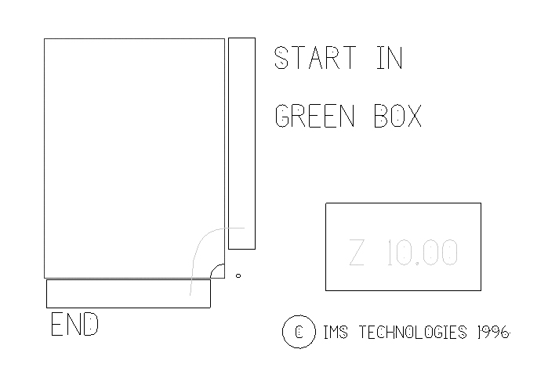

Save Your Drawing

- In the upper menu bar select File – Save.

- Type your name followed by the letters car. (example: xxxcar)

- Click on the green check mark.

Trimming the splines

- In the status bar, select Level:

- Click on the Vis. Levels button and click on the All Off button. All the levels should be gray or turned off.

- Click on levels 30,31,32,34,36,38,40 and level 50. These are the splines you drew and the trimming lines.

- Click on the green check mark.

In the toolbar, find and select the Gview Side icon.

- In the toolbar, find and click on the Fit icon.
- From the Menu Bar select Edit – Trim/Break – Trim/Break/Extend

- Make sure 2D is set in the status bar bar.

- Move the mouse into the drawing area and click on a spline anywhere on the left of the vertical trimming line. Then click on the vertical line.

- Repeat steps 6 and 7 for all of the remaining splines until they are all trimmed to the vertical line.

- From the Main Menu select Edit – Trim/Break – Trim/Break/Extend

- Move mouse into the drawing area and click on a spline anywhere above the horizontal line, and then click on the horizontal line.

- Repeat steps 10 and 11 for all of the splines and trim them to the bottom horizontal line.

- Save your file. File – Save

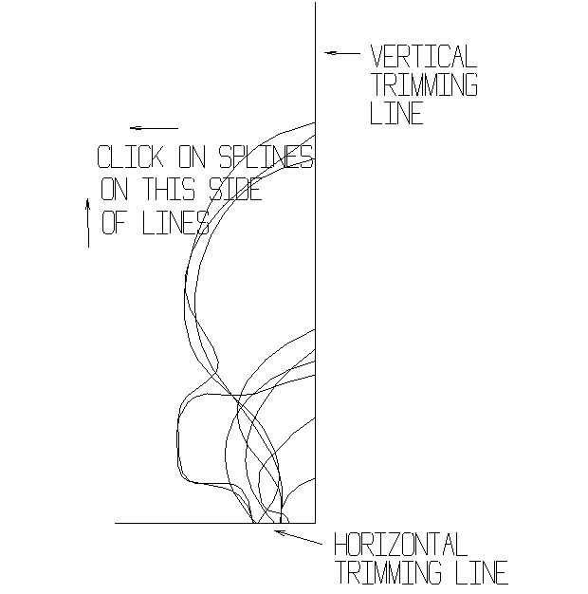

Creating a Surface from the Splines

- In the status bar area, select level and right click on level 100 and select make main to make it active.

- Click in the Vis. Levels area on the All Off button. All the levels should be turned off.

- Click on levels 30, 31, 32, 34, 36, 38, 40 and level 100. These are the splines you drew and the surface level.

- Click on the green check mark.

- In the toolbar, find and select the Gview Isometric icon.

- In the toolbar, find and select the Fit icon.
- From the Menu bar, select Create – Surface – Create Ruled/Lofted Surfaces.

- Select each spline in order at the bottom of each.

- Then select the green check mark from the menu.

- From the toolbar, select the shade icon.

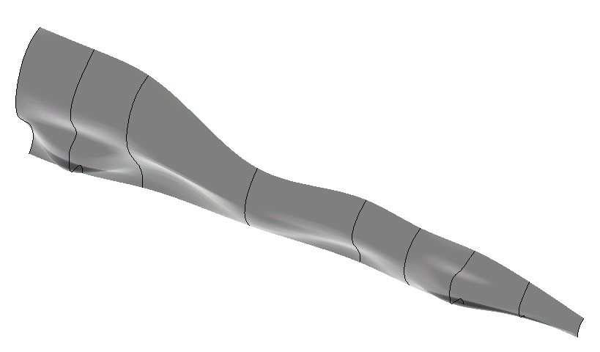

Mirroring the Surface

- In the status bar Area, select level. Then click Level: 60 to turn it on.

- Turn off all the spline levels.

- Select the wireframe icon to turn off shading.

4. From the Menu bar, select Xform – XForm Mirror .

5. Select the surface, then the green end selection icon in the tool bar.

6. 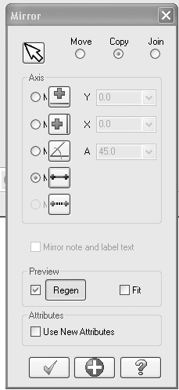 Select the select line icon.

7. Select the mirror line level 60
8. Then select the green arrow from the Dialog box

9. From the toolbar, select the shade icon.

Mirror Line
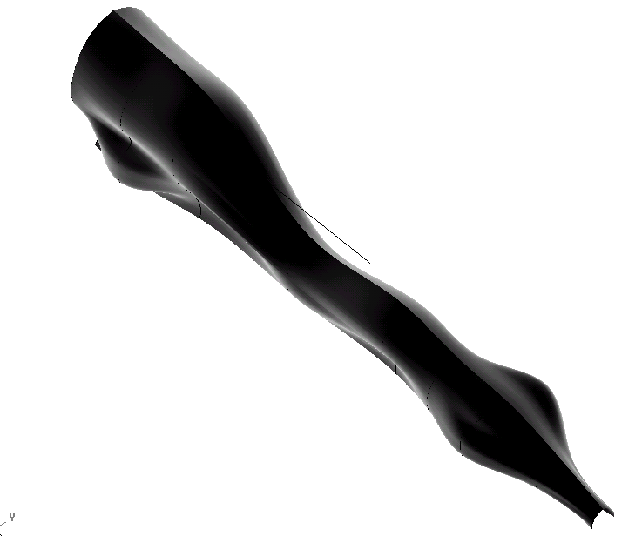

Setting up the Drawing for a Toolpath

- From the Toolbar, find and select the wireframe icon.
- You should have one surface that is red, which is the surface that we mirrored, and you should have another surface that is magenta, which is the resulting surface.

- Select from the Menu Bar, Edit Delete – delete entities

- From the tool bar select ALL, then XForm Result, then the green end selection icon in the tool bar

Make sure that the construction plane is set to side in the status bar.

- Select on Planes and choose Right from the status bar area.

Next we will rotate the original surface.

- From the Menu bar, select Xform – XForm Rotate.

- Select the surface, then the green end selection icon in the tool bar

- From the Dialog select Point.
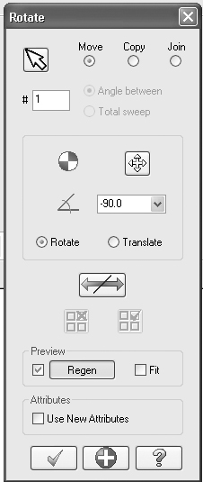
- Move into the drawing area and select the Green rotation line.

- In the dialog, type –90 in the rotation angle field.

- Click on the Move radio button and then select the green arrow.

Hide the Rotating line.

- Select level from the status bar Area.

- Right click on level 100 and select make main to turn it on. Click on All Off.

Creating the Toolpath

Make sure that the construction plane is set to Top in the status bar.

- Select on Planes and choose Top from the status bar.

- Select Machine Types Mill – Techno Davinci

- From the Menu Bar, select Toolpaths – Surface Finish – Finish Flowline Toolpath.

- Select the surface, then the green end selection button.

- In the dialog box that shows up type in the name of your file followed by an R for the right side of your car, then select the green check mark.

- From the resulting dialog box, select flowline

- Select offset to flip the offset direction so that the toolpath is on the top.

- Select Cut dir to flip the cutting direction so the toolpath follows the length of the car.

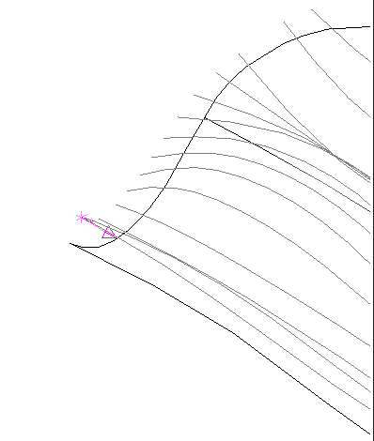
- Then select the green check mark twice.

- Choose Select Library Tool and choose a ¼” ball end mill then the green check mark.

- Double click the tool in the list and change the tool number to 1.

- Select the green check mark twice to close the dialog boxes and create the toolpath.

- The right side Toolpath is done.

Creating the Left Side Toolpath

- Right click 1 – Surface Finish Flowline in the browser then Select Mill Toolpaths - Transform

- In the Type and Methods choose Mirror, then choose the Mirror Tab

- Select the x-axis

- Then click on the green check mark.

- Post each toolpath in the browser separately.

- Save your file. From the Menu Bar, select File – Save. Find the name of your file and select he save button. Answer yes to overwright the exist’g file.

Right side view

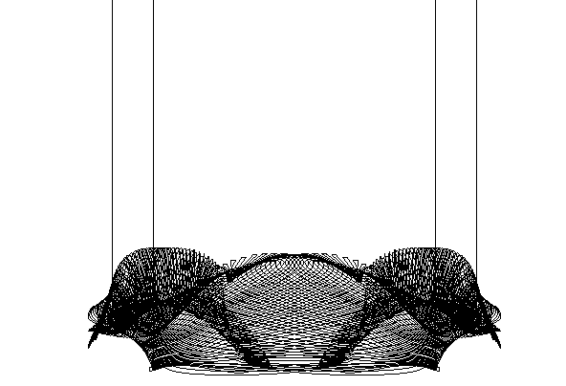

You are now ready to machine your car.

SETTING UP THE CAR TO BE MACHINED

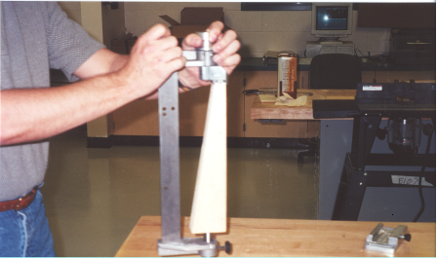

- Step one would be to mount the car blank in the jig. It will only fit one way.
Use a mallet or the bench top to make sure the shaft is all the way in the CO2 hole, in the back of the car blank.
Turn the car blank into the left or right side and tighten the thumb screws to secure it.

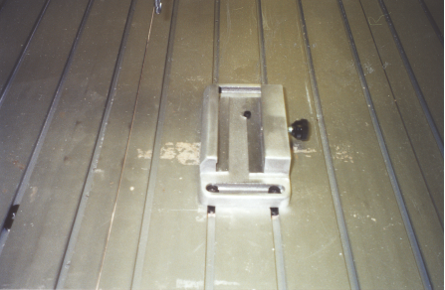

2. Mount the base of the jig on the bed of the mill with the thumb screw on the right.
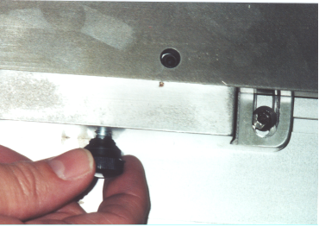

3. Place the jig in the base with the car blank on the left and line up the hole with the set
Screw. Then tighten the screw to secure the jig to the base.

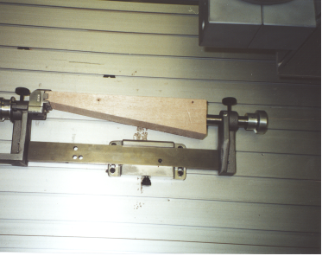
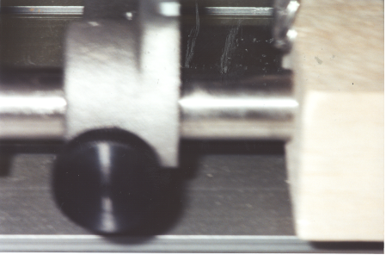

- Next you will need to home the machine and clear the x, y and z coordinates. Then you will need to jog the tool to the back of the car blank. When the tool is touching the back of the car you need to record the y coordinate.

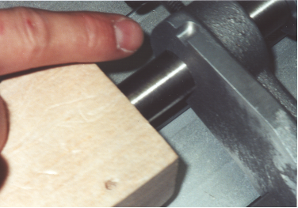

- Next you will need to jog the tool into the slot on top of the jig. Once you get it there
You will need to record the X and Z coordinates.

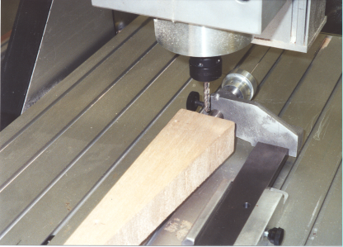

- With the recorded X, Y, and Z coordinates, use the jog tool to go to those coordinates. It should be about a 1/8 inch above the center line of the CO2 hole.

8. Clear the X, Y. and Z coordinates and exit out of jog. You are now ready to machine your car.

