From: Rojhano
To: Beginners Group
Subj: Lesson 13

How to give INSTRUCTIONS and make REQUESTS in English

Objectives
After this lesson students should be able to express their requests and instructions in a correct and polite way.
When you want someone to do something for you, you use requests or instructions. If you do it wrongly, people will not know what you want them to do, or they may get angry because they do not think you are being polite. Also, when someone is talking to you, you must know when they are making a request, and when they are giving an instruction.

In this part, we are going to look at
- The difference between requests and instructions
- The grammar of requests and instructions
- The different levels of register for requests and instructions
- What to say when you get a request or instruction.

The difference between requests and instructions

The difference between a request and an instruction is a choice. If a person can choose to do the thing he has been asked to do, then this is a request. If he has no choice, then it is an instruction. This is important to remember, because in English many people give instructions as if they are requests. Also sometimes you will hear requests that sound like instructions.

You see written instructions very often:
- "Click here." (On web pages) "Push / pull" (on doors).

Note: You can get books full of instructions. These are called manuals. You may have one for your computer.

You will hear instructions less often. You might get them at work:
- "Bring me the Jones report, Bob."
Or from officials:
- "Step out of your car, sir."

But very often when people give instructions they say them as requests:
- "Can I see you in my office, Bob?"
- "Please would you open your suitcase, Madam?"

And requests often sound like instructions:
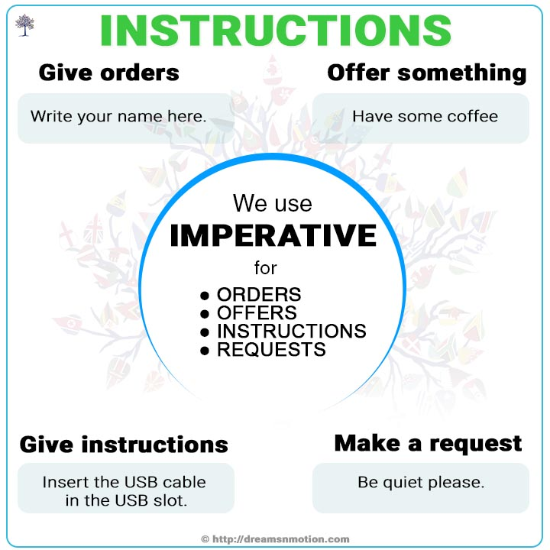
- "Come to the party tonight. It will be fun."
- "Kiss me, quick!"

The grammar rule for REQUESTS and INSTRUCTIONS

Requests and instructions that sound like instructions are easy. They are what grammarians call imperatives. The imperative does not have a past or future tense. It is always a present simple.

If the person is receiving the imperative, the name goes first or last:
- "Bob, come here!"
- "Come here, Bob!"

Requests are more difficult. Generally we use modal verbs such as “Can” or "may":
- "Can you pass me the salt?"
- "May I have the salt?"

Polite requests use a type of English called the subjunctive. We won't learn the subjunctive now - all you need to remember for this lesson is that more polite requests use modals as if they were past tense:
- "Could you pass me the salt?"
- "Might I have the salt?"

The word "please" is often used with requests or instructions to make them more polite. "Please" comes at the beginning or end, as with names, but it does not usually come before the name at the beginning or after the name at the end:
- "Samantha, please come here."
- "Samantha, come here please."
- "Come here please, Samantha."
- "Please come here Samantha.
These are all different ways of saying the same thing. If it is a boss speaking to his secretary, this would be an instruction. If it is a boy talking to his girlfriend, it is a request.
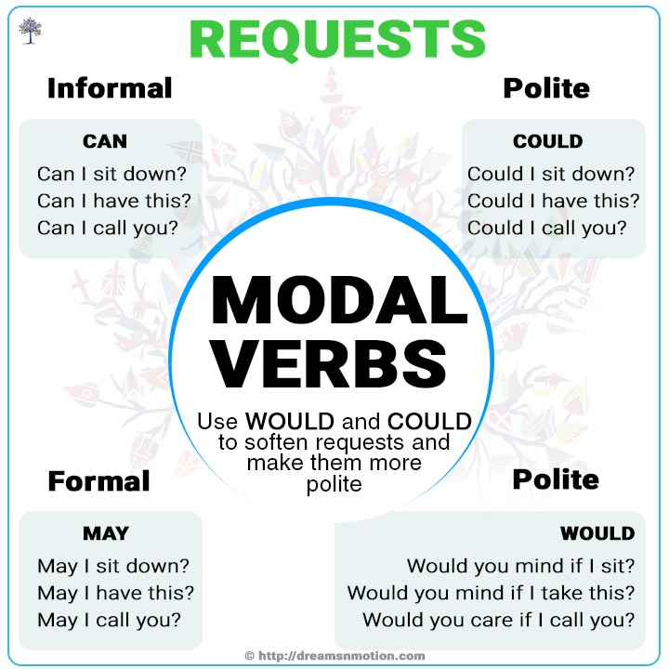

REQUESTS

English people make requests very politely using COULD from people they do not know:
- "Excuse me, could I come through, please?"
They make ordinary informal requests using CAN with people at their level who they don't know well.
- "Can I get past, please?"
They often use imperatives with friends and family.
- "Get out of the way."

People in official positions often make requests when they are commands. Often they use "would" as a modal:
- "Would you leave now, please Sir?"
- "Would you like to explain why you were driving too fast?"

Notice that the request is the same as for offers but the meaning is completely different:
- "Would you like some more tea?"
- "Would you like to come to the party?"
Offers are different from requests because someone is suggesting something to you, instead of you asking something from them. Instructions from friends and family are often friendly:
- "Come on, you go first."
- "Have fun!"
- "Enjoy your food!"

Answering requests and Instructions

The right response to an imperative might be "Yes" followed by a title:
- "Yes, Mrs Jones" or "Yes, Sir!" (Or for husbands) "Yes, dear."
It is not usual to refuse a request or instruction. Instead, if you want to say "no" you should ask the reason.
If someone says "Get out of your car, please sir." You can answer:
- "Must I?"
- "Why?"
- "Is this really necessary?"
If you must say no to a request, apologize at the same time.
- "No, sorry, I can't."
- "I'm afraid that's impossible."

With friends and family, responses can often be much less polite. To say "yes", you can use
- "Sure", "Ok" "If you like".
It is the same when you say "no".
- "No", or "Do it yourself", or even insulting "get lost!"

