Defining Basic Properties of Physical Immunotherapy using HIFU and Immune Checkpoint Inhibition
Gail ter Haar, Petros Mouratidis, Elizabeth Repasky
Final Report, Deliverable 9

Defining Basic Properties of Physical Immunotherapy using HIFU and immune checkpoint inhibition- Deliverable 9: Number of infiltrating T lymphocytes, tumour growth and overall survival quantified. Ability of ultrasound exposure of tumor microenvironment to enhance the anti-cancer HIFU-induced immune response determined. Detailed report on the ability of ultrasound to affect the anticancer HIFU-induced immune response
Prologue: In this study Deliverables 1 and 2 described protocols for growing pancreatic tumours in murine C57BL/6 subjects, and for assaying tumour histology and immune cell subsets. In Deliverable 3 we showed that treatment of these tumours with continuous (cHIFU) and pulsed (pHIFU) high intensity focused ultrasound resulted in the regulation of immune cell subsets, including T helper and T cytotoxic cells. In Deliverable 4 we combined cHIFU and pHIFU treatments with systemic administration of immune checkpoint inhibitors (ICI) and developed a scheduling regime that could be safely used in murine subjects to treat pancreatic tumours. In Deliverables 5 and 6 we undertook pilot experiments to treat the subjects with cHIFU/ pHIFU combined with ICIs, and showed that the combined pHIFU/ ICI exposures have the potential to increase tumour infiltrating lymphocytes, improve tumour growth control and increase overall survival. In Deliverables 7 and 8 we targeted the microenvironment of the pancreatic tumours using histotripsy-like pHIFU exposures and showed that these treatments degrade components of the matrisome including collagen and hyaluronan. In order to complete our study and build on the exciting results found in Deliverables 5, 6, 7 and 8 we treated the subjects with combined pHIFU and ICI, and analysed cavitation, tumour infiltrating lymphocytes, tumour growth and overall survival to generate a complete set of data from tumours targeted with pulsed sequences of focused ultrasound.
Treatment of subjects: Murine pancreatic cancer KPC cells (KrasG12D/+; Trp53R172H/+; Pdx-1-Cre) were used to establish syngeneic orthotopic pancreatic KPC tumours in C57BL/6 subjects. Subjects carrying orthotopic pancreatic tumours of 380 ± 190 mm³ were randomly assigned to a control, or one of 3 treatment, groups: pHIFU treatment, ICI treatment or combined pHIFU + ICI treatment. Subjects in the control group were sham-exposed to pHIFU to mimic any potential physiological effects of anaesthesia, handling and partial submersion in degassed water and were injected intraperitoneally (IP) with isotype antibodies (i.e. the inactive backbones of the inhibitors) at the same concentration and frequency as the anti-CTLA-4 + anti-PD-1 ICIs used in treatments. For pHIFU treatment subjects were exposed (electrical input power = 200 W, acoustic power = 132 W, focal peak pressure = 15.8 MPa, peak positive/negative pressure = 32.5/-17.6 MPa, pulse repetition frequency = 1 Hz, f = 1.5 MHz, duty cycle = 1%, exposure time = 25 seconds) using our small animal pre-clinical VIFU 2000 (Alpinion, USA) system (Figure 1). Subjects in the pHIFU treatment group were also injected IP with the standard regime of isotype antibodies as described for the control group. The ICI treatment subjects were sham exposed to pHIFU and IP injected with the anti-CTLA- and anti-PD-1 immune checkpoint inhibitor antibodies (200μg/dose/mouse). In the combined treatment group, subjects were treated with pHIFU and anti-CTLA-4 and anti-PD-1 antibodies as described above. Figure 2 shows the sequencing of pHIFU and antibody treatments used in all experiments. For survival experiments up to 21 days, ICI treatments (or isotype sham treatments) were delivered every 3 days until the time of death of the subject.
Acoustic cavitation results: Acoustic cavitation was monitored during pHIFU bursts using a weakly focused polyvinylidine fluoride (PVDF), broadband (0.1 to 20 MHz) passive cavitation detector (PCD) transducer (PA385, 75 mm focal length, 15 mm active diameter, Precision Acoustics, UK). This was pulse-echo aligned with the pHIFU focal peak at the start of each treatment day. To acquire cavitation data, the PCD was connected to a 1.5 MHz notch filter (in-house adapted Allen Avionics F5181 filter, New York, USA) to remove the drive frequency. This was connected to a low noise 20 dB broadband (0.1-30 MHz) pre-amplifier (7866, Advanced Receiver Research, Burlington, CT, USA), to improve detection sensitivity. The output was then connected to one channel of a data acquisition system (DAQ) which recorded data at up to 30 MS/s, a second channel was used to record the pHIFU drive voltage via a V/1000 pickoff box. The DAQ system included a 4-channel, 8-bit data acquisition card (MI.2031, 100MS/s, Spectrum Systemwicklung Microelectronic GmbH, Grosshandsorf, Germany), installed in a dual-bus desktop computer (Supermicro X8STE, DataQuest Solutions, Lincolnshire, UK). Data recording was controlled using custom-written MatLab software (version 7.0.1 R14, MathWorks Inc, Natick, MA, USA). Each 10 ms long pHIFU pulse was recorded along with 1 ms of off-time immediately following exposure. PCD detected data were processed to obtain frequency domain data (via Fast Fourier Transforms) and then comb filtered to remove harmonics and ultra-harmonics of the drive and low-pass filtered to remove obvious ultrasound imaging signals. The residual frequency range over which broadband signals were integrated was 0.1 to 2.5 MHz. Broadband signals were assumed to be unique indicators of inertial cavitation. In addition, half harmonic was quantified, and compared to a reference frequency slightly below it. In the absence of a broadband signal, half harmonic is likely to indicate non-inertial cavitation activity. Finally, the pHIFU drive was Fast Fourier transformed and filtered to isolate the drive frequency signal which was plotted as a function of time. Also kurtosis was used to assess whether the transducer impedance was changing as a result of cavitation bubbles in the focal region. Results showed that broadband and half harmonic emissions were detected in all subjects treated with pHIFU. In subjects of the pHIFU treatment group 87% of individual exposures resulted in broadband emissions and 100% in half harmonics. In the pHIFU + ICI treatment group 70% of the exposures resulted in broadband emissions and 100% in half harmonics. These results are indicative of bubble activity at every exposure position. Figure 3 shows a representative example of acoustic cavitation detection during a 10 ms pulse of pHIFU and demonstrates the detection of continuously elevated broadband emissions and frequently elevated half harmonic (relative to a reference frequency) signals that are significantly above off-time signals. In addition, significant kurtosis of the drive voltage (e.g. around 7.5 and 9.5 ms) and the formation of hyperechoic ultrasound image features within tumours were typically seen.
Tumour growth and cell survival results: Tumours were imaged in the cranial/caudal (sagittal) and medial/lateral (axial) imaging planes using 2D high frequency (14 MHz) B-mode ultrasound (E-Cube 9, Alpinion, USA). Images were recorded in 1 mm steps. For tumour growth experiments, at the time of culling tumours were excised and their dimensions measured with Vernier callipers. In all cases, tumour volume was calculated assuming an ellipsoidal shape using:

$Tumour Volume \left({mm}^{3}\right)= \frac{π}{6}×x×y×z$
Equation 1

Figure 4 shows that all tumours grew, despite treatment. Tumours in the control, pHIFU treatment and ICI treatment groups had grown 4.6 ± 1.1, 3.1 ± 0.3, and 3.8 ± 0.8 fold, respectively, compared to their initial values 12 days after sham and/or pHIFU exposures. These differences between the treatment and control groups were not statistically significant. In contrast tumours treated with combined pHIFU + anti-CTLA-4 + anti-PD-1 showed a statistically significant delay of tumour growth relative to control, pHIFU and pHIFU + ICI groups (p<0.05) with tumours grown 2.3 ± 0.3 fold over their initial values, 12 days after pHIFU treatment. For survival experiments, subjects were allowed to survive until their tumour reached 300% of its initial volume. Figure 5 shows an improvement in the survival of subjects treated with combined pHIFU + anti-CTLA-4 + anti-PD-1 with subjects surviving up to 21 days with a median survival of 19 days (range; 14-21 days). Subjects in the control group survived for 11.5 days (range: 11-14 days), subjects treated with pHIFU had a median survival of 13 days (range: 10-17 days) and subjects treated with anti-CTLA-4 + anti-PD-1 had a median survival of 11.5 days (range: 11-14 days). These results showed a statistically significant survival advantage for subjects treated with the combined pHIFU and ICI treatment compared to all other groups.
Tumour infiltrating lymphocyte results: Immunohistochemical analysis of tumour sections was undertaken as described previously (please refer to Deliverable 8). Here for detecting tumour infiltrating lymphocytes, tumour sections 5mm thick were stained with CD4 (cat. nu. ab183685, Abcam, UK) or CD8 (cat.nu. 14-0195-82, eBiosciences/Affymetrix, USA) antibodies. All slides from all subjects were processed as one batch to minimise background signal intensity variation and therefore enable more accurate quantification. Quantification of the IHC signal was performed using the the NIH developed Image J software program and the IHC profiler plug-in. In brief, the tumour overview microscopy (x40 magnification) image was uploaded into ImageJ, and the brown and blue staining was de-convoluted using the IHC profiler plug-in function. The tumour was cropped using a polygon gate to normalise the signal to the whole tumour area and quantification of areas of different staining intensity was undertaken using threshold ranges to denote high (dense) expression of the biomarkers (intensity bin range: 51-150 + 151-200), low levels or inconclusive levels of expression (intensity bin range: 201-220) and no staining (intensity bin range: 221-230 + 231-250). These ranges were chosen to differentiate highly stained cells from negatively stained cells in order to quantify the abundance of these cells with reasonable confidence. The intensity bin range between 0-50 occasionally resulted in false positive artefacts being counted as positive staining and for this reason were excluded from our analysis. Quantification was undertaken using the “Analyse particles” function of the Image J program (Figure 6 and 7). Using this approach the relative abundances of CD4+ and CD8+ cells in the tumours were determined. Figure 8A and 9A show that control sections had 1.9 ± 0.4 % of the tumour area covered by high (dense) CD4+ expressing cells, and 0.5 ± 0.1% by CD8+ cells respectively. The same figures show that pHIFU treated sections had 3.2 ± 0.7 % of their area covered by dense CD4+ cells and 1.4 ± 0.4 % by dense CD8 + cells respectively. Anti-CTLA-4 + anti-PD-1 antibodies treated sections had 3.0 ± 0.5 % and 0.95 ± 0.2 % of their area covered by dense CD4+ and CD8+ cells, respectively. Finally, sections of tumours treated with combined pHIFU + anti-CTLA-4 + anti-PD-1 had 3.9 ± 0.7 % and 1 ± 0.2% of their area covered by dense CD4+ and CD8 + cells, respectively. These results show a statistically significant increase of tumour infiltrating cells expressing high levels of CD4 and CD8 in tumours treated with combined pHIFU and ICI relative to sham exposed subjects. Also Figures 8B and 9B show a statistically significant increase in the relative abundance of cells expressing basal levels of CD8, but not basal CD4 expressing cells, in tumours exposed to combined pHIFU and ICI relative to sham exposed tumours. Finally Figures 8C and 9C show that the abundance of cells negative for CD4 or CD8 expression is decreased in tumours treated with combined pHIFU and ICI relative to sham exposed tumours. Collectively the results shown in this Deliverable 9 report demonstrate that combined pHIFU and ICI treatment of orthotopic pancreatic KPC tumours results in the reduction of growth of pancreatic tumours and the extension of survival of subjects, whereas pHIFU or ICI treatments alone show no statistically significant effects. Also these effects are associated with increased abundance CD4+ and CD8+ tumour infiltrating lymphocytes in the tumours.
Overall Conclusion:
In this study we have defined basic properties of physical immunotherapy in pancreatic cancer. We have presented the 1st evidence to suggest that pulsed focused ultrasound, designed to induce acoustic cavitation, in combination with immune checkpoint inhibitors (combinations of anti-CTLA-4 and anti-PD-1) can result in increased anti-cancer therapeutic benefit relative to the respective monotherapies. These results will be used to apply for further grants to illustrate the mechanistic basis of the observed anti-cancer effects, optimise our double combinations in additional animal models including metastatic models of pancreatic cancer, and accelerate clinical translation.

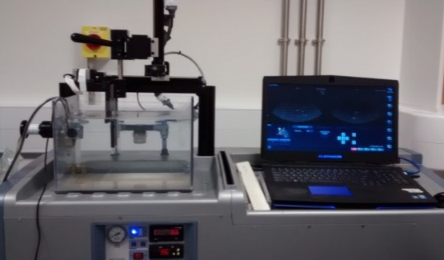
A
Motion gantry

VIFU laptop

Passive cavitation sensor

Animal holder
Water tank

Transducers

Degassing and heat controller

HIFU transducer
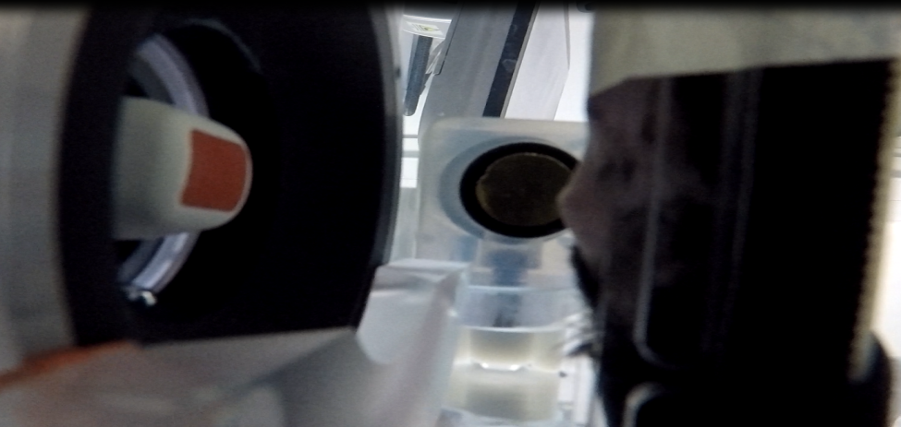
B
Passive cavitation sensor

Subcutaneous pancreatic tumour

Ultrasound imaging probe

Figure 1: (A) Alpinion small animal VIFU 2000 Therapeutic ultrasound system comprising a HIFU transducer (1.5 MHz, 75 mm focal length, 15 mm active diameter) with centrally mounted, co-aligned 3.5 MHz imaging probe for treatment guidance and monitoring facilitated by software control of the chosen target position within the mouse to coincide with the position of the focal peak. (B) broadband sensor side mounted so as to interrogate the HIFU focal region used to perform cavitation detection

anti-CTLA4
(200ug /subject) +
anti-PD-1
(200ug/ subject)
or isotypes

anti-CTLA4
(200ug /subject) +
anti-PD-1
(200ug/ subject)
or isotypes

anti-CTLA4
(200ug /subject) +
anti-PD-1
(200ug/ subject)
or isotypes

anti-CTLA4
(200ug /subject) +
anti-PD-1
(200ug/ subject)
or isotypes

Pulsed HIFU +
anti-CTLA4
(200ug /subject) +
anti-PD-1
(200ug/ subject)
or isotypes

Day -3 Day 0 Day 3 Day 6 Day 9

Figure 2: Sequencing regime of treatments. Subjects were injected intraperitoneally with a combination of 2 ICIs (anti-CTLA4 and anti-PD-1) 3 days before pHIFU exposures, on exposure day (immediately after pHIFU) and every 3 days thereafter until the time of culling 12 days (or up to 21 days for survival experiments) after pHIFU (or sham-pHIFU). Subjects not treated with pHIFU were sham-exposed and subjects not treated with ICI were injected with isotype antibodies at the same dose and frequency as the ICI.

A

Significant voltage kurtosis

C
B

Figure 3: Sample cavitation detection dataset for a 10 ms pHIFU pulse followed by a ~2 ms quiescent period. In (A), the 1.5 MHz drive voltage applied to the HIFU transducer measured via a voltage pick off box (V/1000) can be seen to have significant kurtosis. In (B), the broadband emissions (indicative of highly energetic inertial cavitation activity i.e. rapid bubble collapse) integrated over the range 0.1 to 2.5 MHz after software filtering to avoid drive harmonics and imaging signals as a function of time are shown. In (C), 0.75 MHz half harmonic signal as a function of time, this would be indicative of more stable bubble activity in the absence of a broadband signal. The discontinuation of all signals is seen after the exposure finish.

Figure 4: Orthotopic KPC tumour volumes as a function of time in control subjects and subjects treated with pHIFU and/or ICI. Tumour volumes of culled animals were determined with Vernier calipers 12 days after pHIFU exposure. Then the ratio of the tumour volume relative to the initial volume was determined. Results are presented as mean ± SEM.

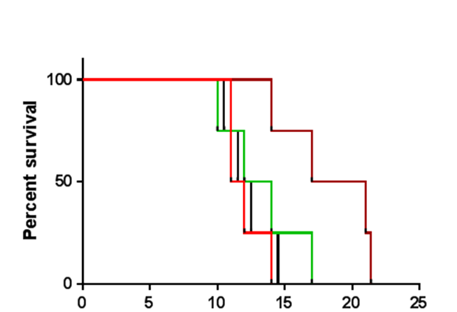

Control
pHIFU
ICI
pHIFU + ICI

p value of Log rank test < 0.05

Days elapsed after pHIFU exposure

Figure 5: Survival of mice with orthotopic pancreatic KPC tumours after sham exposure or treatment with pHIFU and/or ICI. Results are presented as Kaplan-Meier plots, showing survival in days after the pHIFU exposure. Statistical analysis with a Log rank test for trend and a Student t-test and shows that pHIFU + ICI treated subjects had statistically significant improvements relative to all other treatments and control subjects.

Upload section image on ImageJ
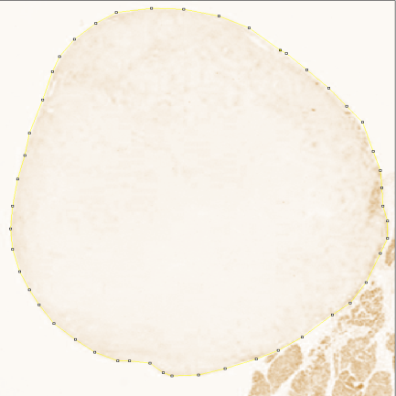
Use IHC profiler and crop the DAB deconvoluted image using a polygon gate

Perform successive quantitative analysis using thresholds from 50-250

Intensity bin range 230-250
Intensity bin range 221-230
Intensity bin range 201-220
Intensity bin range 151-200
Intensity bin range 51-150

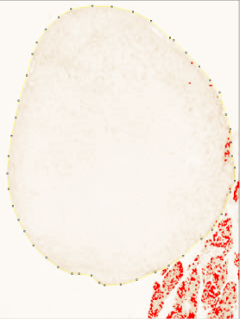
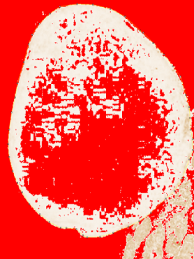
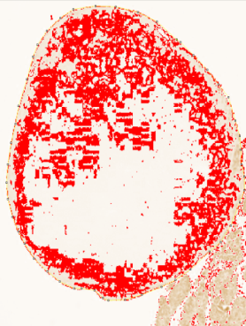
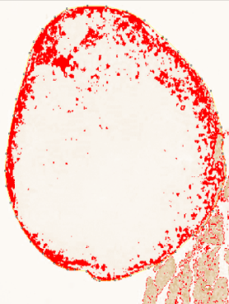
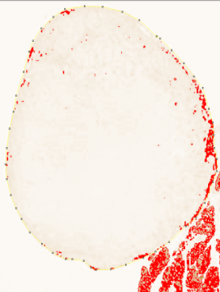

Analyse particles and process results in Excel

Figure 6: Protocol for ImageJ software program and the IHC profiler add-on to quantify tumour sections

Light microscope section
Light microscope overview
Areas of no staining (221-250)
Areas of high staining (50-200)
Areas of basal / inconclusive staining (201-220)

Intensity: 151-200
Percentage area covered = 1.5 %
Intensity: 0-50
Percentage area covered = 0%
Intensity: 51-150
Percentage area covered = 0.1 %

Intensity: 201-220
Percentage area covered = 13.5 %
Intensity: 231-250
Percentage area covered = 49%
Intensity: 221-230
Percentage area covered = 34.5 %

Figure 7: Quantification of CD4 staining in pancreatic tumour sections

A

B

C

Figure 8: Abundance of tumour infiltrating lymphocytes expressing high levels of CD4 (A), basal/inconclusive levels of CD4 (B), or being negative for CD4 (C). Results are presented as means ± SEM of tumour sections taken from all subjects (n=5) for each treatment group 12 days after initial treatment with pHIFU. Statistical significance has been calculated using a Student’s t-test and defined as p<0.05.

A

B

C

Figure 9: Abundance of tumour infiltrating lymphocytes expressing high levels of CD8 (A), basal/inconclusive levels of CD8 (B), or being negative for CD8 (C). Results are presented as means ± SEM of tumour sections taken from all subjects (n=5) for each treatment group 12 days after initial treatment with pHIFU. Statistical significance has been calculated using a Student’s t-test and defined as p<0.05.

