From: Rojhano
To: Beginners Group
Subj: Lesson 4

Lesson Objective
The student shall be able to use the pronouns and the verb TO BE, read and comprehend basic language and demonstrate understanding.

First Portion
Reading

Evaluation Criteria
- Ability to read, with clear pronunciation, and comprehend the meaning of the text.

ARTICLE

My name is Steve. My family and I were born in South Korea; we weren't born in the U.S. I was born in the city of Incheon, in 1998. And my brother was born there, too. My parents weren't born in Incheon. They were born in the capital, Seoul. In South Korea, my father was a businessman and my mother was a teacher.

Questions:
- Was Steve born in the U.S?
- Were his parents both teachers?
- Where was his brother born?
- When was Steve born?
- How old was he 2000?

Conversation practice
- Talk with a partner about yourself and tell him/her when and where you and your family members were born.

Second Portion
Grammar Refresher
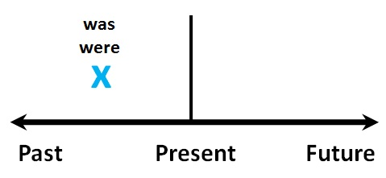
Be - Past Tense

The verb "be" has two forms in the past tense: was and were

Singular | Plural
I was | We were
You were | You were
He was | They were
She was
It was

1. Listen and read:

- I was in my classroom yesterday.
- You were there, too.
- He was at a movie last night.
- She was at home.
- This cantaloupe was in my garden this morning.
- It was delicious.
- We were at school yesterday.

(I + you = we)
- You were on this website earlier.
- They were outside in the snow.

2. Watch this video

TO MAKE A QUESTION:

Singular | Plural
Was I ... | Were we ...
Were you ... | Were you ...
Was he ... | Were they ...
Was she ...
Was it ...

To make a negative sentence, add "not" after the verb to be:

- He was not in school yesterday.
- He wasn't in school yesterday.

- was not = wasn't
- were not = weren't

Third Portion
Vocabulary
- Students should be able to define these words and make multiple sentences using them with different forms of verb "To Be".

Cultivation
Cultivation is the act of caring for or growing plants...

Harness
A harness is a set of straps that are put on a horse so it can be hitched to a wagon or a carriage.

Burglar
Use the word burglar when you're talking about someone who steals things from inside a house or a building.

Scatter
If you hear someone shout "Everybody scatter!” that person wants everyone to spread out and leave the area.

Glossary
A glossary is a dictionary of terms specific to a certain subject.

