San Francisco State University Michael Bar

Typing Math in Microsoft Word

- Opening the Equation Editor
To access the equation editor, either choose the “Insert” tab on the main menu, and click on the π symbol, or press “Alt=”, and an equation editor object will open.

- Typing equations.
Once you pressed the “Alt=”, an equation window will appear:

At the top of the page, you will see the Equation Tools templates:
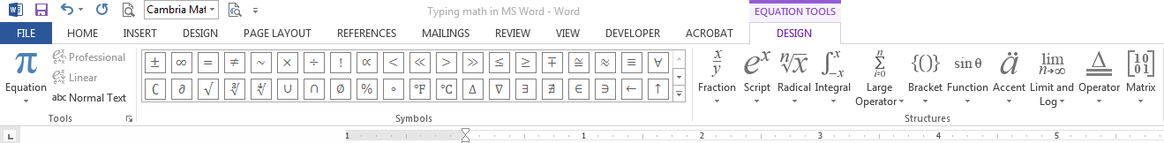
You can use the mouse to choose the symbols and structures. For example, regular fraction template, power, integral, summation, etc., as shown below:
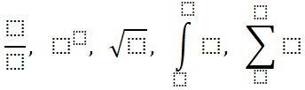
You can move within the template using the arrow keys.

All major equations should start on a separate line, and are called “display” equations, for example
$$\overline{X}=\frac{1}{n}\sum_{i=1}^{n}{X_{i}}$$
If you type the same equation in the middle of a text, it will appear like this: $\overline{X}=\frac{1}{n}\sum_{i=1}^{n}{X_{i}}$, i.e. squished, to reduce vertical space. Such math objects are called “in-line” objects. Only small objects should be inline, e.g. $θ=0.35$, while the major math objects should be displayed. In your homework assignments, all the math should be displayed.

- Useful Shortcuts
The true power of the new equation editor is that it allows typing a huge variety of mathematical objects and symbols using shortcut codes.

- Greek letters and mathematical symbols can be typed using the backslash “\” key followed by space key. Let [SP] denote the space key. For example, “\alpha[SP]” gives $α$, “\infty[SP]” gives $∞$, “\sqrt[SP]x[SP]” gives $\sqrt{x}$ , “\bar” add bar on top of the variable, “\hat” adds hat on top of the variable, etc. In order to use these code names efficiently, one needs to know the Greek alphabet, and the meaning of various mathematical symbols.
- Subscripts and superscripts are obtained using the underscore “_” key and the caret “^” key. For example, “x^2[SP]” gives $x^{2}$, “A_(t+1)[SP]” gives $A_{t+1}$, “K_(t+1)^\theta[SP][SP]” gives $K_{t+1}^{θ}$ and “\int_a^b[SP]” gives $\int_{a}^{b}{}$.
- Fractions can be typed with the forward slash. For example “3/4[SP]” gives $\frac{3}{4}$, and “(a+b)/(c+d)[SP]” gives $\frac{a+b}{c+d}$.
Notice that when you point with the mouse to any symbol, the name of the symbol and its shortcut code shows up, for example:
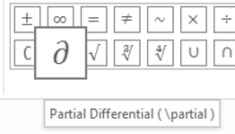
This is one way to learn some of the shortcuts in the new Equation Tools.
Comprehensive list with many shortcuts used in the new equation editor are available at:
http://www.iun.edu/~mathiho/useful/Equation%20Editor%20Shortcut%20Commands.pdf

and

http://www.chem.mtu.edu/~tbco/cm416/EquationEditor_main.pdf.

- Breaking long equations into parts

Suppose that you have a long equation, or several mathematical steps of solving a problem, for example:
$$E\left(X\right)=\int_{0}^{2}{x\left(1-0.5x\right)dx=\int_{0}^{2}{xdx-0.5\int_{0}^{2}{x^{2}dx=}}}{\left[\frac{x^{2}}{2}\right]}_{0}^{2}-0.5{\left[\frac{x^{3}}{3}\right]}_{0}^{2}=2-0.5∙\frac{8}{3}=\frac{2}{3}$$
The above can be written as:
$$E\left(X\right)=\int_{0}^{2}{x\left(1-0.5x\right)dx=\int_{0}^{2}{xdx-0.5\int_{0}^{2}{x^{2}dx=}}}{\left[\frac{x^{2}}{2}\right]}_{0}^{2}-0.5{\left[\frac{x^{3}}{3}\right]}_{0}^{2}=2-0.5∙\frac{8}{3}=\frac{2}{3}$$
In order to break the long equation into several parts, right click with the mouse at the point where you wish to break the equation and choose “Insert Manual Break”. Then use the “Tab” key to align the equations as shown above.

- Aligning systems of equations.
Suppose you have the system of equations:
$$2x+10y=15+3z \\ x-y+16z=-5 \\ x^{2}+y^{3}=7z$$
For the above to be recognized as a system, you need to use “Shift+Enter” at the end of the first two equations. Once the system is typed, click on the right edge of the any of the equations, and select “Justification”, “Center as a Group”. Then Select the “=” sign, right click with the mouse and choose “Align at this Character”. You need to do this in every equation. The result is:
$$2x+10y=15+3z \\ x-y+16z=-5 \\ x^{2}+y^{3}=7z$$
All the above equations are aligned at “=”.

Exercise: type the following mathematical objects.

$$\int_{-∞}^{∞}{\frac{1}{σ\sqrt{2π}}e^{-\frac{1}{2}{\left(\frac{x-μ}{σ}\right)}^{2}} dx}=1$$

$$\ln\left(x^{α}y^{β}\right)=α\ln\left(x\right)+β\ln\left(y\right)$$

$$k_{t+1}=\frac{\left(1-δ\right)k_{t}}{1+n}+\frac{sA_{t}k_{t}^{θ}}{1+n}$$

