From: Lala
To: IELTS Prep Group
Subj: IELTS Speaking Lesson 5

Lesson Objective
The student shall be able to use “power words” as part of their oral vocabulary, read and comprehend business language and demonstrate effective oral communication skills

First Portion
Power Words

Evaluation Criteria
- Ability to understand the definition of the word and how to use in context within a complex statement/sentence

Direction: Choose the correct definition for the phrasal verbs then use them in sentences.

1 | find out
2 | get on with
3 | hold on
4 | get away
5 | take after
6 | cut down
7 | look after
8 | come up with
9 | add up
10 | put through

a | discover
b | connect on the phone
c | think of a solution
d | make sense
e | inherit characteristic
f | reduce
g | care for
h | escape
i | continue doing something
j | wait

Second Portion
Timed Speaking

Evaluation Criteria
The student shall be asked additional questions upon completion of their timed speaking session.
- Fluency and coherence
- Lexical resource
- Grammatical range and accuracy
- Pronunciation

TRANSITION WORDS
What are transitions and how are they used?

- Transitions are phrases or words used to connect one idea to the next

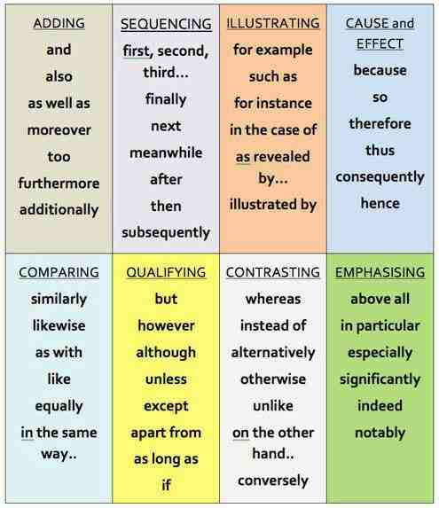

Exercise 1
Select and Connect!
One person (preferably the teacher) begins a tale and stops after a few sentences. The next person picks up the story thread and continues it, then stops. Next person adds to it and so on until the tale comes to a resolution. The story could begin with a pre-selected title or subject to guide the improvisation. But the catch is that, each person has to use at least one transition word (given above). Let’s see how the story will be! Have fun!

Exercise 2
Persuasive Speech Topics

1 | What Television Program Should Be Banned And Why?
2 | Is a glass half full or half empty? Explain your choice.
3 | How to impress your parents.
4 | Why your mom/dad is special.
5 | Why Do I Play Golf? Or another kind of sports
6 | Tell us about a nickname you have and how you got it.
7 | What is the biggest effect of the internet?
8 | Why books are important.
9 | Convince us that homework is harmful to your health.
10 | How to achieve your dreams.

