From: Johny
To: IELTS Prep Group
Subj: IELTS Reading lesson 10

Lesson Objective
The student shall be able to use “power words” as part of their oral vocabulary, read and comprehend business language and demonstrate effective oral communication skills

First Portion
Power words

Evaluation Criteria
- Ability to understand the definition of the word and how to use in a sentence.

Directive: Match the word with its meaning.

foment | thorough | endear | abhor | glimpse
bosom | handkerchief | lurk | stout | to and fro

- To make beloved or admired.
- To cause or try to cause the growth or development of (something bad or harmful).
- A small cloth used for wiping your face, nose, or eyes.
- To look at or see (something or someone) for a very short time. A partial view.
- Complete with regard to every detail; not superficial or partial. Performed or written with great care and completeness. Careful about doing something in an accurate and exact way.
- In a constant movement backward and forward or from side to side.
- A person's chest when it is thought of as the place where secret thoughts and feelings are kept.
- Brave and strong.
- To dislike (someone or something) very much.
- To be in a hidden place: to wait in a secret or hidden place especially in order to do something wrong or harmful.

Second Portion
Reading comprehension: Team work.

Evaluation Criteria
- Ability to read, with clear pronunciation following as best the punctuation rules. The listeners will have to comprehend the articles. All students will be asked several questions to validate their comprehension of the reading material and listening skills.

Exercise 1
- One student will read the one given article and another student will answer a question. One question per student. The roles will alternate until all students have read one article and answer one question.

ARTICLE 1
Abigail Adams: Persuading Her Husband
Part of her letter from March 31, 1776.
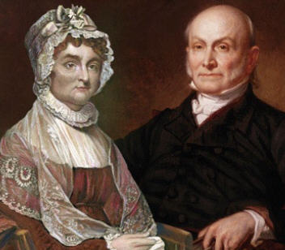
I long to hear that you have declared an independency. And, by the way, in the new code of laws which I suppose it will be necessary for you to make, I desire you would remember the ladies and be more generous and favorable to them than your ancestors. Do not put such unlimited power into the hands of the husbands. Remember, all men would be tyrants if they could. If particular care and attention is not paid to the ladies, we are determined to foment a rebellion, and will not hold ourselves bound by any laws in which we have no voice or representation.
That your sex are naturally tyrannical is a truth so thoroughly established as to admit of no dispute; but such of you as wish to be happy willingly give up the harsh title of master for the more tender and endearing one of friend.
Why, then, not put it out of the power of the vicious and the lawless to use us with cruelty and indignity with impunity? Men of sense in all ages abhor those customs which treat us only as the vassals of your sex; regard us then as beings placed by Providence under your protection, and in imitation of the Supreme Being make use of that power only for our happiness.

Questions:
Student 1. What is Abigail trying to convince her husband to do?
Student 2. Give two examples of how she attempts to persuade him.

ARTICLE 2
Great Expectations
By Charles Dickens

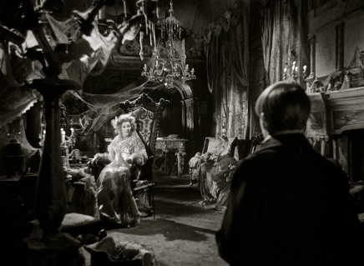
This was very uncomfortable, and I was half afraid. However, the only thing to be done being to knock at the door, I knocked, and was told from within to enter. I entered, therefore, and found myself in a pretty large room, well lighted with wax candles. No glimpse of daylight was to be seen in it. It was a dressing-room, as I supposed from the furniture, though much of it was of forms and uses then quite unknown to me. But prominent in it was a draped table with a gilded looking-glass, and that I made out at first sight to be a fine lady’s dressing-table. Whether I should have made out this object so soon if there had been no fine lady sitting at it, I cannot say. In an arm-chair, with an elbow resting on the table and her head leaning on that hand, sat the strangest lady I have ever seen, or shall ever see.

(Optional: Second paragraph could be read by another student)
She was dressed in rich materials,—satins, and lace, and silks,—all of white. Her shoes were white. And she had a long white veil dependent from her hair, and she had bridal flowers in her hair, but her hair was white. Some bright jewels sparkled on her neck and on her hands, and some other jewels lay sparkling on the table. Dresses, less splendid than the dress she wore, and half-packed trunks, were scattered about. She had not quite finished dressing, for she had but one shoe on,—the other was on the table near her hand,—her veil was but half arranged, her watch and chain were not put on, and some lace for her bosom lay with those trinkets, and with her handkerchief, and gloves, and some flowers, and a Prayer-Book all confusedly heaped about the looking-glass.

Now Answer:
- Pip sees Miss Havisham and her room as strange. List three examples from the text that support this idea and explain how they add to the oddness of the scene. (One example per student)

ARTICLE 3
The Speech

We dare not forget today that we are the heirs of that first revolution. Let the word go forth from this time and place, to friend and foe alike, that the torch has been passed to a new generation, born in this century, tempered by war, disciplined by a hard and bitter peace, proud of our ancient heritage, and unwilling to witness or permit the slow undoing of those human rights to which this nation has always been committed, and to which we are committed today at home and around the world.
Let every nation know, whether it wishes us well or ill, that we shall pay any price, bear any burden, meet any hardship, support any friend, oppose any foe to assure the survival and the success of liberty. This much we pledge – and more.

Now answer:
One of the most famous lines from the President’s speech is: “the torch has been passed to a new generation...”
Student 1. Explain in your own words what he means.
Student 2. What is the torch?
Student 3. Why is does it apply to the President?

The President reminds his audience that “those who foolishly sought power by riding the back of the tiger ended up inside.”
Student 4. What does the tiger represent?
Student 5. How does it relate to supporting freedom?

ARTICLE 3
The Red Badge of Courage
Stephen Crane’s novel

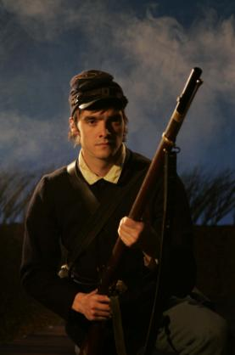
However, he perceived now that it did not greatly matter what kind of soldiers he was going to fight, so long as they fought, which fact no one disputed. There was a more serious problem. He lay in his bunk pondering upon it. He tried to mathematically prove to himself that he would not run from a battle. Previously he had never felt obliged to wrestle too seriously with this question. In his life he had taken certain things for granted, never challenging his belief in ultimate success, and bothering little about means and roads. But here he was confronted with a thing of moment. It had suddenly appeared to him that perhaps in a battle he might run. He was forced to admit that as far as war was concerned he knew nothing of himself. A sufficient time before he would have allowed the problem to kick its heels at the outer portals of his mind, but now he felt compelled to give serious attention to it.

(Optional: Second paragraph could be read by another student)
A little panic-fear grew in his mind. As his imagination went forward to a fight, he saw hideous possibilities. He contemplated the lurking menaces of the future, and failed in an effort to see himself standing stoutly in the midst of them. He recalled his visions of broken-bladed glory, but in the shadow of the impending tumult he suspected them to be impossible pictures.
He sprang from the bunk and began to pace nervously to and fro. “Good Lord, what’s the matter with me?” he said aloud.
He felt that in this crisis his laws of life were useless. Whatever he had learned of himself was here of no avail. He was an unknown quantity. He saw that he would again be obliged to experiment as he had in early youth. He must accumulate information of himself, and meanwhile he resolved to remain close upon his guard lest those qualities of which he knew nothing should everlastingly disgrace him. “Good Lord!” he repeated in dismay.

Now answer:
In this passage, Henry is facing a part of himself that he knew nothing about. What is this characteristic?

