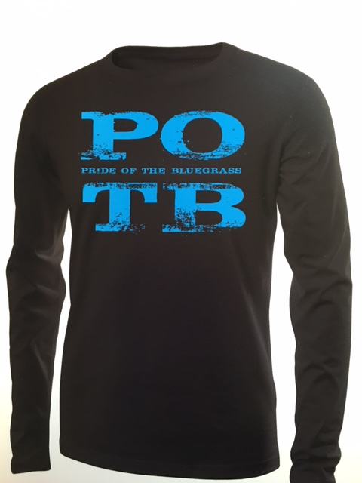
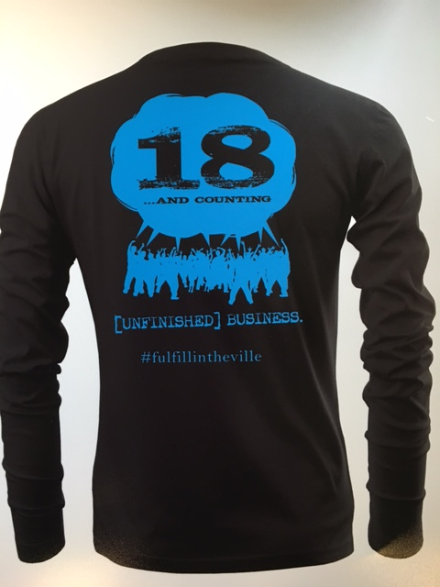
Lafayette Band 2016
“18 and Counting” apparel order form

NAME:_____________________________________
PHONE:____________________________________

TOTAL QUANTITY:__________TOTAL AMOUNT:________________

The order deadline is Monday, October 17. PLEASE ORDER CAREFULLY! ALL ORDERS ARE PRE-PAID AND FINAL. NO RETURNS OR REFUNDS WILL BE AVAILABLE. Make checks payable to LBA and bring to the Band store on Friday evening at the football game or Monday after practice. If you have any questions, please contact Brenda Boggs at 859-806-1967.

PLEASE INDICATE THE QUANTITY NEEDED IN THE SHADED BOX BELOW EACH SIZE.

SHORT SLEEVE T-SHIRT IN BLACK WITH BLUE IMPRINT
SMALL | MEDIUM | LARGE | XL | PRICE | AMOUNT
 |  |  |  | $12.00
 | 2XL | 3XL | 4XL
 |  |  |  | $15.00

LONG SLEEVE T-SHIRT IN BLACK WITH BLUE IMPRINT
SMALL | MEDIUM | LARGE | XL | PRICE | AMOUNT
 |  |  |  | $15.00
 | 2XL | 3XL | 4XL
 |  |  |  | $18.00

CREW NECK SWEATSHIRT IN BLACK WITH BLUE IMPRINT
SMALL | MEDIUM | LARGE | XL | PRICE | AMOUNT
 |  |  |  | $22.00
 | 2XL | 3XL | 4XL
 |  |  |  | $25.00

HOODED SWEATSHIRT IN BLACK WITH BLUE IMPRINT
SMALL | MEDIUM | LARGE | XL | PRICE | AMOUNT
 |  |  |  | $28.00
 | 2XL | 3XL | 4XL
 |  |  |  | $30.00

THANK YOU FOR YOUR ORDER!

