Lev Savranskiy

Full Stack Developer Portfolio
https://lev.js.org/

Senior Fullstack Developer
Nutrafol, Sep 2020 - Now
Project Description: multiple customer touchpoints of a fast-growing wellness company.
https://nutrafol.com/

Tech:
• JavaScript ES6/ES7.
• React and other tools in the ecosystem.
• Dynamic experiences via GraphQL/Apollo.
• Gatsby - static site generation.
• magento/Shopify/Recharge/applepay integrations
• Node/AWS/Lambda.
Video: https://www.youtube.com/watch?v=NDSEJG3-4h4
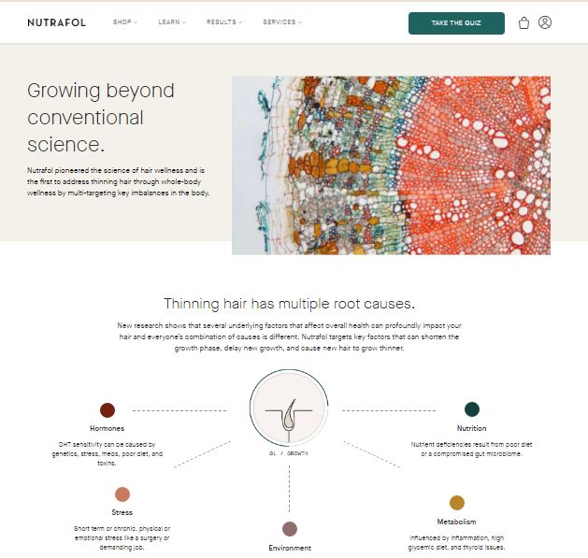

Senior Frontend Developer
TD Bank, Oct 2019 – Sep 2020
Project Description: Top-notch UI for TD Business Banking
https://www.td.com/us/en/small-business/
Duties:
• Respect TD’s technology delivery practices and standards: accessibility, architecture, production capacity, methodologies, documentation, tools and frameworks.
• Conduct code reviews to address quality, standards compliance, and ease of maintenance.
Tech:
• Angular 1...9
• Angular Material
• NodeJS for Unix, Windows, IIS
• nvm, bower, webpack
• Accessibility tools: a11y CDK, Voiceover, TalkBack, JAWS, ARIA for all platforms
Transfer and deposit UI
https://www.youtube.com/watch?v=nlPjPDKxXn4
Account Opening
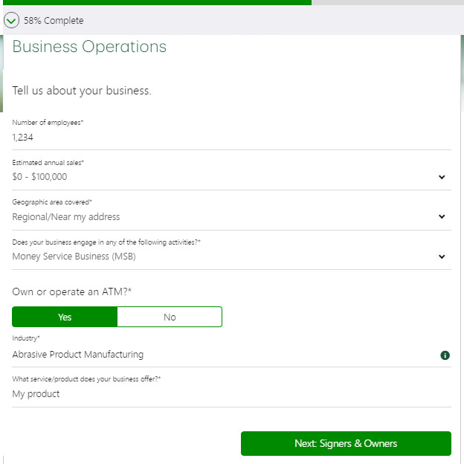
Comcast
Nov 2018 – Oct 2019

Philadelphia, USA
https://www.xfinity.com/mobile/
Project Description:
Present and Next Gen Xfinity Mobile Applications
Duties:
• Worked across the full stack of technologies (MEAN).
• Performed code reviews and advised other team members on code reusability, maintainability and standards.
• Tasks in related areas: requirements and code security analysis, system design, release management etc.
Tech:
• CI• d3• Angular 6+• Angular Material• RxJS • VanillaJS• Webpack• SCSS• Node.js• Express.js• MongoDB
Client facing application.
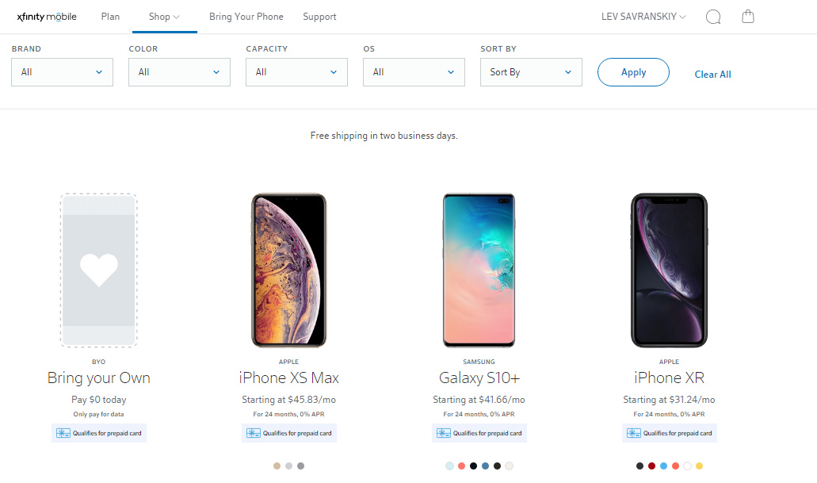

Agent facing dashboard.
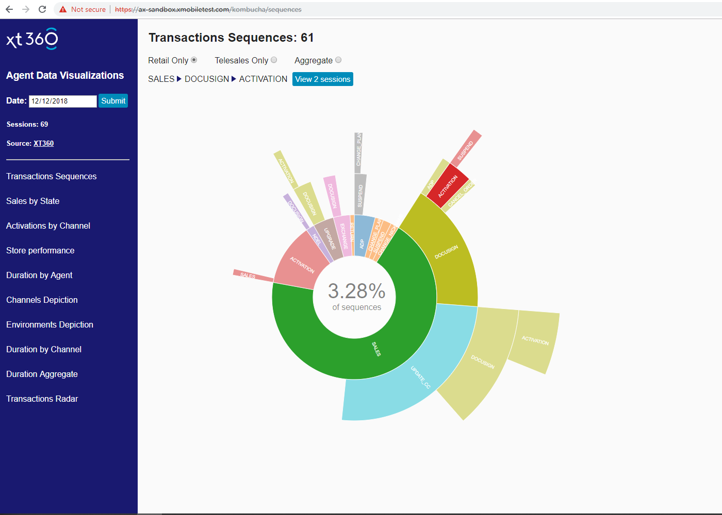

The Bridge Corporation (Bridge Marketing)

Jun 2016 – Sep 2018

Fort Lee, USA

http://www.thebridgecorp.com/
Project Description:
• Internal and external tools for multi-channel marketing solutions
• B2B/B2C user count systems
• Data processing utilities
• S3 based file repository with custom tagging
• What we do slideshow - https://www.slideshare.net/slideshow/embed_code/key/F6BVfkxV4GqYGf
Duties:
• Build rich interactive experiences in a fast pace agile collaborative environment
• Leverage JS/PHP frameworks with HTML5 and numerous API
Tech:
• INTEGRATIONS: Sendy / Amazon SDK / NPI Medical / NCOA / O*NET Career
• FRAMEWORKS: Angular/ React JS/ Express / Kendo UI / Ant Design / Bootstrap / Symfony / Zend / Struts / Flask
• ENV: Docker / Ubuntu / CentOS• TOOLS: node / grunt / babel / webpack / git / jenkins
• DB: Amazon RDS / Oracle / MariaDB / BigQuery / Postgres / Sequelize
• DB: Google Clud / S3• TESTING: Jasmine/ Karma/ PhantomJS / Protractor / istanbul
• XLXS & ZIP on-client processing• Continuous Integration / Delivery (CI/CD)• Shell / bash scripting
Marketing metrics
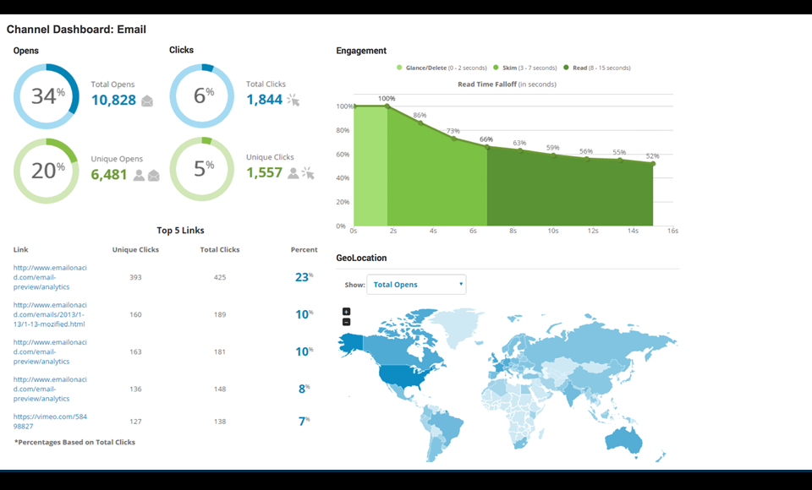

Marketing metrics

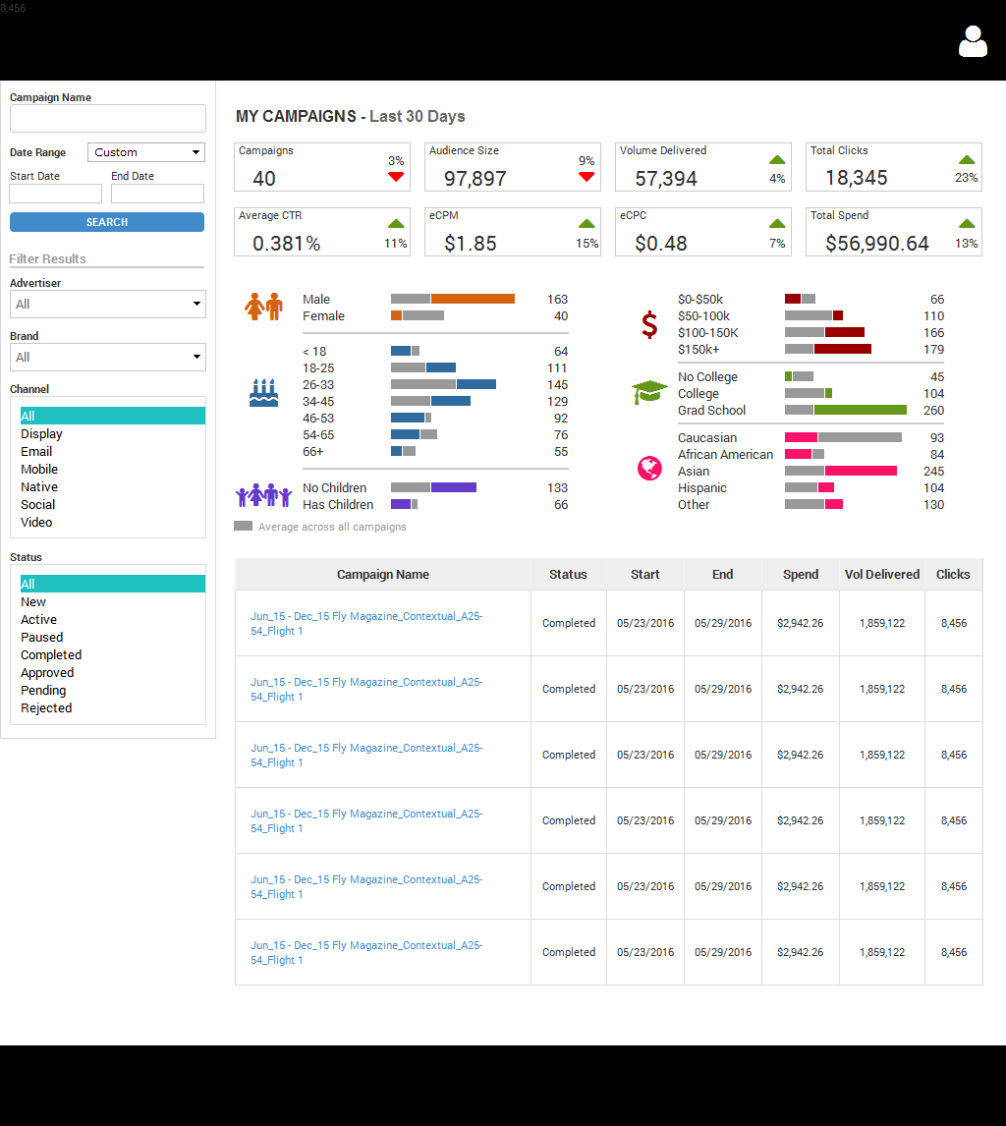

EPAM Systems
Jul 2014 – Jun 2016

Saint Petersburg, Russian Federation
Links: NDA
Project Description: Innovative, global healthcare leaders committed to improving health and well-being in countries around the world. (Tissue storage management, Antibodies workbench, Operation quality)
Duties:
• Create modular, scalable, testable HTML, CSS and Javascript code that is clean and standards-compliant
• Actively participate in the global development process, contribute to knowledge base, suggest process improvements
Tech:
• Continuous Integration
• ADOBE ACROBAT js / forms / plugins & plugins installers
• FRAMEWORKS extjs / Jquery / Backbone / Marionette / handlebars
• TOOLS node / uglify / grunt / git
• PLUGINS FOR selectize / handsontable / jstree
• TESTING Selenium / Mocha / Chai / Sinon / nodeunit / istanbul / pre-commit hooks
• DOCS groc / jsdoc
DNA sequence manager

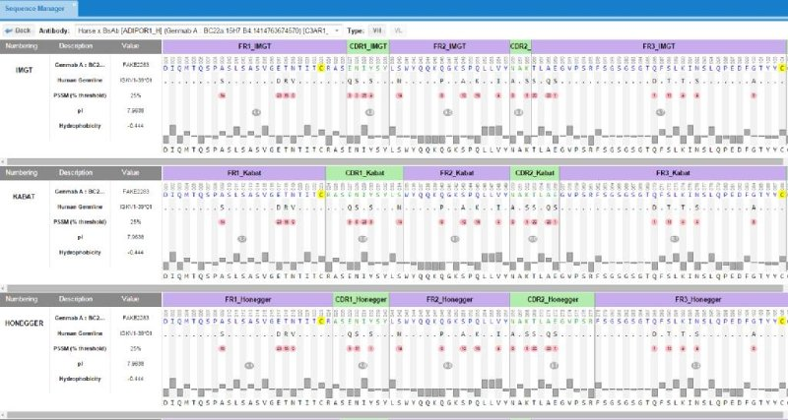

Dynamic PDF quality exchange

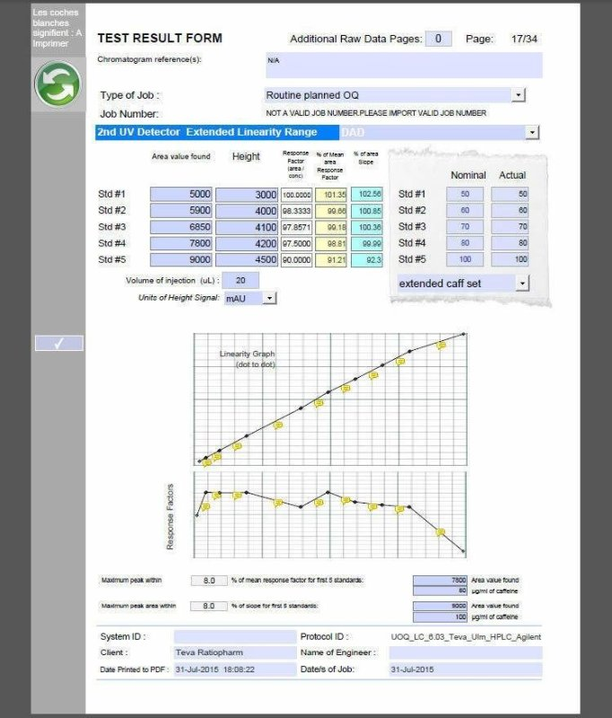

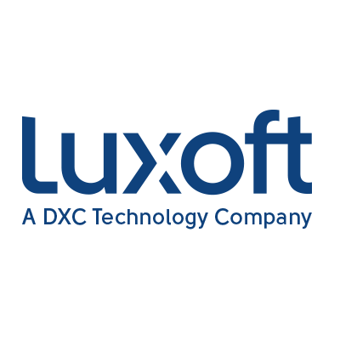
Luxoft

July 2013 – Jun 2014

Saint Petersburg, Russian Federation
Links: NDA
Project Description:
One of the Top US Bank`s innovating Margin Calculations platform with advanced support of sync/async calculation and reports, maker/checker decision logic. The system is designed with the rich dojo UI
Duties:
• Participate in requirements gathering by working closely with onshore technology team, business users, and quants.
• Design and develop UI components, with responsibilities for the full development life cycle
• Stay abreast of the new UI technology - tools/frameworks/approaches/etc.
Tech: * dojo* Continuous Integration
Margin call calculator
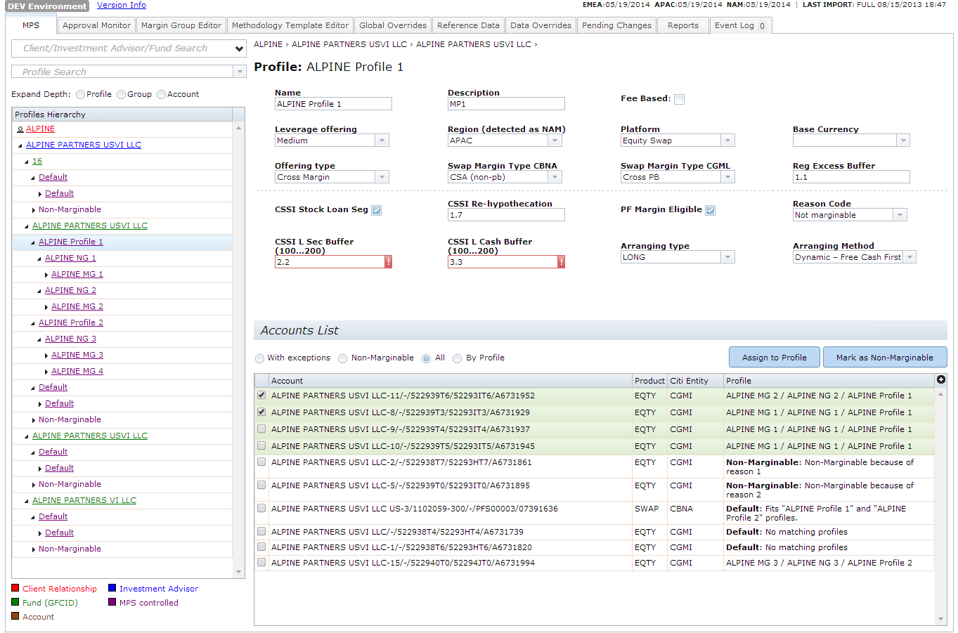

iCrossing

May 2010 – Jul 2013

Chicago, USA

Project Description: UI Development for large advertising agencies and marketers.
Company was known as Red Aril, acquired by iCrossing (digital branch of Hearst Corp.)
http://coreaudience.com
Duties:
* Implement key components/ wireframe based design.
* Develop and maintain software product following company`s process and coding standards.
* Prepare and maintain software documentation.
* Create unit-tests.
* Assign tasks for developers/testers and control execution.
* Report to manager about assignments.
* Work with other team members within projects part.
* Investigate problems, search optimal decisions.
* Increase junior staff proficiency.
Tech:
* ExtJS 3/4 (MVC, RIA , plug-ins, Single page application)* jQuery* SCSS* PHP SOAP translator* Data Leakage Monitoring (PHP/Httpwatch)* XUL plug-ins (Firefox)* CRX plugins
Data management platform
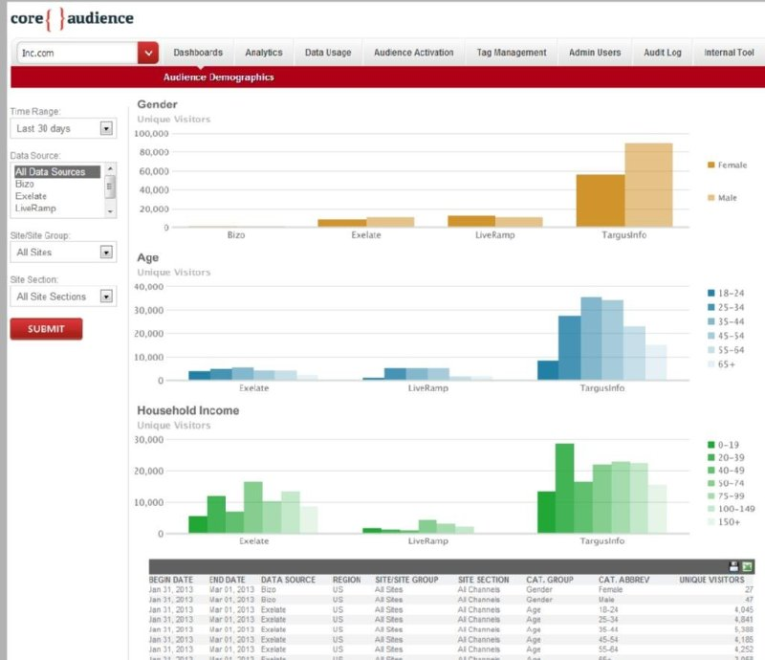
Chrome plugin - taxonomy qualifier
