QUALITY ENHANCEMENT CELL

In recent years, it has become an obligation that institutions of higher education demonstrate the effectiveness of their academic programs in providing higher education that positively impacts students ultimate the stakeholders. Also, most accrediting bodies and Higher Education Commission (HEC) concerned with quality assurance are requesting that institutions assess student’s leaning outcomes as a means of improving academic programs. | 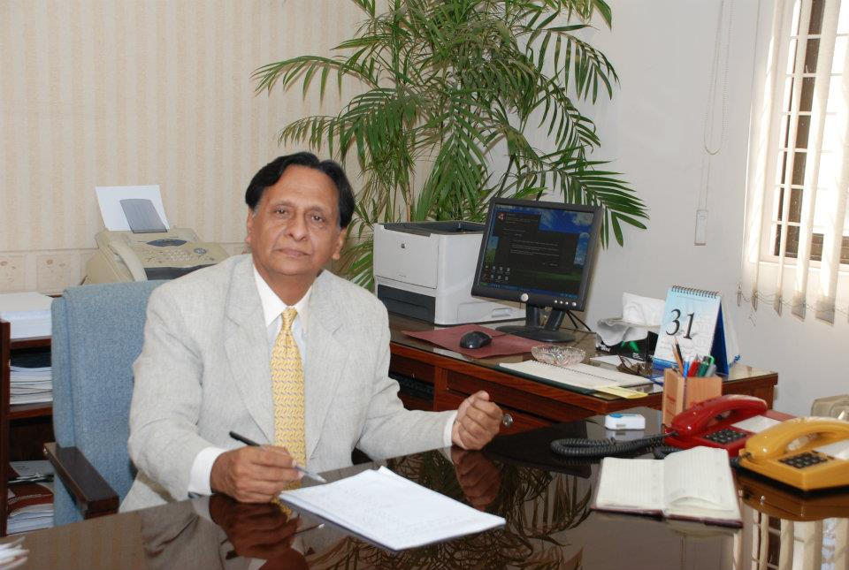

PIFD, in pursuance of the decision of Syndicate taken in its meeting held 15th March, 2013 duly endorsed by the Senate in its 2nd meeting held on 16th May, 2013 has established Quality Enhancement Cell (QEC) on 21st October, 2013 and appointed Mr. Attique Ahmad as Head QEC to implement Quality Enhancement Procedures / Criteria incorporated in the Self Assessment Manual (SAM) provided by the Quality Assurance Agency (QAA), HEC to attain an improved level of international compatibility and competitiveness at institute / program level and develop a viable / sustainable mechanism of quality assurance in higher learning sector to meet the rising challenges of transforming the country in to a knowledge economy.
The mandate of QEC is to plan, apprise coordinate and follow up the activities of conducting Self Assessment (SA) of the Teaching Departments in terms of their Degree Programs on the basis of Criteria, Standards and Survey Forms incorporated in the Self Assessment Manual (SAM) provided by the QAA, HEC Islamabad to determine the weaknesses / gray areas of the departments and to address the same to achieve the following objectives and it is a continuous process.
- Improvement and maintenance of academic standards.
- Enhancement of student’s learning.
- Verify that of the existing programs to meet their objectives and institutional goals.
- Provide feedback for quality assurance of academic programs.
QEC is monitored by the Vice-Chancellor and QAA/HEC, Islamabad. QAA fixes the targets, asks to submit Yearly Progress Report (YPR) followed by a power point presentation at HEC Islamabad or at any HEC Regional Center of Pakistan and then ranks QEC. QEC initiates the SA one semester prior to the end of assessment cycle in which the program is offered and if the program is undergoing the SA for the first time, the department will be given one academic year for preparation.
In accordance with Self Assessment Procedure (SAP) as laid down in SAM, the Vice Chancellor, on nominations of faculty by the Course Coordinators/Head of the Departments, has constituted the following six Program Teams (PTs) comprising 3-4 faculty members of all the six departments with indication of Team Leaders to prepare the Self Assessment Reports (SARs) of the departments in terms of degree programs. QEC has developed a power point presentation on SAM to conduct awareness sessions of PTs to prepare SARs of each department for assessment by the program Assessment Teams (ATs).
Program Teams
Sr.No. | Name | Designation
Department of Fashion Design
1 | Mr. Abdul Manan Khalid | Assistant Professor (Team Leader)
2 | Ms. Fatima JabeenIqbal | Lecturer
3 | Ms. Sarah JavaidMehmood | Lecturer
4 | Ms. Farah ArifAli Khan | Lecturer (Foundation Year Studies )
Department of Fashion Marketing & Merchandising
1 | Ms. Khadija Hassan | Lecturer (Team Leader)
2 | Ms. Sabah Faizan | Lecturer
3 | Ms. Mariam Ali | Lecturer (Foundation Year Studies )
4 | Ms. Asma Khan | Teaching Associate
Department of Textile Design
1 | Ms. Bushra Jamil | Assistant Professor (Team Leader)
2 | Mr. Kamran Maqsood | Lecturer
3 | Ms. FareehaNadeem | Lecturer ( Foundation Year Studies)
4 | Ms. Mehreen Hafeez | Teaching Associate
Department of Jewellery Design & Gemological Sciences
1 | Mr. Muhammad Umar | Assistant Professor (Team Leader)
2 | Ms. WajihaPervaiz | Lecturer
3 | Ms. Sana Khan | Lecturer ( Foundation Year Studies)
4 | Ms. Qurat ul Ain Ali | Teaching Associate
5 | Ms. Mehreen Ahmed | Teaching Associate
Department of Furniture Design and Manufacture
1 | Mr. NaveedAnwar Butt | Assistant Professor (Team Leader)
2 | Mr. Qaiser Khan | Assistant Professor
3 | Mr. Kausar Iqbal | Lecturer ( Foundation Year Studies)
4 | Ms. Rabia Almas | Lecturer
Department of Leather Accessories & Footwear Design
1 | Ms. Maimoona Ajmal | Assistant Professor (Team Leader)
2 | Ms. FareehaSardar | Assistant Professor
3 | Ms. Asmarah Ahmed | Assistant Professor ( Foundation Year Studies)
4 | Ms. Farhat Ahmed | Consultant

Since PIFD Annual Report is for the period upto December, 2013, therefore, it seems appropriate to indicate QEC future plan as under:
- To conduct awareness sessions regarding SA for the PTs to prepare SARs of all the six departments in terms their degree programs and to record minutes.
- To conduct surveys as prescribed in SAM to incorporate its feedback in the SARs.
- To constitute program Assessment Teams (ATs) comprising 2-3 faculty members by the Vice-Chancellor, on the recommendations of QEC.
- To plan and schedule the ATs visit period in coordination with the departments to conduct the assessment and submit reports to QEC.
- To conduct Exit Meetings to be attended by QEC, Course Coordinators/Head of the Departments, PTs, ATs and faculty members of the departments wherein the ATs present their finding of assessment for discussion.
- To submit Executive Summaries to the Vice-Chancellor by QEC on the ATs findings.
- To prepare and submit an Implementation Plan including ATs findings, corrective actions to be taken, assignments of responsibility and time frame of such actions by the Course Coordinators/Head of the Departments to QEC for follow up.
- To conduct Awareness Seminars regarding SAM for the faculty of each department.
- To attain membership of quality oriented professional associations / societies etc.
- To develop QEC website
- To submit Yearly Progress Report of QEC on the HEC prescribed format to QAA upto 10th June 2014.

