*From: Lala*

*To: IELTS Prep Group*

*Subj: IELTS Reading Lesson 2*

**Lesson Objective**

The student shall be able to use “power words” as part of their oral vocabulary, read and comprehend business language and demonstrate effective oral communication skills

1. **Power Words**

Evaluation Criteria

* Ability to understand the definition of the word and how to use in context within a complex statement/sentence

Match the word with the correct definition:

**Confront harrowing liberation inexplicable propaganda**

**Clutch flee traffic inflict reinforce**

1. to make something ​[stronger](http://dictionary.cambridge.org/us/dictionary/english/strong), usually by ​[adding](http://dictionary.cambridge.org/us/dictionary/english/add) more ​[material](http://dictionary.cambridge.org/us/dictionary/english/material) or another ​[piece](http://dictionary.cambridge.org/us/dictionary/english/piece)
2. to ​[hold](http://dictionary.cambridge.org/us/dictionary/english/hold) or ​[try](http://dictionary.cambridge.org/us/dictionary/english/try) to ​[hold](http://dictionary.cambridge.org/us/dictionary/english/hold) something ​[tightly](http://dictionary.cambridge.org/us/dictionary/english/tightly)
3. ​[extremely](http://dictionary.cambridge.org/us/dictionary/english/extremely) ​[upsetting](http://dictionary.cambridge.org/us/dictionary/english/upsetting) because ​[connected](http://dictionary.cambridge.org/us/dictionary/english/connected) with ​[suffering](http://dictionary.cambridge.org/us/dictionary/english/suffering)
4. that cannot be ​[explained](http://dictionary.cambridge.org/us/dictionary/english/explain) or ​[understood](http://dictionary.cambridge.org/us/dictionary/english/understand)
5. to ​[deal](http://dictionary.cambridge.org/us/dictionary/english/deal) with a ​[difficult](http://dictionary.cambridge.org/us/dictionary/english/difficult) ​[problem](http://dictionary.cambridge.org/us/dictionary/english/problem), ​[situation](http://dictionary.cambridge.org/us/dictionary/english/situation), or ​[person](http://dictionary.cambridge.org/us/dictionary/english/person)
6. to ​[escape](http://dictionary.cambridge.org/us/dictionary/english/escape) by ​[running](http://dictionary.cambridge.org/us/dictionary/english/running) away, esp. because of ​[danger](http://dictionary.cambridge.org/us/dictionary/english/danger) or ​[fear](http://dictionary.cambridge.org/us/dictionary/english/fear)
7. Freedom from limits on thought or behavior.
8. to ​[illegally](http://dictionary.cambridge.org/us/dictionary/english/illegal) ​[buy](http://dictionary.cambridge.org/us/dictionary/english/buy) or ​[sell](http://dictionary.cambridge.org/us/dictionary/english/sell) ​[people](http://dictionary.cambridge.org/us/dictionary/english/people), or make ​[money](http://dictionary.cambridge.org/us/dictionary/english/money) from ​[work](http://dictionary.cambridge.org/us/dictionary/english/work) they are ​[forced](http://dictionary.cambridge.org/us/dictionary/english/forced) to do
9. to ​[force](http://dictionary.cambridge.org/us/dictionary/english/force) someone or something to ​[experience](http://dictionary.cambridge.org/us/dictionary/english/experience) something ​[unpleasant](http://dictionary.cambridge.org/us/dictionary/english/unpleasant)
10. I[nformation](http://dictionary.cambridge.org/us/dictionary/english/information) or ​[ideas](http://dictionary.cambridge.org/us/dictionary/english/idea) that are ​[spread](http://dictionary.cambridge.org/us/dictionary/english/spread) by an ​[organized](http://dictionary.cambridge.org/us/dictionary/english/organized) ​[group](http://dictionary.cambridge.org/us/dictionary/english/group) or ​[government](http://dictionary.cambridge.org/us/dictionary/english/government) to ​[influence](http://dictionary.cambridge.org/us/dictionary/english/influence) people’s ​[opinions](http://dictionary.cambridge.org/us/dictionary/english/opinion)
11. **Reading**

Evaluation Criteria

* Ability to read, with clear pronunciation, and comprehend the meaning of the paragraph. Student will be asked several questions to validate their comprehension of the reading material

**ARTICLE 1.**

**Toni Morrison: “The Night I Stood My Ground”**

*The Nobel Prize winner writes about finding courage and confronting evil.*

By Toni Morrison



TWO BLOCKS. Two very, very long blocks beyond in deep darkness. It is 1953, and I have walked these blocks many times on my way to the room I rent off campus. I get off the bus after leaving the library at ten o’clock in the evening clutching books in my arms, with a purse hanging from a strap on my shoulder.

My landlady works the night shift at the hospital, so at this hour, the house will be as dark and blank as the others on this street. Everything is quiet and closed. Far ahead (or so it seems) is a streetlight. I am thinking about a paper due in a few days. What theme should I explore? Will the professor admire or dismiss it? Why are we reading Dreiser anyway?

I notice headlights coming toward me. A car is driving slowly down the street on the other side. As it passes, I glance at the driver—male, blond. I keep walking. The car slows down and stops. I hear its door slam shut. A few seconds later, I hear footsteps behind me. I keep walking; I do not speed up, because I don’t want to call attention to myself. The walker may be going to a house nearby, visiting a friend. Besides, what would be the point of hurrying, running?

I still have to get my door key from my purse. When I reach my house, I will have to walk upstairs to the porch, fumble in the dark to insert my key in the lock. Then he will climb the steps behind me, put his right hand over my mouth, knock me down on the porch floor, scattering my books, the contents of my purse. His breath smells of mint, but there is a sour smell too. There is no one to see. He will hold me down with one hand squeezing my throat, reach under my skirt with the other, and say, “Don’t fight me; don’t fight.”

QUESTIONS:

1. What was the persona’s feeling?

2. Why was she feeling that way?

I am exhausted. The scene I have imagined is detailed, brutal, and unbearable. I cannot live through what I anticipate.

I stop. I refuse to experience that imaginary assault again.

I turn around and wait for him. I wait and wait until he catches up to where I stand, with nothing to defend myself but the urgency to escape not what might happen but what has already happened in my mind.

He comes close, closer. I can see his eyes (or I think I can).

“Will you please leave me alone.” It is neither a question nor a scream. My voice is low, conversational. Nothing can be worse than what I have imagined.

He pauses.

“I’m not going to bother you,” he whispers, then turns around and walks back to his car.

Although this encounter was important to me, it should not be understood as appropriate action for anyone else. Confronting evil can be dangerous, bloody, even fatal. Each of us responds in our own way. But for me, a young student, it sealed the connection between my imagination and the source of courage. I did not run away.

*From O, The Oprah Magazine  
Also in Reader's Digest Magazine April 2014*

**QUESTIONS:**

*1. How did the author show her courage?*

*2. What would you do if you were in her place?*

Source

*http://www.rd.com/true-stories/inspiring/toni-morrison-the-night-i-stood-my-ground/*

**ARTICLE 2.**

**My Escape From North Korea: How I Moved On From a Life of Horrors**

***Yeonmi Park shares the harrowing tale of her liberation from North Korea.***

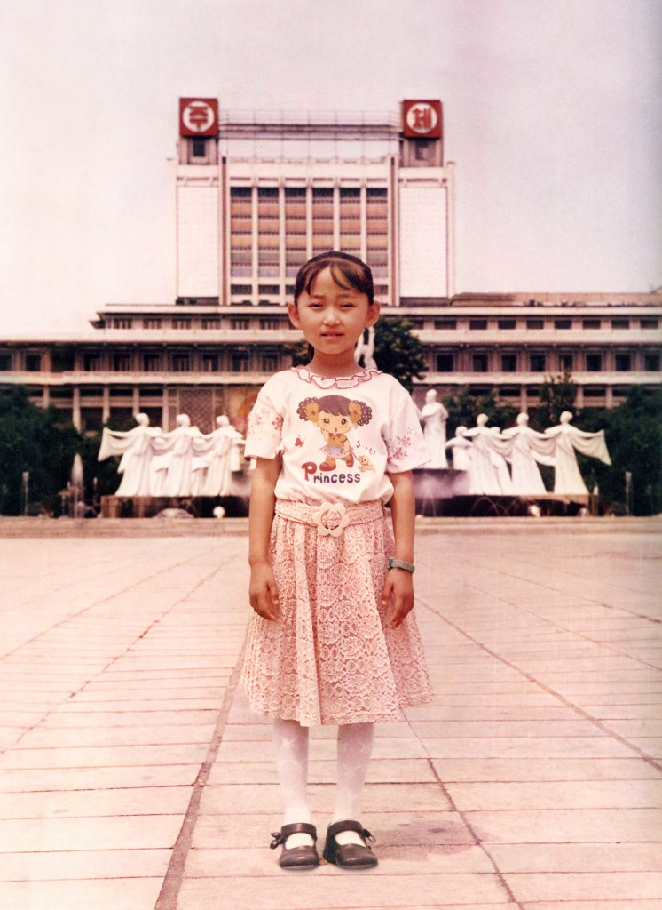

I am most grateful for two things: that I was born in North Korea and that I escaped from North Korea. Both of these events shaped me, and I would not trade them for an ordinary and peaceful life. But there is more to the story of how I became who I am today.

There’s a quote I once read from Joan Didion: “We tell ourselves stories in order to live.” Sometimes, the only way we can survive our own memories is to shape them into a story that makes sense out of events that seem inexplicable. I’ve seen the horrors that humans can inflict, but I’ve also witnessed acts of kindness and sacrifice in the worst circumstances. I know that it is possible to lose part of your humanity in order to survive. But I also know that the spark of human dignity is never completely extinguished and that given the oxygen of freedom and the power of love, it can grow again.

**QUESTIONS:**

* *What are the two things that the author is thankful for?*
* *Why is she thankful for these two things?*

I grew up in Hyesan, a city of 200,000 on the Yalu River, which runs between China and North Korea. It is the coldest part of North Korea, with temperatures plunging to minus-40 degrees Fahrenheit.

My mother and father encouraged me from the start to be proud of who I am. My father sometimes held me in his lap and read me children’s books. The only ones available were published by the government and had political themes. Instead of fairy tales, they were stories set in a place called South Korea, where homeless children went barefoot and begged in the streets. It never occurred to me that they were really describing life in my country.

Children were taught to hate the enemies of the state with a passion.

We also read about our Leaders and how they worked so hard and sacrificed so much for us. Our Dear Leader Kim Jong Il had mystical powers. His biography said he could control the weather with his thoughts and that he wrote 1,500 books during his three years at Kim Il Sung University, named after his father. This worship of the Kims was reinforced in documentaries, movies, and TV shows broadcast by the single, state-run station. Whenever the Leaders’ pictures appeared on the screen, stirring sentimental music would play. It made me so emotional. North Koreans are raised to venerate our fathers and our elders, and in our collective minds, Kim Il Sung was our beloved grandfather, and Kim Jong IL was our father.

**QUESTIONS:**

* *How did the North Korean government teach the people, especially the children to hate the enemy state?*
* *What could happen to the people if the government reinforces nationalism on them?*

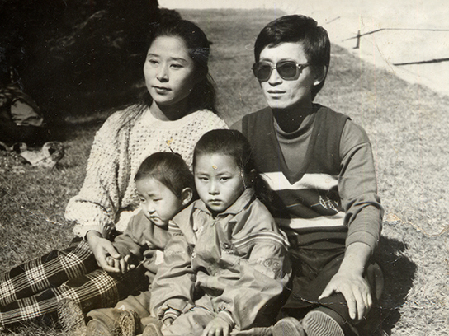

Children were taught to hate the enemies of the state with a passion. Our schools and textbooks were full of images of grotesque American GIs with blue eyes and huge noses executing civilians. Sometimes at recess we lined up to beat or stab dummies dressed like American soldiers. Every subject in school came with a dose of propaganda. A math problem would go like this: “If you kill one American bastard and your comrade kills two, how many dead American bastards do you have?”

There were so many things we were forbidden to do, buy, or sell, and public executions were used to teach lessons in loyalty and the consequences of disobedience. When I was little, a young man was arrested for killing and eating a cow. Cows were the property of the state, and they were too valuable to eat because they were used for plowing fields and dragging carts. Anybody who butchered one would be stealing government property.

**QUESTIONS:**

* *Why isn’t’ allowed to butcher cows?*
* *Why are the children taught to hate the enemy of the North Korean state?*

This man suffered from tuberculosis and had nothing to eat, but that didn’t matter to the police. They took him behind the market and tied him to a piece of wood. Three men with rifles began firing at him until his body flopped to the ground. My mother watched in shock—she couldn’t believe that in her own country, a human’s life had less value than an animal’s.

Families could watch only state-generated propaganda films, which were boring. So there was a huge demand for smuggled foreign movies and TV shows, even though you never knew when the police might raid your house. They’d first shut off the electricity so that the videocassette or DVD would be trapped in your machine for them to find. People got around this by owning two players and switching them if they heard a police team coming.

**QUESTIONS:**

* *How do the people outsmart the police who come to raid their houses?*

My uncle had a VCR, and I went to his house to watch Hollywood movies. My aunt covered the windows and told us not to say anything. I loved Cinderella, Snow White, and the James Bond movies. But the film that changed my life was Titanic. I couldn’t believe that someone had made a movie out of a shameful love story—in North Korea, the filmmakers would have been executed. I was also amazed that the characters were willing to die for love, not just for the regime, as we were. The idea that people could choose their destinies fascinated me. Titanic gave me my first small taste of freedom.

Mongolian soldiers took the women to a detention center, where they were held for several weeks before they were put on a plane to South Korea. In Seoul, they were detained again while being interrogated by officials looking for spies. Following a stay in a resettlement center, they moved to a small town in South Korea. Yeonmi studied diligently and entered college. In 2013, she and her mother were reunited with her sister, Eunmi.

In September 2014, Yeonmi went to Dublin to represent North Korea at the One Young World Summit, an annual meeting of youth leaders. She was planning to speak about human trafficking in China, although she had no intention of revealing that she, too, had been trafficked.

**QUESTIONS:**

* *What movie changed the author’s life?*
* *How did it change her life?*

One of my great fears has always been losing control. Sometimes I feel anger inside me, and I know if I ever let it out, it might explode. I worry that if I start to cry, I may never stop. So I keep these feelings deep down inside me. People who meet me think I’m the most upbeat person they’ve ever met. My wounds are well hidden.

But that day in Dublin, they were there for all to see. As I stood in front of an audience of 1,300, I fought to speak through my tears. “North Korea is an unimaginable country …,” I began. I told people that in my country, you could be executed for making an illegal international phone call. I told them when I was a child, my mother told me not to whisper, because even the birds and mice could hear me.

**QUESTIONS:**

* *Why did YeunMi. (The author) decide to keep her feelings deep inside her?*

“The day I escaped North Korea, I saw my mother raped by a Chinese broker who had targeted me,” I said as tears flowed down my face. The Chinese preyed upon the vulnerability of refugees. “Seventy percent of North Korean women and teenage girls are victimized. Sometimes sold for as little as two hundred dollars …  
“When I was crossing the Gobi, I wasn’t afraid of dying as much as I was afraid of being forgotten … But you have listened. You have cared.”

Everybody in the audience was on their feet, crying with me. I looked around and knew that justice was alive in that room. But there was still one more desert for me to cross.

Afterward, I gave dozens of interviews. I believed that by changing a few details about my escape, I could hide the fact that I had been trafficked. If I was truthful about everything else, then the details shouldn’t matter.

**QUESTIONS:**

* *Why did the author want to hide the fact that she was trafficked?*

Less than a month after my speech, I began this memoir. As soon as I started writing, I knew that I could no longer hold anything back. How could I ask people to face the truth about North Korea and what happens to the women who flee if I couldn’t face it myself?

When I returned to Seoul, my mother and sister and I stayed up one night, talking. There were things that happened in China that my mother and I had never told Eunmi. For all its bullet trains and modern architecture, South Korea is still a conservative country with old-fashioned notions of female virtue. If people knew what I had done to survive, I was sure nobody would ever look at me the same way. And what difference would it make? Would anyone care enough to try to change things?

But my mother recognized the potential impact of our story. “You have to tell the world that North Korea is like one big prison camp,” she said. She wanted people to know the plight of North Korean women in China. “If you don’t speak up for them, who will?” she said. My sister agreed.

As soon as I decided to tell my secret, I felt free for the first time ever. It was like a heavy sky had been pushing down on me, pinning me to the earth, and now it was lifted, and I could breathe again.

**QUESTIONS:**

* *How did the author describe South Korea?*
* *How did the author feel when she revealed her secret?*

*Source*

*http://www.rd.com/true-stories/survival/escape-from-north-korea*

**ARTICLE 3:**

**These Hero Pilots Volunteer to Fly the Very Sick to Help save Their Lives**

**How heroes take flight to lift others in their most difficult moments.**

*By Amy Paturel*

Larry Camerlin knows what desperation sounds like. Each week, his small Massachusetts office answers dozens of frantic phone calls from families of very sick people who hope Larry and his team can help. What they need are flights—to a liver or kidney transplant, to receive ongoing chemotherapy and radiation, or to treat severe burns or other crippling diseases at medical centers far away from home.

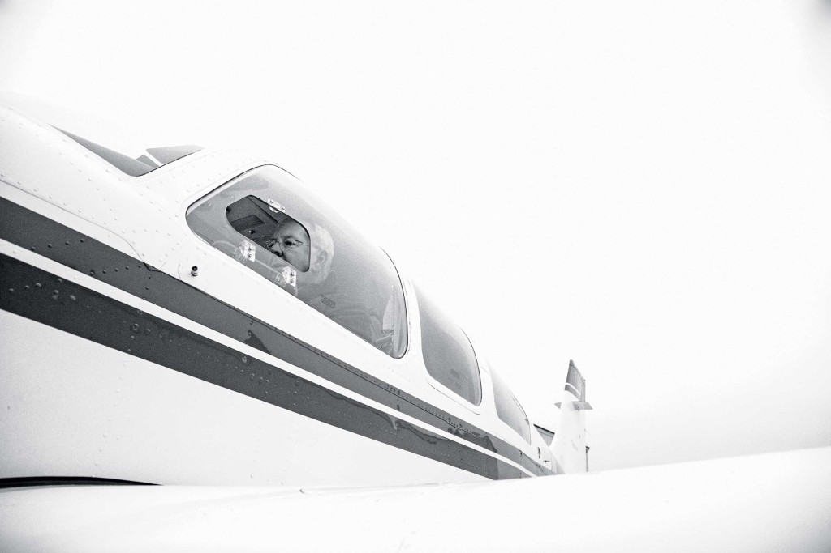

As the founder of Angel Flight Northeast, a group that connects patients in need with volunteer pilots who shepherd them, Larry, 68, has never turned away a request.

“People come to us at some of the most frightening times of their lives—they’re running out of money, out of time, and out of faith,” says Larry, who pilots some trips himself while also overseeing scheduling, fund-raising, and other administrative responsibilities. “We help replace that fear with tremendous healing and hope.”

**QUESTIONS:**

* *How do Larry and his team help people?*
* *Who does Larry help and what do they need?*

Larry, a father of four and grand-father of six, has spent his entire career providing hope during trauma. He and his wife, Ruth, built a successful ambulance company, and after they sold the business in 1994, Larry got his pilot’s license. Then he read a magazine article about a pilot in California who flew a ten-year-old boy to receive [cancer](http://www.rd.com/health/conditions/how-to-prevent-cancer/) treatment and immediately knew what his next chapter would be.

“This enormous emotional wave hit me,” Larry says. “This is what God wants me to do.”

The first Angel Flight NE trip took to the skies on May 31, 1996. Today, Larry relies on a network of nearly 500 volunteer pilots who donate their own time, planes, and fuel. Larry’s crews on the ground, Earth Angels, drive patients to and from the airport. To date, Angel Flight NE has helped 65,000 people. Bonds between patients and pilots can last for weeks, months, or longer. One cancer patient took more than 585 trips over ten years. And every single one—for every single patient—is free of charge.

**QUESTIONS:**

* *What event propelled Larry to help people?*
* *What service does Angel Flight NE provide?*

“Sometimes patients can’t talk to their family about their fears, but being up in the heavens, it’s therapeutic to talk to a pilot helping you get better,” Larry says. “Mothers, if their children are asleep, may break down about how difficult it is to see their kids so badly hurt.” Not every journey, of course, has a storybook ending. Larry had been flying a boy with a life-threatening genetic disorder from Maine to Boston for years.

“He was witty, fun, and insightful—an 11-going-on-40-with-a-PhD-from-Harvard type,” says Larry. One day, he got a call from the boy’s mother: “Benjamin [name has been changed] is dying, and he would like to see you.” Larry flew there the next day.

**QUESTIONS:**

* *Who is Benjamin?*
* *What does the phrase “not every journey has a storybook ending” mean?*

“Why does God hate me?” Benjamin asked Larry. “I’m only a little boy, and I’m dying. I shouldn’t be dying as a little boy.” Larry thought for a second. “Look how smart you are, how good you are, how many people you’ve touched,” he said. “God needs you to be one of his special angels. He loves you so much; that’s why he wants you.”

That flight home from Benjamin’s house felt different from usual. “The closer I got to home, the sky became more flushed with yellow and orange,” Larry remembers. “The sun dipped below the horizon as I touched down my wheels. Everything was so ethereal. It was like God was telling me everything was going to be OK.”

**QUESTIONS:**

* *How did Larry respond to Benjamin’s question?*
* *Why was Larry’s flight home from Benjamin’s house felt unusual?*

*Source*

*http://www.rd.com/true-stories/inspiring/angel-flight-pilot-heroes/*

*Articles used for this educational lesson come from:*

*http://www.rd.com/*