**Supervisor Improvement Program**

**(SIP)**

**Class #3: December 5, 2019**

**Conflict Resolution,**

**Generational Communications,**

**and Coaching**

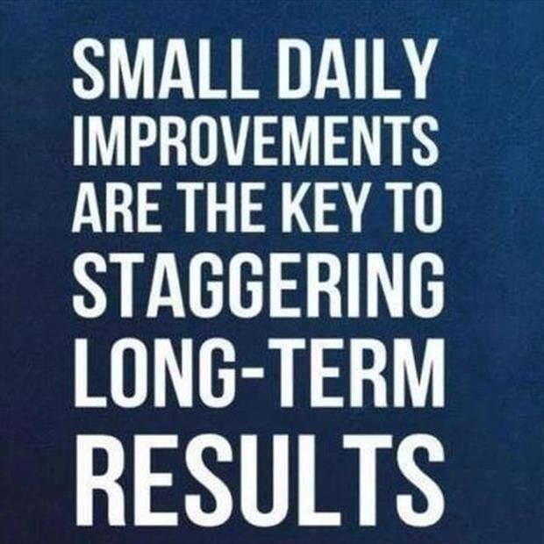

Hosted by:

**OMAG at Edmond, OK**