Second Dimension – Christianity Experienced
Segment VI – The Culmination (Concepts 54-60) Progressive Bible Concepts - #60 “The New Heavens and the New Earth”

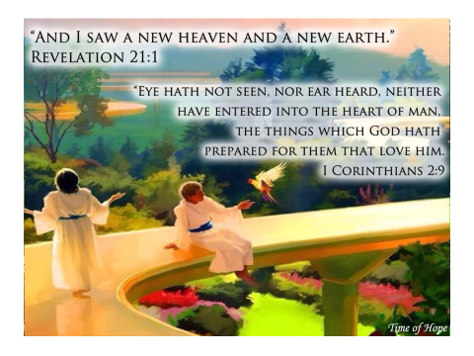
Ice Breaker Questions:
- How would you define heaven?
- What do you think heaven is going to be like?

Order of Events:
- D________ – separation
  - Physical - soul/b______
  - Spiritual - soul/G____
- I_______________________ state – F________ Heaven
- S__________ Coming of Christ
- R________________________ of the Dead
- J________________
- E______________ Life – New Heaven and New Earth

Observations:
- The book of Genesis tells how things b_______, the book of Revelation tells us how things e____.
- “…I am the f______ and the l____…I am the A_______ and the O_______…” said Jesus

Jesus Commanded John “…write…”:
- “Write in a b______ what you see…” 1:11
- “Write therefore the things you have s______…” 1:19
- “To the c__________…write…” 2:1, 8, 12, 18; 3:1, 7, 14
- “Write, blessed are the d______ who die in the Lord” 14:13
- “Write, blessed are those who are invited to the m___________ s___________ of the lamb…” 19:9
- “Write for these words are f______________ and t______…” 21:5

Observation:
- The book of Genesis contains the s______ of redemptive history, the book of Revelation contains the full bloom of the f__________ of redemptive history.

Parallels - Genesis and Revelation:
- God created the h____________ and the e________ 1:1
  - God created the n____ heavens/n____ earth – 21:1
- God c____________ luminaries – sun, moon, stars – 1:14-16
  - God illumines heaven – no sun or moon – 21:23
- Paradise l______ (3:23)
  - Paradise g__________ (21:25)
- Devil’s v____________ (3:1-7)
  - Devil’s d__________ (20:10)
- Man’s a____________________ from God (3:8)
  - Man’s c__________________ with God (21:3)
- Tree of life c__________ to sinful man (3:24)
  - Tree of life is o______ to those in the Lamb’s book of life (21:27).

New Heavens and Earth Foretold:
- “For behold, I c__________ a new heavens and a new earth…” Is 65:17
- “For just as the new heavens and the new earth which I m______ will endure before Me…” Is 66:22

New Jerusalem Foretold – Ezekiel:
- The B______ of E____________ contains the first record of the New Jerusalem. Within Ezekiel 40-48, there is an extended and detailed description of the measurements of the Temple, its chambers, porticos, and walls. Chapter 48:30-35 contains a list of twelve Temple gates named for Israel’s tribes.

New Jerusalem – OT – Isaiah:
- Though the actual phrase is never used, the New Jerusalem is further extrapolated in Isaiah, where the new creation is adorned with precious sapphires, jewels, and rubies. The city is described as a place free from terror and full of righteousness. Here, Isaiah provides an example of Jewish a__________________________, where a hope for a p________________ Jerusalem and freedom from oppression is revealed.

New Jerusalem Foretold – Zechariah:
- The B______ of Z________________ expands upon Ezekiel’s New Jerusalem. After the S__________ T__________ was built after the exile, Jerusalem’s population was only a few hundred. There were no defensive city walls until 445 BC. In the passage, the author writes about a city wall of fire to protect the inhabitants. This text demonstrates the beginning of a progression of New Jerusalem thought. In Ezekiel, the focus is primarily on the human act of Temple construction. In Zechariah, the focus shifts to God’s intercession in the f______________ of New Jerusalem.

Present Heavens and Earth – NT:
- “But by His word the p____________ heavens and earth are being reserved for fire, kept for the day of judgment and destruction of ungodly men. But the day of the Lord will come like a thief, in which the heavens will pass away with a roar and the earth and its works will be burned up. Since all these things are to be destroyed in this way, what sort of people ought you to be in holy conduct and godliness, looking for and hastening the coming of the day of God, because of which the heavens will be destroyed by burning, and the elements will melt with intense heat!” II Peter 3:7, 10-12
- “Heaven and earth will p______ a______…” Matt 24:35

New Heavens and Earth – NT:
- “But according to His promise we are looking for n____ heavens and a n____ earth, in which righteousness dwells.” II Peter 3:13

New Jerusalem – OT & NT:
- “…for he was looking for the c______ which has foundations, whose a_______________ and b____________ is God.” Heb 11:10
- “But as it is, they desire a b__________ country, that is, a h______________ one. Therefore God is not ashamed to be called their God; for He has prepared a c______ for them.” Heb 11:16
- “But you have come to Mount Zion and to the city of the living God, the h______________ J________________, and to myriads of angels…” Heb 12:22
- “For here we do not have a l____________ city, but we are seeking the city which i__ to c______.” Heb 13:14

Foretelling of New Jerusalem:
- “He who overcomes, I will make him a pillar in the temple of My God, and he will not go out from it anymore; and I will write on him the name of My God, and the name of the city of My God, the n____ J________________, which comes down out of heaven from My God, and My new name.” Rev 3:12

Revelation 21:1-4
“Then I saw a new heaven and a new earth; for the first heaven and the first earth passed away, and there is no longer any sea. ² And I saw the holy city, new Jerusalem, coming down out of heaven from God, made ready as a bride adorned for her husband. ³ And I heard a loud voice from the throne, saying, “Behold, the tabernacle of God is among men, and He will dwell among them, and they shall be His people, and God Himself will be among them, ⁴ and He will wipe away every tear from their eyes; and there will no longer be any death; there will no longer be any mourning, or crying, or pain; the first things have passed away.”

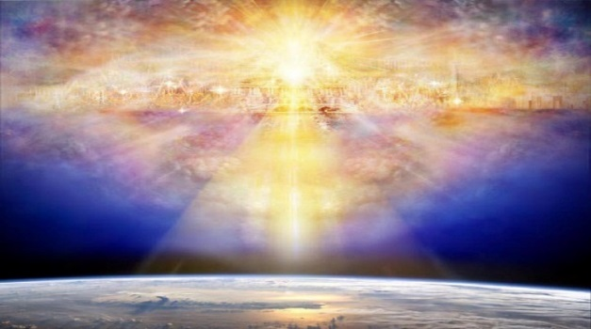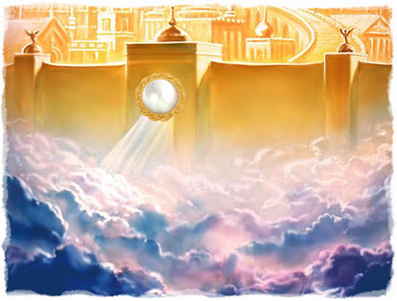

Revelation 21:1-4

Observations:
- As promised, the first heaven and the first earth p______ away
- As promised, a new heaven and a new earth e__________ in replacement of the former
- No longer any sea – water is e__________________? See 22:1
- Comes down out of heaven – spiritual in o__________
- God will d________ in the city with his people
- Former things pass away – the e____________ of sin are removed – death, mourning, pain, and crying

Revelation 21:5-9
“And He who sits on the throne said, “Behold, I am making all things new.” And He *said, “Write, for these words are faithful and true.” ⁶ Then He said to me, “It is done. I am the Alpha and the Omega, the beginning and the end. I will give to the one who thirsts from the spring of the water of life without cost. ⁷ He who overcomes will inherit these things, and I will be his God and he will be My son. ⁸ But for the cowardly and unbelieving and abominable and murderers and immoral persons and sorcerers and idolaters and all liars, their part will be in the lake that burns with fire and brimstone, which is the second death.” ⁹ Then one of the seven angels who had the seven bowls full of the seven last plagues came and spoke with me, saying, “Come here, I will show you the bride, the wife of the Lamb.”

Revelation 21:5-9

Pronouncements:
- I am making a____ things new
- Write, these things are faithful and t______
- I am the A________ (beginning) the O________ (end)
- I will give l__________ water to the one who thirsts for it
- He who o________________, inherits these things
- I will be his God and he be my s____
- For those who are disbelieving and unrighteous, their part is the l______ of f______

Revelation 21:10-14
“And he carried me away in the Spirit to a great and high mountain, and showed me the holy city, Jerusalem, coming down out of heaven from God, ¹¹ having the glory of God. Her brilliance was like a very costly stone, as a stone of crystal-clear jasper. ¹² It had a great and high wall, with twelve gates, and at the gates twelve angels; and names were written on them, which are the names of the twelve tribes of the sons of Israel. ¹³ There were three gates on the east and three gates on the north and three gates on the south and three gates on the west. ¹⁴ And the wall of the city had twelve foundation stones, and on them were the twelve names of the twelve apostles of the Lamb.”

Revelation 21:10-14

View from the Mountain Top: (see Matt 4:8):
- A reflection of the g________ of God
- The b__________________ of a costly stone
- Boundaried by a great and high w______
  - Accessed by twelve g________ posted with twelve angels and named after the twelve tribes of Israel
  - Founded upon twelve s__________ with the names of the twelve apostles of the Lamb

Revelation 21:15-21
“The one who spoke with me had a gold measuring rod to measure the city, and its gates and its wall. ¹⁶ The city is laid out as a square, and its length is as great as the width; and he measured the city with the rod, fifteen hundred miles; its length and width and height are equal. ¹⁷ And he measured its wall, seventy-two yards, according to human measurements, which are also angelic measurements. ¹⁸ The material of the wall was jasper; and the city was pure gold, like clear glass. ¹⁹ The foundation stones of the city wall were adorned with every kind of precious stone. The first foundation stone was jasper; the second, sapphire; the third, chalcedony; the fourth, emerald; ²⁰ the fifth, sardonyx; the sixth, sardius; the seventh, chrysolite; the eighth, beryl; the ninth, topaz; the tenth, chrysoprase; the eleventh, jacinth; the twelfth, amethyst. ²¹ And the twelve gates were twelve pearls; each one of the gates was a single pearl. And the street of the city was pure gold, like transparent glass.”

Revelation 21:15-21
Features:

- The shape of a c______ – 1500 miles square
- The wall is 72 yards high and made of j__________
- The city is made of pure g______, like c________ glass
- The foundational stones are adorned with p______________ stones of every kind
- Twelve gates each had a p________
- S____________ are made of pure gold

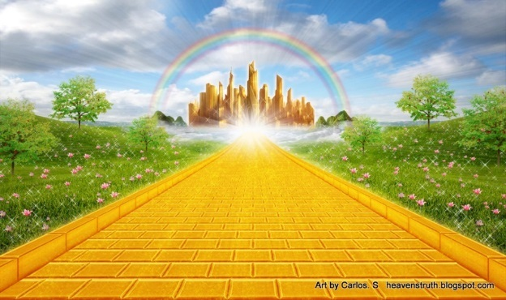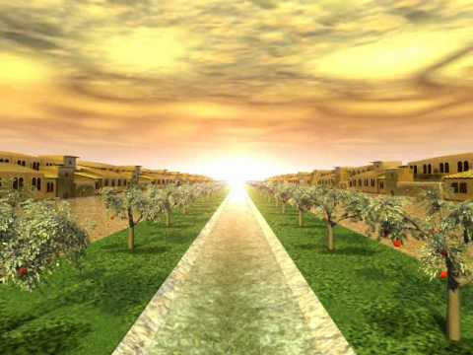
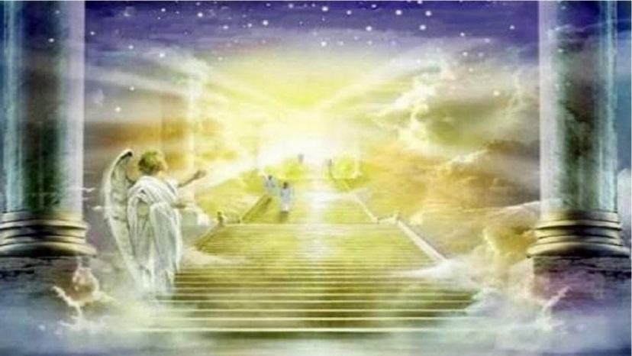

Revelation 21:22-27
“I saw no temple in it, for the Lord God the Almighty and the Lamb are its temple. ²³ And the city has no need of the sun or of the moon to shine on it, for the glory of God has illumined it, and its lamp is the Lamb. ²⁴ The nations will walk by its light, and the kings of the earth will bring their glory into it. ²⁵ In the daytime (for there will be no night there) its gates will never be closed; ²⁶ and they will bring the glory and the honor of the nations into it; ²⁷ and nothing unclean, and no one who practices abomination and lying, shall ever come into it, but only those whose names are written in the Lamb’s book of life.”

Revelation 21:22-27

Absences:

- No t__________ or building for worship
- God’s p______________ is immanent
- No i____________________
  - God’s g________ is light
  - Lamb is its l______
- No n________
- No gate c____________
- Nothing u____________ shall enter it
- No one who practices a__________________ behavior is welcome

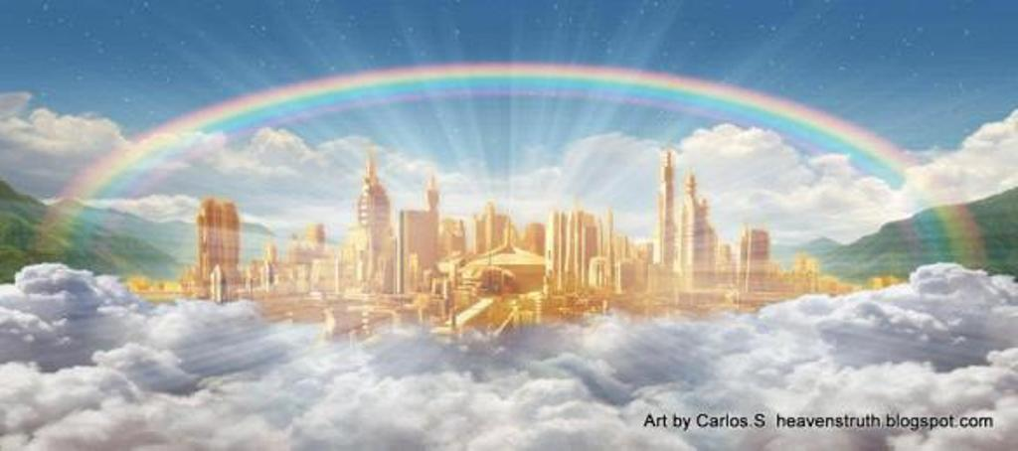

Revelation 22:1-6a
“Then he showed me a river of the water of life, clear as crystal, coming from the throne of God and of the Lamb, ² in the middle of its street. On either side of the river was the tree of life, bearing twelve kinds of fruit, yielding its fruit every month; and the leaves of the tree were for the healing of the nations. ³ There will no longer be any curse; and the throne of God and of the Lamb will be in it, and His bond-servants will serve Him; ⁴ they will see His face, and His name will be on their foreheads. ⁵ And there will no longer be any night; and they will not have need of the light of a lamp nor the light of the sun, because the Lord God will illumine them; and they will reign forever and ever. ⁶ And he said to me, “These words are faithful and true”
Revelation 22:1-6a

Paradise Regained:

- R________ of life
- T______ of life
  - T__________ kinds of Fruit
  - Leaves that h______ the nations
- C________ of sin is removed
- T__________ of God and the L______ of God are present
- His bondservants will serve him f______ to f______
- His n______ is upon their foreheads
- They shall r________ together forever
- These words are f______________ and t______

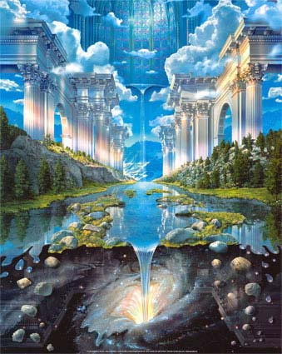

Heaven – Your Thoughts?:
- Heaven is at times perceived as a dull and boring place. Do you agree or disagree on this perception? See I Cor 2:9
- What will you miss the least about planet earth? See Isaiah 65:17
- What aspect of heaven do you most look forward to? See John 14:2

Summary – Concept 60:
- As the first heaven and the first earth pass away, the imperfect earthly life gives way to the perfect heavenly afterlife in the new heaven and the new earth.

Next Track – Third Dimension:
- Christianity Exerted: Mastering the Fundamentals

