From: Rojhano
To: Beginners Group
Subj: Lesson 5

Lesson Objective
The student shall read and comprehend basic language and demonstrate understanding.

First Portion
Reading

Evaluation Criteria
- Ability to read, with clear pronunciation, and comprehend the meaning of the text.

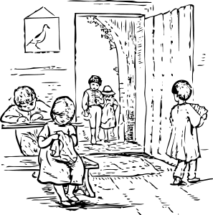
Who are they? Where are they? What are they doing?

Now the children are at school. Amy is sewing. She is practicing. She is sitting on a bench. She is sitting near Timmy.

Timmy is at school too. Timmy is studying. He is sitting behind his desk. He wishes he could play with the other children.

John and Susan are also at school. They are playing outside. They are picking flowers for their teacher. John is carrying his hat. Susan is wearing a bonnet

At this moment, Sarah is walking by the door. She is helping the teacher. She is carrying textbooks to the shelf.

Second Portion
Grammar Refresher

This is the present continues tense
Subject + To Be (am, is, are) + main verb (-ing)

Singular | Plural
I am learning | We are learning
You are learning | You are learning
He is learning | They are learning
She is learning
It is learning

1. We use the present continuous when we talk about something that is taking place at the time of speaking:
Example:
- Please be quiet. I am studying, I'm trying to concentrate.

2. We also use the present continuous when we talk about something that is happening around the time of speaking, but not necessarily at the time of speaking. Example:

- Jane and Mary are talking and having lunch together, Jane says:" I'm reviewing my school books these days; I'll lend them to you when I've finished them.

3. We often use the present continuous when we talk about a period around the present. For example: today, this week, this season….
    - You are working hard today.
    - Tom isn’t playing football this season.

4. We also use the present continuous when we talk about changing situations.

    - Is your English getting better?
    - The population of the world is rising very fast.
Exercises:

- Practice these questions with a partner.

1. I_____(look) at some people through the window.
2. He______(leave) his house to the stadium to play football.
3. She_______(narrate) short stories to her grandsons.
4. We_______(hope) to succeed in that championship.
5. They________ (read) nice English books.
6. You_______(wait) for your friend in the street to talk to him.
7. We_______(sing) a beautiful song by Michael Jackson.
8. My friend and I________(speak) about our dream house.
9. You_______(tell) him all your secrets because you rely on him.
10. He_______(weep) because he is angry and sad.

Third Portion
Vocabulary
- Students should be able to understand the meaning of the words from the list below and make multiple sentences using them.

1. Above
At a higher level or layer.

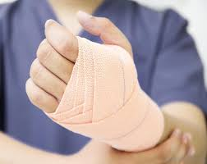
2. Bandage
A covering (such as a strip of cloth) that protects or supports part of the body that has been hurt

3. Cabbage
Any of several brassicas (Brassica oleracea) of European origin; especially: a leafy garden plant (Brassica oleracea capitata) with a short stem and a dense globular head of usually green leaves that is used as a vegetable

4. Damage
a) Physical harm that is done to something or to someone's body.
b) Emotional harm that is done to someone
c) Problems that are caused by a mistake, wrong action, etc.: bad or harmful effects on a situation, a person's reputation, etc.
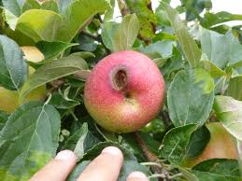
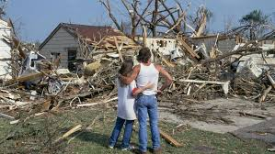

5. Eager
Strongly wanting to do or have something.

