From: Rick Howard

To: IELTS Prep Group

Subj: [IELTS Lesson 2-10-2016](https://dl.dropboxusercontent.com/s/l9nf82wfftypq86/IELTS%20Prep%202-10-2016.docx?dl=0)

1. **Lesson Objective**
   1. **The student shall be able to use “power words” as part of their oral vocabulary, read and comprehend business language and demonstrate effective oral communication skills**
2. **Power Words**

**Evaluation Criteria**

* **Ability to understand the definition of the word and how to use in context within a complex statement/sentence**

|  |  |  |
| --- | --- | --- |
| **Union**  [**http://dictionary.reference.com/browse/union?s=t**](http://dictionary.reference.com/browse/union?s=t) | **Remedial**  [**http://dictionary.reference.com/browse/remedial?s=t**](http://dictionary.reference.com/browse/remedial?s=t) | **Insurgents**  [**http://dictionary.reference.com/browse/insurgent?s=t**](http://dictionary.reference.com/browse/insurgent?s=t) |
| **Sovereignty**  [**http://dictionary.reference.com/browse/sovereignty?s=t**](http://dictionary.reference.com/browse/sovereignty?s=t) | **Poaching**  [**http://dictionary.reference.com/browse/poaching?s=t**](http://dictionary.reference.com/browse/poaching?s=t) | **Unprovoked**  [**http://dictionary.reference.com/browse/unprovoked?s=t**](http://dictionary.reference.com/browse/unprovoked?s=t) |
| **Tardiness**  [**http://dictionary.reference.com/browse/tardiness?s=t**](http://dictionary.reference.com/browse/tardiness?s=t) | **Clandestine**  [**http://dictionary.reference.com/browse/clandestine?s=t**](http://dictionary.reference.com/browse/clandestine?s=t) | **Trauma**  [**http://dictionary.reference.com/browse/trauma?s=t**](http://dictionary.reference.com/browse/trauma?s=t) |

All definitions provided through <http://dictionary.reference.com>

1. **Reading**

**Evaluation Criteria**

* **Ability to read, with clear pronunciation, and comprehend the meaning of the paragraph. Student will be asked several questions to validate their comprehension of the reading material**

**ARTICLE 1**

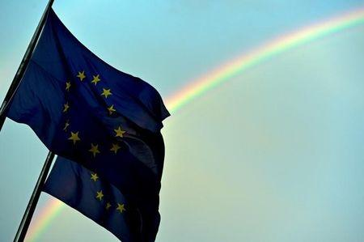

**Founding members say European Union is in bad shape**

<http://news.yahoo.com/founding-members-european-union-bad-shape-211749765.html>

ROME (Reuters) - The European Union faces "critical times" and all its members should set aside selfish interests to tackle problems such as immigration and terrorism, the bloc's six founding nations said on Tuesday.

A week after the EU accepted that some members may never go further in sharing sovereignty, as part of the price for keeping Britain in the club, Germany, France, Italy, Belgium, the Netherlands and Luxembourg pledged to pursue "ever closer union" at a meeting in Rome, where they founded the bloc in 1957.

"We are concerned about the state of the European project," the foreign ministers of the Six said in a statement after their talks. "Indeed, it appears to be facing very challenging times. It is in these critical times that we, as founding members, feel particularly called upon."

The meeting was held against the backdrop of deep division in the 28-nation bloc over how to handle the flows of hundreds of thousands of migrants arriving in Europe fleeing war and failing states in the Middle East and North Africa.

It also came a week after Brussels agreed a draft deal with Britain Prime Minister David Cameron that, among other things, reaffirmed the limitations of a treaty commitment to pursue the "ever closer union" of the peoples of Europe, part of a package to help Cameron campaign before a referendum that the EU's second biggest economy should continue its 43-year membership.

While acknowledging that the Union "allows for different paths of integration", the original signatories of the Treaty of Rome declared: "We remain resolved to continue the process of creating an ever closer union among the people of Europe."

Meeting in Italy, which has been in the frontline of a wave of migration to Europe across the Mediterranean, the ministers also stressed the need to overcome divisions on the EU response.

Hungary and Austria this week called for fences on the Macedonian and Bulgarian borders with Greece and between Austria and Slovenia, and several states have called into question the Schengen accord on free circulation inside the EU.

The statement called for better management of the Union's external borders in order to make them more secure while preserving Schengen and not hampering freedom of movement.

It contained no concrete policy proposals, but said Europe "is successful when we overcome narrow self-interest in the spirit of solidarity".

* **How many nations are in the European Union? 6**
* **In what year was the European Union founded? 1957**
* **How many nations were the original members of the European Union?**

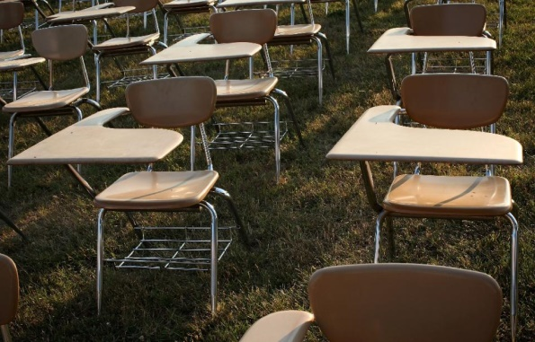**ARTICLE 2**

**13 million pupils in OECD nations 'failing at 15': report**

<https://news.yahoo.com/13-million-pupils-oecd-nations-failing-15-report-084403774.html>

Paris (AFP) - Around 13 million pupils in OECD countries have failed to attain a sufficient level of proficiency in either reading, maths or science by the time they reach 15, according to a new study released by the think-tank on Wednesday.

The figure equates to more than one in four of 15-year-olds in the 64 countries and economies that took part in the 2012 PISA study, the Paris-based organization’s comparative study of education worldwide.

In some countries, 50 percent of students were falling behind in at least one of the key subjects.

The OECD says fighting poor performance at school will bring more to the countries than it will cost them to introduce the special measures needed to combat the problem.

And the wealth of a country need not be the main factor.

"It is education policy and practice that can help students clear this bar, not just per capita income," the report says.

The danger to countries' future economic health cannot be underestimated -- students who perform poorly aged 15 face a high risk of dropping out of school and when a high proportion of the population does not have basic skills, "long-term economic growth is severely compromised".

Between 2003 and 2012, the OECD analyzed nine countries that did not manage to reduce the number of pupils failing to achieve the basic level in maths -- Brazil, Germany, Italy, Mexico, Poland, Portugal, Russia, Tunisia and Turkey.

It found that all of the countries could improve pupils' performance, providing they take the necessary steps.

The OECD's first recommendation is that countries must prioritize reducing the number of low-performing students, using a "multi-pronged" approach.

For example, remedial support must be provided as early as possible in a struggling child's school career.

There is also an onus on governments to identify low-performing schools and attribute greater funding as quickly as possible.

And in a recommendation aimed at countries taking in high numbers of migrants, the OECD says special programs must be offered for immigrant and minority-language students.

Germany, which last year took in more than a million people fleeing war and poverty, recently brought in a specially-tailored program of language learning for immigrant pupils.

But the report also says that without the support of parents, pupils will fail to consolidate their progress.

It cited progress made in Japan, where school reforms "encourage parents and community members to assume some responsibility for managing schools and providing individualized instruction to students during lessons when necessary".

As a result, in 2012, pupils reported a stronger sense of belonging, lower rates of tardiness and better attitudes towards school compared with a decade earlier.

* **The three core school subjects discussed were:**
  + **Gym, Math, Science**
  + **History, Reading and Science**
  + **Reading, Science and Math**
* **Which country recently brought in a specifically tailored program of language learning for immigrant pupils?**
* **What was OECD first recommendation for solving this problem?**
* **Which 9 countries failed to reduce the number of low performers in math?**

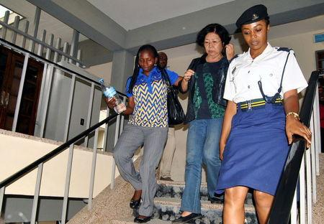**ARTICLE 3**

**How to trap elephant poachers with their own technology**

<https://news.yahoo.com/trap-elephant-poachers-own-technology-071725071.html>

DAR ES SALAAM (Reuters) - One day last October, agents from a crack Tanzanian crime unit raced past Dar es Salaam's Palm Beach Hotel in pursuit of the suspected leader of a global elephant poaching ring.

The chase was the result of new breakthroughs in Tanzania's fight against an increasingly rapacious poaching trade, which has felled 60 percent of the country's elephant population in the past five years.

The agents' target that day was Yang Feng Glan, a 66-year-old Chinese national dubbed the "Ivory Queen," who is accused of running a smuggling empire stretching from the game parks of Tanzania to the clandestine ivory markets of Asia.

Her arrest was the culmination of more than a year's work and relied in large part on the novel use of old crime fighting methods at Tanzania's National and Transnational Serious Crimes Investigation Unit (NTSCIU). Helped by a $1.5 million donation from an American philanthropist, the serious crimes squad has started to tackle poaching using the lessons it learned hunting al Qaeda in the years after the group bombed two U.S. embassies in East Africa in 1998.

A Tanzanian court in October charged Yang with heading a criminal network responsible for smuggling 706 pieces of ivory worth 5.44 billion Tanzanian shillings ($2.51 million) between 2000 and 2014. Prosecutors say Yang organized, managed and financed a criminal racket in ivory totaling 1.9 tonnes.

Yang, currently in jail, could not be reached for comment. But her lawyer, Nehemia Mkoko, says she is innocent of all charges.

The new techniques follow work done in neighboring Kenya, where poaching rates have nosedived. In both countries the police have started concentrating on the poachers' own technology – guns and phones – and using it against them. By combining that with old-fashioned detective work, they have captured more suspects.

"From just one arrest, you can open up the syndicate, and go up the ladder from grassroots to brokers, to dealers and transporters ... all the way up to international traffickers," said one agent from the squad. The history of a suspect's gun, the phone calls he or she makes, and the money they move, create a trail of evidence.

Tanzania has been hit hard by a global spike in poaching over the past decade. Its elephant population has dropped to about 43,000 in 2014 from 109,000 in 2009. Interpol has said a "significant portion" of ivory reaching international markets originated from elephant herds in Tanzania.

The region has also become a vital part of the African "Smack Track," a smuggling route for Afghan heroin bound for Europe; Western diplomats see a growing overlap between ivory smugglers and narcotics traffickers.



An elephant walks in Serengeti National Park in this August 18, 2012 file photo. REUTERS/Noor Khamis

"They are all interlinked. Drugs traffickers in East Africa use the same people that weapons smugglers use and that the ivory smugglers use," said one Nairobi-based agent from the U.S. Drugs Enforcement Administration (DEA).

SWAHILI SPEAKER

The capture of Yang Feng Yang started with a tip-off in 2014.

In the baobab-studded hills of the Ruaha–Rungwa ecosystem, where the elephant population plummeted from 20,000 to 8,000 between 2013 and 2014, local informants pointed crime squad agents towards Manase Philemon, a suspected Tanzanian ivory dealer who was barely literate but could mysteriously speak Chinese.

Under interrogation, Philemon fingered Yang, who police believe taught him Mandarin. "Manase worked so closely with this woman for a long time," the NTSCIU agent told Reuters.

Yang's ties to Tanzania spanned four decades. She studied Swahili at a Chinese university and moved to the country in the 1970s to work as a translator for Chinese engineers building a railway line to Zambia, according to court documents, police sources and an interview she conducted with the China Daily newspaper.

In the 1990s she returned to Tanzania and opened a popular Chinese restaurant in Dar es Salaam. She was also the secretary-general of the Tanzania China-Africa Business Council.



Yang Feng Glan (R), who is suspected of trafficking ivory, covers her face as she leaves the Kisutu

After Philemon's tip-off, she became the NTSCIU's top target.

"FOLLOW THE GUN"

But the anti-poaching team had problems. Many of the NTSCIU's agents were trained by Western spy agencies in the wake of the U.S. embassy bombing in Tanzania, and their main task was to counter the threat from home-grown Islamists. There was not enough cash or manpower to act against poaching and the unit did not operate country-wide.

At this point the not-for-profit PAMS Foundation got involved. Its leader Wayne Lotter sought help from David Bonderman, an American billionaire who made a fortune in private equity and had The Rolling Stones play at his 60th birthday bash. Bonderman's Wildcat Foundation donated about $1.5 million, and the NTSCIU anti-poaching team began recruiting trusted people from the Tanzania Intelligence and Security Service, police, army, immigration, judiciary and the national wildlife service.

"I believe (NTSCIU) provides a model of how serious enforcement against wildlife poaching and trafficking can be accomplished if a country's leadership has the political will to make it happen," said Wildcat Foundation director Rodger Schlickeisen.

By the time of Yang's arrest, about 60 people were working on the anti-poaching team out of 200 or so NTSCIU agents. They set about building networks of informants, and built a strategy.

They called it "follow the gun, save the elephant."

Immediately after a suspect is captured, the agents focus on the suspect's weapon. Tracing how the poacher obtained that gun leads to the person one level above in the syndicate, and points in the direction of a team. Philemon helped here. "He gave us the cream of the dealers," said the agent.

But just as they began building a case against Yang, she vanished. In June 2014 a Tanzanian court charged Philemon with trafficking ivory and Yang fled to Uganda, according to sources familiar with the case. Philemon has not entered a plea and could not be reached the comment.

FOLLOW THE MOBILE MONEY

More than a year later, her phone revealed where she was.

NTSCIU is able to pull up poachers' phone numbers and call histories, said one security expert who works closely with the squad. Computer software is used to delineate links between on-the-ground poachers, dealers and transnational criminal gangs. A server flags to NTSCIU mobile phone numbers when they become active, but does not record calls. "The machine is on 24 hours," said the expert.

Mobile phones also help agents follow the money. Many Africans send and receive money via their phones. That means agents who monitor phone calls can also track payments, helping to build up a picture of who is involved.

"The mobile phones technology has come in very handy," said Robert Muasya, head of security for Kenya's Wildlife Service. "If we catch a poacher, we are able to analyze his phone and analyze the content... know whether this phone had appeared somewhere else, and we are able to connect the dots."

It was thanks to Yang's phone that about a year after she had left for Uganda, Tanzanian agents discovered she was back in Dar es Salaam. But the unit still had a major problem, said the agent. "We had no photographs of her."

Again, her mobile phone helped them track her to a house in the center. They laid a trap, and waited.

As dusk fell seven hours later, Yang burst out of the house, dashed for her car, and sped off. The agents followed, zig-zagging through heavy traffic. Fearing they would lose her, they hit her car to bring it to a halt.

Yang was shocked by the agents' audacity, said the NTSCIU agent: "She came out of the car very angry."

* **What country is Yang from?**
* **Do Africans often use their mobile phones to send and receive money? Yes or No**
* **What country did Yang flee to from Tanzania?**
* **How much did the Bonderman's Wildcat Foundation donate to the anti-poaching team?**
* **In what country did the elephant population drop to 43,000 in 2014 from 109,000 in 2009?**
* **Where is the biggest market for the ivory taken from killed elephants?**

**ARTICLE 4**

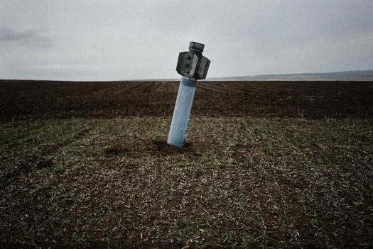

**Between mines and mortars: stranded lives in eastern Ukraine**

<https://news.yahoo.com/between-mines-mortars-stranded-lives-eastern-ukraine-032048125.html>

Zaitseve (Ukraine) (AFP) - Imagine picking your way through a minefield to go to work every day. Or even to go shopping for basic supplies.

That is what faces 42-year-old Irina, ever since one of the main crossing routes in eastern Ukraine was shuttered by a recent upsurge in attacks in the war-scarred former Soviet state.

Like thousands of other locals, the water plant employee can no longer make a living because she lives on land seized by pro-Russian insurgents but works in a government-run part of eastern Ukraine.

"After they closed the checkpoint, they starting shelling this place not only at night, but also during the day," says Irina, lugging heavy bags of provisions.

**- Bypassing roadblocks -**

"I had to make my way around both the rebel roadblock and the Ukrainian one, too," she adds, as the sound of rocket and mortar fire rolls in from the barren fields.

Monitors from the Organization for Security and Cooperation in Europe (OSCE) said at least two civilians were recently hurt by mines laid here by separatist and government forces during the 21-month war.

The contested village of Zaitseve -- and its 4,000 destitute inhabitants lies -- just 35 kilometers (20 miles) north of the rebels' de facto capital Donetsk.

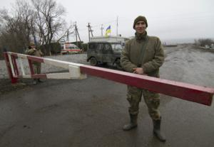

Ukrainian servicemen manning a closed checkpoint in

the village of Zaitseve, some 35 kilometers.

The deadlocked conflict has seen Kiev's troops dig themselves in just to the north and west.

The guerrillas are spread within easy shooting distance to the south and east of Zaitseve, which happens to lie at the war's epicenter.

"The situation here has gotten a lot worse in the past week," 33-year-old government soldier Andriy Miroshnichenko told AFP.

The insurgents "have started staging around 100 mortar attacks a night," he said. "And a road that is being used by thousands of people has become a target."

**- Saving hundreds of lives -**

One of Europe's deadliest conflicts since the Balkans wars of the 1990s has killed more than 9,000 people and driven an estimated 1.5 million from their homes.

But many in Ukraine feel abandoned by EU leaders who are more worried by a recent influx of Middle Eastern migrants, a crisis closer to home for the 28-nation-bloc.



A pro-Russian rebel shows unexploded munitions on his base in Donetsk (AFP Photo/ALEKSEY FILIPPOV)

The war itself also appears to have lost much logic or reason. Russia continues to dismiss growing evidence of its tanks and heavy weapons being used by the insurgents to capture patches of the industrial heart of Ukraine.

Periodic truces and spells of relative calm are often broken without warning.

Ukraine decided to close a 14-kilometre stretch of a road running between Zaitseve and neighboring settlements on February 3 as a precaution.

Kiev had then accused the rebels of staging a new wave of unprovoked shellings that threatened the lives of civilians.

"If we had kept this place open, we would have seen hundreds die," says Miroshnichenko.

The insurgents counter that Ukrainian forces had decided to shut the crossing in advance of an offensive that could take them to the very edge of Donetsk and its seat of separatist power.

"We used to let up to 6,000 cars through a day," said a 48-year-old pro-Moscow fighter who uses the nom de guerre "Yakut" -- a word applied to natives of Russia's eastern Arctic Sakha Republic.

"I think they closed the crossing in order to intensify their attacks," he added.

- **'Civilians trapped' -**

The United Nations' humanitarian coordinator for Ukraine has already taken the unusual step of condemning the pro-Western leadership in Kiev for closing the road.

"Closure of checkpoints has an immediate impact on people's lives, directly increasing hardship and humanitarian need," Neal Walker said immediately after the road was blocked off.

"If hostilities increase, civilians may be trapped in unsafe areas, at the mercy of violence, mines and unexploded munitions. We urge the government to keep checkpoints open."

But neither Kiev nor the insurgents can predict when passage for people like Irina might once again become safe.

Irina herself says she now feels like a hostage caught in the crossfire of two irreconcilable foes.

"The people of the rebel and government regions live their own separate lives," she says with a sigh.

"And we are caught in the middle and paying for it all."

* **What is the OSCE?**
* **How many people live in the village of Zaitseve?**
* **How many people have died since Russia invaded Ukraine?**

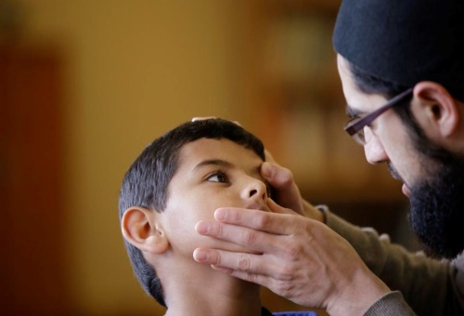**ARTICLE 5**

**Refugee mental health needs could overwhelm, experts fear**

[https://news.yahoo.com/refugee-mental-health-needs-could-overwhelm-experts-fear-061515314.html#](https://news.yahoo.com/refugee-mental-health-needs-could-overwhelm-experts-fear-061515314.html)

BOSTON (AP) — For the thousands of Syrian refugees expected to arrive in the U.S. in coming months, the first order of business will be securing the basics — health care, jobs, education and a safe home.

But what organizations helping resettle them might not be prepared for, and what refugees themselves might be in denial about, is the need to treat the mental scars of war, experts said.

Iham Al Horani, a 32-year-old refugee living in Worcester, Massachusetts, said he has had little time to think about his mental health in between months of job hunting and shuttling his mother, recovering from sniper gunfire, to doctor's appointments.

"It was difficult, what we came from," Al Horani said through a translator. "The living conditions in the refugee camp were bad. But at least we're all here."

Organizations that work with refugees said it's too early to assess the full scope of arrivals' mental health needs. But experts say it's important to keep tabs on the emotional state of new arrivals, since symptoms may not appear until months or years later — well after most resettlement support services have ended.



*In this Friday, Dec. 18, 2015, photo Syrian refugee Ahmad Alkhalaf, 9, sits on a prayer rug in a mosque*

The U.S. has taken about 2,500 Syrian refugees since the conflict there began in 2011, including about 100 in Massachusetts. The Obama administration expects to take in at least 10,000 in the federal fiscal year that began in October. Experts estimate 10 to 20 percent of incoming Syrians will have war-related psychological problems warranting treatment.

"They're in the honeymoon phase," said Richard Mollica, a psychiatry professor at Harvard Medical School who has spent decades working with torture and genocide victims. "In the first year, they're so happy to be out of that situation.

They feel something wonderful is going to happen in America.

"It's only about two years later or so when there's a mental health crisis," he said. "It's at that point that reality hits and they really need a lot of mental health care."

Ahmad Alkhalaf, a 9-year-old who arrived in the Boston area this past summer for medical treatment, said he used to have restless nights when he would relive his mother's screams from the night a bomb killed three of his siblings and left him without arms. But those sounds, he said, have largely faded.

"I'm fine," Ahmad said through a translator. "They're gone."



*In this Friday, Dec. 18, 2015, photo Syrian refugee Ahmad Alkhalaf, 9, leans up against his father*

Ahmad's father, Dirgam Alkhalaf, said he recently took his son to a counselor, who found nothing concerning. They don't plan to go back.

Ahmad Houssam Hallak, a 51-year-old Syrian recovering from an artillery attack that left him with speech and movement problems, said winning asylum last year hasn't eased his stress. He is working to bring over his wife and three children, who remain in Lebanon.

"They live in an unstable country," Hallak said through a translator. "It's a constant fear that I'm living in."

Such stresses — finding a job, adjusting to a new culture or dealing with life apart from family — can also contribute to mental health problems, said Bengt Arnetz, a professor at Michigan State University who has been studying trauma in Middle Eastern refugees.

Failure to address them could lead some refugees to withdraw from society, increasing the chances they'll be drawn to extremist groups, Arnetz warned.

Alexandra Weber, chief program officer at the International Institute of New England, an agency contracted by the U.S. government to resettle refugees, agreed mental health services can be improved. Many agencies, for example, don't have enough Arabic speakers, she said.

But, she said, agencies are increasingly asking refugees about their emotional state as part of initial health screenings — something not done in years past.

[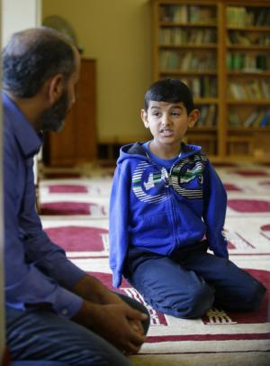](https://news.yahoo.com/photos/friday-dec-18-2015-photo-syrian-refugee-ahmad-photo-053758326.html)

*In this Friday, Dec. 18, 2015, photo Syrian refugee Ahmad Alkhalaf, 9, talks with his father Dirgam*

"For the first time in my career, I feel encouraged," Weber said. "In some ways, Syrians couldn't be coming at a better time."

A spokesman for the U.S. Department of Health and Human Services, which oversees the federal Office of Refugee Resettlement, declined to comment but pointed to general information on the office's website about federally funded programs for torture victims and its efforts at promoting "emotional wellness."

At the Arab Community Center for Economic and Social Services, a Detroit-area nonprofit, public health manager Madiha Tariq said she hopes the government will hurry to get refugees out of squalid, dangerous refugee camps and to the U.S.

"With the Syrian population, they've already been the victims of extreme trauma. They've also been in refugee camps for a long time," Tariq said. "So the longer that displacement is, the more work we'll have to do repairing the stress and damage."

* **Where does public health manager Madiha Tariq work?**
* **What is a common problem for many agencies trying to resettle refugees?**
* **What are some of the stresses that can contribute to mental health problems for refugees?**
* **How many Syrian refugees has the USA taken in since the conflict began in 2011?**

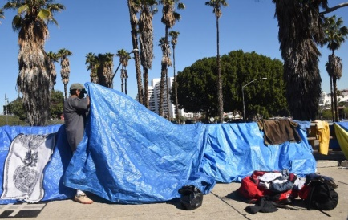**ARTICLE 6**

**Los Angeles passes $1.87 bn homeless plan**

*https://news.yahoo.com/los-angeles-passes-1-87-bn-homeless-plan-033053308.html*

Los Angeles (AFP) - Los Angeles, sometimes called the homeless capital of America, adopted a $1.87 billion plan Tuesday to help its 44,000 down-and-out people without homes.

The 10-year plan adopted by the city council, with the ambitious goal of ending LA's growing homelessness, includes hiring social workers, offering quality housing and building permanent housing.

In addition, Los Angeles County supervisors also agreed to release $100 million over several years ($42 million in the first 12 months) toward housing the homeless.

Homelessness is "the most serious humanitarian crisis confronting our county today," said county CEO Sachi Hamai.

Plans for funding the initiatives still must be adopted, with the city of Los Angeles scheduled to vote on its budget in April.

City Councilman Jose Huizar, who co-chairs the Homelessness and Poverty Committee, acknowledged that a series of past plans to reduce homelessness had failed.

[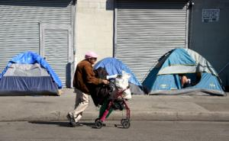](https://news.yahoo.com/photos/woman-pushes-her-walker-past-tents-housing-homeless-photo-033053637.html)

*A woman pushes her walker past tents housing the homeless in Los Angeles, California on February 9*

A woman pushes her walker past tents housing the homeless in Los Angeles, California on February 9

Between 2013 and 2015, the number of homeless in Los Angeles County soared by 12.4 percent, with the percent of those living in the street or in their car -- without access to emergency shelter -- soaring by 85 percent.

Of the 44,000 homeless people living in the county, some 29,000 or two-thirds, sleep in the streets, tents or their cars, according to a spokesman for the Los Angeles Homeless Services Authority.

The 2008-2009 economic crisis took a hefty toll on Californians, while housing inflation has drastically limited affordable options.

In addition, many homeless opt to live in Los Angeles due to its mild weather and social services, notably near Skid Row, where some 5,000 homeless live.

By comparison, the homeless population in New York, America's largest metropolis, is larger at 57,000 people, but 95 percent of them live in shelters or temporary housing funded by local authorities and the state.

Los Angeles County spends around $1 billion a year on medical, psychiatric and social welfare care for its homeless, not including police expenditures.

"A real bed is much less expensive than a jail bed or a hospital bed," Phil Ansell, director of the county's Homeless Initiative, told the Los Angeles City Council.

* **How much does Los Angeles County spend each year on medical and other help for the homeless?**
* **What years were the economic crisis that took such a large toll on the California economy?**
* **Who said “Homelessness is "the most serious humanitarian crisis confronting our county today,"**
* **How many people are homeless in Los Angeles County?**

*Articles used for this educational lesson come from:*

*https://www.yahoo.com/*