Second Dimension – Christianity Experienced
Segment III – “Strengthening Your Core” Progressive Bible Concepts - #30 “Responsible Faith”
Segment III – Strengthening Your Core (Concepts 25-32):
- Concept 25 – “Living By Faith”
- Concept 26 – “The Eyes of Faith”
- Concept 27 – “Little Faith”
- Concept 28 – “Increasing Your Faith”
- Concept 29 – “Proactive Faith”
- Concept 30 – “Responsible Faith”
Key Verse:
- “...the r_________________ man shall l______ by his f________…” Habakkuk 2:4

Summary – Concept 29:
- “Proactive Faith is distinguishing God’s responsibility from mine in the affairs of everyday life and then responding wisely.”
Point of Discussion:
- You are a counselor and a counselee comes to you and reports that he is angry at his boss. He relates that he always feels put down, and in spite of a satisfactory work performance, he never feels any appreciation. His attempts to speak with the boss are ignored and he has given up on having any meaningful interaction with him. This counselee is engaged to be married and needs a job.
How would you counsel this frustrated man?
Types of Determinism:
- Genetic – you i_________________ it -‘your grandparents did it to you’
- Psychic – you i________________________ it -‘your parents did it to you’
- Environmental – you i_____________ it - ‘your boss did it to you’

Case Study – Victor Frankl
- A Jewish prisoner in the Nazi concentration camps
Between Stimulus and Response
In answer to those questions, let me share with you the catalytic story of Viktor Frankl.
Frankl was a determinist raised in the traditional Freudian psychology, which postulates that whatever happens to you as a child shapes your character and personality and basically governs your whole life. The limits and parameters of your life are set, and, basically, you can’t do much about it.
Frankl was also a psychiatrist and a Jew. He was imprisoned in the death camps of Nazi Germany, where he experienced things that were so repugnant to our sense of decency that we shudder to even repeat them.
His parents, his brother, and his wife died in the camps or were sent to the gas ovens. Except for his sister, his entire family perished. Frankl himself suffered torture and innumerable indignities, never knowing from one moment to the next if his path would lead to the ovens or if he would be among the “saved” who would remove the bodies or shovel out the ashes of those so fated.
One day, naked and alone in a small room, he began to become aware of what he later called “the last of the human freedoms” – the freedom his Nazi captors could not take away. They could control his entire environment, they could do what they wanted to his body, but Viktor
Frankl himself was a self-aware being who could look as an observer at his very involvement. His basic identity was intact. He could decide within himself how all of this was going to affect him. Between what happened to him, or the stimulus, and his response to it, was his freedom or power to choose that response.
In the midst of his experiences, Frankl would project himself into different circumstances, such as lecturing to his students after his release from the death camps. He would describe himself in the classroom, in his mind’s eye, and give his students the lessons he was learning during his very torture.
Through a series of such disciplines – mental, emotional, and moral, principally using memory and imagination – he exercised his small, embryonic freedom until it grew larger and larger, until he had more freedom that his Nazi captors. They had more liberty, more options to choose from in their environment; but he had more freedom, more internal power to exercise his options. He became an inspiration to those around him, even to some of the guards. He helped others find meaning in their suffering and dignity in their prison existence.
In the midst of the most degrading circumstances imaginable, Frankl used the human endowment of self-awareness to discover a fundamental principle about the nature of man: Between stimulus and response, man has the freedom to choose.

Vocabulary
- Event – a life c______________________
- Response – how you f_______ about that event
- Evaluation – how you i__________________ the event
- Mind – reservoir of b____________ about life
- Old man – old sin nature – f________
- New Man – new redeemed nature – s__________
- Heart – seat of being which contains our life i____________________ from which we choose our life d_________________ – see Proverbs 4:11
- Self – our primary r_________________ point for life
- Faith – the m________ that shifts our primary reference point to God
HOW FAITH LIBERATES

Verses:
- “ So this I say, and affirm together with the Lord, that you walk no longer just as the Gentiles also walk, in the f______________ of their mind, being d______________ in their understanding, excluded from the life of God because of the i_________________ that is in them, because of the hardness of their heart; and they, having become callous, have given themselves over to sensuality for the practice of every kind of impurity with greediness.”
- “But you did not learn Christ in this way, if indeed you have heard Him and have been taught in Him, just as truth is in Jesus, that, in reference to your former manner of life, you l____ a________ the old self, which is being corrupted in accordance with the lusts of deceit, and that you be r____________ in the spirit of your m______, and p____ o__ the new self, which in the likeness of God has been created in righteousness and holiness of the truth.” Eph 4:17-24
- “Do not be conformed to this world but be transformed by the r______________ of your mind…” Rom 12:2
- “Count it a____ j____ when you encounter various trials, knowing that the testing of your faith produces endurance.” James 1:2,3
- “Love your e____________/p______ for those who persecute you…” Matt 5:44
- “Who shall separate us from the love of Christ? Shall tribulation, or distress, or persecution, or famine, or nakedness, or peril, or sword? But in all these things we o__________________________ c____________ through Him who loved us.” Rom 8:35,37
Examples:
- “Now I want you to know, brethren, that my c__________________________ have turned out for the greater p______________ of the g__________, so that my i________________________ in the cause of Christ has become well known throughout the whole praetorian guard and to everyone else, and that most of the brethren, trusting in the Lord because of my imprisonment, have far more courage to speak the word of God without fear. Some, to be sure, are preaching Christ even from envy and strife, but some also from good will; the latter do it out of love, knowing that I am appointed for the defense of the gospel;” Phil 1:12-16
- “When they had struck them with many blows, they threw them into prison, commanding the jailer to guard them securely; and he, having received such a command, threw them into the inner prison and fastened their feet in the stocks. But about midnight Paul and Silas were praying and singing h________ of p__________ to God, and the prisoners were listening to them…” Acts 16:23-25
- A pastor once asked a congregant, “So how are you?” The man replied, “Well, under the circumstances…” The pastor said, “Well, what are you doing u________ t________…?”

Quotes:
- “Between event/stimulus and response, man has the f____________ to c__________.” Stephen Covey
- “He is most powerful who has power over h_____________ .” ~ Seneca
- “The fountain of contentment must spring up in the mind, and he who has so little knowledge of human nature as to seek happiness by changing anything but his own d______________________, will w________ his life in fruitless efforts and multiply the grief he proposes to r__________.” Samuel Johnson
“Gut Check”:
- To what degree are you responsible for your reactions to life?
- The bible states that man is a r_____________________ m________ agent. Rom 14:12
- Responsibility – ‘r______________-a____________’ – the ability to choose your response.
- Empowered, proactive people recognize this and live their lives making choices based upon t________ through faith, not f______________.
- Faith is the game changer when it comes to attitude. It enables a person to e______________ events from God’s perspective, and then with God’s help, choose to r____________ in a godly way.
Principles:
- Concentrate first on your r______________, not the circumstances, asking God’s help by faith to see thru His eyes.
- By concentrating on your response, you gradually e__________ your circle of control. In other words you begin to affect the circumstances around you proactively. Example: I Peter 3:1, 2 – believing wives winning unbelieving husbands.
- By concentrating on b________, we get out from under the tyranny of h__________…
  - If I had a little more money – Let me be c____________
  - If I had more obedient kids – Let me be more p____________
  - If I had an understanding spouse – Let me be u__________________________
  - If I just had more time – Let me learn to be in the m__________
- Be the c__________ you want to see in o__________.

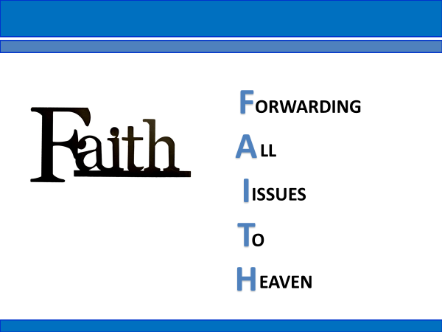

Summary – Concept 30
- “Responsible faith is exercising the empowerment God has given me to respond to the circumstances of everyday life in an overcoming way that honors Him, blesses me, enables me to be a blessing to others.”
Next Week – Concept 31 – “Faith that Works”

