From: Rick Howard
To: IELTS Prep Group
Subj: IELTS Lesson 02-17-2016

- Lesson Objective
  - The student shall be able to use “power words” as part of their oral vocabulary, read and comprehend business language and demonstrate effective oral communication skills

- Power Words

Evaluation Criteria
- Ability to understand the definition of the word and how to use in context within a complex statement/sentence

Regional  http://dictionary.reference.com/browse/regional?s=t | Revived  http://dictionary.reference.com/browse/revived?s=t | Advocate  http://dictionary.reference.com/browse/advocate?s=t
Reaping  http://dictionary.reference.com/browse/reaping?s=t | Resettlement  http://dictionary.reference.com/browse/resettlement?s=t | Repellant  http://dictionary.reference.com/browse/repellant?s=t
Resolved  http://dictionary.reference.com/browse/resolved?s=t | Strain  http://dictionary.reference.com/browse/strain?s=t | Cognitive  http://dictionary.reference.com/browse/cognitive?s=t
All definitions provided through http://dictionary.reference.com
- Reading

Evaluation Criteria
- Ability to read, with clear pronunciation, and comprehend the meaning of the paragraph. Student will be asked several questions to validate their comprehension of the reading material

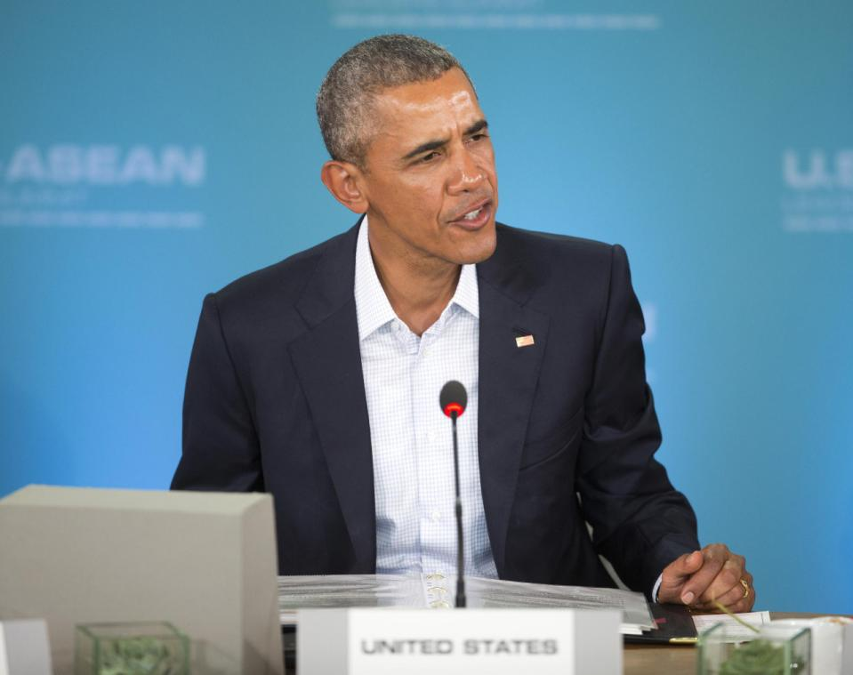
- Obama welcomes Southeast Asian leaders to US for talks
http://news.yahoo.com/obama-welcome-southeast-asian-leaders-184110965.html

RANCHO MIRAGE, Calif. (AP) — President Barack Obama opened a meeting of leaders from a 10-nation bloc of Southeast Asian nations on Monday, calling the landmark gathering on U.S. soil a reflection of his personal commitment to an enduring partnership with the diverse group of countries.

Obama and leaders of the Association of Southeast Asian Nations will spend two days discussing economic and regional security issues.
In brief remarks as the leaders sat around a horseshoe-shaped table, Obama said he became familiar with Southeast Asia as a boy living in Indonesia with his mother. Since becoming president, Obama has made numerous trips to Asia-Pacific countries as part of his policy "pivot" toward the region, with the goal of reassuring allies unnerved by China's assertive presence there while also reaping economic gains for the U.S.

"You and the people of ASEAN have always shown me extraordinary hospitality and I hope we can reciprocate with the warmth today and tomorrow, which is why I did not hold this summit in Washington," Obama said.

"It is cold there. It's snowing, so welcome to beautiful, warm Sunnylands," he said. Sunnylands is the storied California desert estate where the leaders will conduct their talks at a conference center with picturesque views of the snow-capped San Jacinto Mountains.
Underscoring the relaxed atmosphere, all leaders wore open-collar shirts with their suits.

View gallery
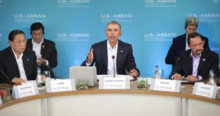

President Barack Obama, center, speaks at the plenary session meeting of ASEAN, the 10-nation Association

It's the first time the leaders of Indonesia, Malaysia, the Philippines, Singapore, Thailand, Brunei, Vietnam, Laos, Myanmar and Cambodia have held a stand-alone meeting in the U.S. China is not an ASEAN member, but its territorial claims over disputed waters have raised international concerns and heightened tensions with some member countries.

Obama said trade between the U.S. and ASEAN had increased 55 percent since he took office. The region is now the U.S.'s fourth-largest goods trade partner. U.S. companies are also the largest source of foreign investment in its member nations, he said.

Obama said he wants to build on that progress "so that growth and development is sustainable and inclusive and benefits all people."
Monday's talks will focus on the economy. After a working dinner, the conversation on Tuesday, the summit's final day, shifts to regional security issues, including the South China Sea and counterterrorism.

China says it has a historical right to virtually all of the South China Sea and has built seven artificial islands, including with airstrips, to assert its sovereignty. Taiwan and ASEAN members Brunei, Malaysia, Vietnam and the Philippines also claim land features in these potentially resource-rich waters, which are an important conduit for world trade.

View gallery
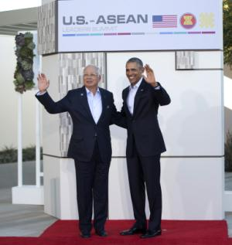

President Barack Obama right, stands with Malaysia's prime minister, Najib Razak, left, at the ranch.

Though not a claimant, the U.S. has spoken out against China's conduct and has angered Beijing by sailing Navy ships near some of the artificial islands. The U.S. has argued for the maritime rights issue to be resolved peacefully and is looking for ASEAN to take a unified stance by calling for the disputes to be resolved based on international law. ASEAN has avoided criticizing China by name in joint statements issued at past summits.

The Trans-Pacific Partnership free-trade agreement among the U.S., ASEAN members Brunei, Malaysia, Singapore and Vietnam, and seven other nations, will likely be discussed. The pact is Obama's signature trade achievement, one he has sought to sell to skeptical lawmakers as a chance for the U.S. to shape the region's trade rules, not China. Congress, however, must ratify the deal and that outcome remains in doubt.

Terrorism inspired by the Islamic State group is of increasing concern in the region. Eight people were killed during assaults last month in Indonesia's capital, Jakarta, the first major attack there in six years. Police said the attackers were linked to IS.

Singapore, Malaysia and Indonesia, the world's most populous Muslim nation, have all reported citizens traveling to fight in Iraq and Syria, and several small militant groups in the Philippines have pledged allegiance to IS.

Obama also plans to raise issues of good governance and adherence to the rule of law.

View gallery
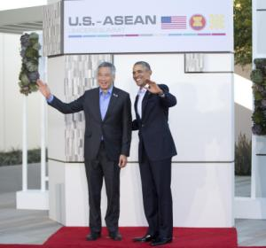

President Barack Obama stands with the Singapore prime minister, Lee Hsien Loong, left, at a meeting.

Human rights advocates have faulted the U.S. for inviting unelected leaders, like Thai Prime Minister Prayuth Chan-ocha, who seized power in a May 2014 coup. Cambodia's Hun Sen, who has used violence and intimidation against political opponents, made his first official U.S. visit during his 31-year tenure as prime minister.

Questions
- What is the world’s most populous Muslim nation?
- Which 4 ASEAN countries are part of the Trans Pacific Partnership Trade Agreement?
- How many countries are in ASEAN?
- How much has trade increased in the past 7 years (since Obama took office) between US and ASEAN?

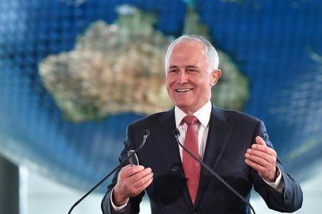
- Australian PM leaves door open to sending refugees to New Zealand
http://news.yahoo.com/australian-pm-leaves-door-open-sending-refugees-zealand-063401122.html

SYDNEY (Reuters) - Australian Prime Minister Malcolm Turnbull on Wednesday left open the possibility of resettlement in New Zealand for asylum seekers facing repatriation to a detention camp in the tiny Pacific Island nation of Nauru.

New Zealand Prime Minister John Key arrives in Australia on Thursday for talks that may revive an offer by Key to accept some asylum seekers now in Australia, providing Turnbull a way out of a growing political headache.
Key reached a deal in 2013 with former Australian Prime Minister Julia Gillard to resettle 150 refugees then in Australia as part of New Zealand's annual humanitarian intake of 750 refugees.

But Turnbull's predecessor, Tony Abbott, had declined to follow up on Key's offer.
"John Key will be here tomorrow," Turnbull told reporters in Brisbane. "He is a very good friend of Australia. We will be talking about these issues together, but I don’t want to foreshadow any changes to our policy."

Australia's tough immigration policies provide that anyone intercepted while trying to reach the country by boat is sent for processing to camps in Nauru and Papua New Guinea's Manus Island. They are never eligible to be resettled in Australia.

Australia's High Court this month rejected a legal test case that challenged its right to deport 267 refugee children and their families who had been brought from Nauru, about 3,000 km (1,800 miles) northeast of Australia, for medical treatment.

The detention center, which houses more than 500 people, has drawn widespread criticism for harsh conditions and reports of systemic child abuse.

The number of asylum seekers trying to reach Australia is small in comparison with those arriving in Europe, but border security is a hot-button political issue in Australia, which is scheduled to hold a national election later in the year.

The New Zealand offer still stands, Key told reporters on Monday, ahead of his first visit to Australia since Turnbull ousted Abbott in a party coup last September.
"If they wanted us to take people then - subject to them meeting the criteria - the New Zealand government would be obliged to do that, because we’ve given that commitment that we’d do so," Fairfax quoted Key as saying.

Abbott had campaigned relentlessly on securing Australia's borders and argued that resettling refugees in New Zealand would spur people smugglers to resume attempts to reach Australia.

Turnbull is under pressure to tackle the Nauru repatriation issue amid criticism from rights groups, the United Nations and medical bodies, including the British medical journal, the Lancet, which slammed the policy in an editorial last week.
Australia says the policies are necessary to stop asylum seekers drowning aboard the unseaworthy vessels used by people smugglers to ship them from Indonesia to Australia

Questions
- What is a hot-button political issue in Australia?
- Is the problem of asylum seekers in Australia larger or smaller than the EU?
- How many asylum seekers does New Zealand take each year?

- More grandparents become caregivers for grandkids. Is that good?
http://news.yahoo.com/more-grandparents-become-caregivers-grandkids-good-235851931.html

More grandparents are becoming caregivers to their grandchildren – an ongoing trend that underscores how America's approach to child care is putting increasing stress on families dealing with a variety of trends, from substance abuse to two-parent working families, experts say.

Census data show that about 2.7 million grandparents in the United States are the primary caregiver for children in their household, up 7 percent from 2009. The figures are part of a new Associated Press report.

While grandparents and other relatives have long played the role of caregiver in many American families, that role has grown more pronounced among the working and middle classes since the Great Recession. Long, irregular working hours for young parents, coupled with the rising costs of professional child care, also transformed grandparents from occasional baby-sitters into a critical safety net for parents with young children.

The situation is characteristic of America's approach to child care – leaving the responsibilities of raising children to parents. But as those responsibilities become more complicated, it is inevitable that many parents will need to turn to the only reliable and cost-effective they can find – their families.

“We don’t have a culture that thinks about children as a national responsibility," says Kathy Simons, an early childhood specialist and senior program manager at the Massachusetts Institute of Technology’s Work-Life Center. "I do think people still think of kids as the responsibility of their direct relations.”

To some, that is as it should be.
"A strong case can be made that parents deserve tax relief to ease the financial strain associated with raising the next generation," writes Carrie Lukas, managing director of the Independent Women's Forum, in an opinion article for The Federalist. "But focusing that support solely on those who use formal daycare programs would be unfair to the millions of parents who have different preferences for their families."

For her part, Dr. Simons worries about the effect that is having on American families.

“We’re expecting families to do too much,” she says. “Child care is a really complicated thing. You don’t solve it once, you solve it six times a month – you have a regular arrangement, a backup arrangement, you have sick days, you have something for trips. You need a bunch of different kinds of arrangements.
Grandparents have increasingly filled many of those roles. In 2008, about 40 percent of grandparents who had grandchildren under age 13 and lived within an hour from them reported providing child care while parents were at work or school, according to the National Association of Child Care Resource & Referral Agencies. Of those, nearly two-thirds said they had grandchildren under 6 years old.

“Child care is expensive, and it’s often not available, especially for lower-income families,” says Elizabeth Peters, director of the Center on Labor, Human Services, and Population at the Urban Institute in Washington. “Often the mother, father, both parents, are working non-standard hours. That’s the advantage of having a grandparent who may be able to provide care during hours when a more formal system is not available.”

There’s also a growing contingent of grandparents who – due to a host of issues, including the growing number of parents struggling with substance abuse or parents away on military deployment – not only provide part-time child care, but are actively raising their grandchildren.

That’s “a whole different ball game,” says Amy Goyer, a family and caregiving expert with the AARP, a national nonprofit that focuses on improving the quality of life of people age 50 and older. “This usually happens when there’s a crisis or chronic problem in the family. There are usually grief and loss issues, [or] the kids have some kind of instability in their life.”

Such situations could have long-term negative impacts on children, families, and society at large, Dr. Peters says. A lack of affordable child care disproportionately affects women’s participation in the labor force – especially among women living at or below the poverty line, she notes.

Research also shows stable environments are critical in early childhood.
“The kind of care we provide our kids can help them develop the early skills and learning that can put them on the right track,” Peters says. “That’s very important, especially for kids coming from disadvantaged backgrounds.”

Initiatives do exist at the state and federal levels, she says. The Department of Health and Human Service’s Head Start program has for decades sought to foster stable family environments for children from low-income homes. Child care subsidies and tax credits also work towards the same goal, Peters says.
Still, some industry experts and advocates say more needs to be done. Simons at MIT, for instance, says enlisting seniors in child care beyond their own grandchildren might be helpful as a way of providing supplementary care that could also be fulfilling for the elderly.

“If we could develop new models for engaging seniors in early education and care; and if the work also got them learning, and kept them mentally active and engaged with other people, that would be fabulous,” she says.

But she and others also would like to see child care made a national priority.
“There are lots of good reasons why family are the best caregivers, but parents should not be forced to rely on grandparents and relatives because they can’t afford any other options,” says Vivien Labaton, co-founder and co-executive director of the Make It Work campaign, a three-year initiative that seeks to improve conditions for working families. “We need to value caregiving in this country.”

Adds Simon: “Grandparents have a really important place to fill in that. But a reliable system of nationally-supported child care has to be a big part of the solution, and we’re a long way from that.”

Questions
- What organization has sought to foster stable family environments for children from low-income homes.
- What is one of the benefits with engaging seniors into child care?
- How does a lack of affordable child care impact women?
- How many grandparents are the primary caregiver for their children?

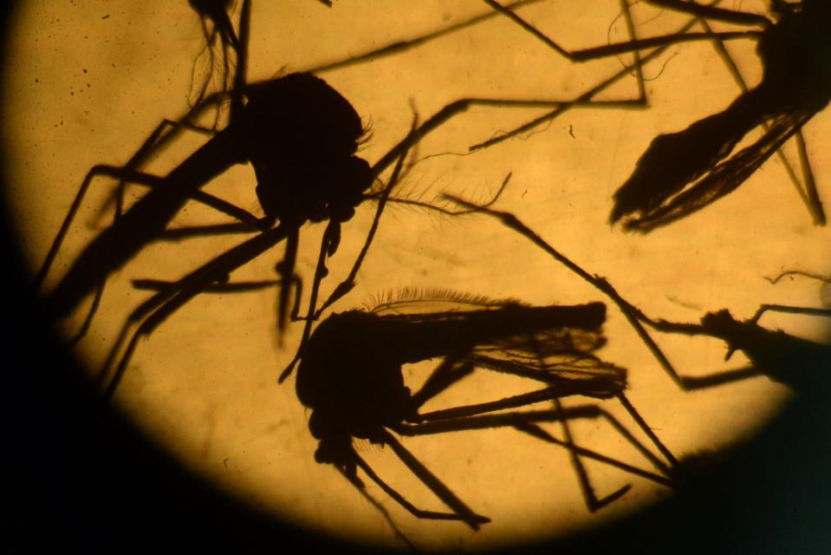
- 6 Things Every Traveler Should Know About the Zika Virus
http://news.yahoo.com/6-things-every-traveler-know-zika-virus-162012998.html

If there's one thing we know about travelers, it's that they have a lot on their minds. And who can blame them? From terrorist attacks to travel warnings in popular vacation destinations across the globe, there's plenty to cause concern for the wanderlust crowd among us.

Sadly, the Zika virus is merely the latest alarm bell for travelers. If you're wondering whether it's a smart idea to modify your plans in light of recent outbreaks, here's what you need to know.

What are the latest developments?
The White House has requested $1.8 billion in emergency funding from Congress to combat the virus. A Reuters/lpsos poll released on Feb. 8 found that 41 percent of travelers say they're less likely to travel to Latin America and the Caribbean. And according to the poll, two-thirds of Americans have now heard of the virus, up from 45 percent in January.

Most of the concern surrounds pregnant women and birth defects. Brazil's eastern coast is ground zero for the virus, where officials say this year there have been 3,500 reported cases of microcephaly, a condition where babies are born with impaired brain development. That's up from 100 to 200 cases per year before the return of the virus last May. Zika first appeared in Uganda in 1947, but has largely been seen as a minor virus found in Africa and Asia. It was thought to have been eradicated until the recent outbreak of the mosquito-transmitted disease.

What countries are currently at risk?
The virus is spreading largely around warm-weather climates in Latin America and the Caribbean. The virus is carried by Aedes mosquitos, which tend to bite more frequently during the daytime. There is also some research that the virus can be spread through saliva or sexual activity, but for now, the main threat comes from being bit by a mosquito carrying the virus.

The 2014 World Cup in Brazil is thought to have been a major cause of the reappearance, as millions of fans worldwide descended on Brazil for the games. For this reason, there is a widespread concern that the Rio 2016 Summer Olympic Games could have the same impact (though Olympics organizers downplay the threat, pointing out that city workers are destroying breeding grounds and that the cool August temperatures will keep mosquitos away).

Beyond Brazil, there are more than 30 reported cases of Zika thus far in the U.S., all from travelers who returned from visits to infected countries. There are two kinds of Aedes mosquitos that could pose a risk to U.S. residents: the yellow fever Aedes and the Asian tiger Aedes. Researchers believe that Hawaii, Florida and destinations along the Gulf Coast are the only U.S. locales warm enough for the yellow-fever Aedes mosquito to thrive though the Zika-transmitting mosquitos have been found as far north as Washington, D.C. in extremely hot weather. Asian tiger mosquitos have also been found in northern cities, such as New York City and Chicago, in the summer.

That hasn't stopped the Centers for Disease Control and Prevention's command center from declaring a Level 1 alert -- a status they have only reached three times: the Ebola outbreak in West Africa in 2014, the H1N1 flu crisis in 2009 and after Hurricane Katrina in 2005. The action not only raises attention for prevention of the virus spreading to the U.S. but also the need for resources to combat the spread of the virus.

What are the latest travel advisories?
Pregnant travelers are being advised to avoid travel to the Caribbean and Latin America region, where Zika is currently most prevalent. If you're pregnant and you've traveled to a country where Zika virus has been present in the past three months, the CDC recommends that you consult your doctor. If you've had a fever, rash, joint pain or blood shot eyes within two weeks after returning from traveling to an affected country, your doctor will run a blood test for the virus.

What are key symptoms of the virus?
In 80 percent of people infected, symptoms never show. But in the worst-case scenario, it's going to feel like the flu. According to health officials, symptoms will usually show between the third and seventh day the virus is in your body. Most people infected recover within seven days as the immune system clears the virus.

How can you prevent contracting the virus while traveling?
There is currently no treatment or vaccine against Zika. Researchers are confident they can develop a vaccine by the end of the summer, but for now, the best way to protect yourself is to carry mosquito nets and insect repellant with you if you are traveling to an infected country.

Should you cancel your trip?
A February survey conducted by the Travel Leaders Group, a heavyweight in the travel agent industry, showed that 93 percent of travel agents said they have had no cancelations from clients ages 60 and up. And when it comes to millennials, 74 percent of agents said they had no cancelations with travelers in their 20s and 30s.
"Armed with the facts, most travelers are opting to travel even as they heed expert advice for avoiding mosquito bites," said Nina Chacko, chief executive for the Travel Leaders Group.

Outside of mosquito protection, your best defense as a traveler is to purchase travel insurance. Policies usually run no more than $200 and can protect you against any calamity you may incur during travels, including illness.
If you've purchased a trip to affected countries and are too nervous to travel, most airlines --including Delta Air Lines, United Airlines and American Airlines -- are offering full refunds to fliers who booked flights to impacted countries.

The bottom line: If you're pregnant, avoid travel to Brazil and all impacted countries (the CDC is constantly updating that list here). For other destinations across Latin America and the Caribbean, the Zika threat is no more than any other peril that travelers face. Take precautions, but enjoy your trip.

Questions
- What Airlines are offering full refunds to fliers who booked flights to impacted countries?
- Is there a vaccine or treatment for Zika disease?
- What insect is responsible for transmitting this disease?
- Can it be sexually transmitted?
- What kind of travelers are being warned against traveling to Caribbean and Latin America region?
- What can happen to babies born to a woman carrying the virus?

Dogs can read human emotions
https://news.yahoo.com/dogs-read-human-emotions-115037348.html

Many dog owners believe their pets are able to pick up on their moods, but scientists have demonstrated once and for all that man's best friend can actually recognize emotions in humans.

Researchers found that by combining information from different senses dogs form abstract mental representations of positive and negative emotional states in people.
Previous studies have shown that dogs can differentiate between human emotions from signs such as facial expressions. But this is not the same as emotional recognition, according to Dr Kun Guo, from the University of Lincoln's School of Psychology.

"This is the first empirical experiment that will show dogs can integrate visual and oratory inputs to understand or differentiate human emotion as dog emotion," Kun told Reuters.

Experiments were carried out by a team of animal behavior experts and psychologists at the University of Lincoln, UK, and University of Sao Paulo, Brazil.

They presented 17 untrained domestic dogs with images and sounds conveying either positive or negative emotional expressions in humans and dogs.
The dogs used in the testing were unfamiliar with the procedure; avoiding any chance of conditioning. The vocalization sound accompanying the human faces was also unfamiliar.

"We used Portuguese to British dogs so they weren't habituated with any words, they weren't familiar with any words. So, we wanted to see if the dogs could assess the emotional content of the human voices and whether they would actually discriminate the emotional information within them," explained Natalia De Souza Albuquerque, a PhD student in experimental psychology.
The results, published recently in the Royal Society Journal Biology Letters, found that dogs spent significantly longer looking at the facial expressions which matched the emotional state of the vocalization, for both human and canine subjects.
View photo
.
Image conveying positive and negative emotional expressions in humans and dogs used in a study on canine cognition.

"What we found is that when dogs were hearing positive sounds they would look longer to positive faces, both human and dog. And when they were listening to negative sounds they would look longer to negative, angry faces," added De Souza Albuquerque.

The study shows that dogs can integrate two different sources of sensory information into a perception of emotion in both humans and dogs. This means dogs must have a system of internal categorization of emotional states. Among animal groups, it's a cognitive ability previously only evidenced in primates.
The researchers believe that the ability to combine emotional cues may be inherent to dogs. As a highly social species, detecting emotions in humans would have helped them in their domestication by people over the generations.

Dr Kun Guo now wants to conduct more experiments in a bid to better understand how man's canine companions decipher human emotions. "(So) we can see whether dogs can use a human-like principle or human-like strategy to perceive, understand and respond to human emotion," he said.

"If we can understand this, surely we can understand dogs better."

Questions:
- How many different sensory sources can a dog integrate?
- The teams at University of Lincoln, UK, and University of Sao Paulo, Brazil consisted of what kind of experts?
- How many dogs were used for the experimentation by the team?
- Dogs can integrate visual and _______ input?

Articles used for this educational lesson come from:
https://www.yahoo.com/

