Species Translocations to Motuihe (to August 2015)
Year | Taxa | Number released | Habitat requirements | Photo | Outcome
2005 | N.I Saddleback (At Risk) | 25 | Forest/shrubland | 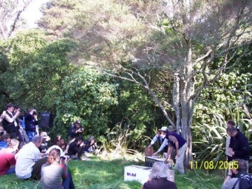 | Established, population increasing, genetic top-up desirable
2008 | Red-crowned kakariki (At Risk) | 35 | Forest, shrublands and grasslands | 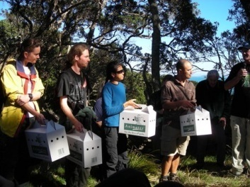 | Established, breeding confirmed, population increasing
2009 | Shore skink (Not threatened) | 60 | Coastal dunelands | 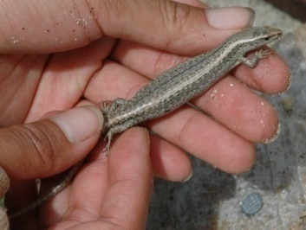 | Established, breeding and range expansion confirmed, population expected to be increasing
 | Little spotted kiwi (Nationally endangered) | 14 | Forest and shrublands and rank grassland | 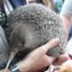 | Established - breeding confirmed, top-up desirable
2010 | Little spotted kiwi (Nationally endangered) | 26 | Forest and shrublands and rank grassland |  | Established - breeding confirmed, top-up desirable
 | N.I bellbird (Not threatened) | 50 | Forest and shrublands | 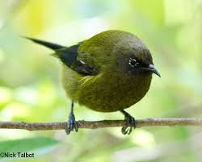 | Failed but individuals present and likely to re-establish from Motutapu/Rangitoto/Rakino pops
2012 | Tuatara (At Risk) | 60 | Coastal forest and shrublands | 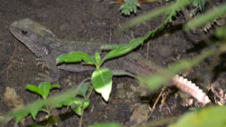 | Still present, no evidence of breeding to date, monitoring ongoing
 | Whitehead (Not threatened) | 40 | Forest and shrubland and cliff habitats |  | Established, breeding confirmed, population increasing
2013 | Common gecko (Not threatened) | 60 | Coastal forest and shrubland and cliff habitats |  | Established, breeding confirmed, range expanded, population increasing, monitoring ongoing
2014 | Duvaucel's gecko (At Risk) | 88 | Forest |  | Unkown, no individuals detected since release, first monitoring scheduled for December 2015
 | Pacific Gecko (At Risk) | 54i | Coastal forest and shrubland |  | Unkown, no individuals detected since release, first monitoring scheduled for December 2015

Some plants that are rare or were no longer present on the island have also been re-introduced. These include kauri (seeds in swamp show was present in the past), pingao and spinefix planted around coast (2010) and shore spurge planted around coast (2012).
Acknowledgement: material provided by Matt Barber of Tonkin and Taylor

