EMPLOYMENT Research Symposium

Jobs and Skills Mismatch: Job-rich Growth for Sustainable Development
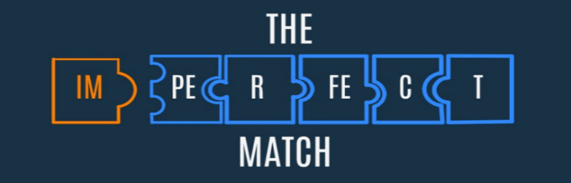

SYMPOSIUM REGISTRATION FORM

Please fill in the form electronically and return by e-mail: jobssymposium2017@ilo.org
(Please note the information provided will be used on your badge and list of participants)

Date: 27-28 November 2017
Place: ILO Geneva, Switzerland

Participant’s information

Family name: Click here to enter text.
First name: Click here to enter text.
Title – Prof. Dr. / Mr. Ms. Mrs. Click here to enter text. Other: Click here to enter text.
Organization: Click here to enter text.
Position: Click here to enter text.
Address: Click here to enter text.
Postal Code: Click here to enter text. City: Click here to enter text.
Country: Click here to enter text.
Telephone: Click here to enter text. E-mail: Click here to enter text.

I will participate in the evening welcome reception (Monday, 27 November 2017)
Yes ☐ No ☐

Date: _____/ _____/ _____/ Signature: ___________________________

