TASK – DESCRIBING PRODUCTS AND SERVICES & PRESENTATION
SAMPLE
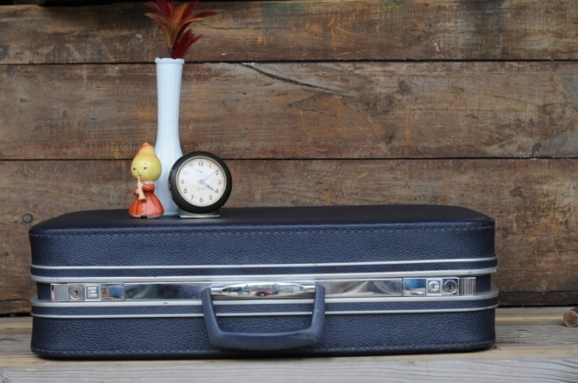
Ladies and gentlemen, this new type of suitcase is average-sized, rectangular and made of leather. It has a name near the handle. That’s the name of our brand. It is made in Italy. It is used to keep your documents when you go travelling. You can choose the colour; black, blue, or brown. Nowadays, brown is very popular in Indonesia.

TASK
- Find a product or a service of a company (from newspaper, magazine, television, internet, etc.). You are the marketing manager.
- Describe how you will promote your product or service.
- Submit your assignment at the last meeting for Presentation subject.

