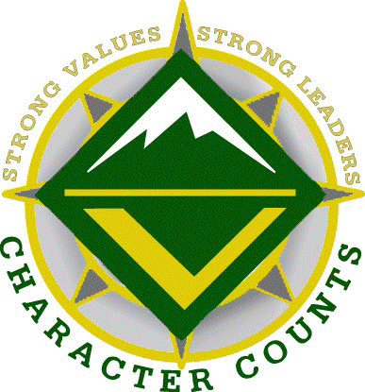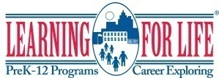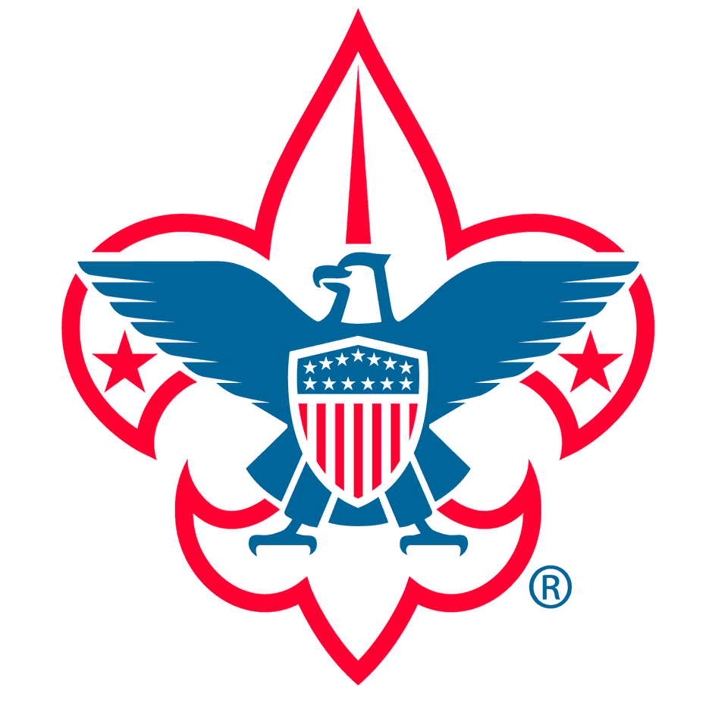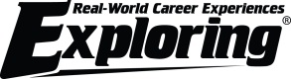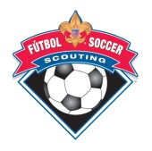

BSA Media Consent Release

Name:_______________________ School/Program:_________________________
I hereby consent to the participation in interviews, the use of quotes, and the taking of photographs, movies or video tapes of the participant named above.
I also grant to the right to edit, use, and reuse said products for non-profit purposes including use in print, on the internet, and all other forms of media. I also hereby release the Boy Scouts of America and its agents and employees from all claims, demands, and liabilities whatsoever in connection with the above.

Signature: _________________________ Date: ______

Address:

________________________________________________________________________

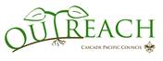

Cascade Pacific Council
2145 SW Naito Parkway Portland, OR 97201
Phone (503)225-5740 Fax (503) 225-5717

