Using Tabroom.com for the
National Speech & Debate Association
District Tournament Process

2018-2019

Table of Contents
Setting Up Your District Tournament 3
Completing your District Dates Form 3
Tournament Setup 12
Setting up the schedule 21
Setting up rooms for competition 24
Setting up judge categories 28
Configuring event settings 35
Running Your District Tournament 45
Sectioning Debate 46
Sectioning Speech 56
Entering Ballots 60
Determining Qualifiers 64
Reporting results 65
Appendix A: Further Resources 66
National Speech & Debate Association Manual 66
Tabroom.com Manual 66
Tabroom.com Support 66
Appendix B: Running Debate Pilot Rules 67
Appendix C: Running Speech Pilot Rules 72
Appendix D: Enabling Diversity Enhancing Judging 75

Setting Up Your District Tournament

Completing your District Dates Form
As an NSDA district chair, you’ll be using Tabroom.com for district tournament registration, tabulation, and reporting results. The Tabroom.com team is striving to help your tournament run efficiently and simplify your reporting of qualifiers to the NSDA National Tournament. During setup, and while running your tournament, you should consult this document for guidance. More help and documentation regarding Tabroom.com is available at docs.Tabroom.com.
Before beginning to set up your district tournament, make sure you can log into Tabroom by pointing your browser to https://www.Tabroom.com, then clicking “Login” near the top of the page.

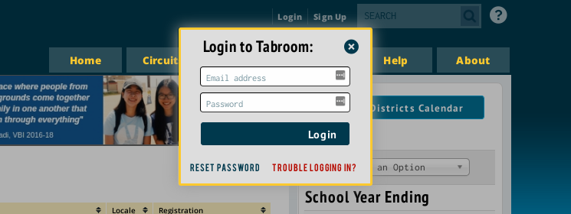
Enter your email address and password and click “Login”. If you’re having trouble logging in, use the “Trouble Logging In?” link located at the bottom of the form. If you still cannot log in, please use the “Reset Password” link and check your email for a customized link to reset your password.

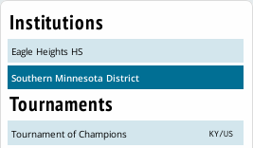
You will be taken to your “Tabroom homepage” after successfully logging in. Your account will be connected to your NSDA district, and you should see your district located in the right sidebar of the homepage. You may click that link to see your district’s NSDA profile in Tabroom and begin the process of creating your district tournament.
After clicking into your districts details page, you can click “Create District Tournament”.
This will begin the process of creating your district tournament records in the Tabroom.com system. Any information you cannot provide at this time can be entered later; it is not imperative that all fields be filled on the first pass.
All district tournament information must be complete and finalized by November 30 if all of your tournament series will be held in the next calendar year. If any part of your tournament series starts in the current year, finalized info must be entered by October 31.

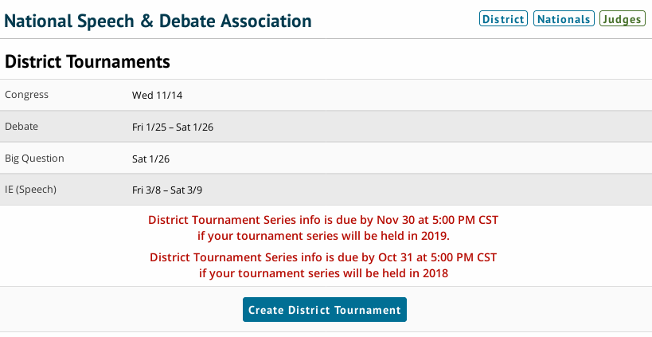

After selecting a timezone, you’ll need to enter the Dates and Weekends of your district tournament.
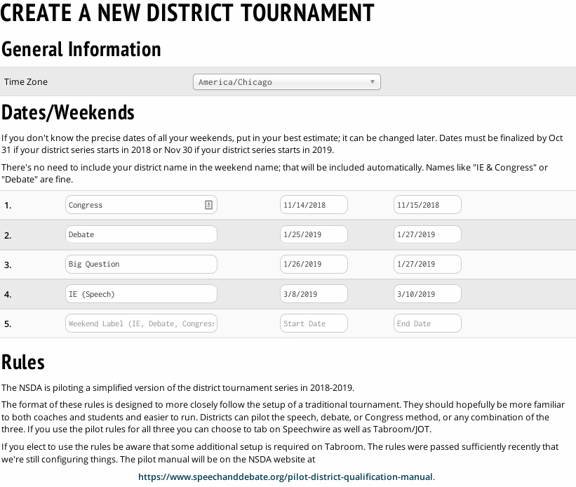
Weekends are a representation in Tabroom of which weekend you’ll be using to host which events. Naming these something like “Debate” or “Speech” will help you set up events next.

If you are using the pilot rules as explained on this page, please see the specific documentation for PILOT RULES.

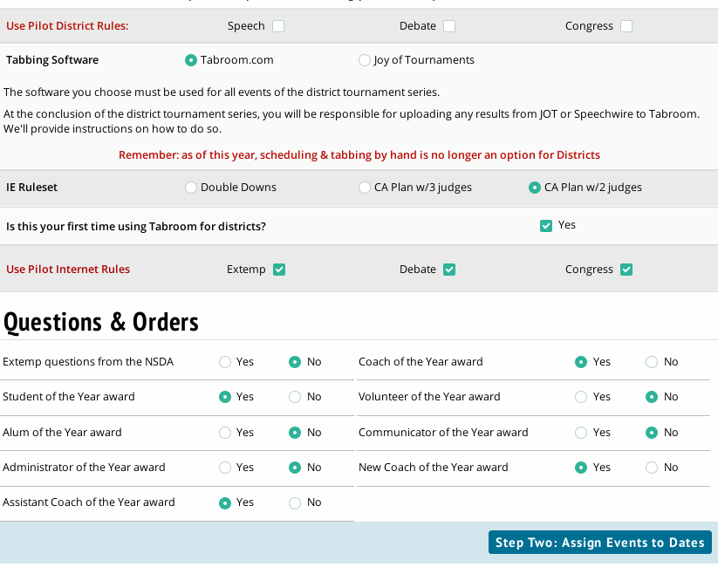
Please select Tabroom.com if you’re using Tabroom for registration and tabulation. Select Joy of Tournaments or Speechwire if you will be tabulating on those softwares. Documentation for non-Tabroom district tournaments can be found at speechanddebate.org/membership

If you need to order resources for your district tournament from the NSDA National Office, you can communicate that through the Questions & Orders section of this page.

Click the “Step Two: Assign Events to Dates” link when you’re done.

On the Events schedule page, you will assign which events will take place on which weekend of your district tournament.
If your district tournament does not offer an event, mark it as “Not Offered”.
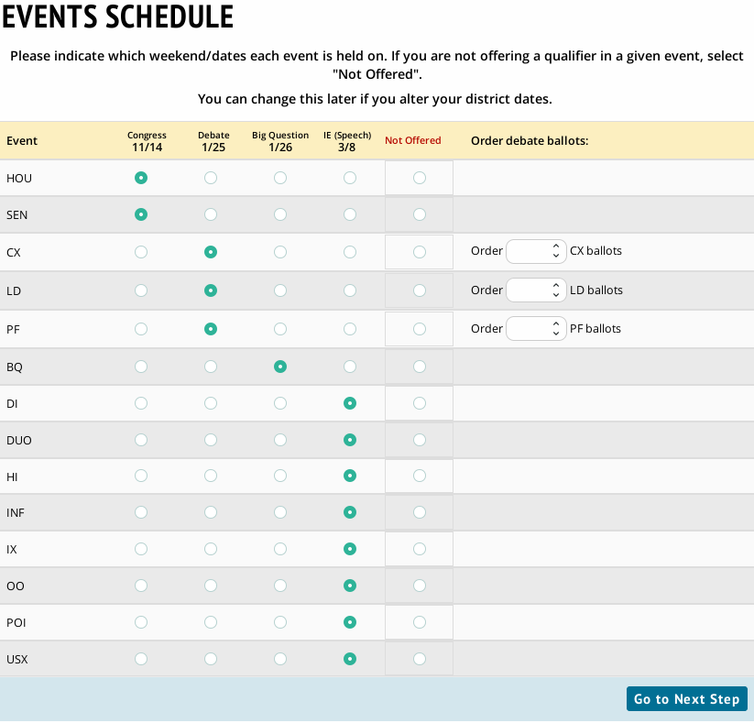
If your district tournament will need to order debate ballots from the National Office, please indicate the desired count of each on this page and we will get them shipped to your tournament location before your debate weekend.

During the next step, you’ll assign specific dates and deadlines for your weekends.
If your site (school at which the tournament will be held) has been used in other tournaments on Tabroom (eg. invitationals), select it from the Host Site and we’ll import your rooms into the tournament to prevent you from re-entering them. If no correct options appear, please enter a new site name.
All date options can be edited, so if you’re unsure of specific registration information, you can use your best available information.
Each weekend will have a Details and a Dates & deadlines section, please do fill out all of them.
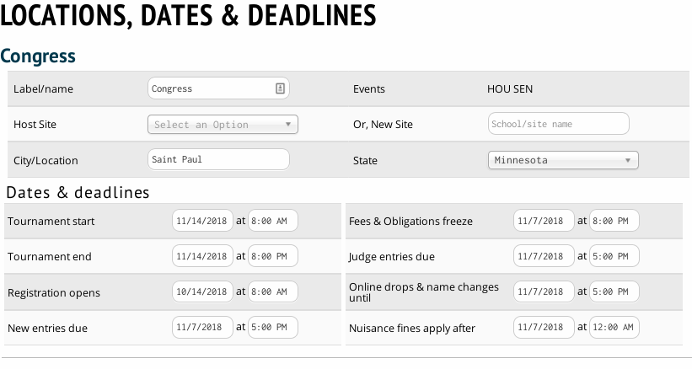
When you’re done, click on “Go to Final Step”.

The final step is our national districts survey. Please take a moment to complete all the questions.
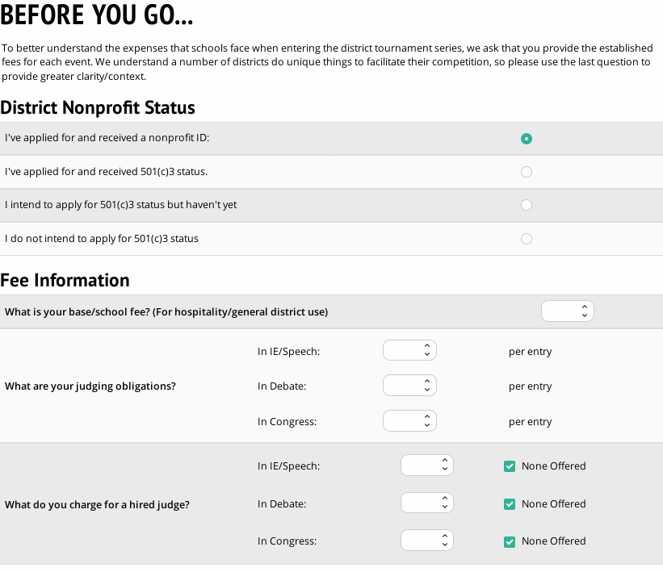
Judging obligations are recorded here as “Judges owed per entry”.

Entry fees entered on the bottom of the survey form will be copied to your tournament for registration and invoicing for registering schools.

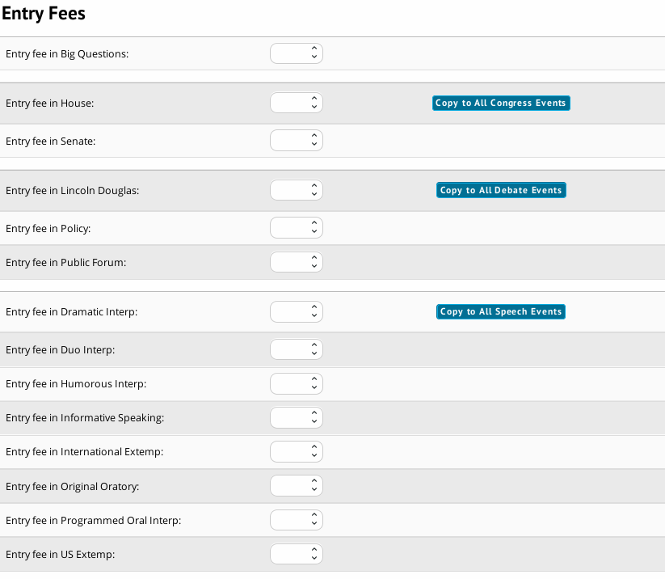

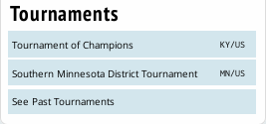
When you’ve finished the survey, you can click on the blue “Finish” button at the bottom of the form. Your district members are now able to register for your district tournament.
This will finalize the creation process of your tournament and return you to your Tabroom homepage. Under “Tournaments” in the right sidebar, you will now see your district tournament.

Tournament Setup
When you are ready to continue the setup of your tournament, click on your district tournament in the tournament list pictured in the previous section.
You'll be taken to the list of schools whose directors have already registered for the district tournament.
Clicking on a school in that list will take you to the school detail page.
A few other school related options, such as adding a new school or viewing school statistics are found under the "Data" or "Reports" menu options and will be mentioned below.
To access a school's page, you select it from one of the dropdown menus under the Schools menu option:
The Judges and Money tabs will appear in red if a school is under their judging obligations or if they owe judge fees.
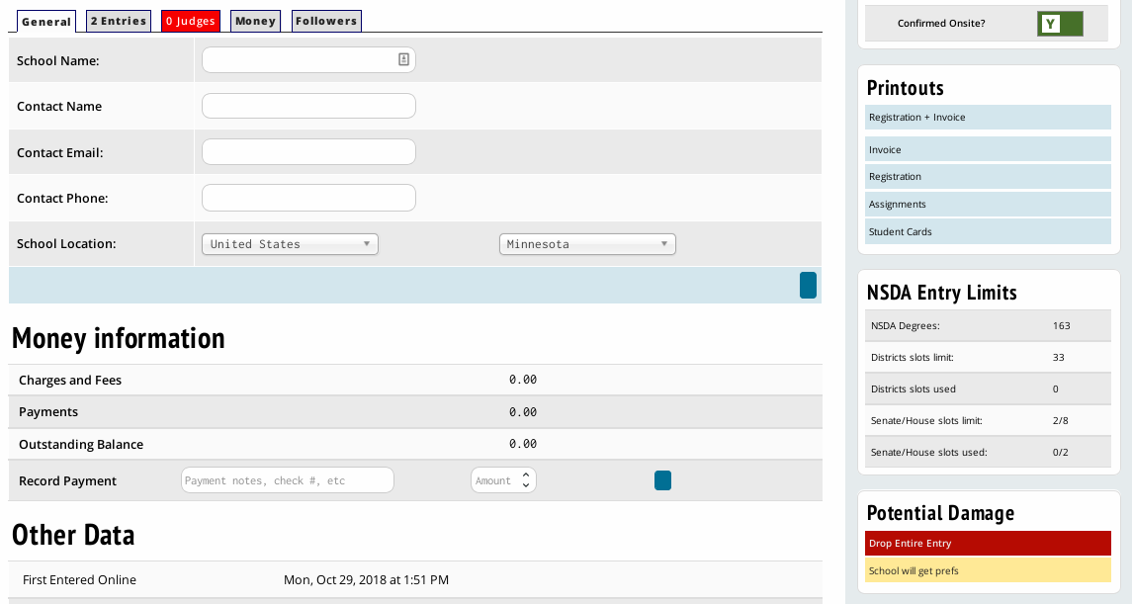
After accessing a school through the Entries - Schools menu, the "General" tab of a school's page lets you edit their basic information, such as name, code, and contact information. You can also enter how much they've paid.

The "Entries" tab of a school's page will first show you the school's complete entry roster.
To access any individual entry, just click on their name or code. You can also Drop or Undrop an entry.
To see only entries in a particular event, click the name of the event on the right (the number is the current number of entries from the school in that event).
Once you have selected an event, you can manually add an entry from the right sidebar. You can also use the “Check NSDA Eligibility” page to determine eligibility for any potential competitor from a school.
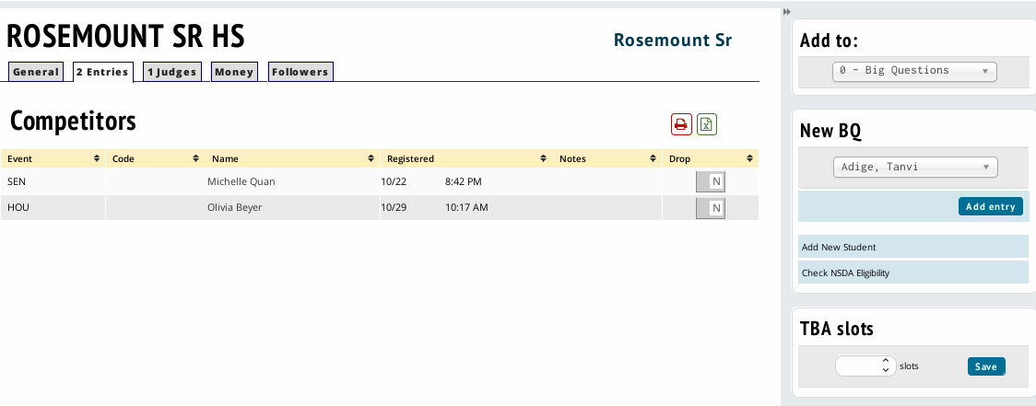

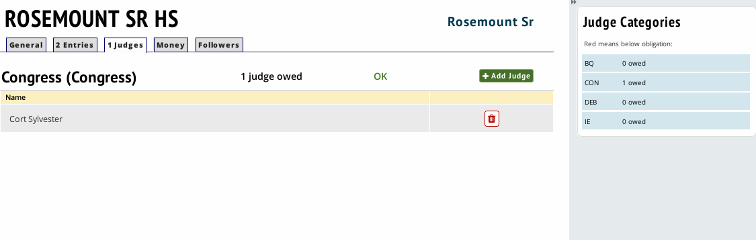
Once you select the "Judges" tab of a school's page, you must then select which judge category to view. If the school is below their obligation in a judge category, it will appear in red.
For each judge category, you will see a list of currently entered judges, with options to edit their values or delete them.
You can also add a new judge to the school using the box on the right, after clicking on a judge category.

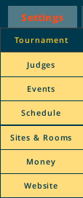
To continue your tournament’s setup process, click on Settings, then Tournament.
You’ll be taken to the Name & Location information screen.
On this page, you can upload your district tournament invitation for other coaches to download and post your Congress Legislation.
Some settings information will be reflected from choices you made during your survey setup at the beginning of this guide.

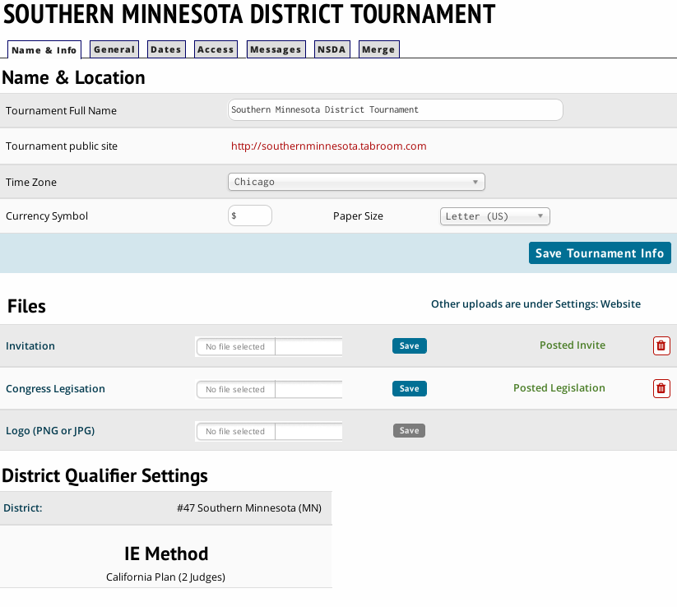
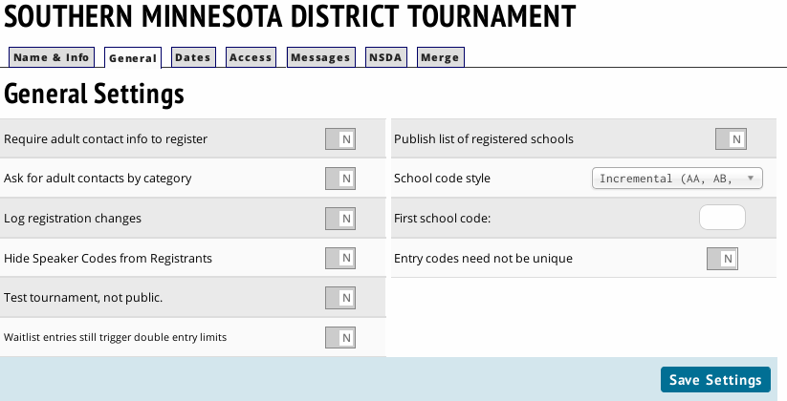
The General settings page will allow you to make some changes, including School Code Style. You may change this value to reflect your district’s preferred posting format for schools.
There are several other flags that change the behavior of your tournament that can be changed on this page.

The dates tab will allow you to edit the date values for your tournament, weekend by weekend, and reassign events to different weekends.
Clicking on the tabs for existing weekends will allow you to update that weekends registration dates and deadlines. If you need to add another weekend, click on the “New Dates” tab and enter your new weekend information there.
You can change which weekend Tabroom is programmed to run a specific event on in the “Event Schedule” section in the right sidebar.
You will not need to delete a weekend, simply reassign the events out of the undesired weekend.
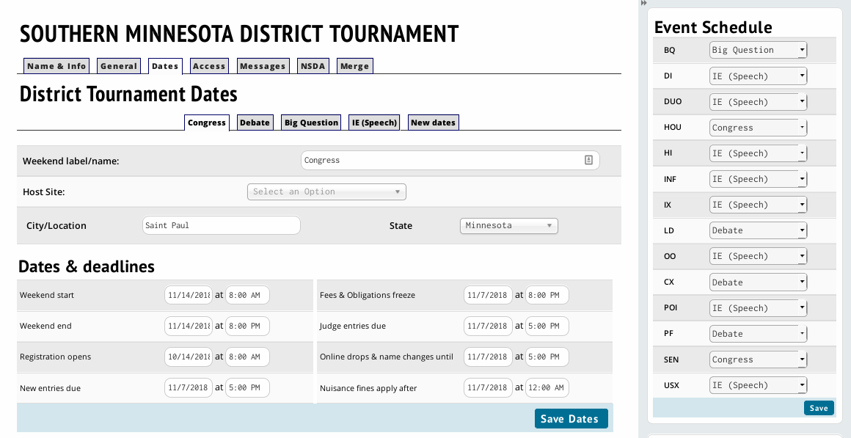
Please note that you MUST contact the National Office by emailing info@speechanddebate.org every time you make a date change or reassign events to weekends.

On the “Access” tab, you may manipulate which users have access to your district tournament.
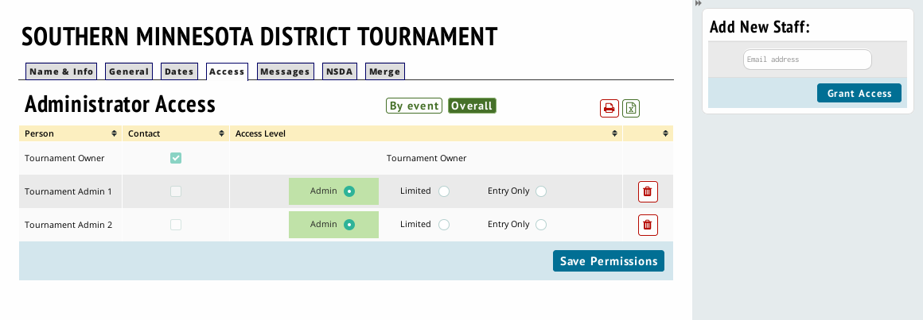
You can add new tournament staff to your tournament by adding their email address in the “Add New Staff” field in the right sidebar, and clicking “Grant Access”. Tournament staff must have a Tabroom.com account to be added. You can have as many tournament staff with access to the tournament as you want.
For each person, you can toggle whether they are listed in public tournament information as a contact and whether they have access to the tournament setup. If you have tournament staff who only need to be able to enter data, such as recording ballots or rounds started, but don't want them to have full administrative access to the tournament, you can select “Entry Only” for their access level.

The Messages tab lets you include information that will appear on invoices (such as a mailing address for checks, or other pertinent payment info), as well as a disclaimer that will appear before allowing schools to register (such as a policy regarding student supervision). The disclaimer provided by the NSDA should not be edited.

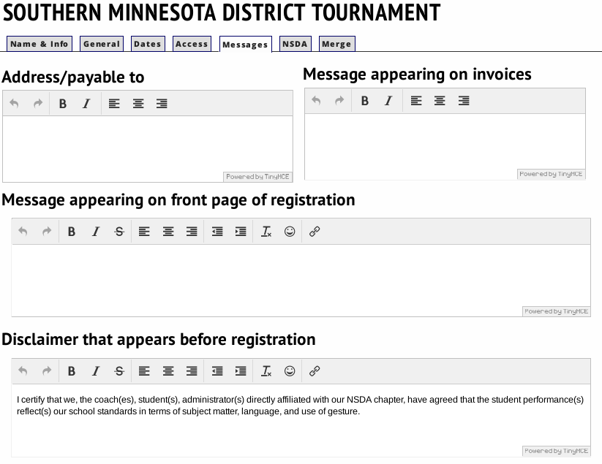

The NSDA tab is specific to NSDA District Tournaments, and allows you to edit your District Orders and displays a list of your National Office Staff contacts that should be contacted, in order, if you have rules or procedures questions during your tournament. NSDA staff member Michael Stroud can be contacted at michael.stroud@speechanddebate.org with any Tabroom.com questions during your event.

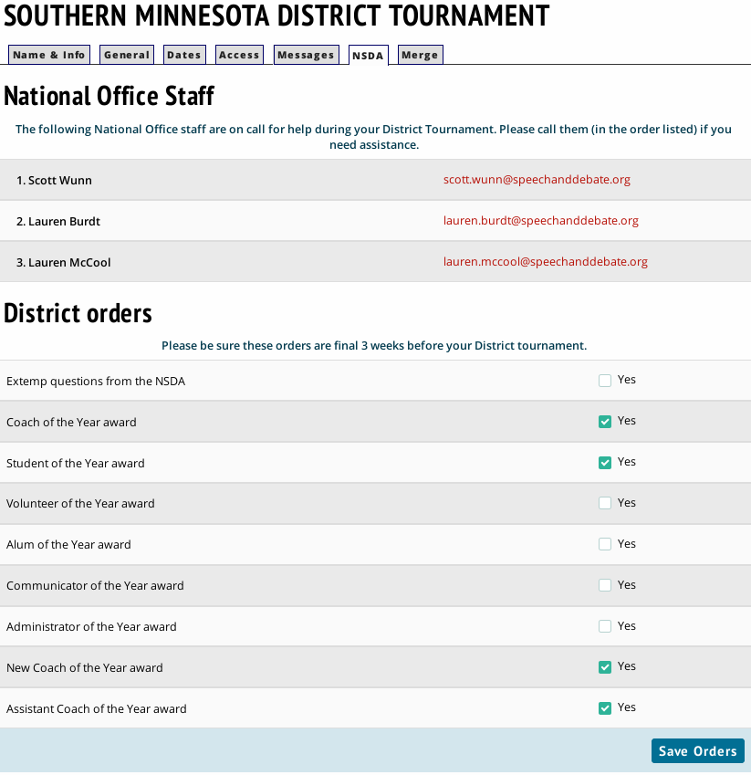

There should be no use for the merge function on a district tournament.

Setting up the schedule
The Schedule menu is where you configure timeslots and assign rounds from each event to a spot on the schedule. This is also where you would typically configure settings for each round, such as which tiebreaker set to use or what powermatching method to use. For districts, a lot of these options are already done for you to make sure you are in compliance with NSDA rules!
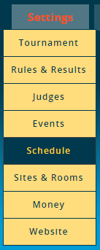
Many of the most common issues people have when running a tournament on Tabroom are the result of improperly configuring the Schedule - it's worth double checking several times that you have set all the options for each round correctly before proceeding to pairing the first round.
Tabroom divides up your schedule into "Timeslots" rather than Rounds. Each timeslot can then have one or more rounds (from one or more events) assigned to it. Different timeslots can also overlap, for example, if you had different events running at different sites that started at different overlapping times.
You can also have multiple timeslots with identical start/end times but different names for different events if it helps you keep things straight. You could have one timeslot from 8-10AM with both PF and LD scheduled, or one 8-10 timeslot for PF and another identical timeslot for LD.
Usually, it helps to have a distinct timeslot for each round of each event, even if there's overlap. That way, you can make changes to a single event's schedule on the fly without affecting any other event.
California Plan specific option: The system will by default only take you through the minimum necessary number of prelims given your entry numbers for each event. However, many district tournaments choose to conduct additional prelim rounds, especially in the case where all events then have the same number of prelims. To extend to more prelims, go to Settings > Events, click on the Sectioning tab after choosing an IE event, and then change the value under “Minimum number of prelims”. If you put 4 in, an event only required to section 3 prelims will nonetheless section 4 prelims before advancing to a semi or a final.

The first step in creating timeslots is to choose a day from the sidebar.
You can then create a timeslot by giving it a name, choosing a start and end time, and clicking “Add”. Once you have configured timeslots, you will see them in a list, where you can make changes or delete them if you made a mistake.
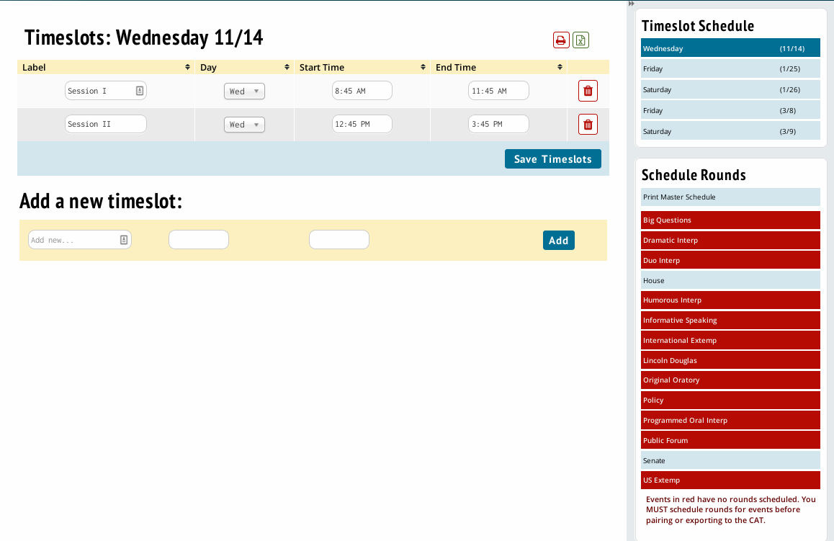
We encourage you to create all of your timeslots before you proceed to scheduling rounds. Ensure the end time of one timeslot is not set to the identical time as the start time for the following time block. Consider the following scenario:
You have a "NO Round 1" part time judge block scheduled from 8-10AM
You then have two timeslots on the schedule: Round 1 - 8-10AM, Round 2 - 10AM-12PM
If a judge is marked as "NO Round 1" from 8-10, they will also not be scheduled for Round 2, because they are listed as "unavailable" at exactly 10AM, which is the start time of Round 2.
Instead, you should configure your timeslots like this: Round 1 - 8-945AM Round 2 - 10AM-11:45AM
And, configure your "NO Round 1" part time block from 8-945AM to match.
That way, a judge who is marked as "NO Round 1" will be available at 10AM and could be scheduled for Round 2.

Once you have created your timeslots, you need to schedule rounds. First, select an event from the sidebar; they will appear in red if no rounds have been scheduled.
To schedule a round, check the box next to the appropriate time slot. If you’re running double elimination method (speech or debate) or the California Plan, you only need to schedule round 1. The system will march you through the creation of future rounds one by one as they are created, and they will choose the appropriate settings depending on the type of tournament you are running.
You have the option of assigning a Label to each debate. This is most useful for elimination rounds, that way you will see things labeled "Finals" instead of "Round 13." For prelim rounds with a number, such as Round 1 or Round 2, a label will not be necessary.
Depending on the event type, you may also have the option of selecting a judge sub-pool or whether to flight the round. If you have multiple Sites configured, you will also have the option of choosing one.
Remember to set up timeslots for each different day of the tournament.
The tiebreaks available in the Tiebreaks dropdowns are set correctly by the NSDA, and you will not need to edit them. They should all be set as Prelim/Preset.
Set round type to the appropriate kind for type of round:
Prelim/Preset - Round will be pre-paired before the start of the tournament, either randomly or using a set of tournament-entered seeds
Elim - Round is an elimination round. Make sure you also choose the correct tiebreaker set for the elims.
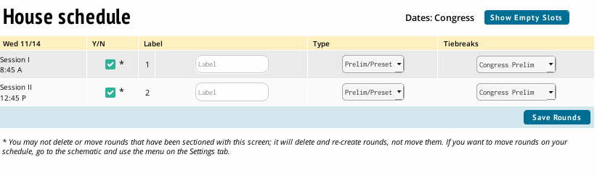
Final - Should be used for the final round in each event. These can be overridden in case you need to create further rounds to determine a qualifier.

Setting up rooms for competition
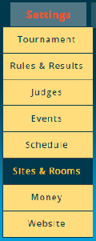
Now that Tabroom knows what times and dates your district competition rounds will occur, it will need to be told where to schedule those rounds to take place.
On Tabroom, a "Site" is a grouping of all the rooms at one tournament location, such as a campus or hotel. Odds are, you'll only need one "site," even if you use multiple buildings. You only need to create multiple sites if your tournament will be spread over completely different locations (such as two separate high schools). Configuring your weekends in the previous setup with the appropriate site information will ensure competitions during your programmed weekends are pulling from the correct site. [Once a Site has been set up, it is reusable from year to year - so if you run a tournament on the same campus every year, you won't have to re-enter all the same rooms over and over.]
Clicking Settings, then Sites & Rooms will begin this process. Sites you have already linked to your tournament will appear in a dropdown menu in the right sidebar of the page.
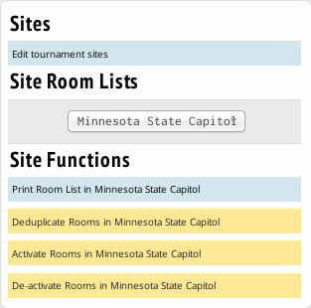
If you need to make adjustments to your tournament site(s) you can click the Edit tournament sites link.
If you’re using more than one site, make sure any edits are happening to the correct site by checking the dropdown menu.

You can add new rooms by clicking the “Add New” tab, then fill out a name for each room. You don't need to fill out every blank link. Each time you Press "Save New Rooms", you'll be given additional lines for more rooms.
Optionally, you can include a number for Quality and Capacity, and any notes about the room, e.g. "Air conditioning broken."
"Quality" is any number greater than zero, where 1 is the "best" room(s), and is open-ended. Ties are allowed. So, for example, you could make all your largest rooms in the best building a 1, decent rooms in a different building a 2, and the basement rooms you only want to use if necessary all a 3. You can have as many "tiers" as you want. When trying to auto-assign rooms, Tabroom will use all the rooms with a better "quality" rating first, then move on to the next highest number, until it finishes or runs out of rooms.
Once you have entered rooms, you can edit their information on the "Edit Rooms" tab.

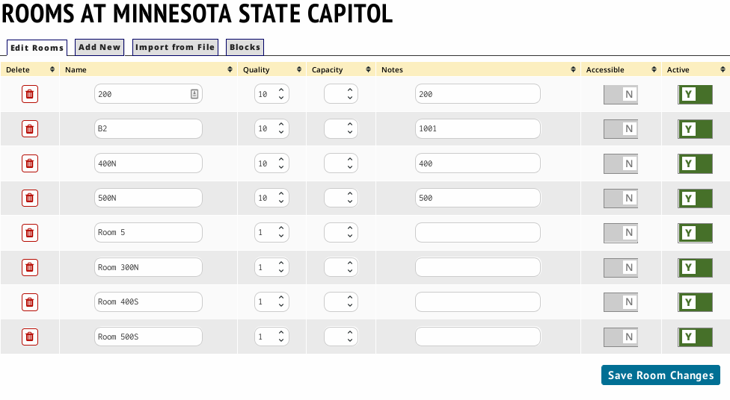
You can also mark a room as "Accessible," and toggle whether the room is active or not. Inactive rooms will not be used when assigning rooms to rounds.
Make sure to "Save Room Changes" at the bottom after making any edits.

A "Room Pool" is a subset of rooms at a site that are used by one or more event. This is helpful to avoid accidentally double-scheduling a room and for keeping events in the same set of rooms throughout the tournament instead of moving around at random.
Consider creating a separate room pool for each event.
To create a room pool, click Paneling, then Rooms, then Pools. In the "Create Room Pool" field on the sidebar and then give it a name, and click Go.
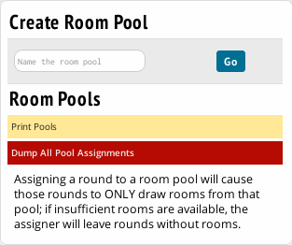
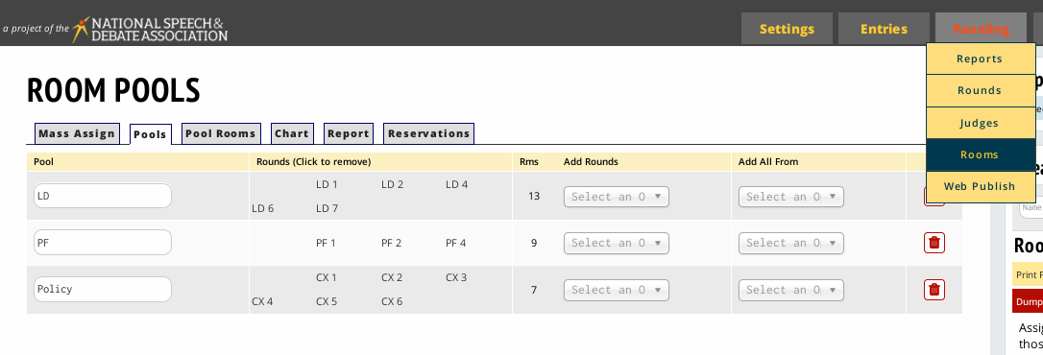
You can then click on the “Pool Rooms” tab, and select your room pool from the right sidebar under “Room Pools”.
Before you add any rooms to your pool, all rooms in the site (the “Pull from” value) will be listed in the “available” column. Clicking on a row in the available column will move that room to the “In Pool” column. Clicking on a room in the “In Pool” column will move it out of the pool and back to “Available”. Rooms highlighted in red are inactive. Once your “In Pool” column has all the rooms you want to be in the pool, you can add rounds that will draw on the pool.
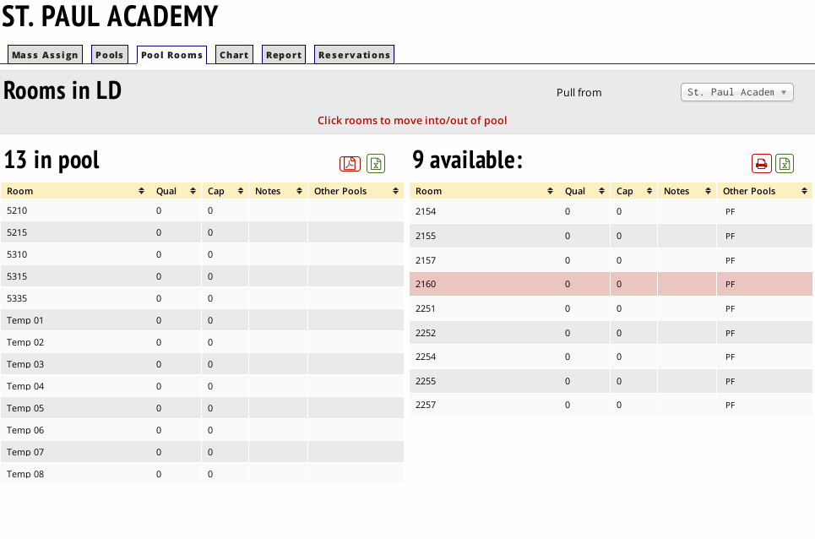
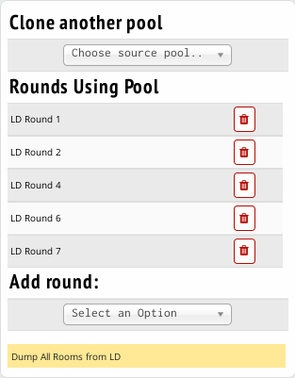

In the right sidebar, there is an “Add Round” dropdown menu where you can select a round (eg. LD Round 1), which will assign the pool to that round. When pairing the round, the Tabroom scheduler will only draw from the list of rooms “In Pool”. Pools can be assigned to multiple rounds, and rounds can draw on multiple pools (although the latter is less common).
On the “Pools” tab, you can assign rounds using your pools, and also use the “Add All From” option.

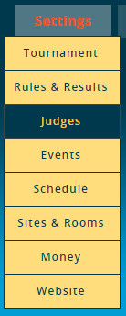
Setting up judge categories
A "Judge Category" (or “Judge Group”) is a collection of judges which can be used in one or more events or divisions. Every event must be in one and only one judge category. For example, you might have a category of judges that can judge either the novice or open divisions of policy, a second judge category exclusively for Congress judges, and a third category of judges which could judge any other IE event.
It may seem odd to set up your judge categories before setting up your events. However, a single category of judges may be used across multiple events, but a single event will only ever pull from a single judge category.
Note that a judge category is different than a judge pool - judge pools are used to draw from a specific subset of judges in the larger judge category - for example, only the judges that are still obligated for the semi-finals. Judge Pools are set up according to almost exactly the same logic as room pools, detailed in the Rooms for Competition section of this document.
Your judge categories will already be created for you, according to weekend. You may create additional judge categories as needed.
To create a Judge category, click the "Add New Judge Category" link in the sidebar. After filling out the information shown below on the "Register" tab, click "Save Registration Settings." Previously created judge categories will appear in the sidebar.
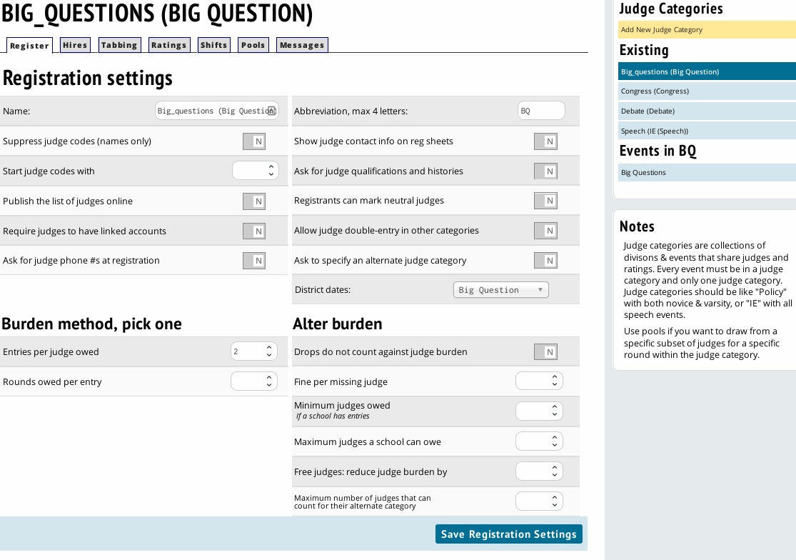
District Dates – This allows you to select which dates you will use this judging category.
Start judge codes with - Lets you set a prefix for the judge codes in this category, like "POL" for policy judges, so that you would have judges codes like "POL356" or "LD229" instead of just numbers.
Ask for judge phone #s at registration - When checked, registering schools will be asked to provide phone numbers for their judges. This can make it much easier for the tournament to get in touch with judges when they go missing, forget to turn in a ballot, etc.
Ask for judge qualifications and histories - This option will ask registering schools to provide a short description of each judge's qualifications and judging history. Note that this is separate from and in addition to the normal judge paradigms.

Abbreviation, max 3 letters: - This abbreviation will be used in various places throughout Tabroom to make things easier to read and make printouts align better, etc. It's recommended you set an abbreviation for each judge category.
Registrants can mark first year outs - When checked, registering schools will be given the option of marking a judge as a "first year out," i.e. that it's their first year judging. You can then use other options in the Judge category and Event settings to make first-year judges free strikes, prevent them from seeing certain events/divisions, etc.
Registrants can mark neutral judges - Registering schools will be able to mark judges they enter as "neutral," which means that they are allowed to judge their own school's entries. This can be useful when schools bring judges to the tournament who aren't actually affiliated with their program and do no coaching, so would not normally be considered "constrained" from judging that school.
Allow judge double-entry - This lets schools enter judges in multiple events. You should only enable this option if you're sure about what you're doing and that your schedule contains no overlap - otherwise it's very easy to find yourself with double-scheduled judges that can't actually be in two places at once.
Ask to specify an alternate category - This will ask the registering school to provide an "alternate" category for the judge, so that you can move judges into their "second choice" judge category if necessary, for example to even out judge numbers between events.

Prevent back to back rounds - Stops a judge from receiving a ballot in consecutive rounds. In tight judge pools or when using MPJ, you probably want to leave this unchecked.
Judges can get the same event twice - For judge groups with multiple events (such as one judge group for all IE's), this option will let a judge see multiple rounds in the same event.
Allow panels w/same school judges - For rounds with more than one judge (e.g. elims or paneled IE rounds), this will allow more than one judge from the same school on the panel.
Use diversity tracking - This will allow judges to self identify as "Diverse," and then will attempt to place more "diverse" judges.

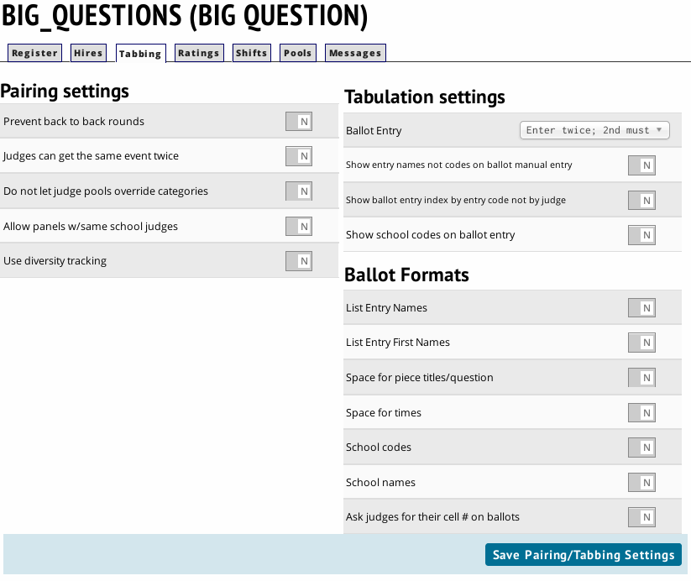
Tabulation Settings is where you configure options for how ballots are entered for events in this judge group.
Ballot Entry Method - Choose which method to use for confirming/double-checking ballot entry. Your choices are:
- "Enter twice; 2nd must match" - each ballot must be entered twice before showing as complete (preferably by two different people, to prevent mistakes).
- "Visual scan with confirmation" - After entering a ballot, you will be shown a review of your entered data and asked to confirm it.
- "Live dangerously; no required double-check - This option will mark a ballot as completed after a single entry, though you can still double-enter them if you wish, and will be notified of any mismatch.

The Shifts tab is how you configure time blocks that coaches can mark judges as unavailable for, or that judges can self-register for. For example, some tournaments have a large number of judges who can only come on one day of the tournament, so it helps to let coaches mark someone as "Unavailable Friday."
Note that you can always manually add a "Time Strike" for a judge in Entries - Judges, which will also prevent them from being scheduled for a round during that period. The Shifts tab is used to allow registering schools to do this themselves, and optionally to charge them if they are under their judging commitment during a time block.
To create a new shift, add a Name, Fee (if desired), then choose the day of the tournament and a Start/End time for the block. You can choose whether to create a block for each round, one for AM/PM, or one for ecah day, for example.
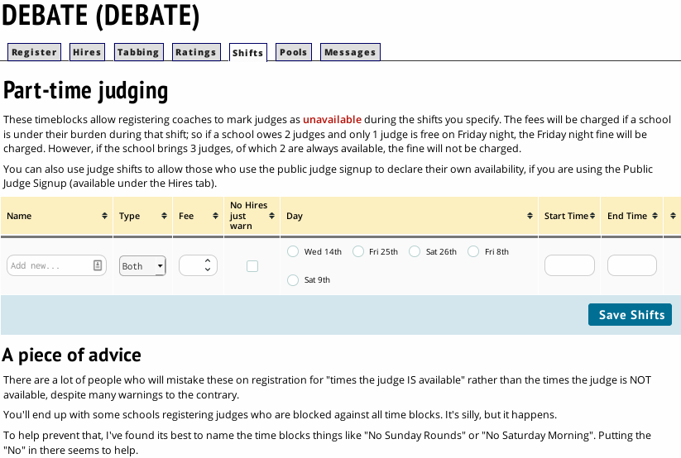
Choose "Both" if you want this shift to apply to both self-registered judges AND coach registered strikes. Choose "public" if you want it only to apply to self-registered judges, and "Strike" to only apply to coach-registered judges.

This should be sufficient setup for your judge categories. Ensure you’ve set your optimizations for each judge category by clicking on the judge group link in the right sidebar of the page. Clicking from one tab to another category should keep you on the same tab for the new category.

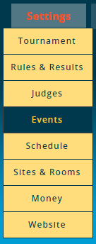
Configuring event settings
After setting up your judge categories and schedule, you are ready to edit any necessary settings for your events.
The Events menu option lets you configure which events you will offer at your tournament, as well as a number of options specific to each event.
All NSDA events should be created, if offered, already. There should not be a need to manually create a new event at a district tournament.
Clicking the name of an event in the sidebar will allow you to edit the settings for that event, and will show you a set of tabs for different settings. You will also have a link on the sidebar to go directly to the settings for the Judge Category affiliated with that event.

The Main tab contains all the general settings for that event.
Full Name - The full name of your event. If setting up multiple divisions of the same event, should include something like "Open" or "Novice in the name as well.
Short abbreviation (limit 5 characters) - Tabroom will use this short abbreviation in many spots in the interface and printed materials. For example, you could use OLD for Open LD and NLD for Novice LD.
Per-Entry Fee - How much a school will be charged for each entry in this event. Note that an "entry" includes however many competitors you set for the event (e.g. 1 for LD, or 2 for CX).
Minimum competitors per entry - The minimum number should almost always be 1 (for IE's and LD), or 2 (for team debate events). You could set it to 1 for a team event if you wanted to allow maverick entries.
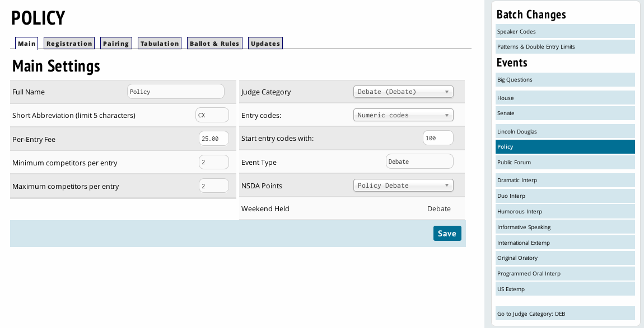
Maximum competitors per entry - The maximum number is almost always 1 (for IE's and LD), or 2 (for team debate events). If you have a debate event that allows 3 or 4 person teams (for example novice policy in some states), you would use a higher number. Note that this is NOT a per-school cap on the number of entries you can have in an event, it is only the limit on the number of people in a single entry.
J
udge Category - Which judge group the event should pull judges from. If you use similar names for your event and judge group, you may find this set to the correct value automatically.
Entry Codes - Controls how entries will appear in registration lists and on schematics and ballots. You have a large number of choices to use various combinations of numeric codes, first/last names, initials, or school codes or names. Note that changing this setting does not affect entries which have already been created/entered. So you if you change this half-way through your registration window, you may need to go to Entries - Data and "recode" your entries to get a consistent scheme.
Start entry codes with - Numeric value to start the entry codes with for the event, so that for example all LD entries start with 200, Oratory starts with 300, etc. You can also assign these values en masse for all events.
NSDA Points - If an NSDA member school has entered your tournament, you'll see an additional option for each event that lets you choose which NSDA event type students should receive NSDA honor points for. Make sure to select this for each event to enable NSDA points from your tournament to be "autoposted."

The Registration tab is where you configure event-specific registration options.
These options will change depending on the event, but should require minimal change on your part.
If your district regularly uses these options, please enable them.
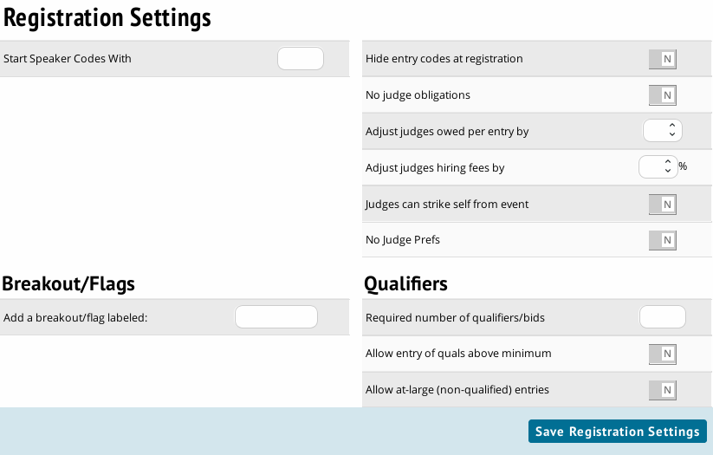
Start Speaker Codes With - The number to start with when creating entry codes for the event.
Judges can strike self from event - This allows judges to self-select that they don't want to judge an event. For example, can be useful to allow inexperienced judges to choose not to judge a "Championship" division.
No Judge Prefs - This disables any form of MPJ for the event.
Hide entry codes at registration - This will prevent showing registering schools the entry codes for each of their entries, to maintain a little extra anonymity.
No judge obligations - Overrides over judging settings and doesn't require any obligated judging for entries in the event.
Adjust judges hiring fees by – adjusts judges hiring fees if judging this event. Negative values allowed.

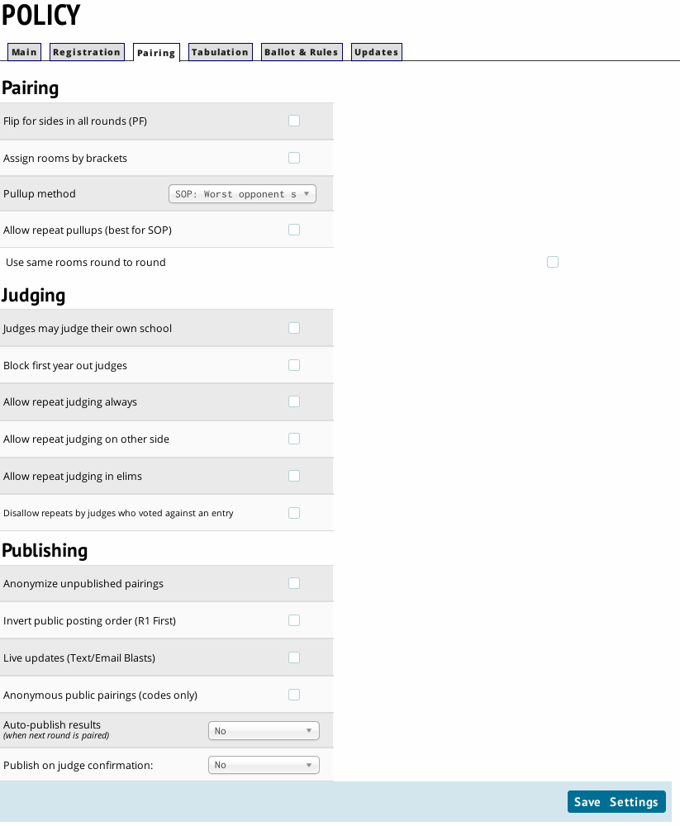
The pairing tab allows you to make changes to how Tabroom behaves while pairing the event. Most options on this page should be left at their default value, but there are a few you’ll want to edit for specific events.

Flip for side in all rounds (PF) - Mostly useful for Public Forum, will cause each round to be listed as flip for sides, with no constraints imposed by the pairing.
Pullup method – Do not edit this, as Tabroom has been engineered for NSDA Districts to follow exactly the method outlined in the District Handbook.
Block first year out judges - This will prevent first year judges from judging this event. Note that this requires you to configure the associated Judge Group to allow marking which judges are first year's, otherwise this setting will have no effect.
Live updates (Text/Emails) - Choose whether to use the Live Updates feature for this event, which will email/text entries and judges with schematics and results if they have linked their Tabroom account to the relevant entry.

For Speech events, a Sectioning tab is available to set speech specific options.
Section Labels – Can be Numbers or Letters, adjust to your districts conventions.
Section size settings – These can be set for defaults, but the pairing engine will allow you to change these values round to round.
All double entries speak early – This option attempts to optimize speaker order for those double-entered in events at your tournament.
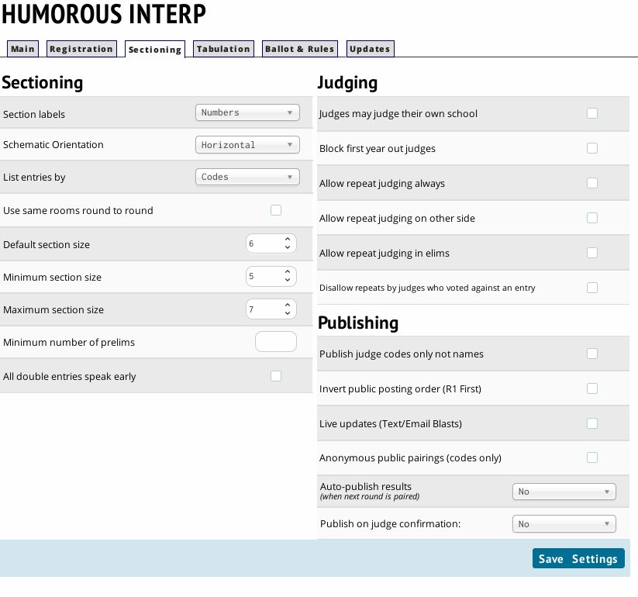
Most other options follow the same convention as previously described.

The Tabulation section lets you configure options for the event's ballot and results computations.

Point increments - Choose whether to use Whole, Half, Quarter, or Tenth points.
Give Team Points, not per-speaker - When selected, will not allow a judge to assign individual points. Not recommended for team events at District Tournaments.
Forbid low-point wins - When selected, will not allow a judge to assign a win to the team receiving lower points.
Speaker Awards – Leave as None
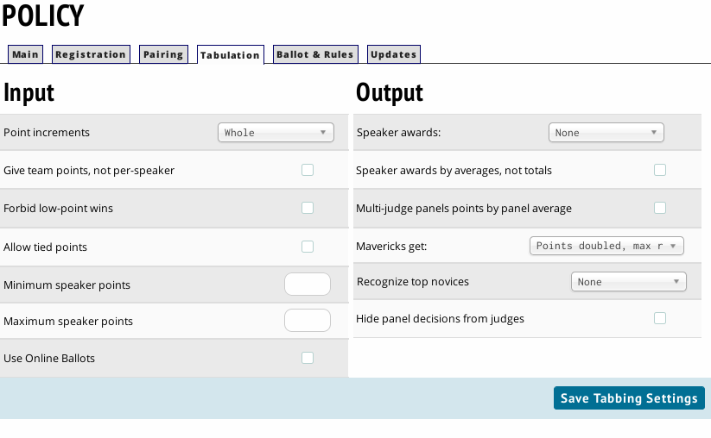
The Ballot & Rules section allows you to set a message or explanation of rules that will appear on ballots for the event, as well as include a description of the event that will be visible on your tournaments public website.
Affirmative and Negative designations can be set to “Pro” and “Con” for PF.
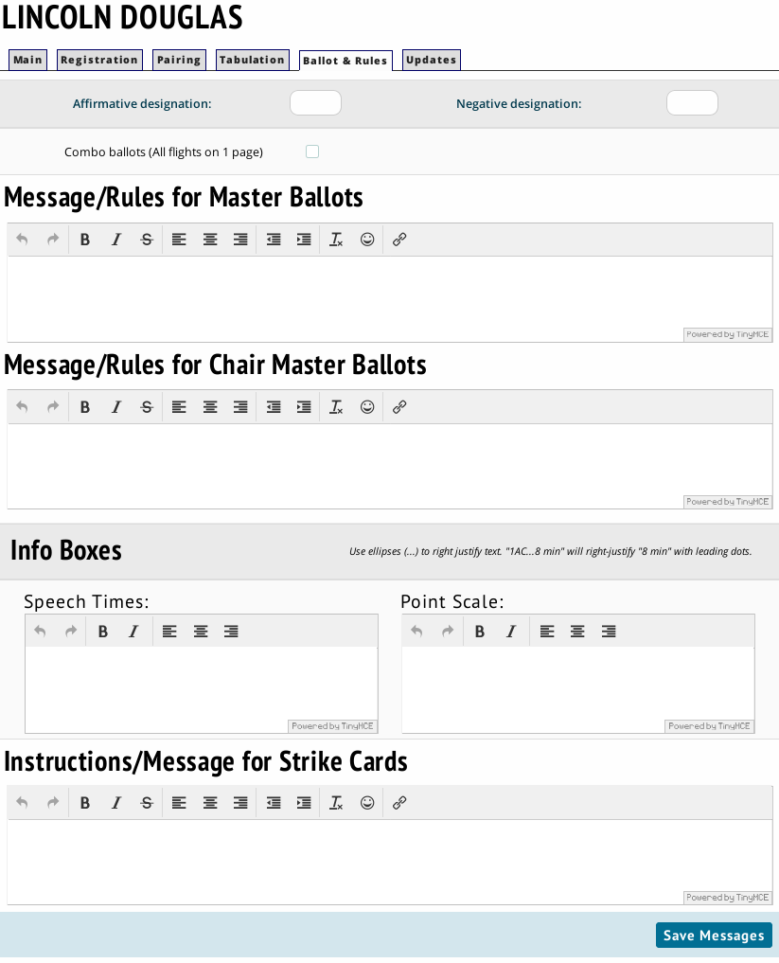

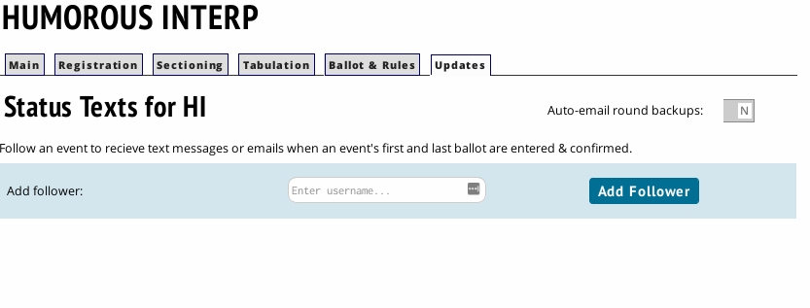
The Updates tab has 2 recent improvements to Tabroom:
You can sign up to receive a text message and email when the first and last ballots are entered for an event, and you can receive automatically generated and emailed round backups when the updater is triggered. This ensures you have a recent backup of your round in the event of data loss.
After customizing each of your events, judge categories, and creating your schedule; your district tournament should be ready for round one.

Running Your District Tournament
Before beginning to section your district tournament, ensure that your competitor and judge totals meet your expectations for attendance.
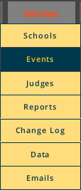
You can see your total registered competitors attendance numbers by clicking on Entries, then Events. You can view your total registered judges by clicking on Entries, then Judges.
The entries pages will show you a breakdown of your registered competitors by event. You may click on an event name to see all registered competitors in that event.
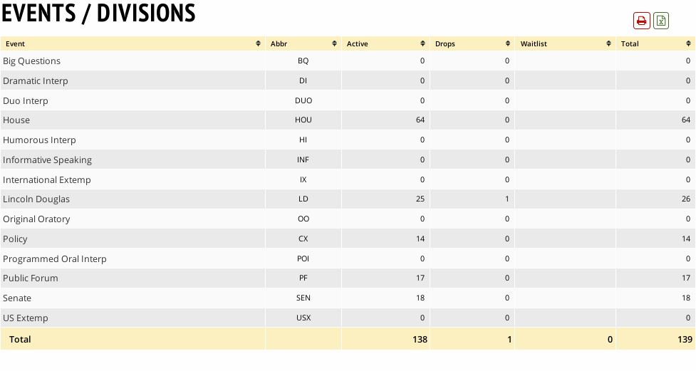

The judges pages will show you a breakdown of your registered judges, by judge category. You may click on a judge category name to see all registered judges in that category.
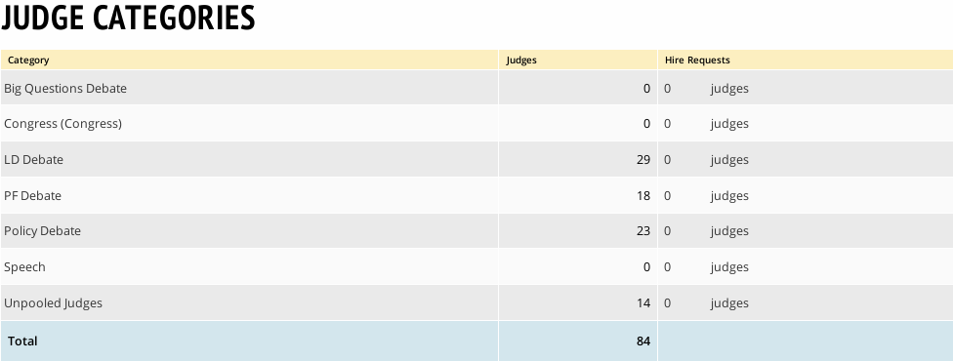

Clicking on the name of a competitor or a judge will show you the detail page of that registered tournament participant. You can drop/stop scheduling a team on their entry detail page, and mark judges as struck from a time block or participant on their judge detail page.
After you’re confident that all registered entries are eligible, you can begin to section your events.

Sectioning Debate
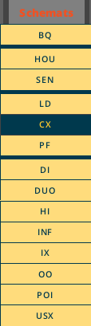
Click on Schemats, then your debate event. You’ll be taken to the “Precreate” section of your round 1 pairing.
In the right sidebar, under “Change & Destroy”, you should see a green “Pair Round 1” link.
If you receive a warning about no rounds being scheduled, please ensure you’ve set up your event correctly in Settings > Schedule. That is documented in the Setting up your district tournament section of this document.
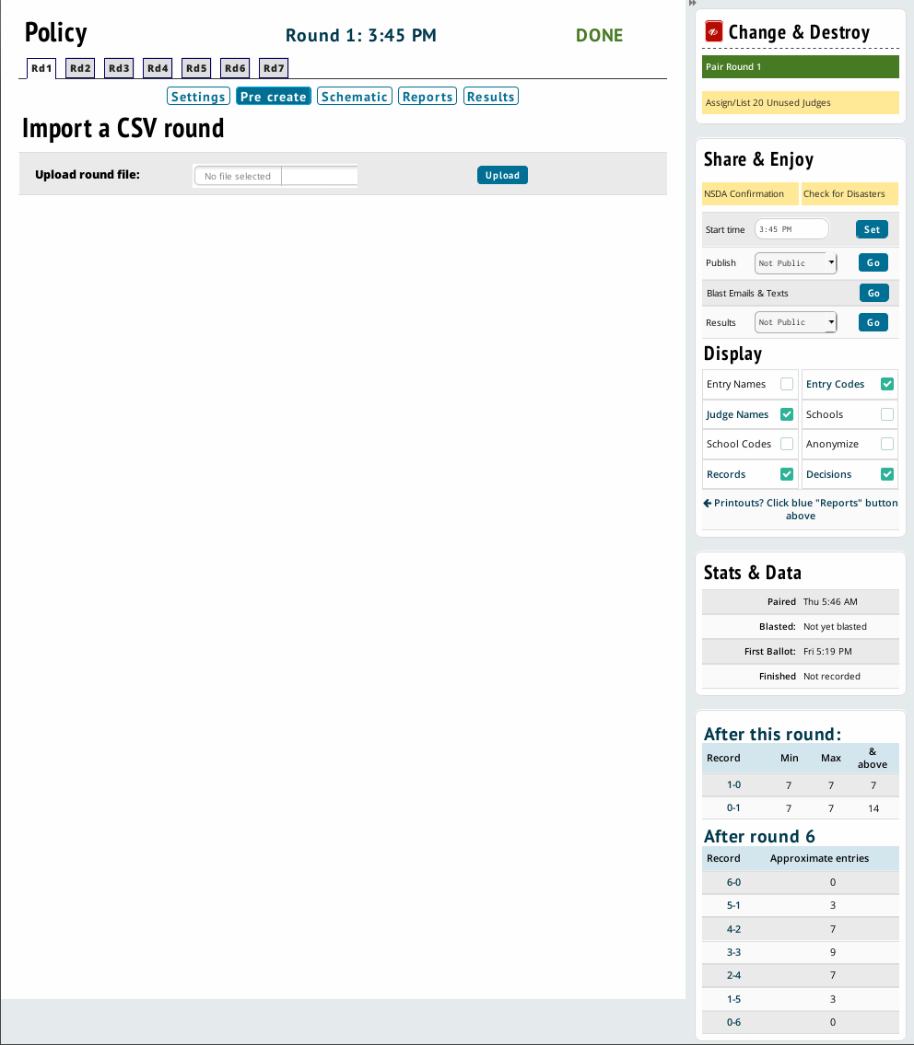

Clicking “Pair Round” will bring you to the section options screen. This allows you fine grained control over your sections.
Select the appropriate options, then click “Create”.
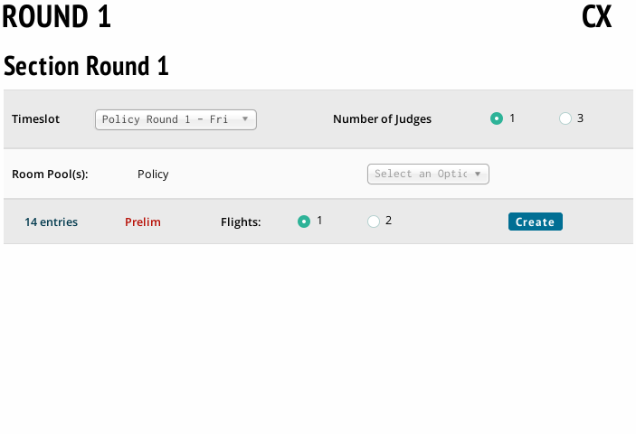
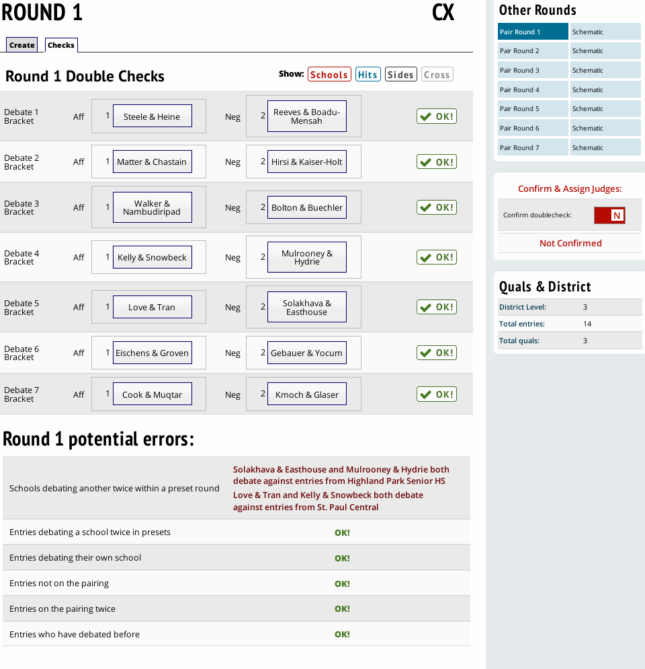
Creating the sections will bring you to the checks page. On this page, you can drag & drop competitors if the pairing is not to your liking. Clicking the bright buttons next to the “Show” label will display extra information.
The potential errors section will alert you if the scheduler finds any, but keep in mind these are potential errors, and not a failure of Tabroom to generate a correct pairing. There will also be a “Log” tab at the top which details the list of rules and the order in which they are followed according to the manual (who was eligible for the byes, who was pulled up, etc). You can click a constraint at right to see the violation directly and verify whether it can be fixed. You can also click that constraint at top to see data for all debaters. The most common violation is a side constraint problem in LD or CX, usually because there are too many due-aff or due-neg teams in a bracket or overall. However, if you do believe you can correct something, simply drag an entry to where they should be moved to, and the entry already there will be swapped with the entry you drag. Be careful to ensure the target entry is highlighted before letting go of the mouse; otherwise an entry can be left out of the pairing and you’ll have to re-section it.
Once you are satisfied with the round 1 pairing, click the “Confirm Doublecheck” slider and then click either the “Auto-assign Judging” or “Auto-assign Rooms” link to proceed. Until you confirm you have audited the sections, the system will not allow you to assign judges or rooms. If you go to the pairing accidentally and want to return to the check/audit screen, you can do so by clicking “NSDA Confirmation” under Share & Enjoy.
You now should see a partial pairing like this:
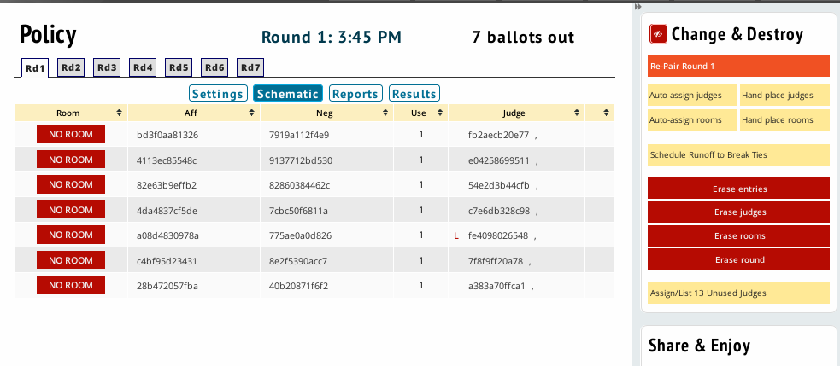
If you need to re-pair the round after noticing an error, click the orange Re-pair Round button. If you want to reschedule judges, click Erase Judges. If you want to change your round settings, click Erase Round. If you’re happy with what you have so far, use the “Auto-assign” link for what’s missing.
If the “Change & Destroy” menu is not visible, and you want to change or destroy some part of your pairing, click the red “Eye” icon to the left of the title.
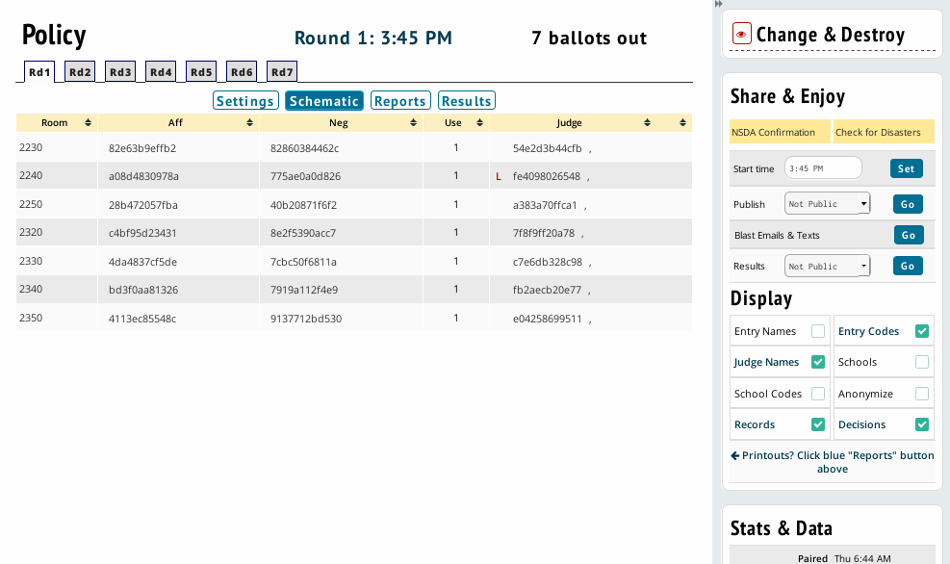

Once you’ve finalized your pairing, you can click on the blue “Reports” button under the tabs of your rounds. The reports page will allow you to print paper ballots, schematics and pairings, and other reports about the sections you’ve created.
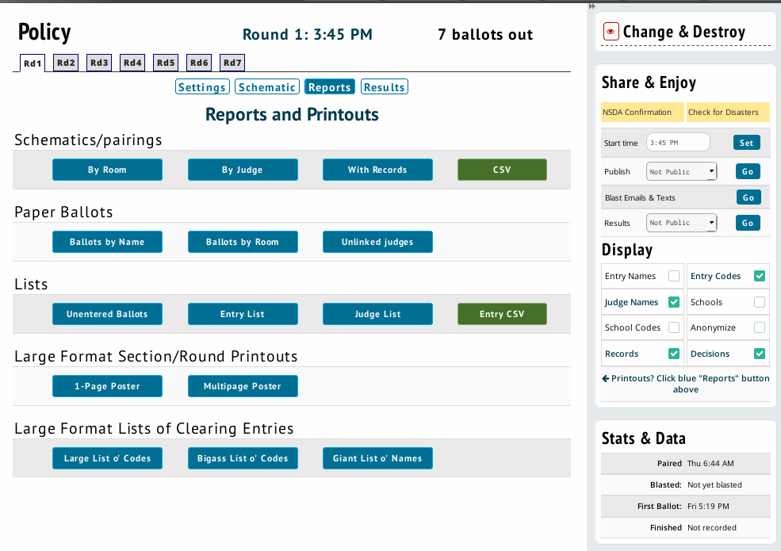
Then run the round normally, print or use online ballots, enter the results as you usually would.
When the round is complete, go back to the round you just did and under Change & Destroy, click on “Create Next Round”. It will then march you through the same process, except that now you have a new tab, Results, where you can see the results of the last round to ensure seedings are done correctly. You will also have a list of Down & Outs on the initial screen.
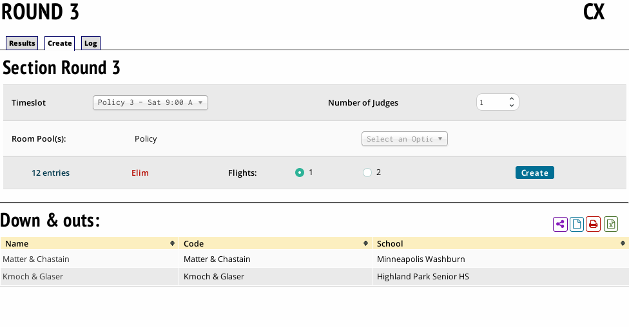
The Round 3 pre-create section screen now has “Down & Out” information. Clicking on the purple “network” icon will publish the list of Down & Outs, and the red Print Icon will generate a pdf you can print and distribute.
Click “Create” to begin sectioning round 3.

Round 3 does not include the Down & Outs, and does not produce any errors requiring repairing.
If it does, click on “Schematic” next to “Round 3” in the right sidebar, then click on “Erase Round” and restart sectioning round 3.
When you are done pairing, auto-assign judges and rooms.
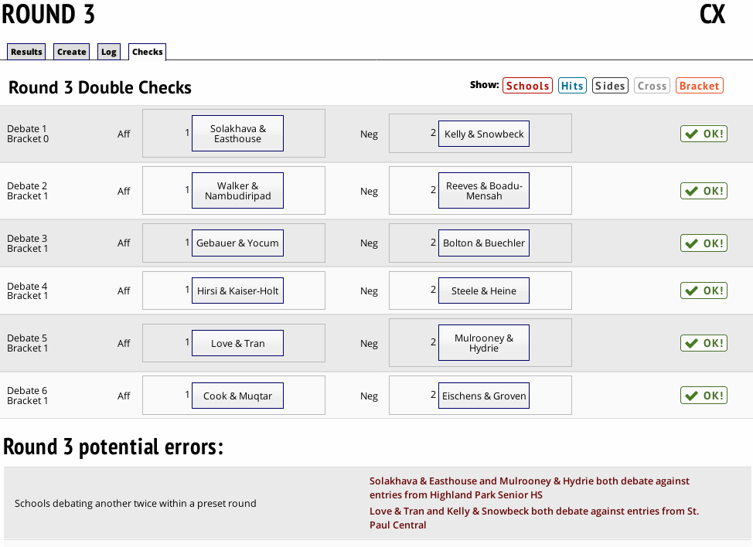
Use the “Reports” link above the schematic to print your ballots and pairings, then when ballots are returned, enter the results in the same manner previously described.

For round 4 we see the updated list of Down & Outs, and the default number of judges increases.
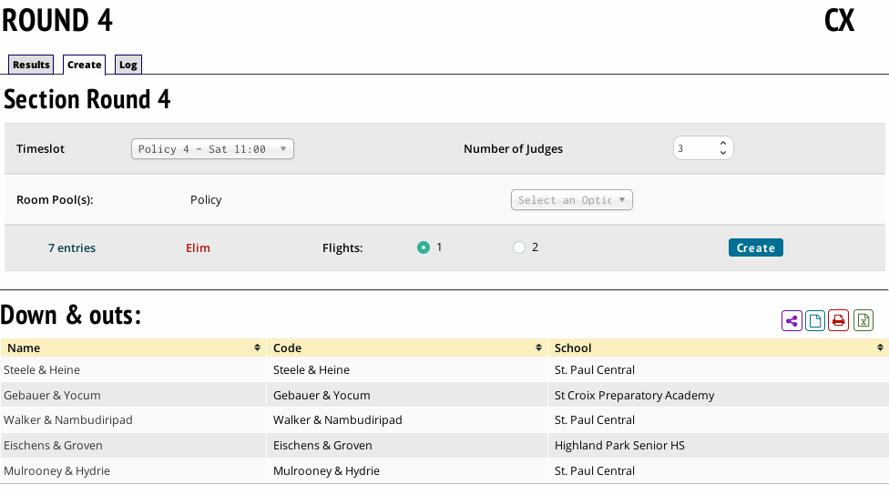
Click “Create”.
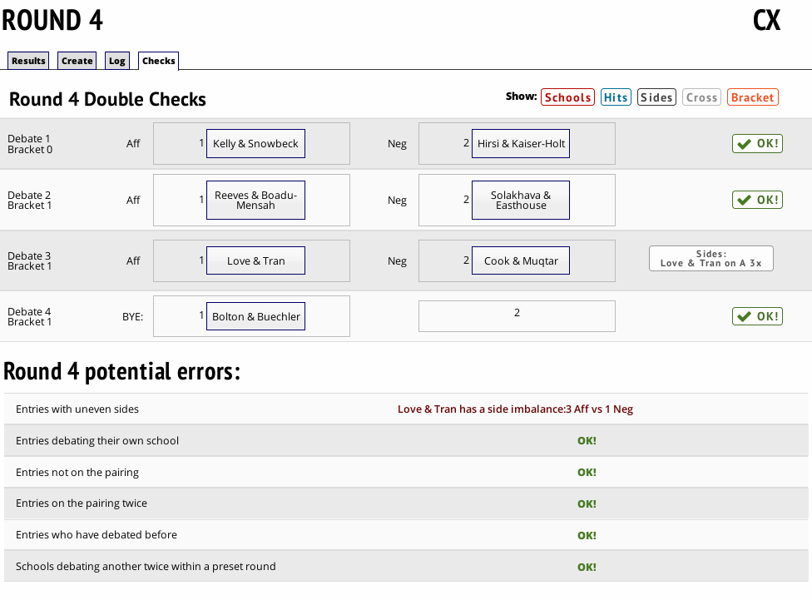

Round 4 has a possible error, and needs to be resolved. You can see the error message in Debate 3 is color coded to the type of error shown on the top of the double checks, which is a hint to what can be clicked to provide further insight to resolving the pairing error. You can switch sides of the competitors in this debate by dragging the Debate 3 Aff to the right spot in the section and Debate 3 Neg to the left spot in the section.
Tabroom will automatically assign the bye to the appropriate team based on the Absolute Pairing Priorities outlined in the Unified Manual.
Once the problem is resolved, confirm the pairing, and auto-assign judges and rooms.
Use the “Reports” link above the schematic to print your ballots and pairings, then when ballots are returned, enter the results in the same manner previously described.
The system will then tell you what the next round will be based on numbers, and it will tell you when you are done and ready for finals. Repeat this process until you are done.
There are situations where a round might end up being the final debate based what happens in the debate - if a certain team wins or loses, you’re done. If that happens and a round ends being your last, you should still click “Create Next Round” on the pairing. The system will recognize that the last round is indeed your final, and retroactively configure it so that it is set up properly with tiebreakers and designate it as a final. The system will then show you to the qualifiers list.

Sectioning Speech
Running a non-pilot district speech tournament, speech events must be paneled a single round at a time, direct from the schematic. Use the Schemats menu to view the round you want to pair, then select Section Round. The process is similar to the Sectioning Debate section of this document.
For round 1, select the event from the schematic screen and click the green “Section” button under “Change & Destroy” at the right. The system will let you choose the timeslot, the judge or room pools (if any exist) they should draw from, and the number of judges (remember if you start with larger panels than required, you cannot go back and use smaller panels later). It will advise you as to how many sections it can create by rule and let you choose. Once you section, it will show you the editable representation of the schematic.
The same information and drag-and-drop interface works for sections in speech just like they do in debate events.
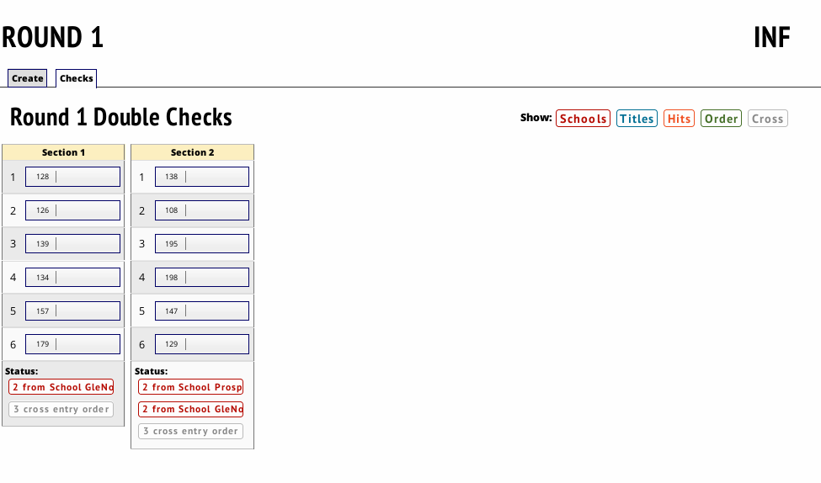
You can click a constraint at the bottom to see the violation directly and verify whether it can be fixed. If there’s a same-school hit for example, but there are 3 sections with a school with 4 entries, you can see right away that the violation is unavoidable. You can also click the constraint type at the top right to see all possible data for that constraint. If you do believe you can correct something, drag an entry where it should be moved, and the entry already there will be swapped with the one you drag. Ensure the target entry is highlighted before letting go of the mouse, otherwise an entry can be left out of the pairing, and you’ll have to re-section it. The thing you may need to adjust is speaker order. The computer does not always do the best at avoiding all possible speaker order constraints, so pay special attention to this!
After you’ve verified the sections are optimal, flip the “confirm” switch at the right so it is green instead of red. Until you confirm you have audited the sections, the system will not allow you to assign judges or rooms.
Then, you may assign judges and rooms from the same screen right below the confirm switch, or you can go back to the schematic and do it from there. You should auto-assign judges, not do it manually unless needed. If you forget to flip the confirm switch, you can go back to do it by clicking “NSDA Confirmation” under Share & Enjoy.
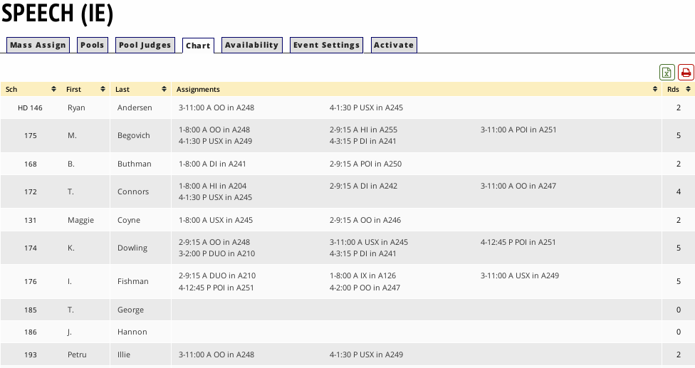
Once your judges are assigned, the Judges menu option (go here by clicking the Paneling tab > Judges) also has a number of helpful tabs. The "Chart" tab shows a list of all judges and their assignments for each round.

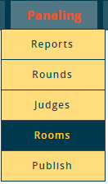
Assign rooms from the schematic using the auto-assign function.
The Paneling - Rooms menu option is also where you configure Room Pools. For more information on setting up Room Pools, see the section of the document on Rooms for Competition.
Once you've assigned rooms, there are a few other helpful tabs with room information. The "Chart" tab (found under Paneling > Rooms) will show you which rounds are assigned to each room.
The "Reservations" tab lets you designate a room for a particular judge. Note that this will make the room unavailable to any other judge, even if the judge it's reserved for isn't judging that round.
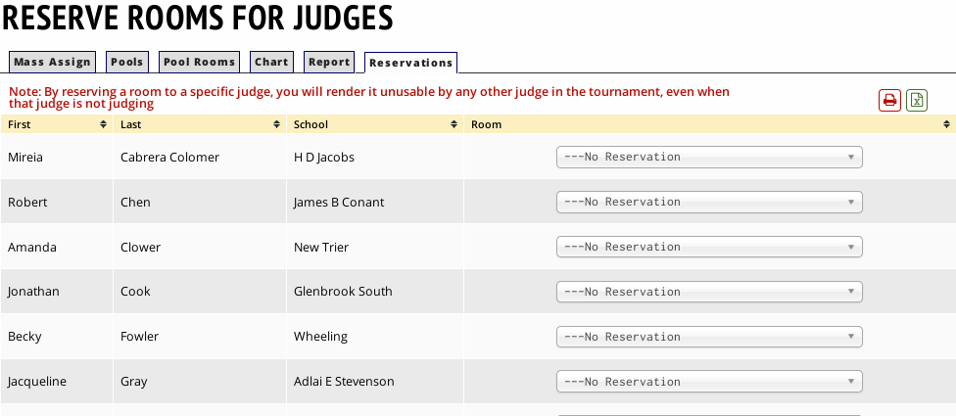

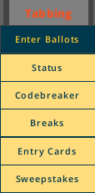
Entering Ballots
After you’ve started to get ballots returned for rounds one and two, you’ll need to begin entering results data.
Click on Tabbing, then on Enter Ballots.
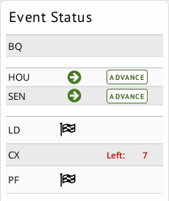
The sidebar will show you which events have outstanding ballots and which are fully entered and ready to pair the next round. The “Checkered flag” icon represents a completed event.

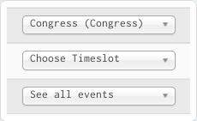
To enter ballots, first select a judge group, timeslot, and event on the sidebar.
You will then be shown a list of ballots, sorted by judge code/name, depending on your event settings. The "Entry" tab contains outstanding ballots - once they are entered, they will appear on the "Done" tab instead. If you have "double enter" set as your ballot entry method, then ballots which have only been entered once will be shown in yellow. “Double enter” requires a second Tabroom user, using their own account, to double-check the ballot (enter a second time). That person will need to have been added to the access list, described in the setup section of this document.

To enter a ballot, click on the judge code/name. You will then be shown the ballot entry screen:
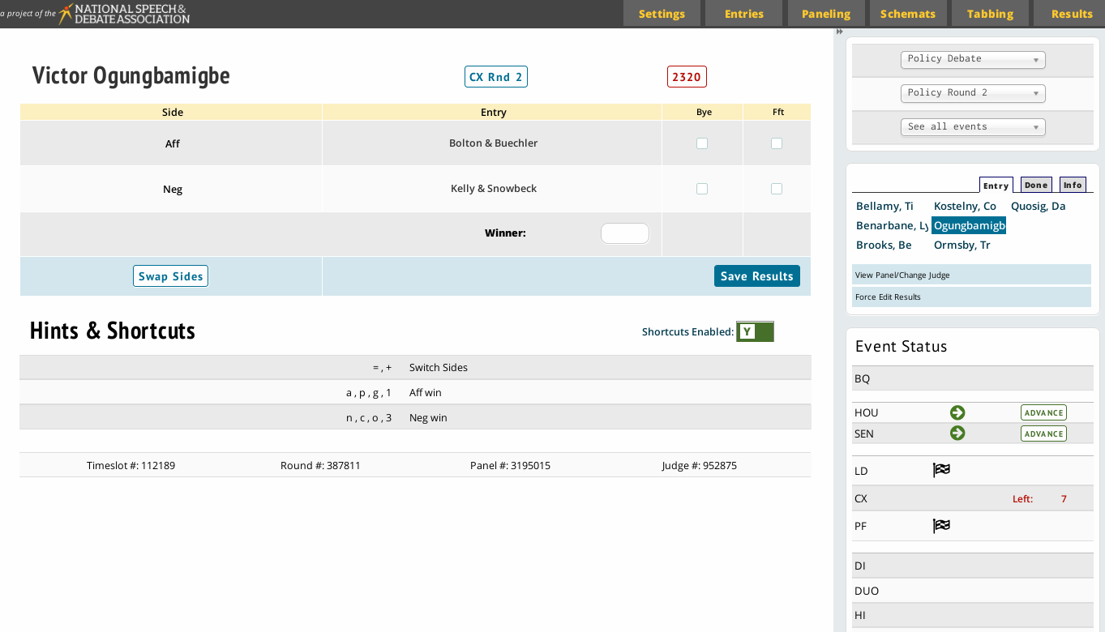
Unless the contest is a Bye or a Forfeit, you should not need to enter anything into those columns.
The winner, after being entered into the ‘winner’ field should highlight in green
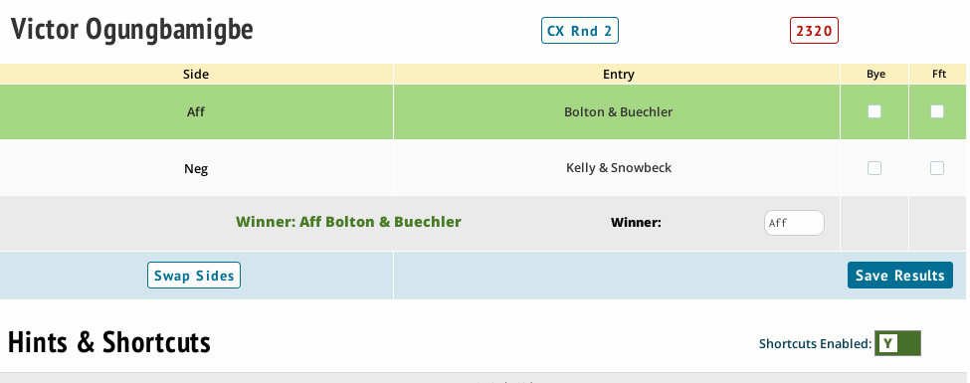

If you need to swap sides on the ballot (as in PF), use the “Swap Sides” button in the lower left shown above.
After entering your round data, click “Save Results”
To print an audit sheet or print a list of ballots still out, use the "Info" tab.

Speech ballots are entered, and appear, similarly to debate ballots.
Rather than having a winner and loser, however, they have data fields for ordinal ranks of competitors.
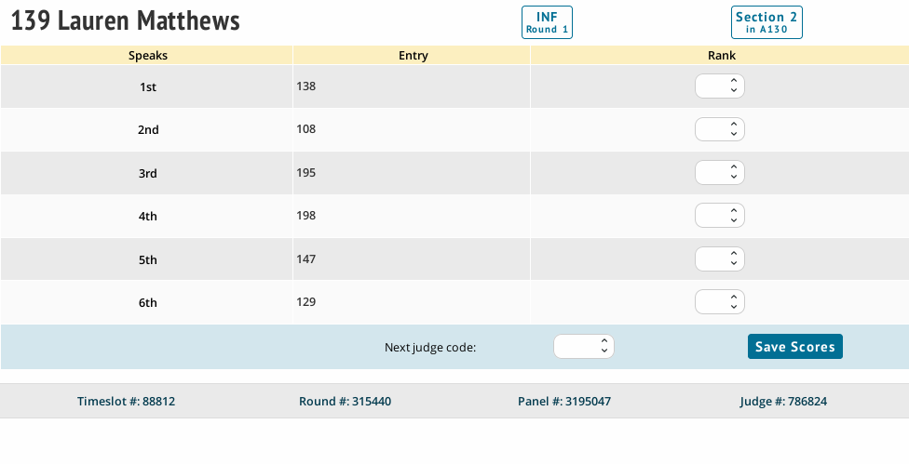

After results have been entered for a section, its last column on the “Schemats” page will be populated with a notification that results are entered.
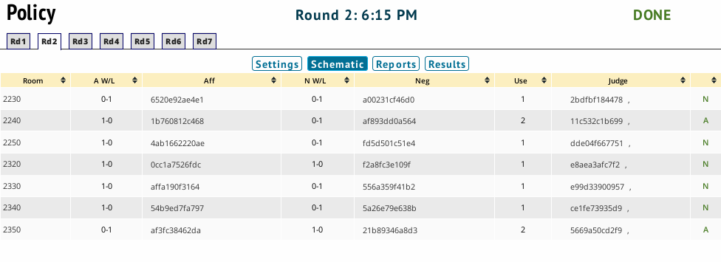
When the round is complete, go back to the schematic of the round you just did, and under “Change & Destroy”, click on “Create next round”. It will then march you through the same process, except that now you have a new tab, Results, where you can see the results of the last round to ensure seedings are done correctly. You’ll also have a list of down & outs on the screen. You can post the first table by printing to show all down & outs, or you can use the buttons above the down & outs on the 2nd tab to post them online or download a PDF. The system will then tell you what the next round will be based on numbers, and it will tell you when you are done and ready for finals.

Determining Qualifiers
Tabroom will let you know when the scheduler believes you’ve achieved sufficient rounds to determine qualifiers to the national tournament in your districts event. After pairing a round, if you see a green “Display Qualifiers” button in addition to your “Re-pair Round” option, you can click on that to determine if your event can conclude.
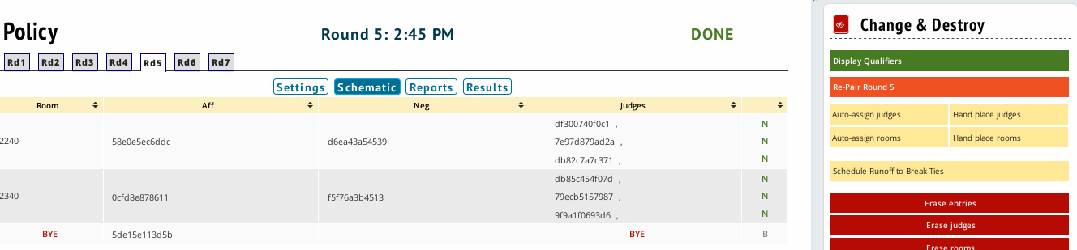
Clicking the Display Qualifiers link will show you a breakdown of your Qualifiers and Alternates.
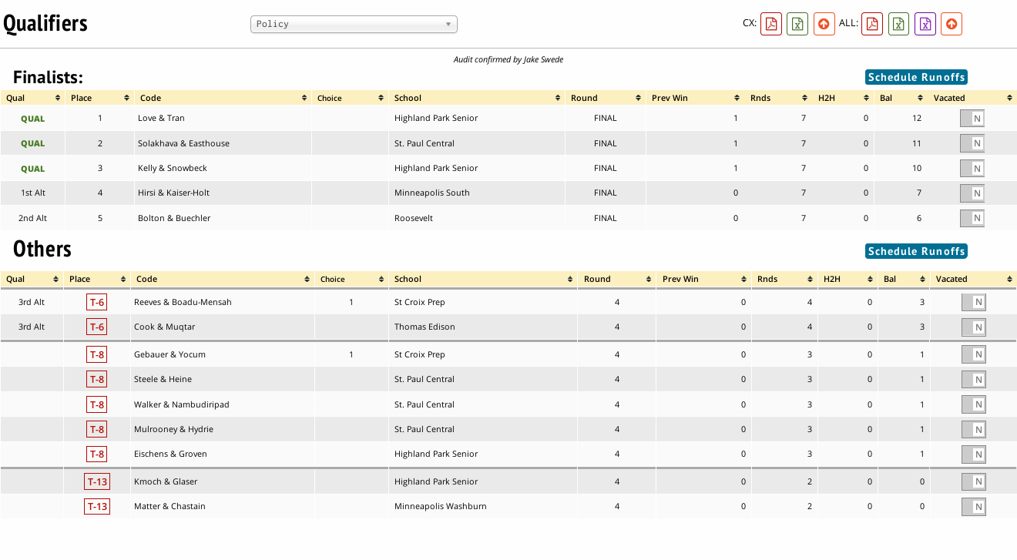
You can check on the qualification status of any event throughout the tournament by click on Results, then on Qualifiers to see the same screen. Select the event you’re looking for more information on from the dropdown toward the top of the screen.

Reporting results
District chairs using Tabroom will not be required to send any electronic files of your tournament to the national office via email or USB; all tournament data is submitted as soon as a list of qualifiers is determined. It is the affirmative duty of the district chair to double check the list of qualifiers. District chairs will need to scan and email any Single Entry Letter of Intent forms to info@speechanddebate.org.
Once you’ve verified that Tabroom is correctly reporting your list of qualifiers using the pages found by clicking Results, then Qualifiers; you can certify and submit a final list by clicking one of the two orange “up arrow” buttons found on the Qualifiers page. The first certifies a single event only, the second certifies results for your entire tournament. Once registration for the National Tournament opens around February, the district chair will need to go back to this Qualifiers page and publish their qualifiers to the registration page by clicking the orange “up arrow” button again.

Appendix A: Further Resources

National Speech & Debate Association Manual
High School Unified Manual Chapter, Rules, and Tournament Operations, 2018-2019
https://www.speechanddebate.org/wp-content/uploads/High-School-Unified-Manual-2018-2019.pdf

Tabroom.com Manual
docs.Tabroom.com Online documentation and knowledge base for Tabroom.com
https://docs.Tabroom.com

Tabroom.com Support
Support forum
https://support.Tabroom.com

Appendix B: Running Debate Pilot Rules
One of the purposes of the Pilot Rules project is to run a tournament more along ordinary and traditional lines. Therefore, there’s more flexibility, and Tabroom gets configured more along the lines of an ordinary tournament.
SETUP MENU
You’ll see more options under the Setup Menu, but generally speaking, you should not change anything (Tiebreakers, Settings, etc.) as it relates to pairing methods. However, you do have more flexibility to review the settings, ensure they are correct, and adjust other settings such as the use of online ballots and settings relating to judging. Note that all changes in the settings menu are logged.
SCHEDULE
One of the key features of the pilot method is that prelims and, to some degree, number of elims is predictable ahead of time. Therefore, you can and should set up your schedule for prelims and elims for each event as usual. To do this:
- Establish time blocks under Settings > Schedule. Set up the expected number of prelims and elims for each event. View page 20 for further instruction.
- Set up the first two rounds for each debate event as “preset” type. All subsequent prelims should be set as “hi/lo” for power matching. Elimination rounds should be set to type “elim”, and the qualifying round should be marked “final”.
Note: The qualifying round would be finals for a district qualifying 1-2 entries to Nationals or the semifinals for those qualifying 3-4. Additional optional finals, or a round for the 3rd spot to Nationals, are scheduled later as “runoffs”. You can create timeslots for those rounds, but don’t create a scheduled round for them yet. You can also go back and add further elimination rounds during the tournament if required, but make sure to adjust your schedule so that the qualifying round and only the qualifying round is marked as the “final”.
TIEBREAKERS
Just as in any other tournament, every round in Tabroom must have a tiebreaker set defined for it. Tiebreakers are how the system knows how to seed rounds for power matching and how it knows what to ask for from judges & print on the ballots.
For all prelim rounds, both presets (the first two debates) and hi/lo power matched rounds, the tiebreaker set should be defined as “Debate”. Elimination rounds should be defined as “Debate Elim.”
The final round tiebreaker is defined based on how you wish to seed alternates after the final round. If you are using Prelim Seed, select “Debate Final Prelim Seed”; if you use runoff debates use “Debate Final Runoff” and if you use NSDA point totals select “Debate Final NSDA Points.” All of these tiebreakers can be selected and checked by going to Settings > Schedule and clicking the event in question on the right side of the page.
This seeding will only apply to entries who broke to elimination rounds. Alternates that did not break to elimination rounds will be ordered based on preliminary round seeding.
PAIRING DEBATES
Debates are, as usual, paired directly on the schematic.
- Go to the round you want to pair and hit the bright green button on the top right corner for “Auto-Pair Round” and the system will generate a pairing for you.
- You can then schedule judges and rooms as well. You can pair rounds 1 and 2 at the same time since they are preset; every round thereafter can only be paired once all ballots are in.
- Click the Check for Disasters button will check for common issues and mistakes. For powermatched rounds, you can also see the seeds in order and see how the matching was done by hitting the Manual Powermatching button at right, which will provide you with the seedings, SOP data, and insight into how powermatching was done for this round. You can adjust the pairings here as well to adjust for odd circumstances; any manual adjustments are logged and subject to review by the national office. Any entries marked in blue on the pairing represent debaters that were pulled up out of their bracket.
A BRIEF ASIDE ON SOP
What is this SOP, you ask? SOP is a method of powermatching created with the aim of producing equal draws during powermatched prelim rounds. It seeds each entry within brackets during powered rounds on the basis not just of their own seeding (win/loss record then points, ranks, etc.) but on the basis of their own seed combined with the average seed of the opponents they’ve debated. Therefore, entries who have done well against harder competition will be given opponents who have done less well against easier draws. The end result is that after prelims, it is more likely that every entry with the same record will have debated against the same strength competition to get to that point. SOP is used in various leagues and circuits in lieu of traditional powermatching, as well as at NSDA districts.

ELIMINATION DEBATES
Elims are paired in the same manner, except that prior to pairing them, you will be presented with a list of contestants from the previous round in order by seeding, and you must select in the bottom right how many elim contestants should advance. For the first elim round, you must select at least all entries with 1 or 0 losses to advance; if the Committee chose to break all winning records, this may also be selected. After any subsequent elim round, you should be presented with half of the entries as being tied for 1st place (if they won their last elim) and the other half tied to not advance, e.g., after a quarter, you’ll have 4 entries tied for 1st that advance and 4 entries tied for 5th that do not.
BYE/WALKOVER DEBATES
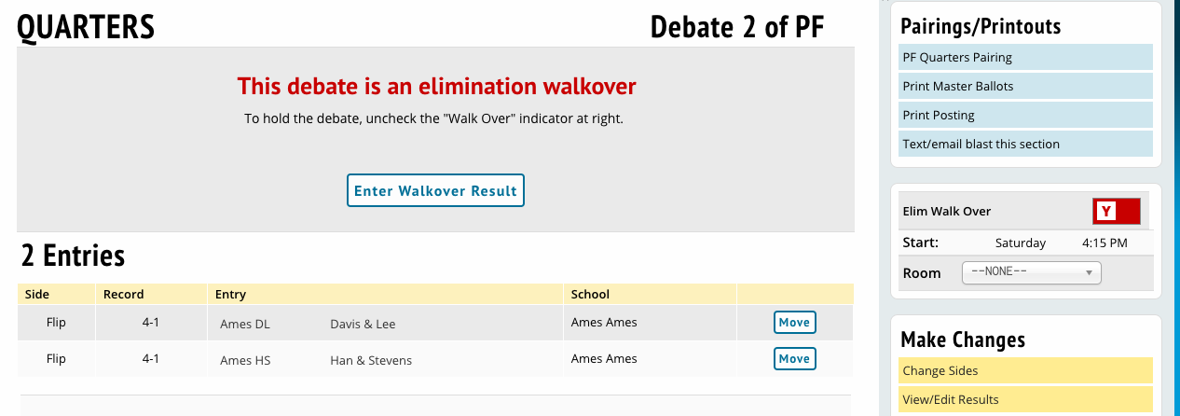
Any debate in elims between the same side will automatically be marked as a bye/walkover. If the coach determines which entry will advance, click the room on the pairing for the BYE round, and then click Enter Walkover Result to advance one entry. To conduct a debate anyway, uncheck the red switch for “Elim Walk Over” at right, then reschedule judges and rooms.

RUNOFFS
Runoffs can determine alternate slots among elim contestants if that’s the method you have elected to use. Runoffs are required between the losing entries of the semifinal rounds for a district qualifying 3 entries to Nationals.
To schedule a runoff debate between non-advancing semifinalists, go to the semifinal after the results have been entered, and click the Eye icon next to Change & Destroy to show the options to schedule rounds. Click on the “Schedule runoff to break ties” button, and you will be shown potential debates for runoffs between tied entries.

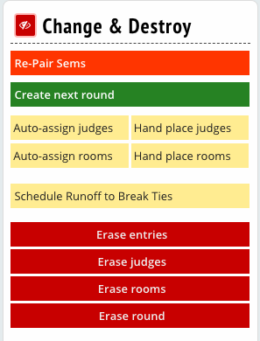
For a semifinal runoff for 3rd place, select a timeslot at top, and then click the checkbox under “Runoff?” under the header Tie for 3: and click Schedule Runoffs. A runoff round will be scheduled between the last two remaining entries to determine 3rd place.
A runoff after quarters will schedule 2 debates between the 4 non-advancing quarterfinalists; then, a 2nd runoff should be scheduled on the pairing screen for the 1st runoff to determine the final order between both the winners and losing entries (if necessary).
Runoffs will cause there to be weird additional tiebreakers created in your tiebreaker set; ignore those. Also, runoffs are reported on the qualifiers sheet in terms of RANKS; so the winning team will be marked as 1 while the losing team will be marked as 2. This is NOT a ballot count.

QUALIFIERS
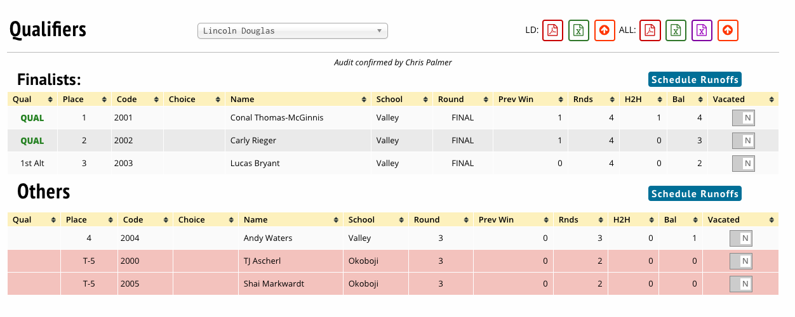
After all is done, go to Results: Qualifiers and you should see a list of qualifying entries and alternates in order. If you are using the runoff method for alternates and only running runoff rounds later as necessary, you will see them marked in pink as being tied until a runoff is held.

Appendix C: Running Speech Pilot Rules
One of the purposes of the Pilot Rules project is to run a tournament more along ordinary and traditional lines. Therefore, there’s more flexibility, and Tabroom gets configured more along the lines of an ordinary tournament.

SETUP MENU

You’ll see more options under the Setup Menu, but generally speaking, you should not change anything (Tiebreakers, Settings, etc.) as it relates to pairing methods. However, you do have more flexibility to review the settings, ensure they are correct, and adjust other settings such as the use of online ballots and settings relating to judging. Note that all changes in the settings menu are logged.

SCHEDULE

One of the key features of the pilot method is that prelims and, to some degree, number of elims is predictable ahead of time. Therefore, you can and should set up your schedule for prelims and elims for each event as usual. To do this:
- Establish time blocks under Settings > Schedule. Set up rounds for each event by clicking on the event name at right on the same screen. See page 20 for details.
- Your 3 or more prelim rounds should be defined as type “preset/prelim”. Elimination rounds should be set to type “elim”, and the qualifying round should be marked “final”.
If you end up during the tournament needing more or fewer elim rounds than you set the tournament up for, make sure to go back to the schedule and set it up so that all elims and the final is marked properly, or your qualifiers will not be calculated correctly.

TIEBREAKERS

Just as in any other tournament, every round in Tabroom must have a tiebreaker set defined for it. Tiebreakers are how the system knows how to set up elimination rounds, and how it knows what to ask for from judges & print on the ballots. For all prelim rounds the tiebreaker set should be defined as “IE Prelim”. Elimination rounds should be defined as “IE Elim” and the final round as “IE Final”.

SECTIONING PRELIMS

There are two ways to section prelim rounds in Tabroom.
- You can go round by round and do them one at a time, which is the method that was required previously for district tournaments.
  - To section round by round, you go to the schematic for each round and click the Auto-Pair Round button at the top right under the Change & Destroy header.
  - After checking the schedule for various constraints, you can follow up by assigning judges and rooms.
  - Click an entry code to be brought to the “Entry Move” screen where you can assess whether the scheduling priorities are being followed or need to be adjusted. All such manual adjustments should be done by multiple people only where necessary. All changes are logged.
- You can also mass-section ALL IE prelims at once by using the Paneling → Rounds menu.
  - You can do them one event at a time (section rounds first, then judges, then rooms) or you can do all IE events on a given weekend at a time by using the Panel All Prelims screen on the top right corner of the Paneling → Rounds menu.
  - Be sure to schedule only events happening on your weekend; do not re-schedule parts of your district tournament that may have already happened!
  - On this screen, select how many sections of each event you wish to schedule. The “Do?” column indicates whether this event should be scheduled. And the “Room” checkbox means rooms will automatically be assigned for those events as well.
  - After that’s done, go to Paneling → Judges if you want to schedule all the judges for the IE tournament at the same time. If you do your IE events across several weekends, be sure to select the judge category at right for the weekend you are operating on. The checkbox for “Erase existing assignments” should only be checked if you’re sure you’re on the right screen; if you go back and re-assign judges for previous weekends, you’ll also necessarily overwrite their results. We do keep backups, but they’re difficult to recover.
  - Once this step is done, you can check for common problems from the screen that results (“Check for Disasters”). You can likewise go to the schematic for each round and click the yellow Disaster Check button there for a finer-grained check of the rounds as they have been scheduled.
TABBING

The tournament operations run just like an ordinary Tabroom tournament at this point. You may use online ballots as long as you publish their results and feedback so your coaches can view them on a regular basis (either make the round results public, or go the Settings tab on the Schematic for a round, and the coach-only publish options will be at the bottom of the screen). You can print paper master scoresheets round by round under the Schematic → Reports tab, or you can print an entire timeblock of scoresheets under Paneling → Reports → Master ballot options.

ELIMINATION ROUND SCHEDULING

When you are ready to advance to an elimination round, go to the schematic for that round. Click the green “Auto-Advance to Elim Round” button at top right. You will be shown a listing of the seeded entries from prelims in order. Ties will be indicated in pink. The system should find the 25% break point and determine if extra entries ought to advance based on ties. However, you should manually verify the break point and see how many entries ought to advance. Once you know and verify the correct number to advance, make sure this is the correct number at right under “Ending Seed”. Then set the number of sections and click Break Them.

The system will deliver you to the semifinal schematic verification screen. It will highlight any possible issues in red beneath the sections. Click the issues to see if they are avoidable (if the same school is in the same section 2x, the “schools” button will show if that school is in all sections) and to verify that the snake has been done as closely as possible. Some of the constraints (same school, speaker order, etc.) may be impossible to satisfy fully.

Once done you can click the Schematic tab at top to proceed with assigning judges and rooms to the elim round. Section further elimination rounds and the final rounds in the same way; verify and enter the correct number of seeds into the Ending Seed box and advance them until you are finished.

FINAL RESULTS

Once the final ballots are all entered, go to Results → Qualifiers and you should see a listing of the qualifiers and alternates in order. Any perfect ties should be marked in pink so you can see if a runoff is required for a qualifying spot. To schedule a runoff, click Schedule Runoffs on the top right corner, and it should detect any ties and allow you to schedule a runoff round.

Appendix D: Enabling Diversity Enhancing Judging
Tabroom now offers tournament directors an option for judges to self-identify as “Diverse”. Enabling this feature is not required to run your tournament using the Tabroom software. Diversity-enhanced judging is enabled for whole judge categories. The option can be set by navigating to:
- Settings
- Judges
- Ratings
- Registration Settings
- Judges may self-identify as diversity enhancing
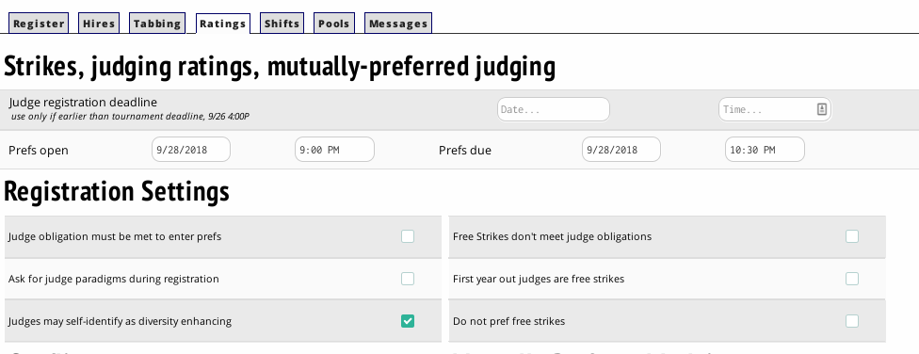

When enabled, this feature adds a checkbox to registered judges’ details page for judges to identify as “Diversity Enhancing”: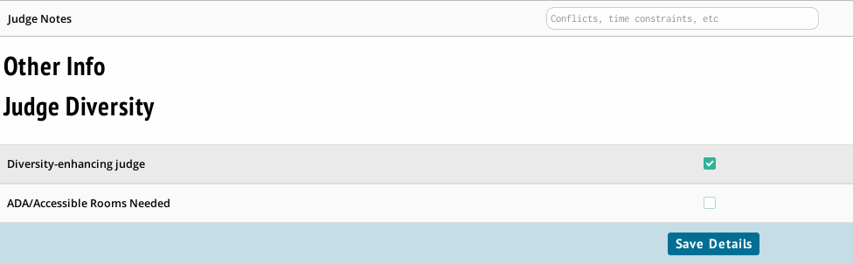

Enabling diversity-enhanced judging enables the judge placement algorithm to use an associated Mutually Preferred Judging weight for "diverse judging" to attempt to place more "diverse" judges. This weight can be adjusted in judge group settings, by navigating to:
- Settings
- Judges
- Tabbing

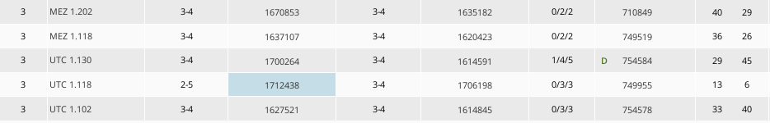
Enabling diversity-enhanced judges also enables the visual display of a judge’s diversity status, when other judge information is available. A judge’s self-identified “Diversity” marker is not displayed when judge information is anonymized (Note the green “D” character next to a judges place on the pairing):

