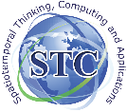
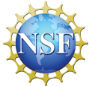
NSF I/UCRC for spatiotemporal thinking, computing, and applications

The I/UCRC for Spatiotemporal Thinking, Computing and Applications (a.k.a. NSF Spatiotemporal Innovation Center) will hold its 8th semi-annual Industrial Advisory Board meeting May 30th - June, 1st, 2018 at George Mason University (conveniently located near Washington DC). This meeting reviews the center’s innovative research and identifies new projects to be supported through collaborations among academia, industry, and agencies. All center research results are freely shared among members to boost their products, services, and businesses. All companies or agencies (with interest in geospatial and spatiotemporal research themes) are welcome to participate. This is a prime time to become familiar with cutting-edge research results, leverage the innovative outcome for your future products and services, increase your efficiency, improve your competitiveness, and boost your business.

What is an Industry/University Cooperative Research Center (I/UCRC)?
Initiated by Congress in 1973, the National Science Foundation (NSF) Industry/University Cooperative Research Center (I/UCRC) Program funds promising technologies created by university scientists and transfers the resulting patents and products to companies and organizations where the results can be applied to benefit society and enhance business. An I/UCRC consists of the funded universities and members from industry, state and federal government agencies, and non-government organizations (NGOs). All collaborate on precompetitive research. Members contribute the annual membership fee to an I/UCRC site. Through membership, the industry and the university form a close partnership that nurtures a pool of scientists and engineers to develop new capabilities for emerging domains.

What is I/UCRC for Spatiotemporal Thinking, Computing, and Applications?
Many 21st century challenges in our contemporary society, such as natural disasters, happen in both space and time, requiring that spatiotemporal principles being incorporated into the computing process. A systematic investigation of these principles can advance human knowledge by providing trailblazing methodologies to explore the next generation of computing for addressing these challenges. On September 15, 2013, the NSF I/UCRC funded three universities, the University of California at Santa Barbara (UCSB), George Mason University (GMU), and Harvard University (Harvard) to establish the I/UCRC for Spatiotemporal Thinking, Computing, and Applications (STC) to develop potential solutions to address these 21st-century challenges. The three collaborating universities each take the leadership in spatiotemporal thinking, computing and application respectively, and collaboratively aim at building up the national and international spatiotemporal infrastructure.
The relevant domains where STC conduct research include, but are not limited to: GISciences, computing sciences, location-based services, transportation, Earth sciences, environmental sciences, space sciences, public health, geological sciences, spatial data infrastructure, biological sciences, and social sciences.
STC operates under the auspices, rules and standard operating procedures of the NSF I/UCRC program. The operations are managed by universities under the guidance of an Industry Advisory Board (IAB), which comprises representatives from every member organization. Each year (research) faculty propose projects to meet the needs outlined by IAB. The IAB then vote to fund projects. The academia researchers work closely with and report regularly to industrial members to ensure the project deliverables and close relevance.
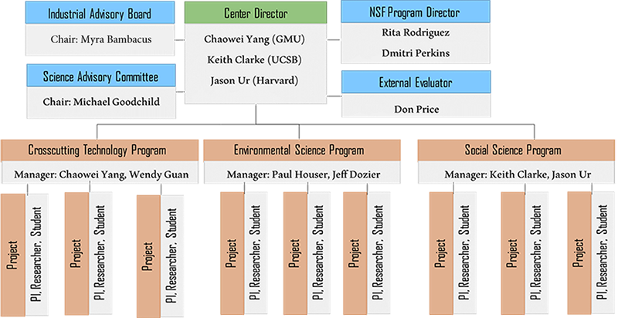
How you would benefit as a Member of STC?
STC provides low cost, low risk precompetitive research for its members from industry, government agencies, and NGOs. As a member of the IAB, you will assess ongoing research and set priorities for new research directions, and your organization will benefit from center innovations. Specifically, the benefits as a member include:
1. Gain full access to R&D results of all three sites collaborating with all members, which far exceeds what can be achieved by one organization’s internal resource (such as staff and funding).
2. Increase the competitiveness and the service or product capabilities of companies, organizations and agencies through deliverable-oriented collaboration with academia.
3. Recruit and attract outstanding students by engaging and collaborating with them through project lifecycles.

Current IAB Members
- NASA National Center for Climate Simulations (NCCS)
- NASA Information Technology and Communications Division (ITCD)
- National Oceanic and Atmospheric Administration (NOAA)
- National Geospatial-Intelligence Agency (NGA)
- National Administration of Surveying, Mapping and Geoinformation (NASG)
- National Geomatics Center of China (NGCC)
- Northrop Grumman Corporation
- United Nations (UN)
- U.S. Geological Survey (USGS)
- U.S. Department of State
- MapD Technologies, Inc.
- Siemens

Past IAB Members
- U.S. Department of Agriculture (USDA)
- The Federal Geographic Data Committee
- Harris Corporation
- Microsoft
- NASA Planetary Defense Coordinate Office
- STIS
- East View Geospatial
- SASMG

