From: Rojhano and Johny
To: Beginner’s Group
Subj: Lesson 8

Articles

1. CONCEPT: What is an article?

An article is a kind of adjective which is always used with and gives some information about a noun. They are used very often and are important for using English accurately.

There are two types of articles: Definite (a, an) and Indefinite (the)

A definite article the indicates that its noun is a particular one identifiable to the listener. It may be something that the speaker has already mentioned, or it may be something uniquely specified. The definite article the can be used for singular and plural nouns.
Whereas Indefinite articles (a, an) are used when you talk about a thing in general, NOT a specific thing.

2. GRAMMAR:

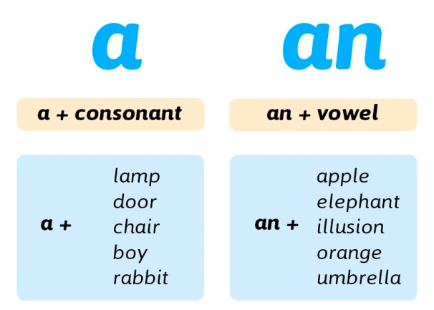
Examples:
- I need a phone. Not a specific phone, any phone
- Mark wants a bicycle. Not a particular bicycle, a bicycle in general
- Do you have a driver's license? In general

Use a, an when talking about a thing which is new, unknown, or introduced to a listener for the first time. Also use a, an when you are asking about the existence of something.

- I have a car. The car is being introduced for the first time.
- Tom is a teacher. This is new information to the listener.
- Is there a dictionary in your backpack? Asking about the existence of the dictionary

Similarly, use a, an to introduce what type of thing we are talking about.

- That is an excellent book. Describing the kind of book
- Do you live in a big house? Asking about the kind of house
- I ate a thick, juicy steak. Describing the kind of steak

REMEMBER: You cannot use a, an with plural nouns because a, an means "one" or "a single".

• I saw a bears in Yellowstone National Park. Not Correct
• I saw bears in Yellowstone National Park. Correct

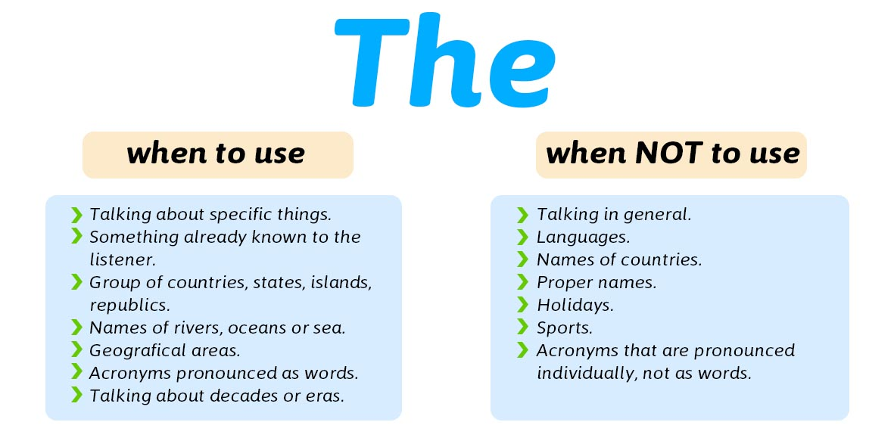
The is called a definite article. "Definite" means "specific". Use The when talking about something which is already known to the listener or which has been previously mentioned, introduced, or discussed.

Examples:
- I have a cat. The cat is black.
- There is a book in my backpack. The book is very heavy.
- Do you know where I left the car keys? The listener knows which specific car keys you are talking about.
- Do you own a car? Is the car blue? You assume they do have a car after asking about it in the first sentence.
- Nobody lives on the Moon. The Moon is known to everyone.

You can use The with both singular nouns and plural nouns:

- I saw the bear in Yellowstone National Park. Correct
- I saw the bears in Yellowstone National Park. Correct

Use The when you assume there is just one of something in that place, even if it has not been mentioned before.

- We went on a walk in the forest yesterday.
- Where is the bathroom?
- Turn left and go to number 45. Our house is across from the Italian restaurant.
- My father enjoyed the book you gave him.

Use The in sentences or clauses where you define or identify a particular person or object.

- The man who wrote this book is famous.
- I scratched the red car parked outside.
- I live in the small house with a blue door.
- He is the doctor I came to see.

Use The to refer to people or objects that are unique.

- The sun rose at 6:17 this morning.
- You can go anywhere in the world.
- Clouds drifted across the sky.
- The president will be speaking on TV tonight.
- The CEO of Total is coming to our meeting.

Use The before superlatives and ordinal numbers.

- This is the highest building in New York.
- She read the last chapter of her new book first.
- You are the tallest person in our class.
- This is the third time I have called you today.

Use The with adjectives, to refer to a whole group of people.

- The French enjoy cheese.
- The elderly require special attention.
- She has given a lot of money to the poor.

Use The with decades.

- He was born in the seventies.
- This is a painting from the 1820's.

Use The with clauses introduced by only

- This is the only day we've had sunshine all week.
- You are the only person he will listen to.
- The only tea I like is black tea.

Proper nouns

Use The with names of geographical areas, rivers, mountain ranges, groups of islands, canals, and oceans.

- They are travelling in the Arctic.
- Our ship crossed the Atlantic in 7 days.
- I will go on a cruise down the Nile.
- Hiking across the Rocky Mountains would be difficult.

Use The with countries that have plural names and also when it’s about a group of Islands.

- I have never been to the Netherlands.
- Do you know anyone who lives in the Philippines?

Use The with countries that include the words "republic", "kingdom", or "states" in their names. In other words, when it’s about a group of states or countries.

- She is visiting the United States.
- James is from the Republic of Ireland.

Use The with newspaper names.

- I read it in the Guardian.
- She works for the New York Times.

Use The with the names of famous buildings, works of art, museums, or monuments.

- Have you been to the Vietnam Memorial?
- We went to the Louvre and saw the Mona Lisa.
- I would like to visit the Eiffel Tower.
- I saw King Lear at the Globe.

Use The with the names of hotels & restaurants, unless these are named after a person.

- They are staying at the Hilton on 6th street.
- We ate at the Golden Lion.

Use The with the names of families, but not with the names of individuals.

- We're having dinner with the Smiths tonight.
- The Browns are going to the play with us.

When NOT to use:
Do not use The with names of countries (except for the special cases above).

- Germany is an important economic power.
- He's just returned from Zimbabwe.

Do not use The with the names of languages.

- French is spoken in Tahiti.
- English uses many words of Latin origin.
- Indonesian is a relatively new language.

Do not use The with the names of meals.

- Lunch is my favorite meal.
- I like to eat breakfast early.

Do not use The with people's names.

- John is coming over later.
- Mary Carpenter is my boss.

Do not use The with titles when combined with names.

- Prince Charles is Queen Elizabeth's son.
- President Kennedy was assassinated in Dallas.

Do not use The after the 's possessive case

- His brother's car was stolen.
- Peter's house is over there.

Do not use The with professions

- Engineering is a well-paid career.
- He'll probably study medicine.

Do not use The with names of shops

- I'll get the card at Smith's.
- Can you go to Boots for me?

Do not The the with years

- 1948 was a wonderful year.
- He was born in 1995.

Do not use The with uncountable nouns

- Rice is an important food in Asia.
- Milk is often added to tea in England.
- War is destructive.

Do not use The with the names of individual mountains, lakes and islands

- Mount McKinley is the highest mountain in Alaska.
- She lives near Lake Windermere.
- Have you visited Long Island?

Do not use The the with most names of towns, streets, stations and airports

- Victoria Station is in the centre of London.
- Can you direct me to Bond Street?
- She lives in Florence.
- They're flying into Heathrow.

3. PRONUNCIATION

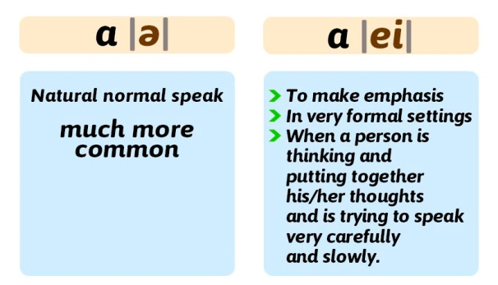

LISTEN:
/ə/ https://www.dropbox.com/s/q7vvt9ds6mnqv16/a.mp3?dl=0

/ei/
https://www.dropbox.com/s/wg4kqbsfnk20vhg/ei.mp3?dl=0

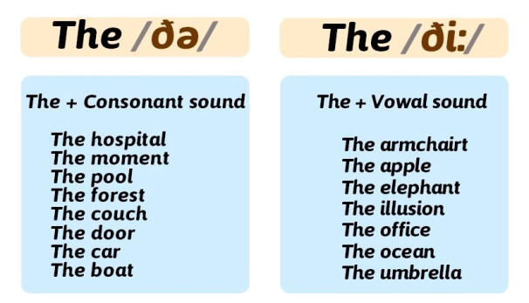

LISTEN:

/ðə/
https://www.dropbox.com/s/pi5889e1ou8ruav/the%20da.mp3?dl=0

/ði:/
https://www.dropbox.com/s/mnszjyte9srned4/the%20di.mp3?dl=0

4. EXERCISE

Complete the following sentences using a, an or The.

1. My mother is ___ doctor and my father is ___ actor.

2. Cindy recommended ___ good dentist, but ___dentist doesn't have any openings for two months.

3. Mt. Hood is___volcano in Oregon. It's ___very beautiful mountain.

4. Sam recommended___ book to Lisa. She didn't like ___book at all.

5. Do you have___ vacuum cleaner? I dropped ___ piece of cake, and I need to clean it up.

6. Honey, where's____umbrella? I can't find it. It was in ___closet, but now it's not there.

7. Do you have ___dictionary? I don't have one, and I need to look up___word.

8. Do you have ___ passport? You need ___passport to travel outside of ___country.

9. There's ___big bear in___backyard. I think ___bear is looking for something to eat.

10. Do you have ___computer? I have ___laptop and___ iPad.

