From: Rojhano
To: Beginners Group
Subj: Lesson 6

Lesson Objective
The student shall be able to use the pronouns and the verb TO BE, read and comprehend basic language and demonstrate understanding.

First Portion
Reading

Evaluation Criteria
- Ability to read, with clear pronunciation, and comprehend the meaning of the text.

Mornings (simple present, habits)
Every weekday morning my alarm clock rings at 7 o’clock and every weekday morning I try to ignore it. I do not like mornings! I hide my head under the covers and I pretend that it isn’t really morning. I groan. I complain. I say nasty things about mornings. Some mornings I fall back to sleep for a few minutes! After a short time I realize that I have to get up. I sigh. I struggle out of bed and I start my day.

Vocabulary help:
- complain (verb) - to say that something is wrong or that you are annoyed about something
- groan (verb) - to make a long low sound when expressing pain or unhappiness
- Habitual (adjective) - usual or typical. A habitual action is something that you do often.
- ignore (verb) - to pay no attention to someone or something
- nasty (adjective) - bad, unkind, angry
- realize (verb) - to notice or understand something
- sigh (verb) - to breathe out slowly & noisily, often because you are annoyed or unhappy
- struggle (verb) - try very hard to do something difficult
- fall asleep in front of the TV (expression) - to fall asleep while watching TV

The Snow (Simple present, statement of fact)

It snows in Canada in the winter. Snow is cold and wet. Snow covers the roads and makes driving difficult. Snow covers the sidewalks too and makes walking difficult. Snowplows clear the roads and sidewalks. People shovel the snow off their driveways. Snow causes problems!
Sometimes snow is pretty. It sparkles and glistens when the sun shines on it. Some people enjoy playing in the snow. They build snowmen or snow forts. They have snowball fights. They slide down hills on sleds or toboggans. They ski down hills. Snow is fun!

Vocabulary help:
- causes (verb) - to make something happen
- clear (verb) - to remove
- covers (verb) - to form a layer on the surface of something
- difficult (adjective) - not easy
- enjoy (verb) - to like doing something
- glisten (verb) - shines, often because it is wet
- slide (verb) - to move smoothly over a surface
- sparkles (verb) - to shine brightly in the light

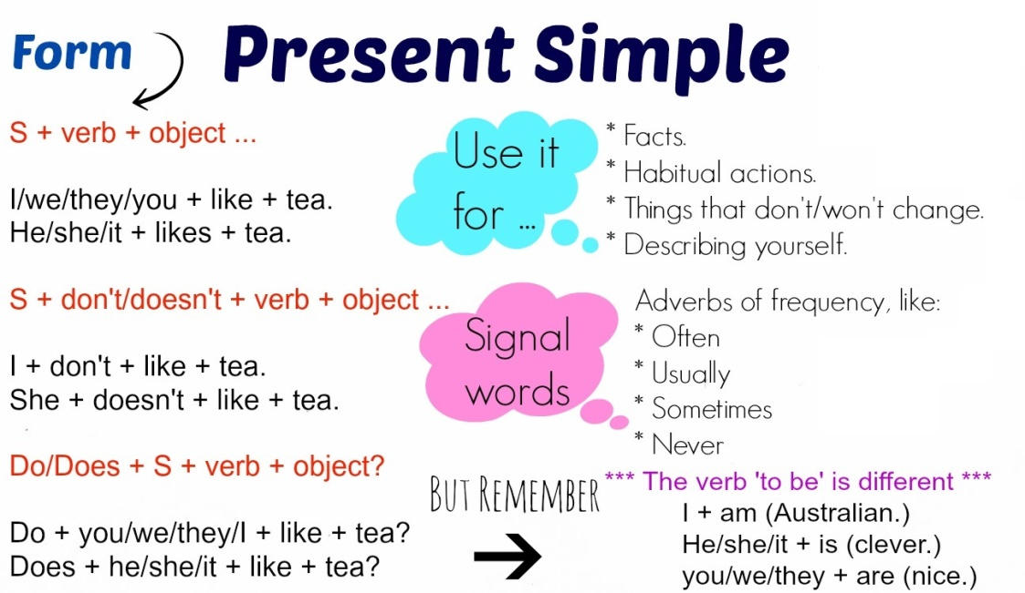
When do we use simple present tense?

We use the simple present to talk about things in general. We are not thinking only about the present. We use it to say that something happens all the time or repeatedly, or that something is true in general. It is not important whether the action is happening at the time of speaking:

- The earth goes around the sun.
- Nurses take care of patients in hospitals.
- In my country, most stores close at 8:00p.m.

We can also say the simple present is used:
- To give your opinion: I like ice cream. I don't like spicy food.
- To talk about schedules: The library opens at eight. It doesn't open at 7.
- To talk about daily habits (routine actions): Sara eats a cheese for breakfast every day. She doesn't eat cereal.
- To give facts: The earth circles the sun. The moon doesn't circle the sun.

The affirmative form of the simple present:

I, you, we, they | play.
He, she, it | plays.

Remember the verbs in the third person singular (he, she and it) always take an "s". For example, "he plays, she sings, it works..."
Examples:
- Nancy and James speak good German.
- Nancy works in a restaurant downtown.

The interrogative form of the simple present:

Examples:
- Do you speak good German?
- Does Nancy work in a restaurant downtown?

The negative form of the simple present:

I, you, we, they | do not | play.
 | don't
He, she, it | does not
 | doesn't

Examples:
- No, I don't speak German.
- No, she doesn't work in a restaurant downtown.

