From: Lala
To: IELTS Prep Group
Subj: IELTS Reading Lesson 3

Lesson Objective
The student shall be able to use “power words” as part of their oral vocabulary, read and comprehend business language and demonstrate effective oral communication skills

First Portion
Power Words

Evaluation Criteria
- Ability to understand the definition of the word and how to use in context within a complex statement/sentence

Match the word with the correct definition:

fatigue | prefecture | circumstantial | hijack | susceptible
swaths | phenomenon | migrate | telltale | shrink

​1) Extreme tiredness.
2) Revealing, indicating, or betraying something.
3) To take control of or use something that does not belong to you for your own advantage.
​4) Easily influenced or harmed by something.
5) To become smaller, or to make something smaller.
6) A political region or local government area in some countries, for example Japan, France, and Italy.
7) ​Containing information, especially about a crime, that makes you think something is true but does not completely prove it.
8) To move from one place to another.
9) a strip or ​belt, or a ​long ​area of something.
10) Something that exists and can be seen, felt, tasted, etc., especially something unusual or interesting.

Second Portion
Reading

Evaluation Criteria
- Ability to read, with clear pronunciation, and comprehend the meaning of the paragraph. The student will be asked several questions to validate their comprehension of the reading material.

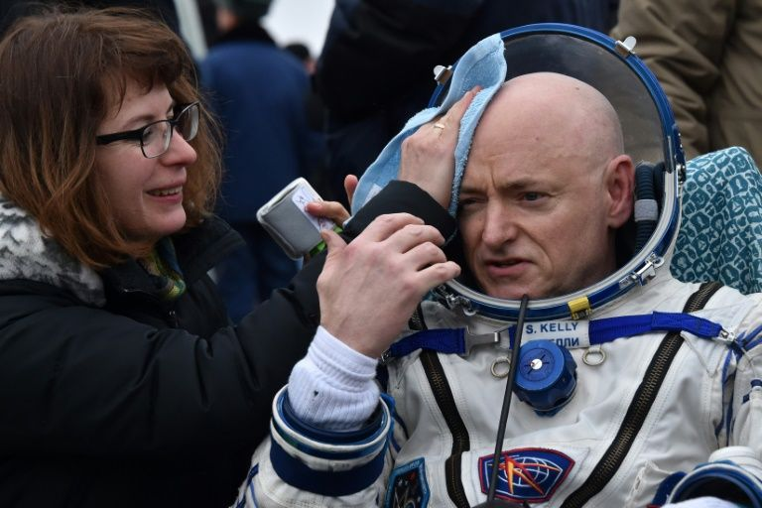
ARTICLE 1.

Sore, but no taller, astronaut Scott Kelly adjusts to Earth
Kerry Sheridan, AFP News. March 5, 2016
Source

US astronaut Scott Kelly said Friday he is battling fatigue and super-sensitive skin, but is back to his normal height after nearly a year in space.
Kelly's 340-day mission -- spent testing the effects of long-term spaceflight ahead of a future mission to Mars, along with Russian cosmonaut Mikhail Kornienko -- wrapped up early Wednesday when they landed in frigid Kazakhstan aboard a Soyuz spacecraft.
One of the effects of spending such a long time in the absence of gravity was that Kelly's spine expanded temporarily, making him grow 1.5 inches (3.8 centimeters), only to shrink as he returned to Earth.
His twin brother, Mark Kelly, said they were the same height again by the time they hugged in Houston early Thursday.
A. QUESTIONS:
- What was Kelly’s 340 day mission about?
- What happened to Kelly’s height when he was in space?

According to John Charles, human research program associate manager for international science at NASA, any height gain "probably went away very quickly because it is a function of fluid accumulation in the discs between the bones in the spinal column."
Kelly also said reports he had grown a full two inches (5.1 centimeters) were exaggerated.
"I don't know where that came from. I did measure myself and it was an inch and a half, so maybe somebody just decided to just round up and write it as a fact," he told reporters in his first extended media appearance since his return.
The specifics are important because a team of doctors is carefully researching the genetic, physical and psychological differences between Kelly and his twin, who is also an astronaut but who stayed on Earth to take part in the study.
B. QUESTIONS:
- How many inches did Kelly really gain?
- What are the doctors researching about?

- 'Better than' -
The details of those ongoing studies are secret for now, as scientists will do further analysis and submit their findings for peer-review before publication.
The idea is to learn more about the harmful effects of spaceflight before NASA greenlights any deep space mission to an asteroid or Mars, journeys that would last a year or more.
The study includes frequent MRIs of the twins' organs and major vessels, genetic analysis and a close examination of the effects of radiation, which in high enough doses can lead to cancer.
C. QUESTIONS:
- In paragraph #2 what does the word “greenlights” mean. (hint: it is a verb)
- What does the study include?
- Why do you think it’s important to conduct these studies before NASA allow another space mission?
Asked if the brothers noticed anything else different about each other upon being reunited, Scott answered: "He's got a better tan."
A veteran of four space missions, 52-year-old Kelly returned to Earth with the record for the longest amount of time spent in space by an American -- 520 days. A Russian cosmonaut holds the all-time record.
"It seemed like I'd lived there forever. It was longer than I thought it would be. But having flown before, I did pace myself appropriately," he told reporters.
C. QUESTIONS:
- What’s the name of Kelly’s twin brother?
- What record does Kelly hold?

- Burning soreness -
Kelly had previously spent six months at the orbiting research lab, and was somewhat prepared for the effects of returning from microgravity.
"Initially this time, coming out of the capsule, I felt better than I did last time," when his mission lasted 159 days, he said.
But that soon changed.
"My level of muscle soreness and fatigue is a lot higher than it was last time. Maybe there is a linear function to it," he said.
"I also have an issue with my skin, that because it hadn't touched anything for so long -- like any significant contact -- it is very, very sensitive. It is almost like a burning feeling wherever I sit or lie or walk."
D. QUESTIONS:
- Why did Kelly’s skin become sensitive?

Kelly added that he was wearing dress shoes only because of his televised appearance, and that a more comfortable pair was waiting nearby.
Other changes he noticed were in his fine motor skills. He said he tried to shoot some hoops but missed the basket each time.
Kelly, who recently wore a gorilla suit in space to chase a fellow astronaut as a joke, also poked fun at himself for his first choice of food upon returning to Earth -- a banana.
"It looked so good," he said.
"As soon as I ate half of it, I recognized the irony."
E. QUESTIONS:
1. What changes did Kelly notice?
2. What was the first food Kelly ate when he returned?

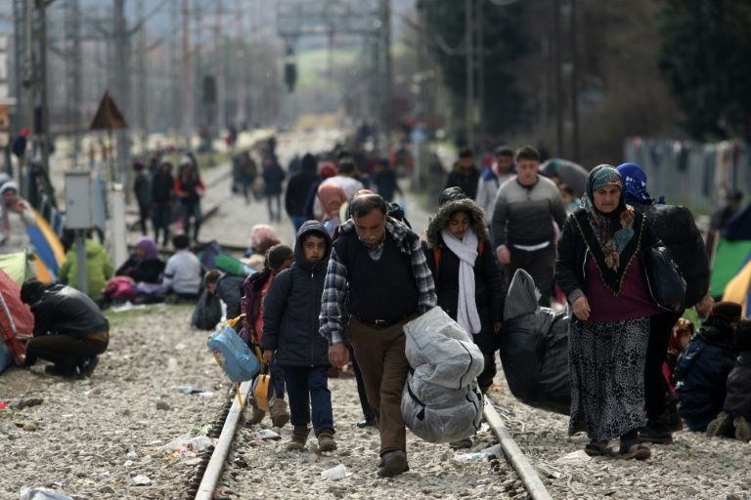
ARTICLE 2

13,000 refugees at Greek border ahead of EU-Turkey migration summit
Vassilis Kyriakoulis. AFP News. March 5, 2016
Source

Some 13,000 refugees are crammed in unhygienic conditions on Greece's border with Macedonia, officials said Saturday, with all eyes on a key EU-Turkey summit on Monday that is seen as the only viable solution to the crisis.
The huge influx of refugees and migrants has caused major tensions and divisions within the European Union, but EU President Donald Tusk on Friday struck an upbeat note about Monday's summit in Brussels, which will include Turkey.
European leaders are expected to use the summit to press Ankara to take back more economic migrants from Greece and reduce the flow of people across the Aegean Sea.
Greece has been plunged at the heart of Europe's greatest migration crisis in six decades after a series of border restrictions along the migrant trail, from Austria to Macedonia has caused a bottleneck on its soil.
A. QUESTIONS:
- What caused the tension in the EU?
- What do the EU leaders want Ankara (place in Turkey) to do?
- How can the EU-turkey summit provide solution to the crisis?

Over 30,000 refugees and migrants have been trapped in the country, around a third of them at Idomeni border crossing, where aid groups report food and tent shortages.
"There are 13,000 people here and nearly 20,000 in this prefecture, over 60 percent of the country's entire refugee and migrant flow," Apostolos Tzitzikostas, regional governor of Greece's central Macedonia prefecture, told Skai television on Saturday.
"We can no longer shoulder this strain by ourselves."
Adding to the EU tensions, Bulgaria said Saturday it will send more than 400 troops and security personnel to guard its border with Greece, amid fears the migrant flow along the Balkan route will pick up with the onset of warmer weather.

B. QUESTION:
What are some of the problems that the refugees and aid groups have?
German Chancellor Angela Merkel -- a key player in the drama -- meanwhile said Greece should have been quicker in preparing to host 50,000 people under an agreement with the European Union in October.
"Greece should have created 50,000 accommodation places for refugees by the end of 2015," Merkel told Bild newspaper in an interview to appear Sunday.
"This delay must be addressed as soon as possible as the Greek government must provide decent lodgings" to asylum claimants, she said.
Greece sent in the army in February to speed up the creation of open camps for migrants and refugees but has occasionally run into opposition from local authorities.
C. QUESTIONS:
- What does “key player” mean in the sentence above?
- According to German chancellor merkl, what Greece should have done?

- Tents and protests -
The Doctors without Borders charity on Saturday began erecting additional tents at Idomeni to shelter over 1,000 people who could not fit in the camp and have been sleeping in muddy fields and ditches, an AFP reporter said.
In past days, the mainly Syrian and Iraqi refugees have regularly held protests in front of the barbed-wire fence guarded by Macedonian riot police, demanding to be allowed through.
Hussam, a 25-year-old Syrian, says the refugees are hoping that Monday's EU-Turkey summit will provide a breakthrough.
"We are calm now because we are hoping for a positive outcome on Monday, that they will help us pass," Hussam said. "If there isn't one, I don't know what will happen."
D. QUESTIONS:
- What did The Doctors without Borders charity do to help the refugees?
- What are the refugees hoping for?
According to Greek officials, Macedonia has allowed some 2,000 people through its borders in the last two weeks. The same number of people fleeing war and poverty arrive in Greece from neighbouring Turkey in two days.
Some 200 people were allowed through between Friday and Saturday, with Macedonian police calling into question registration documents handed to refugees by Greek police at the islands.
In many cases, the documents do not carry full dates of birth, only the year, while disputes over the correct colour of a police stamp can also hold up the process for hours.
Athens is building additional facilities to house the refugees and migrants, but many prefer to go to the border in the hope of eventually getting through, and are stuck there for days and weeks.

Why do the Macedonian police question the refugees’ registration documents?
Why do some refugees prefer to go to the border instead of going to the facilities?

"I haven't bathed in 15 days," said Almuthanna, a 35-year-old Iraqi stranded at the camp with his family for eight days.
"One of my sons is ill and there's no medicine. This is war too, only they don't kill you with a gun, but slowly," he told AFP.
"We hope the politicians will reach a solution on Monday. Hope is all we have left. It will be disastrous if no solution is found," he said.
Greece has asked the EU for 480 million euros ($526 million) in emergency funds to help shelter 100,000 refugees. A senior UN migration official has warned that the numbers stuck in Greece will probably reach 70,000 in the coming weeks.
E. QUESTIONS:
Why did said Almuthanna compare his situation to a war?

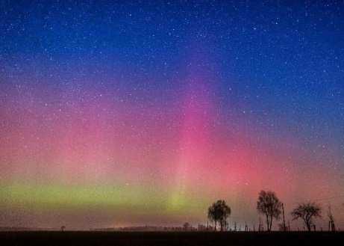
ARTICLE 3

Swaths of Britain, Germany treated to northern lights
Associated Press. March 7, 2016
Source

BERLIN (AP) — Parts of Britain and Germany have been treated to a display of the northern lights, a colorful phenomenon that is usually only seen further north.
The aurora borealis painted skies green, purple and blue late Sunday and early Monday as far south as the southern English county of Oxfordshire, as well as in some northeastern regions of Germany.
A. QUESTIONS:
- What are northern lights?
- Where and when did aurora borealis occur?

An aurora appears when a magnetic solar wind slams into the Earth's magnetic field, exciting electrons of oxygen and nitrogen.
Amanda Townsend, a space weather adviser for Britain's Met Office, said that "once in a while the solar winds are enhanced to levels stronger than normal, with particles at higher speeds." She added that "on this occasion it has connected really well with the Earth's magnetic field."
B. QUESTION:
- How does an aurora form?

