From: Rojhano
To: Beginners Group
Subj: Lesson 12

Lesson Objective
The student shall be able to learn the English grammar rules.

Adjectives
What is an adjective?

Adjectives are words that describe or modify other words, making your writing and speaking much more specific, and a whole lot more interesting. Words like small, blue, and sharp are descriptive, and they are all examples of adjectives. Because adjectives are used to identify or quantify individual people and unique things, they are usually positioned before the noun or pronoun that they modify. Some sentences contain multiple adjectives.

What Do Adjectives Look Like?
English can be very tricky, so you have to be careful, but a lot of English adjectives end with these suffixes:

- -able/-ible – adorable, invisible, responsible, uncomfortable
- -al – educational, gradual, illegal, nocturnal, viral
- -an – American, Mexican, urban
- -ar – cellular, popular, spectacular, vulgar
- -ent – intelligent, potent, silent, violent
- -ful – harmful, powerful, tasteful, thoughtful
- -ic/-ical – athletic, energetic, magical, scientific
- -ine – bovine, canine, equine, feminine, masculine
- -ile – agile, docile, fertile, virile
- -ive – informative, native, talkative
- -less – careless, endless, homeless, timeless
- -ous – cautious, dangerous, enormous, malodorous
- -some – awesome, handsome, lonesome, wholesome

Many adjectives also end with -y, -ary and -ate, but lots of nouns and adverbs also end with -y, lots of nouns also end with -ary, and lots of nouns and verbs also end with -ate, so be careful with those.

Prefixes
To make many opposite adjectives we use the prefixes un, in, or dis at the start of the word.
- believable – unbelievable
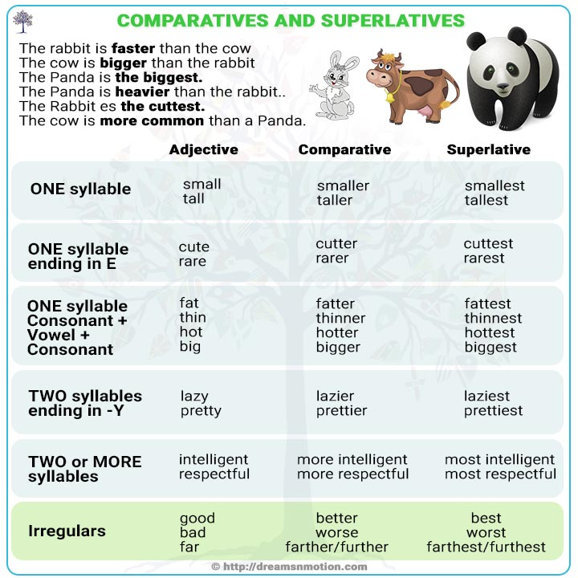
- complete - incomplete

Comparatives:
We use comparative adjectives to compare two nouns. Short one-syllable words usually take er in the adjective to make the comparative followed by than:
- My sister is older than me.

One syllable made of consonant + vowel + consonant doubles the last consonant and add er (it applies also to superlatives but you add est):

- Big: bigger – biggest
- Hot: hotter - hottest

Longer words with two or more syllables take more to make it comparative:
- I think dogs are more intelligent than cats.

For adjectives that end in y, change the y to i and add er:
- The town is even dirtier than I remember.

Superlatives:
The superlative form is made by adding -est or most:

- Small – smaller –smallest
- Beautiful – more beautiful – most beautiful

What’s the Correct Order for Multiple Adjectives?

When you list several adjectives in a row, there’s a specific order they need to be written or spoken. Native speakers of English tend to put them in the correct order naturally, but if you’re learning English, you’ll have to memorize the order. It goes like this:

- Determiner – This means an article (a, an, the), a number or amount, a possessive adjective (my, his, her, its, your, our, their), or a demonstrative (this, that, these, those).
- Observation/Opinion – Beautiful, expensive, gorgeous, broken, delicious, ugly
- Size – Huge, tiny, 4-foot-tall
- Shape – Square, circular, oblong
- Age – 10-year-old, new, antique
- Color – Black, red, blue-green
- Origin – Roman, English, Mongolian
- Material – Silk, silver, plastic, wooden
- Qualifier – A noun or verb acting as adjective

This is the correct order for adjectives that come directly before a noun, and they are separated by commas.
- My beautiful, big, circular, antique, brown, English, wooden coffee table was broken in the move.

If the adjectives come after the verb “be” as the complement, then the qualifier will stick with the noun at the beginning of the sentence. The adjectives in the complement are separated by commas with the final two being separated by “and.” For example: My coffee table is beautiful, big, circular, antique, brown, English and wooden.

Exercise 1
Read the sentence and write down which word you think is the adjective.

1. It's a small problem. _____________________________
2. I have a great idea. ______________________________
3. The price is cheap. ______________________________
4. I like hot food. __________________________________
5. The flowers are pretty. ___________________________
6. He is my new friend. ____________________________
7. The bus is slow. ________________________________
8. Winter is cold. _________________________________
9. I want a different haircut. _________________________
10. She arrived early. ______________________________

Exercise 2
Underline all adjectives and circle the noun they modify. HINT: There are 20 adjectives in all.

- Soccer is fast and exciting.
- Football has defensive teams and offensive teams.
- Sometimes the weather is cold and snowy when people snowboard.
- Skiing is exhilarating and dangerous.
- You need a strong, muscular body to be good at sports.
- A favorite sport of Americans is baseball, which has a grassy outfield.
- Athletes need nutritious foods and healthy snacks.
- Sports are beneficial and fun.
- You need great reflexes and an agile body to study martial arts.
- People who play tennis wear white clothes to reflect the hot sun.

