From: Rojhano
To: Beginner’s Group
Subj: Lesson 3

Lesson Objective
The student shall be able to use the pronouns and the verb TO BE, read and comprehend basic language and demonstrate understanding.

First Portion
Reading

Evaluation Criteria
- Ability to read, with clear pronunciation, and comprehend the meaning of the text.

ARTICLE
CHICAGO PIZZA
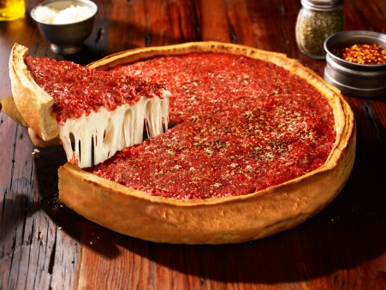
Chicago pizza is a unique and famous pizza from Chicago. But how is Chicago pizza different from the pizza served in New York, London, or Italy?
First, the crust is about 2.5 inches deep, or about 6.35 cm. It is cooked like a pie in a deep, round pan. The pan has a lot of olive oil, so the crust becomes crunchy on the bottom.
For toppings, the pizza usually has about 1/4 inch of sausage, 1/4 inch of cheese, and 1/4 inch of chunky tomato sauce. Other popular ingredients include pepperoni, green peppers, mushrooms, and olives.

No one knows exactly who made this style of pizza first, because several restaurants claim to be the creators. However, everyone from Chicago has a favorite pizza restaurant, and they feel very strongly that it is the best pizza.

1. Discuss these questions with a partner.

- Do you like pizza? What kind of pizza do you like?
- How is Chicago pizza different from other pizzas?
- Who made the first Chicago-style pizza?

2. Discuss these questions with a partner. Support your answers.

- Do you want to try Chicago pizza? Why/not?
- Does your hometown or country have an unusual / unique dish? Please explain.

Second Portion:
Grammar refresher
To Be - Present Tense
Questions
(Be) + Subject + ____?
Singular | Plural
Am I….? | Are we…?
Are you…? | Are you…?
Is he…?
Is she…? | Are they…?
Is it…?

Yes-No Questions:
Question: Are you a student?
Answer: Yes, I am.

1. _____ he a good student?
2. ______ the cars parked in the garage?
3. ______ I supposed to go to work today?
4. ______ you in this class?
5. ______ she from Mexico?

Be - Past Tense
The verb "be" has two forms in the past tense: was and were

Singular | Plural
I was | We were
You were | You were
He was | They were
She was
It was

1. Listen and read:

- I was in my classroom yesterday.
- You were there, too.
- He was at a movie last night.
- She was at home.
- This cantaloupe was in my garden this morning.
- It was delicious.
- We were at school yesterday.

(I + you = we)
- You were on this website earlier.
- They were outside in the snow.

2. Watch this video

TO MAKE A QUESTION:

Singular | Plural
Was I ... | Were we ...
Were you ... | Were you ...
Was he ... | Were they ...
Was she ...
Was it ...

To make a negative sentence, add "not" after the verb to be:

- He was not in school yesterday.
- He wasn't in school yesterday.

- was not = wasn't
- were not = weren't

Third Portion
Vocabulary

Cultivation
Cultivation is the act of caring for or growing plants...

Harness
A harness is a set of straps that are put on a horse so it can be hitched to a wagon or a carriage.

Burglar
Use the word burglar when you're talking about someone who steals things from inside a house or a building.

Scatter
If you hear someone shout "Everybody scatter!” that person wants everyone to spread out and leave the area.

Glossary
A glossary is a dictionary of terms specific to a certain subject.

