From: Rick Howard
To: IELTS Prep Group
Subj: IELTS Lesson 02-24-2016

- Lesson Objective
  - The student shall be able to use “power words” as part of their oral vocabulary, read and comprehend business language and demonstrate effective oral communication skills

- Power Words

Evaluation Criteria
- Ability to understand the definition of the word and how to use in context within a complex statement/sentence

Agitated  http://dictionary.reference.com/browse/agitated | Tuition  http://dictionary.reference.com/browse/tuition?s=t | Brazen  http://dictionary.reference.com/browse/brazen?s=t
Pragmatic  http://dictionary.reference.com/browse/pragmatic?s=t | Skeptical  http://dictionary.reference.com/browse/skeptical?s=t | Obstruct  http://dictionary.reference.com/browse/obstruct?s=t
Feasible  http://dictionary.reference.com/browse/feasible?s=t | Affiliated  http://dictionary.reference.com/browse/affiliated?s=t | Contingent  http://dictionary.reference.com/browse/contingent?s=t
Marginalized  http://dictionary.reference.com/browse/marginalized?s=t | Mortality  http://dictionary.reference.com/browse/mortality?s=t | Dense  http://dictionary.reference.com/browse/dense?s=t

- Reading

Evaluation Criteria
- Ability to read, with clear pronunciation, and comprehend the meaning of the paragraph. Student will be asked several questions to validate their comprehension of the reading material

- Free college in Europe: An attractive option, but not for everyone

Just a couple of years ago, the most popular reason to move abroad was to escape taxes. More and more, cheap – and even free – college tuition is becoming an enticing factor for young Americans to move abroad.

In a survey conducted last year, more than a third of American respondents said they would consider moving out of the country. Nearly half, or 48 percent, cite educational opportunities as the major incentive. And a small but rising number of American students have made the move – in 2012, there were 47,000 college students getting their degrees outside of the US.

According to Peggy Blumenthal, the senior counselor to the president at the Institute of International Education, about half are post-grad students and the other half are undergrads – "a growing trend, though it's still a niche," she tells The Christian Science Monitor.

But even free college tuition comes with its own invisible set of costs, and for many low-income students, traveling across the Atlantic isn’t exactly the most viable option.

"Whether you're the child of a doctor, lawyer or garbage man, you'll have the same opportunity and the same education here,” Hannah Remo, an American student currently studying at the Hague University in the Netherlands, told CNN Money’s Katie Lobosco.

By “here,” she’s not talking about the US.

According to Beyond the States, an organization that connects students in the US with educational opportunities abroad, there are more than 300 schools in Europe offering over 1,500 bachelor’s programs taught in English. All of these programs are at least 20 percent cheaper than the average cost of tuition in the US. And out of the 300 institutions, at least 44 in countries like Norway, Germany, Finland, and Iceland are completely free for international students.

The majority of colleges in Europe charge less than $2,225 a year, Beyond the States’ founder Jennifer Viemont told CNN.

Here in the states, the 2015-2016 list price for public universities cost an average of $9,410, not including room and board. At private institutions, it’s $32,405. But taking scholarships and financial aid into account, the average price falls to under $4,000.

“The premise of free college in Europe seems a little misleading,” Adela Soliz, an education fellow at the Brookings Institution, tells The Christian Science Monitor. “People are comparing free to the list prices of colleges, but if you look at the net price of college, it’s much lower.”

How much students can save by going abroad for college, it turns out, is a case-by-case calculation.

"This is a perfect option for middle, upper-middle class families whose children don’t need the substantial financial aid that many Americans that rely on to get through college," Ms. Blumenthal says.

For Ms. Remo, the Hague University certainly isn’t much cheaper than the highest she would’ve paid for public school in the US, but the Dutch lifestyle and culture make up for it.

“I disagree with the way a lot of things are run at home,” she said. “It blows my mind that college is so expensive in the US, it makes me think that I don't want to raise a family there."

But moving abroad isn’t a feasible option for every cash-strapped college student in America. Transcontinental airfare can cost up to thousands of dollars, especially accounting for visits home during holidays. A round-trip ticket to Amsterdam alone is more than $1,000.

And the degree itself isn’t without shortcomings. Beyond the culture gap and lack of immediate support, foreign degrees may not be as valuable for work in the US as domestic ones. The alumni network may also be much smaller outside of the international colleges’ home countries.

“A big potential disadvantage is partly a branding issue,” Ms. Soliz says.
“Potential employers are responding to a name [of an institution] on a CV,” she explains, so if they see Harvard, or Ohio State University, they have a general impression of that institute and its alums.

Ms. Blumenthal adds that because education tends to be more hands-off in Europe, the ideal student would be someone who's more self-sufficient. Not to mention, working in foreign countries often require special visas that students cannot obtain, which means that room and board will have to be paid out of pocket. So for the most underprivileged college students, then, the best options may be at home.

“Of course college is still very unaffordable in the US, but there’s also a lot of financial aid that’s left on the table,” Soliz says.

In the 2014-2015 school year, full-time undergraduate students received an average of $14,210 in financial aid each, totaling $238.9 billion in grants. While 37 percent of that money comes from the federal government, more than 40 percent can be attributed to colleges and universities themselves.

Top-tier schools, such as Columbia and Duke, are free for students in families that make less than $60,000, and local programs like Tulsa Achieves offers high-school graduates with C-averages, who are willing to do community service, full-ride scholarships to regional community or state colleges.

Still, depending on personal resources, the foreign college savings may be better than taking on student debt in the US.

Hunter Newsome, for instance, would’ve spent close to $14,000 a year at the University of California, Davis. But instead, it costs him less than a quarter of that to study at the Tallinn University of Technology in Estonia. And rent is only $256 per month.
"It was my Dad's idea and I thought, why the hell not?” Mr. Newsome, who studies international relations, told CNN Money. “My mom was skeptical at first but she started researching and found out it was going to be a lot cheaper."

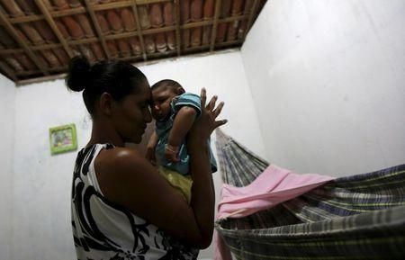
- Texas hospitals say they have developed rapid test for Zika
https://news.yahoo.com/texas-hospitals-developed-rapid-test-zika-180642480--finance.html

AUSTIN, Texas (Reuters) - Two major Texas health centers have developed what they are calling the country's first hospital-based, rapid test for the Zika virus that can produce results in a matter of hours, the hospitals said on Tuesday.
Researchers at Texas Children's Hospital and Houston Methodist Hospital developed the test that detects the genetic material of the Zika virus, which can speed diagnosis and treatment, they said in a statement.

"With travel-associated cases of the Zika virus becoming more prevalent in the United States, coupled with the looming increase in mosquito exposure during spring and summer months, we must be prepared for a surge of Zika testing demand,” said James Versalovic, pathologist-in-chief at Texas Children's and leader of test development team.

The test is designed to cut down on testing time, which can take days or even weeks. Typically, the testing would be done by state health agencies equipped to do so or federal authorities such as the U.S. Centers for Disease Control of Prevention.

Work on the test started in January and it is available only at the two hospitals for now. But the researchers are looking at allowing others to tap into its testing.
"We are definitely supportive of labs bringing up the ability to test for Zika virus across the state," Texas Department of State Health Services spokeswoman Carrie Williams said. The agency expects to augment its own testing abilities by the end of the week.

The Zika virus has been reported as having been transmitted by mosquito in Puerto Rico and the U.S. Virgin Islands, but in the continental United States the only cases reported so far are associated with travel abroad.

Brazil is worst hit in the current Zika outbreak, which has spread to more than 30 countries and territories, most of them in the Americas. The World Health
Organization declared a global emergency over Zika this month, citing concerns that it may be linked to a birth defect called microcephaly, a condition marked by unusually small heads that can result in developmental problems.

Much remains unknown about Zika, including whether the virus actually causes microcephaly.

Texas Children’s Hospital is a not-for-profit health care organization affiliated with Baylor College of Medicine, while Houston Methodist comprises an academic medical center in the Texas Medical Center and six community hospitals serving the Greater Houston area, according to the hospitals' websites.

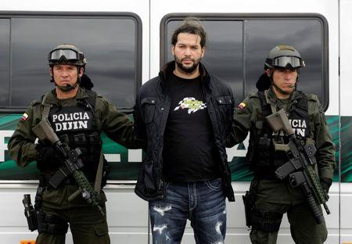
- Colombia drug cartel leader gets 25 years in U.S. prison
https://news.yahoo.com/colombia-drug-cartel-leader-gets-25-years-u-224814674.html

NEW YORK (Reuters) - The former leader of a violent Colombian drug cartel was sentenced on Tuesday to 25 years in a U.S. prison after pleading guilty to conspiring to import massive amounts of cocaine into the United States.
Ericson Vargas Cardona, 42, was sentenced by U.S. District Judge Loretta Preska in Manhattan, after pleading guilty last April of conspiring to traffic in cocaine and using a semiautomatic assault weapon in the process.

Vargas, who authorities said by the time of his capture by Colombian authorities in 2012 had risen to the top of the leadership of the drug cartel La Oficina de Envigado, said he had only himself to hold responsible for why he was in court.
Speaking through a translator, and clad in tan jail clothing, Vargas, who was extradited from Colombia in 2013, said that in the years since his capture, he had "come to be happy that life has come to an end."

Prosecutors said that from 2000 to 2012, Vargas was a member of La Oficina, which began as a debt collection agency associated with the paramilitary organization United Self-Defenses Forces of Colombia.

View gallery
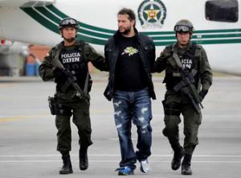

Colombian Erickson Vargas Cardona (C), also known as 'Sebastian,' is escorted by the Colombia police.

Authorities said La Oficina collected debts for drug traffickers and invested in drug shipments before eventually producing cocaine independently, and also engaged in systemic bribery of Colombian officials and violence.
Prosecutors said Vargas began working for La Oficina by stealing cars and eventually became an assassin.

He continued to rise through its ranks, and after his predecessor surrendered to authorities in 2009, became its leader, prosecutors said.
"Armed with machine guns, explosives, and a grenade launcher, Vargas Cardona distributed his drugs all over the world, including the United States," Manhattan U.S. Attorney Preet Bharara said in a statement.

Vargas' capture followed a lengthy manhunt that ended at a farm prosecutors said was used to store an arsenal of weapons and explosives, including 69 bars of C4 explosives, a rocket-propelled grenade launcher, and machine and sub-machine guns.

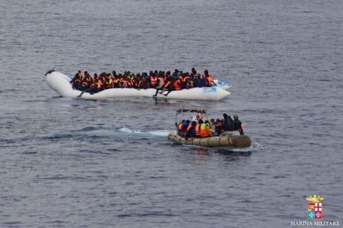

- War crimes, illegal refugee returns marred 2015 human righs: Amnesty
https://news.yahoo.com/war-crimes-illegal-refugee-returns-marred-2015-human-074106395.html

LONDON (Thomson Reuters Foundation) - At least 30 countries illegally forced refugees to return to places where they would be in danger last year, Amnesty said on Wednesday as it warned that many governments were brazenly breaking international law.

War crimes or other violations of the "laws of war" were committed by governments or armed groups in at least 19 countries, Amnesty said in its annual review of human rights around the world.

Amnesty Secretary General Salil Shetty said that short-term national self-interest and draconian security crackdowns had led to an "unprecedented assault on human rights" in 2015.

"Your rights are in jeopardy: they are being treated with utter contempt by many governments around the world," he said.

One of the most egregious examples of countries turning their backs on asylum seekers took place when human traffickers left thousands of people from Myanmar and Bangladesh adrift on the open seas without food and water.

Hundreds are thought to have died from thirst and hunger as countries in the region played "ping-pong in the sea" with them, Amnesty said.
In Europe, the report strongly criticized Hungary for sealing its borders to keep out thousands of desperate refugees and obstructing collective regional attempts to help them.

More than 1 million refugees and migrants arrived in Europe last year, many fleeing war zones. Amnesty said that, with the exception of Germany, the response to the crisis had been woeful.

"That Europe, which is the richest bloc in the world, is not able to take care of the basic rights of some of the most persecuted people in the world is shameful," Shetty said.

He called for the world to find legal and dignified ways for refugees to reach safety and said 1.2 million of them must be resettled without delay.

Around half the arrivals in Europe last year were from Syria, which Shetty described as a "human rights-free zone".

Amnesty condemned the killing in Syria of thousands of civilians in direct and indiscriminate attacks with barrel bombs and other weaponry and criticized lengthy sieges of civilian areas and the blocking of international aid to starving people.

It also said Saudi Arabia had committed war crimes in the bombing campaign it had led in Yemen and criticised it for obstructing the establishment of a U.N.-led inquiry into violations by all sides in the conflict.

"HIGH STAKES"
Shetty warned that not only human rights, but also the laws and institutions meant to protect them, were under attack.

Many African countries have threatened to walk out of the International Criminal Court, which was set up to end impunity for leaders who commit war crimes.

Countries hampering cooperation with the ICC include Kenya, Ivory Coast and South Africa, which ignored a court order last year to arrest Sudan's president.

Shetty also said too many governments were using the threat of violence from armed groups as an excuse to "take short cuts on human rights".
"The human rights of civilians cannot be sacrificed under some vague notions of combating terrorism," he said.

"Human rights are a necessity, not an accessory ... the stakes for humankind have never been higher."

Amnesty's annual review, which includes reports from 160 countries and territories, said there had been some gains for human rights last year.
Three countries - Madagascar, Fiji and Suriname - abolished the death penalty in 2015, and Mongolia is set to do so in 2016. Other countries launched national campaigns to end child marriage or passed laws to recognize same-sex relationships

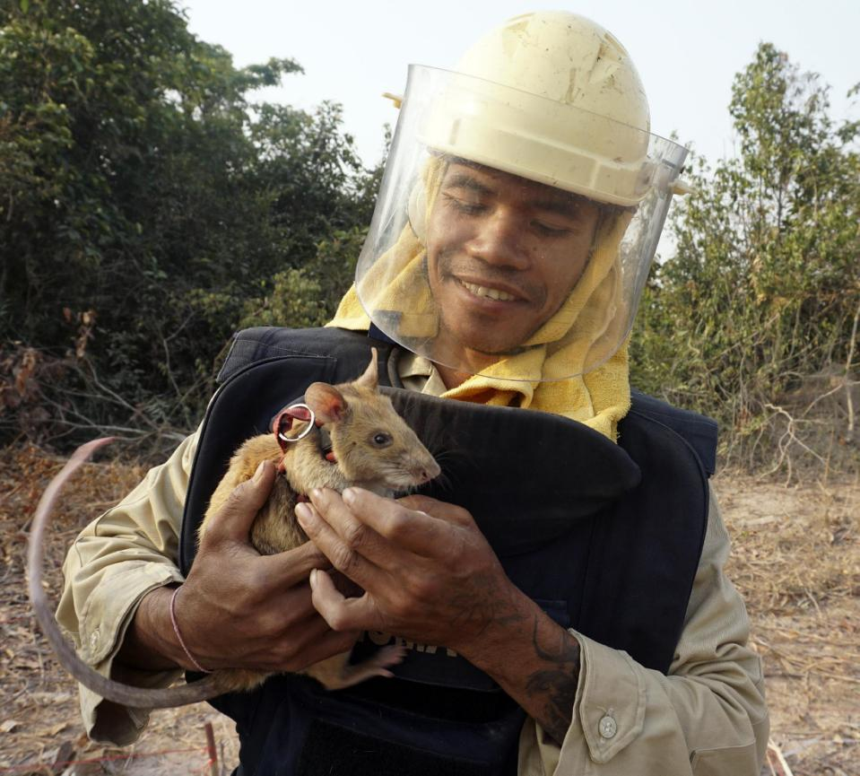
- Smart rats sniffing out Cambodia's vast mine fields
https://news.yahoo.com/smart-rats-sniffing-cambodias-vast-064251091.html

TRACH, Cambodia (AP) — It's been a busy morning for Cletus, Meynard, Victoria and others of their furry band. Tiny noses and long whiskers twitching, they've scurried and sniffed their way across 775 square meters (8,300 square feet) of fields to eliminate a scourge that has killed thousands of Cambodians: land mines.

Meet the Hero Rats: intelligent, surprisingly adorable creatures with some of the most sensitive noses in the animal kingdom. Sent from Africa, where they successfully cleared minefields in Mozambique and Angola, they began the same task in northwestern Cambodia early this month and have already scored tangible results.

Two hectares (4.4 acres) have been declared mine-free around this village where more than 15 people have been killed or wounded by the explosives, forcing some to abandon their homes and rice fields and seek jobs elsewhere.
One villager, Khun Mao, says the rats have been sniffing for suspected mines in a rice field he had been afraid to cultivate for years. He says that while it is too soon to say whether the rodents can remove every mine, "To me, these rats are wonderful."

"The villagers have started to get excited about farming their land again. You can see the light in their faces," says Paul McCarthy, Cambodia program manager for the Belgian nonprofit organization APOPO, or Anti-Personnel Land Mines Detection Product in English.

On a recent morning, the African giant pouched rats were working two suspected, taped-off minefields. Each rodent wore a harness connected to a rope strung out in a straight line between two handlers standing about 5 meters (15 feet) apart and outside the danger zone. The rodents then darted from one handler to the other, constantly sniffing the ground and only taking time out to scrub their bodies with tiny front paws or to answer nature's call. The handlers moved a step or two down the field to repeat the process, and a second rat was later sent over the same terrain to double check.

View gallery
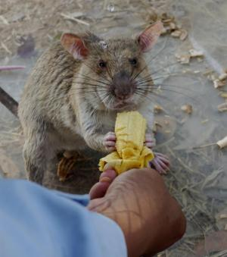

In this Feb. 19, 2016, photo, a landmine clearing rat gets a favorite reward - a banana - after a moment.

Two-year-old Victoria proved particularly swift — "very active," one team member calls her. She stars in APOPO's "adopt-a-rat" fund-raising drive.

At the second field, Merry and Meynard were completing three hours of effort as a midday sun beat down on the parched earth. The duo had earlier nosed in on an explosive, halting just above it and scratching the ground — the learned response when a rodent detects TNT inside a land mine. A deminer with a detector followed and the mine was dug up and detonated.

Unlike standard mine detectors, the super-sniffers pick up only TNT and not other metal objects. And unlike wage-earning humans, the rats work for peanuts — and their other favorite, bananas.

Theap Bunthourn, operations coordinator for the 34-member team, cited other advantages of using rats: They are cheaper to acquire and train than mine-sniffing dogs and easier to transport. Rats, averaging 1 kilogram (2.2 pounds), are also too light to detonate a pressure-activated mine, though dogs avoid that danger by staying a few feet away from the explosives they detect.
Each rat can clear an area of 200 square meters (2,150 square feet) in 20 minutes, something a technician with a mine detector would take 1 to 4 days to complete. Their sense of smell is so keen that in Africa they are also used to detect tuberculosis in human sputum samples at a rate much faster than the standard laboratory method.

View gallery
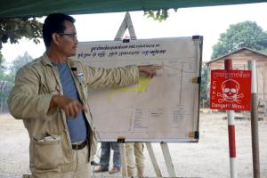

In this Feb. 19, 2016, photo, Theap Bunthourn, operations coordinator, describes the land mine threats.

Unlike dogs, the rats don't get attached to their handlers and thus can be rotated among many, Theap Bunthourn says. But McCarthy, an ex-British Army demolitions expert, recalls watching the student rats "following their trainers like puppies, stopping when they stopped."

Critics say that rats may offer a lower level of guarantee that an area is mine-free than man-and-machine techniques, that the animals cannot search well in thick vegetation and can only work for relatively short periods in the heat.

"I would never discard any asset that could prove useful, but I can't envision hordes of rats wiping out minefields in Cambodia," says Greg Crowther, who heads the U.K.-based Mines Advisory Group in South and Southeast Asia. One of half a dozen demining outfits operating in Cambodia, MAG employs Belgian shepherds and a variety of mechanical devices.

"I don't think they can add a whole lot to what dogs can do. But if they can speed up the pace of demining, great. Let's wait and see," Crowther says. He adds that there is plenty of work to go around: It will take up to 15 more years to clear the country's explosives.
McCarthy notes that there was skepticism about using dogs to detect landmines decades ago, "and look at them now."

View gallery
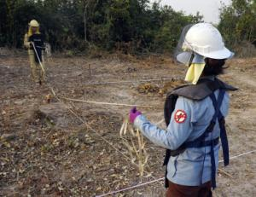

In this Feb. 19, 2016, photo, handlers So Malen, foreground, and Ok Chann guide Hero Rat Cletus across the field.

"As we accumulate more data, the more we break down the skepticism." McCarthy says APOPO, the only organization using rats, doesn't have the total solution for mine-clearing but just "one fantastic tool in the tool box."
The group was founded in 1997 by Belgian Bart Weetjens, who bred rats, hamsters and other rodents as a boy and developed the idea of using rats to find mines while at university.

Even Mark Shukuru was skeptical when he joined APOPO in 2001 at the group's headquarters in Tanzania. "At first I thought: 'Rats finding mines? It's impossible.' But they proved they could do it," he says, noting that in Mozambique they cleared more than 13,000 mines without a single injury, to humans or rats.
Shukuru shepherded the Tanzanian-born rats to Cambodia, one of the world's most heavily landmined countries, with up to 6 million mines or pieces of unexploded ordnance still left in the ground from decades of war. The mines at Trach were laid in the 1980s by Khmer Rouge guerrillas fighting the Vietnamese army.

Countrywide, about 67,000 people have been killed or injured since 1979, and with more than 25,000 amputees Cambodia has highest ratio of mine amputees per capita in the world, according to de-mining organizations. A mine accident occurs every 2½ days on average.

View gallery
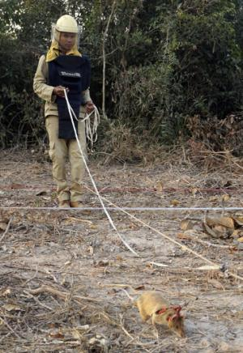

In this Feb. 19, 2016, photo, handler Ok Chann guides mine-sniffing African rat Cletus across a suspected mine field.

Training the Cambodian rat contingent — eight males and six females — began at age 4 weeks by getting them accustomed to humans. This was followed by a rigorous, 9-month-long boot camp in Cambodia with APOPO, supported by the Cambodian Mine Action Center, one of a half-dozen demining outfits in the country.

The rats learned to associate a click with a food reward before being taught to respond to the scent of TNT. When they indicated TNT by scratching, a click was sounded and food followed. Eventually the click became unnecessary.
Before going into the field, the recruits are tested: One missed mine, and they don't graduate to Hero Rats, registered as the trademark HeroRATs.
Now, they are falling into an operational routine, usually working six days a week and being somewhat pampered when off-duty, sleeping indoors in roomy individual cages on wood shingles and kept healthy by regular exercise walking on a leash or on a running wheel. They are given multivitamins and weighed twice a week (a fat rat is a lethargic rat; one keeper says).
On weekends there's a special feast of apples, potatoes, watermelon and carrots. But what really drives their mine-sniffing are bananas and peanuts.

View gallery

In this Feb. 19, 2016, photo, Cambodian team member So Malen plays with Cletus after he scampered across the field.

After the morning session, Victoria, Cletus and the others rested in portable cages near the mine fields while handlers offered them bananas, which they grabbed and greedily devoured. Grateful villagers gathered round the cages.
"It's not often you hear people say that they love rats," McCarthy says

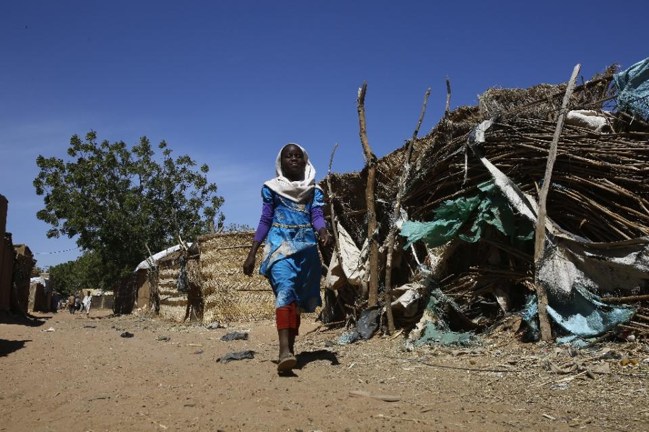
- In Sudan's Darfur, displaced children battle to learn
https://news.yahoo.com/sudans-darfur-displaced-children-battle-learn-072610175.html

Abuzar Camp West Darfur (Sudan) (AFP) - Abuobeida Ali was a toddler when militiamen stormed his village in Sudan's Darfur in 2003, murdering his father and driving his family out, ending his hopes for a normal childhood and education.
Now aged 17 and out of school for nine years, he is one of the more than 870,000 Darfuri children living in camps for the displaced who struggle to balance their studies with the need to survive.

"When we came here, I left school after four years to help my mother support my sisters who are studying," Ali said, sitting in the yard behind the hut he shares with his family in the Abuzar camp near West Darfur state capital Geneina.
Since leaving school, he has worked in a restaurant at the small marketplace set up in the winding, dusty alleys of the camp.

He works serving cheap meals and scrubbing plates from morning until sunset bringing in a daily salary of 15 Sudanese pounds ($2.50, 2.20 euros).
In West Darfur, where 30 percent of children are out of primary school, Ali's meagre salary helps to allow his four younger sisters to attend two government-run primary schools that serve the camp.

"I want to go back to school, but circumstances..." he said, his voice trailing off.
- 'Lost childhood' -

View gallery
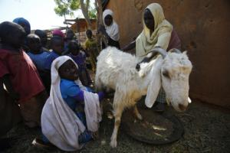

Sudanese girl Darussalam Abdel Gadoos, 10, milks a goat at the Abuzar camp near West Darfur state capital.

Ali's home village of Nuri -- dominated by the Masalit ethnic group he hails from -- was one of the first attacked in the 13-year Darfur conflict.

Ethnic minority insurgents rebelled against the Arab-dominated government of Omar al-Bashir in 2003, saying their region was being marginalized.

The Arab-dominated government unleashed ground forces and allied militia to crush the rebels, with villages like Ali's torched and 2.5 million people driven from their land in the ensuing fighting.

Now 1.4 million live in camps for the displaced, more than half of them children.
They risk a "lost childhood," a spokesperson for the United Nations' children's agency (UNICEF) told AFP.

Clashes in Jebel Marra in the heart of Darfur that erupted on January 15 have displaced another 82,000 people, 60 percent of them children.
Sudan's conflict-stricken peripheries "have amongst the highest levels of malnutrition, lowest vaccination coverage, highest percentage of children out of school and highest levels of child mortality," according to UNICEF.

View gallery
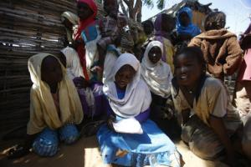

Abdel Gadoos was keen to show off what she had learned in school, laughing and chanting her times table.

UNICEF said under-18s "unfortunately continue to bear the biggest burden of one of the most protracted man-made disasters."

In a bid to persuade children like Ali to stay in education, the UN's World Food

Program provides nearly 600,000 Darfuri children with meal assistance.
The plates of lentils or fava beans are provided in schools so parents do not have to cover the costs of meals and pull children out to work.

- 'Most stop studying' -

Two thousand children in Abuzar -- one of Darfur's smaller camps with about 17,000 residents -- receive this support, among them 10-year-old Darussalam Abdel Gadoos.

Her family fled an attack on their village three years before she was born.
Dressed in a bright blue dress and gleaming white headscarf, Abdel Gadoos was keen to show off what she had learned in school, laughing and chanting her times tables in a lilting voice in a courtyard among the camp's densely packed shacks.
She has already seen many of her classmates leave the government-run school she attends next to the camp.

"Our class is full of boys and girls, there are about 115 of them but most stop studying," she said.
She has been receiving the food assistance in class from the WFP and her father -- a community leader in the camp -- said it has helped her.

"Lots of children don't go to school because of their circumstances, the father doesn't work, like me -- I work one day and then wait a few more without any job," Abdel Gadoos Atim said.

With nine other children to feed, Atim said conditions are difficult for his family, but he wants Abdel Gadoos to stay in school.

His daughter helps the family outside school hours, tending to the goat they keep on a patch of dirt near their home.

But she is determined to continue her studies, and has already decided on a career.

"I want to become a teacher," she smiled

- Teenage voices from around the world
https://news.yahoo.com/teenage-voices-around-world-064432022.html
Paris (AFP) - For teenagers the world over, life is often an edgy, even volatile balance -- do you live for the moment or plan for what's ahead, chase the ideal or focus on the pragmatic?
From one continent to another, their priorities are strikingly similar -- friends, studies, family, future -- but their worries are often shaped by where they live.
As part of our series on teenagers, we asked a random selection of middle-class youngsters from various capitals how they see their world.
Anthika, 18, Bangkok
Being a teenager in one of the world's most vibrant capitals is a thrill, says Anthika, but she admits to worrying about the impact of globalization on Thai culture.
Her generation has led Bangkok's transformation into social media hotspots and Anthika enjoys how sites such as Facebook and Instagram keep her in touch with her peers and the easy access to information.
But, she adds: "Our values (as teenagers) are more materialistic, people want big cars and motorbikes from parents. Maybe it is the influence from other countries."
This first-year psychology student fears that with everyone glued to their gadgets, there is a danger teens are losing their way.
"People nowadays use so much social media that they forget to interact with people in their own families," she says. "They often don't go to temples...They interact less with older people."
Katinka, 17, Berlin
Katinka is representative of a new Germany that is open to the world, and welcomes the arrival of hundreds of thousands of refugees to her country.
She views the future with an optimism, in a country often weighed down by its war past.
"I think that we are ... becoming more tolerant towards all kinds of minorities. We have not reached the goal of course but we are on the right path," she says.
What she does not like about the world today is "hate, and all the things it causes, such as racism, sexism and all other kinds of humiliation."
Like many other teenagers, Katinka is focused on "handling school and keeping my relations up while still graduating with good grades."
"But I also worry what may come after school. What will I study? Will I get a good job? Will I be able to 'succeed' and do I want that?"
Jedidiah, soon to be 13, Lagos
For Jedidiah, who lives in an upmarket suburb in Africa's biggest city, the priority is getting the best education she can. "And having fun!"
There are not many places for teenagers to go out in Lagos. "But we go to the cinema and we have sleepovers at friends," says Jedidiah, who also enjoys making music videos on a smartphone app.
In this megacity, where crime is an ever-present fear, there is no chance of going anywhere without a chaperone as youngsters elsewhere might do. "I am afraid of getting kidnapped," says Jedidiah, adding how much she hates what Boko Haram Islamists are doing to her country.
"I wouldn't want to stay in Nigeria," she adds. "I would like to become an architect or a fashion designer and go around the world."
Elad, 14, Tel Aviv
Elad dreams of a "less hateful world" and thinks the solution is that "each country calms hatred in its own territory, or makes it illegal." Afterwards, "we talk to one another to make peace," he says.
This young man, who faces compulsory military service in four years, is not yet too worried about the wars "far away".
"I'm afraid of an attack outside my home, murders of Jews, because we are Jewish," he says.
But his most immediate concern is that Beyonce does not cancel her upcoming show in the face of pressure by anti-Israel campaign.
"If we are boycotted because of hate toward us and she cancels the concert, it will be annoying," he says with a sigh.
Florencia, 15, Santiago
"What matters to us right now is going out and having a crazy time! Hanging out with other young people smoking on the town squares," says Florencia, a high school student on the outskirts of Santiago.
But she worries that youngsters her age are growing up too quickly in the Chilean capital. "You see girls of 12 in the street with makeup and dressed like grown women."
"I don't like that there are so many cases of paedophilia. And I don't like that now that young people nowadays are more agitated, we want everything right now, quick," she says.
Florencia sees a world where one day "children will no longer be children, they will skip that step."
"But all the same, diversity and new ideas about conservation make me think there will be a better future where we can live in harmony with nature," she said.

Articles used for this educational lesson come from:
https://www.yahoo.com/

