From: Rick
To: IELTS Prep Group
Subj: IELTS Speaking lesson 5-19-2016

Lesson Objective
The student shall be able to learn and use new vocabulary, and develop critical thinking skills through timed speaking.

First Portion
Word Puzzles

Evaluation Criteria
- Correctly identify words in the attached puzzles, and use words in a complex sentence.

EXERCISE ONE
EXERCISE TWO

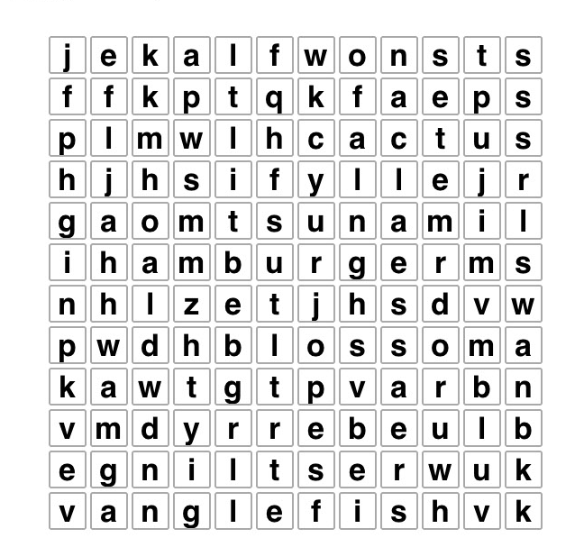

SCRAMBLE
Descramble the words below. Hint, words relate to Dreams ‘N Motion goals

- LVATRE ___________
- NFIESST ___________
- LENIGHS ____________
- TINUY____________
- LGOSA__________
- CUTEDAOIN_________
- REAMD N TONIMO_________
- ECRAER__________
- CHAVIEE__________
Second Portion
Timed Speaking

Evaluation Criteria
- Ability to use critical thinking skills, communicate effectively on randomly selected topics. Able to use an in depth lexicon, correct grammar and pronunciation and overall coherency in speech.

Exercise
- Students will be assigned random topics, given 60 seconds to think about it, then 2 minutes to speak.

- What is your idea of a perfect day?
- Name and talk about the top three goals you have?
- When it comes to friends, quality is more important than quantity. Is this a true statement to you?
- Exercise is more important than eating right, is this true? And why?
- What is your favorite leisure activity, and why?
- Your teacher should be someone you can trust, is this true? And why?
- Success has nothing to do with luck, it’s all about working hard, is this true? And why?
- Saving your money for the future is more important than spending it now and enjoying your life, is this true? And why?
- Developing your leadership skills is more important than developing your team work skills. Is this true? And why?
- Why are traditions important?

