Name _{(last,first,m)}_______________________
___________________________________

Address_____________________________

City _______________St____ Zip________
Driver License # ______________________

RANGE OPERATION/SAFETY RULES

Safety is always our major concern. Please read all of our range rules carefully as they will be strictly enforced. It is not our intention to inconvenience anyone in anyway, but maintaining a safe environment for all is our number one priority. Anyone violating a safety rule or range procedure is subject to being barred from the PDHSC facility.

BASIC SAFETY RULES:
1. Always keep the gun pointed in a safe direction.
2. Always keep your finger off the trigger until ready to shoot.
3. Always keep the gun unloaded until ready to use.
4. Be sure the gun is safe to operate.
5. Know how to use the gun safely.
6. Use only the correct ammunition for your gun.
7. Know your target and what is beyond.
8. Wear Eye and Ear protection as appropriate.
9. Never use alcohol or drugs before or while shooting.
10. Store guns so they are not accessible to unauthorized persons.

Additional, PDHSC SAFETY RULES:
- ABSOLUTELY NO HANDLING OF LOADED FIREARMS WILL BE ALLOWED ANYWHERE IN THE BUILDING EXCEPT IN A SHOOTING LANE.
- Anytime you transfer or hand a firearm to another individual, it should be unloaded, action open and presented grip first (without pointing the muzzle at anyone) so that the receiver can verify that it is unloaded.
3. For your safety, commands issued by Range Officers and Range Personnel must be obeyed immediately and without question.
4. The range is always considered "HOT" unless declared otherwise. This means that firing may commence at any time, you are free to handle your firearm, and everyone must remain behind the firing line.
5. When the command “CEASE FIRE” is given by anyone:
* Stop shooting IMMEDIATELY, Remove your finger from the trigger
* Keep the gun pointed in a safe direction, Wait for further instructions
6. No one other than PDHSC Range personnel may go forward of the firing line unless authorized or instructed to do so by the Range Officer.
7. Anyone using offensive language, abusive behavior or in any way a nuisance or distraction
to others will be warned once. A subsequent offense will result in being barred from the
facility.
8. Eye and Ear protection must be applied before entering the range and must be worn at all
times while on the range.
9. Expecting Mothers should not participate in range activities due to NOISE and possible LEAD
Exposure.

PDHSC RANGE OPERATIONAL PROCEDURES
1. All federal, state, and local firearm laws must be obeyed.
2. Owners of Class III firearms must be in possession of any special permits or paperwork required by law. Notify the range officer before firing Class III firearms.
3. Range officer will assign a numbered lane. No one will be allowed to change lane positions
unless authorized by range officer.
4. You will be required to surrender membership card and drivers license for lane assignment.
Upon leaving the range, cards will be returned.
5. All loading/unloading must be done on the range in a firing lane.
6. Firearm and ammunition must be compatible. Only one firearm and the compatible ammunition is permitted in the firing lane at one time. Additional firearms (unloaded with
the action open) and compatible ammunition must be kept on the bench to the rear of the firing position.
7. Only our targets may be used.
8. Use the appropriate size target, place at eye level, to ensure that your shots strike the backstop and not the floor, ceiling or target holder. Small targets should be taped to larger targets to minimize the chance of hitting the target carrier. Intentionally Firing a shot that results in the bullet striking anything other than the target and/or backstop, at the discretion of the range officer, may result in a damage or repair fine and/or your removal from the range.
9. Firing at targets not in your lane is prohibited.
10. You may draw from a holster and fire only after obtaining authorization to do so from the
range officer. Shoulder holsters and cross-draw holsters may not be used.
11. Malfunctions
• Keep the firearm pointed down range and wait at least 30 seconds before
clearing the jam or notifying a range officer.
• If you need assistance clearing the malfunction notify a range officer.
• Do not take jammed or malfunctioning firearm away from the firing point.

RANGE OCCUPANTS
1. Persons under 18 years of age must be accompanied by a parent or legal guardian, who
must remain with the under age member at all times while in the firing area.
2. PDHSC Inc., reserves the right photograph or videotape all patrons.
3. Food, beverages, and smoking are prohibited on the range.
(Smoking is prohibited throughout the building.)
4. Always wash your hands and face immediately after shooting and/or cleaning your firearm.
5. Only one member and guest (range officer discretion) are permitted per firing lane.
6. Guests of Gold Members are limited to 2 free visits per year.
7. Only authorized members and guests assigned to a firing lane are permitted on the range.
(spectators are to remain in the observation area behind the ballistic glass)

FIREARMS and AMMUNITION
1. All Standard handgun calibers are permitted. High powered rifle calibers are prohibited.
Any questions pertaining to firearm/caliber should be directed to the range officer.
2. Tracer, gas, steel core, incendiary, explosive or armor piercing ammunition is prohibited.
3. Hand Reloaded Ammunition is permitted for use by you and in your own firearms only.
4. No muzzle loading firearms may be fired on the range.

* Please initial here to confirm that you have read and agree to abide by the safety rules and regulations. Initials _____
Please take a few minutes and fill out the Range Safety Test to help us identify any areas of concern or safety that we need to clarify.
(Please circle the correct answer or put question mark next to any question that you are unsure about to give us the opportunity to discuss the correct answer)

1. Which of the following is not one of the three fundamental gun safety rules:
a. Always keep the gun pointed in a safe direction.
b. Always keep your finger off the trigger until ready to shoot.
c. Always keep the gun unloaded until ready to use.
d. Always clean your firearm after use.

2. What direction(s) is /are considered safe to have a gun pointing while on the range?
a. down range (only) b. down at your feet c. up at the ceiling

3. When shooting, you should:
a. always make sure you are using the proper ammunition for your gun.
b. wear eye protection.
c. wear hearing protection.
d. All of the above

4. When a cartridge fails to fire immediately, you should:
a. put the safety on and lay the firearm down.
b. keep the firearm pointed in a safe direction and, after waiting at least 30 seconds, open the action and remove the cartridge or notify range officer. (hint)
c. open the action immediately and inspect the cartridge to determine the malfunction.

5. Circle the example of the proper sight alignment for a firearm with open sights:

6. The safety on a firearm:
a. when activated, guarantees that the gun will not fire.
b. is found only on semi-autos.
c. is a mechanical device that can fail and is not a substitute for safe handling. (hint)
d. makes it impossible to pull the trigger.

7. When aiming, you should focus on the ____________ so that it appears sharp and clear.
a. rear sight
b. target
c. front sight (hint)
d. bullseye

8. Identify and label the parts indicated on the handguns shown below:
(a)Barrel, (b) muzzle, (c) trigger, (d) hammer (write the correct letter next to the correct part)
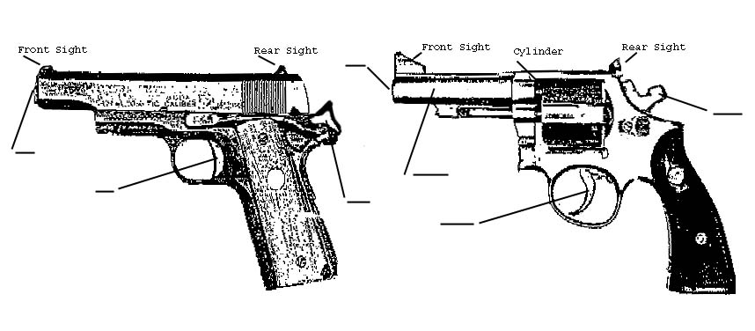

9. Number the boxes 1 thru 4 listing the proper sequence to safely unload a semi-automatic pistol with a detachable box magazine:
Cycle slide to the rear of the firearm ejecting the chambered cartridge.
Press the magazine release button and remove the magazine.
1 Keeping the muzzle pointed in a safe direction grasp the firearm firmly.
Visually and physically inspect the chamber to assure that it is unloaded.

10. Your finger should be on the trigger:
a. only after the gun is loaded.
b. after you are safely set-up on your firing point and the gun is pointed down.
c. only when your sights are on the target and you are ready to fire. (hint)

(True or False) circle one
11. T F The muzzle of the firearm should always be pointed in a safe direction. Even
when the firearm is unloaded.

12. T F When shooting, you should always know your target and what is beyond it.

13. T F When gripping a semi-automatic pistol with both hands, you should always keep both thumbs on the same side of the gun to keep clear of the movement of the slide.

14. T F Anytime you hand a firearm to another individual, it should be unloaded, action open, and presented grip first (without pointing the muzzle at yourself or anyone else) so the
receiver can verify that it is "clear" and "unloaded".

15. T F To minimize the noise in the lobby when entering or leaving the firing ranges only one
of the air lock doors should be opened at any one time.

16. T F Only one firearm and the proper ammunition for it are allowed in the shooting booth at any one time. Additional firearms and ammo can be kept on the rear bench.

