Customer Ergonomics Website Work

Note that the screen shot for each example below is actually a link to our client’s live websites which have been continuously updated since our initial work.

Financial Services – Total site redevelopment; customer experience, competitive analysis, architecture, technology recommendations, design and implementation.

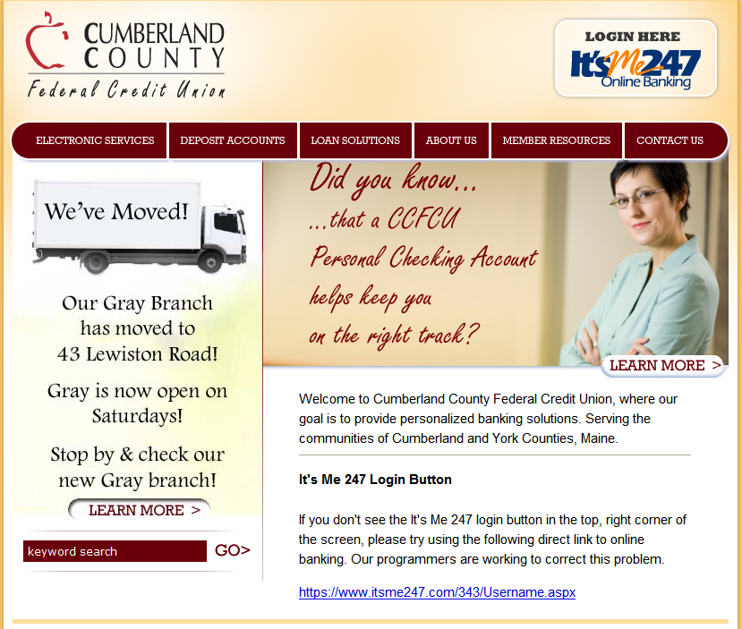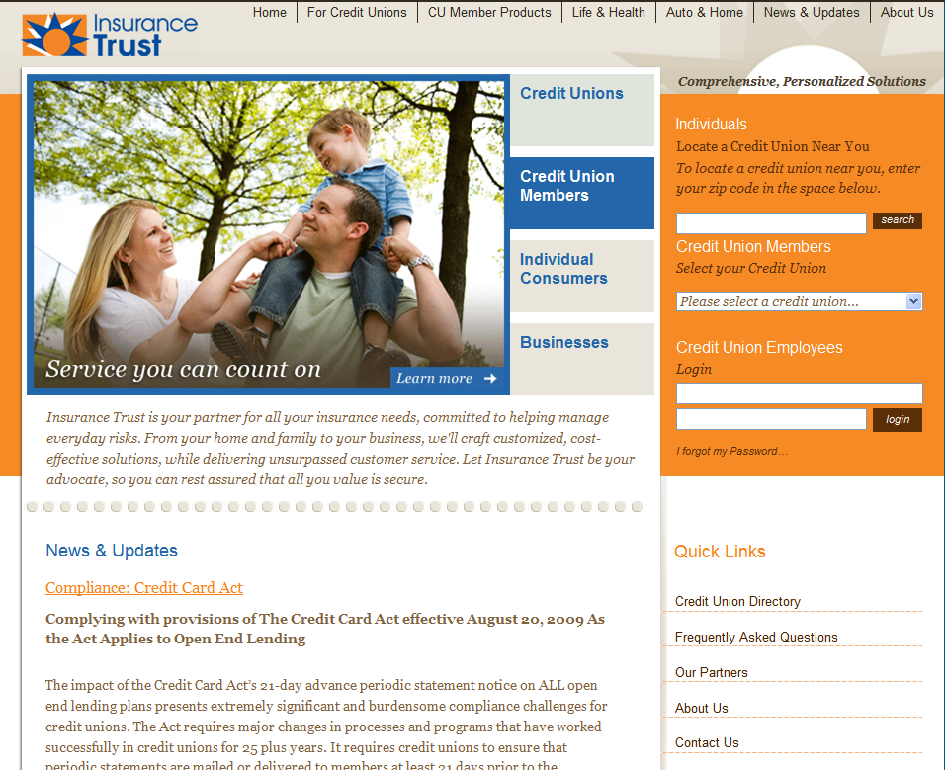

Medical Supply Company

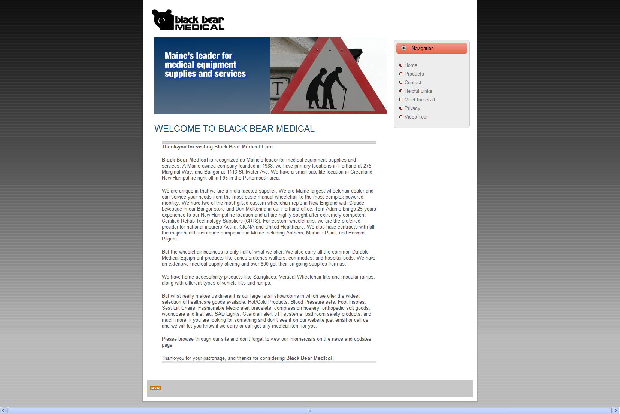
High End Luxury Good – Maine Distilleries; Total site redevelopment for Cold River Vodka

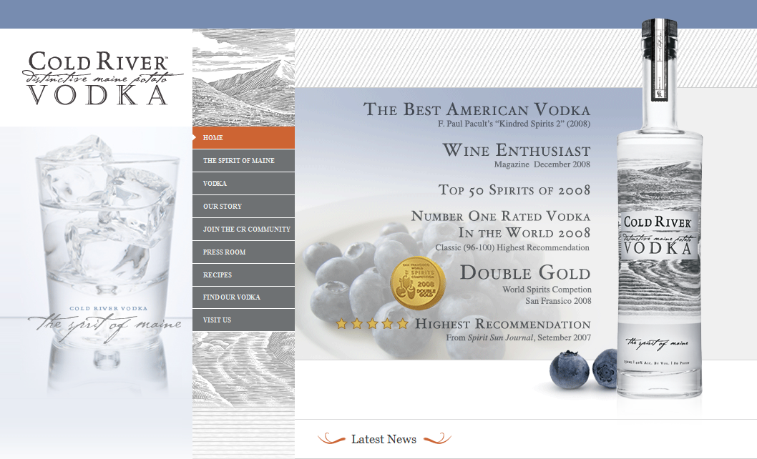

Travel Sites
Mahoosuc Guides – Cleaned up using their design and contents. Visits skyrocketed.

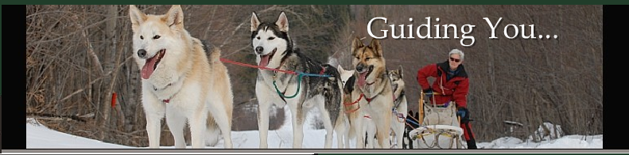
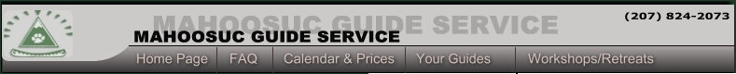
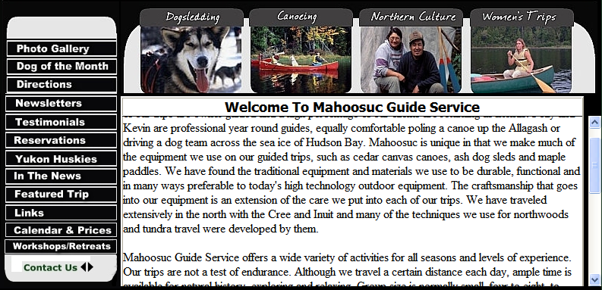

GORP – Great Outdoor Recreation Pages. Early internet travel portal. Created from scratch, beginning with customer research.
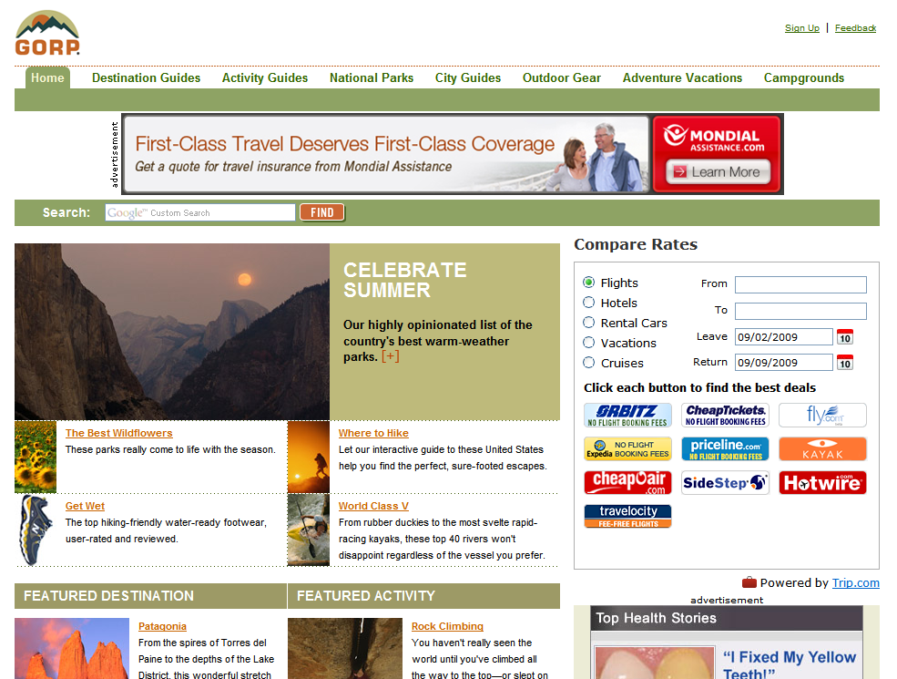

Maine Wilderness Guides – Redesign & revision of old site
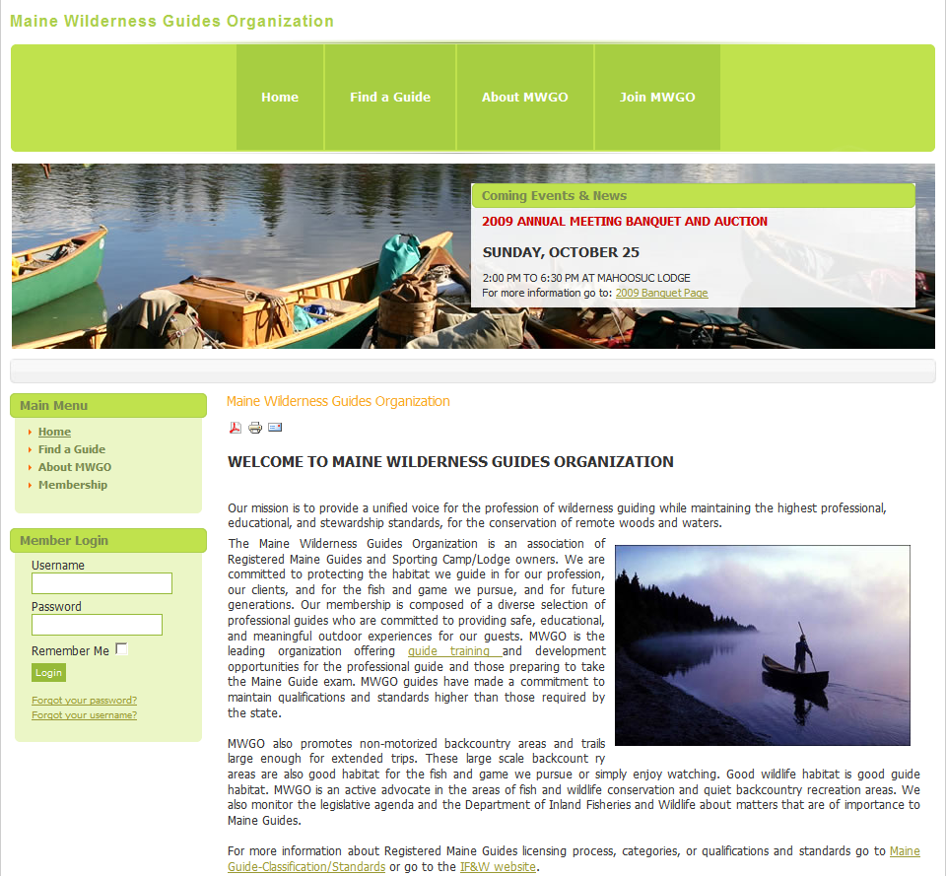

Hurley Travel Experts – Complete site rebuild. Created user based Personas & Scenarios, conducted competitive review, wrote developer Request For Proposal, selected provider and managed entire site build – Graphics, Search Engine Keywords, User Experience (UX).

