Comenius Bilateral Partnership

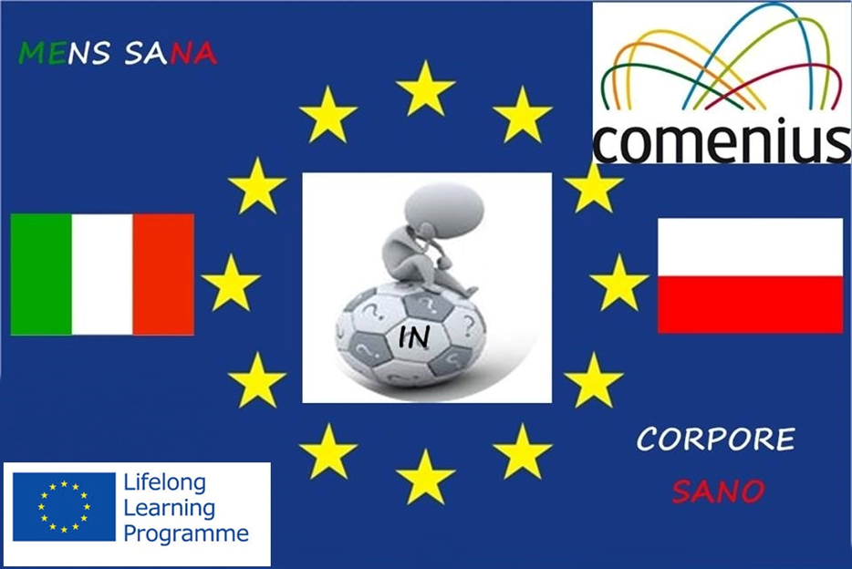

MENS SANA IN CORPORE SANO- ADDICTION SURVEY

Place of residence:
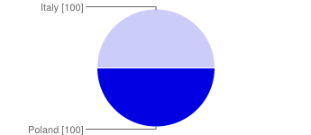
Poland | 100 | 50%
Italy | 100 | 50%

Sex:
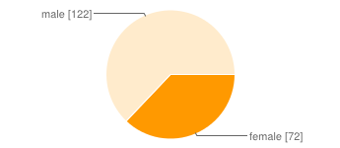
female | 72 | 36%
male | 122 | 61%

Year of birth:
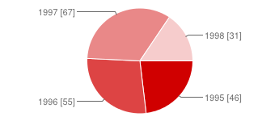
1995 | 46 | 23%
1996 | 55 | 28%
1997 | 67 | 34%
1998 | 31 | 16%

Have you ever drunk alcohol:
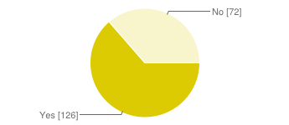
Yes | 126 | 63%
No | 72 | 36%

What kind of alchol do you drink most frequently:

I don't drink alcohol | 75 | 38%
beer | 82 | 41%
wine | 52 | 26%
coctails | 54 | 27%
vodka | 62 | 31%
Inne | 12 | 6%

How often do you drink alcohol?
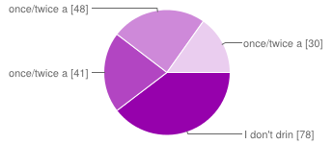
I don't drink alcohol | 78 | 39%
once/twice a year | 41 | 21%
once/twice a month | 48 | 24%
once/twice a week | 30 | 15%

What is the reason why you choose to drink alcohol:

I don't drink alcohol | 76 | 38%
to have fun | 65 | 33%
I get persuaded by friends | 52 | 26%
I feel lonely and unhappy | 32 | 16%
I want to relieve stress | 20 | 10%
Inne | 5 | 3%

Have you ever been intoxicated by alcohol:
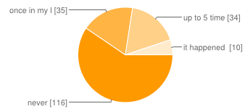
never | 116 | 58%
once in my life | 35 | 18%
up to 5 times | 34 | 17%
it happened many times | 10 | 5%

Where do you drink alcohol most frequently:

I don't drink alcohol | 82 | 41%
at parties/disco | 69 | 35%
in a pub | 65 | 33%
Inne | 17 | 9%

Are you aware of the effects of drinking alcohol on your health:
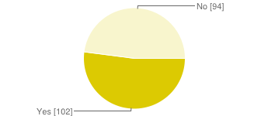
Yes | 102 | 51%
No | 94 | 47%

Have you ever smoked a cigarette:
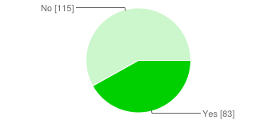
Yes | 83 | 42%
No | 115 | 58%

How often do you smoke cigarettes:
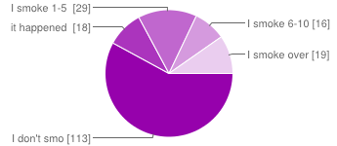
I don't smoke | 113 | 57%
it happened only once, just to try it | 18 | 9%
I smoke 1-5 cigarettes per day | 29 | 15%
I smoke 6-10 cigarettes per day | 16 | 8%
I smoke over 11 cigarettes per day | 19 | 10%

What is the reason why you choose to smoke cigarettes:

I don't smoke | 119 | 60%
I want to be noticed | 35 | 18%
to relieve stress | 44 | 22%
Inne | 5 | 3%

Who do you smoke cigarettes with:

I don't smoke | 119 | 60%
with friends | 65 | 33%
I smoke alone | 33 | 17%
Inne | 2 | 1%

Where do you smoke cigarettes:

I dont smoke | 119 | 60%
at a party/disco | 55 | 28%
in a pub | 40 | 20%
Inne | 8 | 4%

Do you think you are aware of the effects of smoking cigarettes on your health:
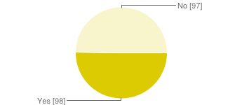
Yes | 98 | 49%
No | 97 | 49%

Have you ever taken cannabis(marihuana)
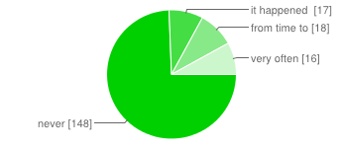
never | 148 | 74%
it happened only once, just to try it | 17 | 9%
from time to time | 18 | 9%
very often | 16 | 8%

Have you ever taken any other types of drugs
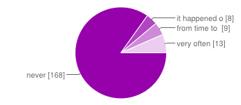
never | 168 | 84%
it happened only once, just to try it | 8 | 4%
from time to time | 9 | 5%
very often | 13 | 7%

https://www.facebook.com/l.php?u=https%3A%2F%2Fdocs.google.com%2Fforms%2Fd%2F1STRcyI-Ht3KtTfrh1nRaCdFMZpKdQo200MD9vgzFWTs%2Fviewform%3Fusp%3Dsend_form&h=4AQHAulAj

