UNIVERSITY OF PORT HARCOURT

FACULTY OF BIOLOGICAL SCIENCES

A

SEMINAR REPORT

ON

CONSERVATION OF WILDLIFE : PROTECTING ENDANGERED FAUNA IN NIGERIA

In partial fulfillment of requirements for the degree of

Bachelor of Science

In

ANIMAL AND ENVIRONMENTAL BIOLOGY

SUBMITTED BY
Igbanibo B. Isaac
U2014/5550059

COURSE CODE : AEB 481.2
COURSE TITLE : SEMINAR
CORDINATOR : PROF(MRS) I.O.F. NDUKA
SUPERVISOR : DR. A.O. NUMBERE

MAY, 2018

DEDICATION

I dedicate this work to the eternal Rock of Ages, without whom all my abilities and efforts would be mere juvenile frivolities.

ACKNOWLEDGEMENT

I appreciate the fatherly support of Dr. A. O Numbere, my lecturer who not only went through this report to make it what it is but also provided me with professional support.

I can not thank my parents enough, Mr.&Mrs. Isaac B. Igbanibo for the financial support they rendered to me.

ABSTRACT

An endangered species is a population of organisms, which are at high risk of becoming extinct either due to loss of habitat, high death rate or changes in environmental and predation parameters. An organism is termed an endangered species if its population has become small such that free mating and reproduction becomes difficult. Environmental degradation, climate change and changes in prey-predation ratio are some of the factors driving many species to extinction today. Without adequate protection, a preservation or conservation measure, an endangered species finally goes into extinction, that is, permanent disappearance from the earth surface. Such species are never seen alive again in this world except in form of fossil (remains) only. In this report, in-situ and ex-situ type of conservation were examined as well as some measures that can be employed in saving some endangered fauna in Nigeria from extinction. This report also recommends adequate documentation and publicity of the species for conservation and preservation.

TABLE OF CONTENTS
1.O. Introduction

2.0. Nigeria's dwindling wildlife

3.0. Wildlife fauna resources in Nigeria
3.1. Other endangered fauna in nigeria

4.0. Why preserve endangered species
4.1. Bio regulators
4.2. Medical use
4.3. Generate revenue

5.0. Why the extinction of wildlife
5.1. Destruction and loss of wild habitats
5.2. Pollution
5.3. Excessive haunting and poaching

6.0. Wildlife conservation
6.1. Exsitu conservation
6.1.0. Zoos
6.1.1. Aquaria
6.1.2. Gene bank
6.2. In situ conservation
6.2.0. Games reserves
6.2.1. National parks
6.3. Cultural conservation

7.0. Technology in conserving endangered fauna
7.1. Smart collars
7.2. Remote control photography and videos
7.3. High-tech fish hooks
7.4. Beehive fences
7.5. Conservation drones

8.0. Conclusion

9.0. Recommendation

10.0. References

1.0 INTRODUCTION

Traditionally, wildlife is used to refer to non-domesticated vertebrate species, i.e. animals that are out of the direct control of man, existing in the wild. These wild animals exist in all ecosystems including deserts, forests, plains and grasslands.
Environmentally conscious activists in recent times have protested against the exploitation of wild animals for human benefit or entertainment . The modern man especially is known for his high appetite for exploiting wild populations in the environment. Anthropology has also shown that the stone- age people depended on wildlife- both plants and animals for their food. This thus, implies that these early human hunters may have hunted some species to extinction. In a more similar fashion, the rate of disappearance of entire species of plants and animals across the planet has been so high in the last few centuries. Exploitation of wild animals does not always lead to extinction of the species in question, but the dramatic loss of entire species across the earth necessitates the review of destruction of wild animals and their habitats.
The death rate of such organism far outweighs its birth rate over a period of time resulting to a decline in its population. Some common examples of endangered animal species include African Elephant, Tiger, Lion and Cheetah

Available literature has shown that today’s human activities are an empirical evidence of humans ruining what nature has bestowed to their care for sustainability. Westing, Warwick and Renner (2001) reported that man more than ever before is encroaching extensively upon what remains relatively of wild nature all over the world. Forests are being exploited and cleared, and converted into croplands with intensified use. As various human activities exert pressures on the global environment, biological diversity declines as habitats are being transformed. In Nigeria, twenty one of the known bird species are facing serious threat of extinction or loss of habitat. The situation is worrisome as two of these species-Anambra Waxbill and the Ibadan Malimbe exist only in Nigeria and nowhere else in the world. So also, with the increase in human population and cattle population for meat in most countries, there is continuous pressure exerted on forest resources causing fragmentation and degradation of wild animal habitats.

In Nigeria, some governmental Agencies and non-governmental agencies like the Nigerian Conservation Foundation (NCF), the Federal Environmental Protection Agency (FEPA), the National Resources Council (NARECO) in collaboration with the United Nations Environmental Programme (UNEP) and the World Wide Fund (WWF) and several other agencies have embarked on programmes to protect and preserve the nation's biodiversity. Nonetheless, the nation's set goals of managing wild animals for tourism, maintenance of ecosystem balance, justifiable cropping of game meat and protection of our national heritage have been difficult to achieve, when we keep facing new and mounting economic problems, a rapidly growing population, and the consequent continuous destruction of wild habitat.

2.0 Nigeria's dwindling wildlife

The peculiarity of wildlife in Nigeria is highly disturbing, calling for urgent action, especially when one considers that the level of wildlife literacy in the country is next to none. With reference to last two year’s World Environment Day, June 2016, Amina Mohammed who until her recent UN’s appointment was the Minister of Environment said, “The status of wildlife in the country leaves much to be desired, as the rate of depletion of the population of animals like the elephants, leopards, giraffes and crocodiles amongst others is frightening. Today I know that if somebody says, what is really the status, or figures for wildlife in Nigeria? I am not sure I can tell you as the Minister of Environment. And if I am going to say something, it is probably 10 years old in terms of its information and data.”

It almost two years after Amina Mohammed promised that the government would develop the capacity to know what the baseline was, what animal was where, which was endangered, what needed to be done to protect those animals and to increase their population in Nigeria for the sake of the wildlife. The truth today is that presently Nigeria’s wildlife is fast disappearing than before, thus, begging the question of what wildlife heritage our generation will preserve.

For long, Nigeria has rested on an erroneous notion that our wild animals were plentiful and not under any threat of extinction, however, following the recent publication of the IUCN red list of globally threatened species which revealed that 148 animal and 146 plant species found in Nigeria were threatened at various degrees including some species near extinction, we hope it is not too late to right the wrongs. Out of the very large landmass that Nigeria boasts of, we are not assured of the functionality of our seven National Parks, we are not sure they really are a refuge for what we have left of our wildlife population, we are yet to see wisdom in prioritising our wildlife heritage, we have chosen not to take a cue from smaller countries like Gabon with 13 well-managed national parks, Egypt with 25 national parks and Kenya with 23 national parks only aside game reserves, wildlife sanctuary and other forms of protected areas in countries like Botswana, South Africa, Tanzania and Madagascar are clear examples for Nigeria to follow.

3.0 Wild Fauna Resources in Nigeria.

Nigeria is rich in wild fauna resources, and can therefore boast of a high biodiversity. There are 22,000 vertebrate and invertebrate species, about 20,000 insect, 1,000 bird, 1,000 fish, 247 mammal and 123 reptile species. The diversity of Nigeria’s wild animals can be attributed to the country’s tropical location, size and its ecosystems . These varieties of ecosystems range from rainforests in the south to moist savannas in the central part of the country and dry arid savannas in the far north. There are also freshwater, brackish and marine ecosystems occurring, while features of montane vegetation have been found at high altitudes in the eastern borderlands. The country’s rich fauna is also as a result of the diverse vegetation types of these ecosystems.
There are mammalian species such as the African Elephants (Loxodonta africana), African buffalo (Syncerus caffer) and hippopotamus (Hippopotamus amphibius) existing in the rainforest. Other large mammalian species found here are the large duikers (Cephabius niger), Chimpanzee (Pan troglodytes), and red river-hog (Potamochoerus porcus). The savannah areas house species such as the hartebeest (Alcephalus buselaphus) and warthog (Phacochoerus aethiopicus) and most of the carnivores. Grass cutters (Thryonomys swinderiannus), Giant rats (Cricetomys spp.) and tree squirrels (Funisciurus spp.) are among the vast variety of small mammals that exist in the savannahs as well as a range of primates. The lowland rain forest provides habitat also for about 200 species of birds (FAO, 2000). Four of the bird species; Anambra waxbill (Estrilda poliopareia), Ibadan malimbe, (Malimbus ibadanensis), Jos Plateau indigo-bird (Vidua maryae) and the Rock Fire-Finch (Lagonosticta sanguinodorsalis) are endemic to the country, making them globally important species for conservation.Wild bird species were found to be relatively abundant where there is dense tree vegetation according to a study on the Dagona-Waterfowl Sanctuary in Borno state, Nigeria.
Nigeria is also noted as a global hotspot for some species of primate. A great diversity of this is found especially in the Gulf of Guinea forests of Cross River State. Some of these species are endemic to Nigeria, like the white-throated monkey (Cercopithecus erythrogaster), Sclater’s guenon (Cercopithecus sclateri) and the Niger Delta red colobus (Procolobus pennantii epieni).

Cross river gorilla

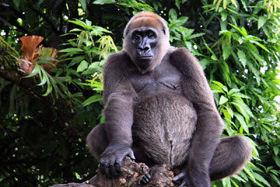

Fig 1

This subspecies of the western gorilla is very similar in appearance to the more numerous western lowland gorilla, but subtle differences can be found in the skull and tooth dimensions. Cross River gorillas live in a region populated by many humans who have encroached upon the gorilla’s territory—clearing forests for timber and to create fields for agriculture and livestock. Poaching occurs in the forests as well, and the loss of even a few of these gorillas has a detrimental effect on such a small population.
Efforts to protect these animals are focused on securing the forests that house them. WWF and partners have worked with the governments of Cameroon and Nigeria to create a protected area for the Cross River gorilla that spans the border of these two nations.

West African lion

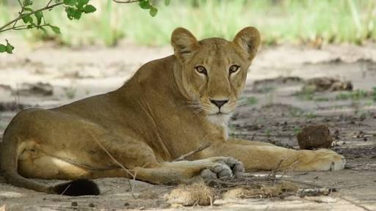

Fig 2

In 1970 there were approximately 200,000 lions all over Africa. Now there are nearly 20,000. It was estimated that there are just 645 genetically distinct wild lions left in western and central Africa, with as few as 34 remaining in the whole terrirtory of Nigeria. Clusters of lions remain in Burkina Faso, Niger, the Central African Republic, Cameroon and Chad. In Ghana, The Ivory Coast and Togo there are already no lions left.

White throated guenon

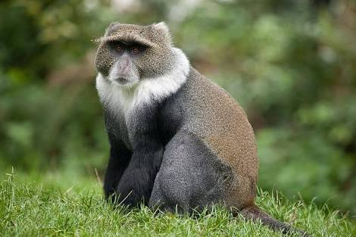

Fig 3

The next vulnerable member of our list is a white-throated guenon. He is also called red-bellied monkey and the red-bellied guenon. These creatures live in rainforests or tropical areas of Nigeria and Benin. These monkeys eat fruits, small insects, leaves and crops. They live in small groups of 4 or 5. The white-throated guenon was once thought to be extinct due to constant hunting for their fur, as the animal has a unique red belly and white front legs. But a small group was found near the Niger River in 1988.

Hartwig's Soft-furred Mouse

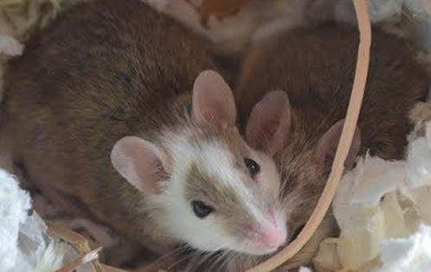

Fig 4
This is a specie of rodent from the Muridae family. It is found only in Nigeria and Cameroon. Its natural habitat is subtropical or tropical moist montane forests and is threatened by habitat loss.

Mammals | Birds | Reptile | Amphibians
Sclater's guenom | Ibadan malimbe | Dunger's file snake | Nigerian toad
Fox's shaggy rat | Jos-plateau indigo bird | Worm snake | Danko puddle frog
Gotel mountain soft furred mouse | Rock fire finch | Giant forest gecko
Savannah swamp shrew | Anambra waxbill | Ondo forest gecko
Forest shrew |  | West african worm lizard
Delta Red Colubus monkey
Forest elephant

3.1 Other endangered fauna in nigeria:

4.0 Why Preserve Endangered species
4.1 Bio-regulators
Preservation of plants and animals is important, not only because many of these species are beautiful, or can provide economic benefits for us in the future, but because they already provide us many valuable services. These organisms clean air, regulate our weather and water conditions, provide control for crop pests and diseases, and offer a vast genetic "library" from which we can withdraw many useful items.
4.2 Medical use
Extinction of a species could potentially mean the loss of a cure for cancer, a new antibiotic drug, or a disease-resistant strain of wheat. Each living plant or animal may have values yet undiscovered. Scientists estimate there are thirty to forty million species on earth. Many of these species are represented by dozens of genetically distinct populations. We know very little about most species; less than two million are even described. Oftentimes, we do not even know when a plant or animal becomes extinct.
Game animals and a few insects are watched and studied. Other species need attention too. Perhaps in them may be found a cure for the common cold or a new organism that will prevent millions of dollars of loss to farmers in their constant fight against crop diseases.

4.3 Generate Revenue
In countries like South-Africa, Kenya and Tanzania; there are swaths of lands dedicated to Wildlife. The Serengeti national park in Tanzania welcomes millions of tourists annually who simply visit to check out these wild animals. Revenues are accrued from these visits which is used to funds substantial chunk of the country’s budget.
In Nigeria, despite the cash crunch, wildlife parks domiciled in different parts of the country still require government attention. If the government can deploy cash to revamp these parks, a steady stream of revenue is guaranteed in the future. So, no one will dare shoot dead a lion. Rather, a well thought out plan will be a conceived to capture the animal alive.
The prospects of ecotourism need to be better explored in Nigeria. Ecotourism as defined by the Ecotourism society in 1991 is a purposeful travel to natural areas to understand the cultural and natural history of that environment, while being careful to avoid any alteration of the integrity of the ecosystem there, and producing economic opportunities that make conservation of natural resources a benefit to local people. Ecotourism is seen by conservationists as a potential vehicle for raising funds for conservation and justifying economic reasons for conservation. Visitors to a protected area may out of empathy for the animals they have seen become advocates for conservation and support in various ways. In a very recent study by Ogunjinmi, Onadeko, and Ogunjinmi (2013), it was noted that the Nigerian broadcast media had no specific programmes on nature conservation. Therefore, it was suggested that there should be synergy between Nigeria National Parks Service and major media establishments as this will increase public awareness, knowledge, appreciation of Parks’ resources, and policy support for biodiversity conservation efforts. All this is deemed to have the tendency to catalyze actions at local and decision-making levels that could halt the destruction of Nigeria’s biodiversity. Hence, Nigerian National parks should be well equipped to suit modern taste, while family vacations to such areas should be encouraged via the media, especially radio jingles in local dialects as most Nigerians are either not well informed, or do not see the essence of visiting a nature Park.

5.0 Why the extinction of wildlife

5.1 Destruction and Loss of Wild Habitats
The ever increasing population in Nigeria may mean that more people will encroach on the few remaining natural ecosystems for wild animals. These larger populations are concentrated in the forested areas of the south and the large urban centres of the far north. Coincidentally, it is in these same locations that the few remaining populations of most endangered species found in the country are left. For example, the Cross River Gorilla (Gorilla gorilla diehli) found in the southern forested areas of Cross River state and protected in the Cross River National park, and the Savannah Elephant (Loxodonta africana) found in Yankari game reserve of Bauchi state in the north. It was once mentioned that the Fulani herders that move annually southward with their large droves of livestock have caused a lot of habitat degradation by lopping trees as fodders for their animals. The reality is that till date, this pattern has continued in the country, with the Fulani herdsmen encroaching often into protected areas and resisting violently any attempt to eject their animals from the protected areas. Another activity that has often resulted in destruction of wild habitat is the dry season fires mostly set by cattle herdsmen and poachers.
5.2 Pollution
Animals may be affected by pollution directly or indirectly. Most birds have toxic substances in their system which is used to control the insects they eat. These substances bioaccumulates to certain level nd gets higher in the birds. This causes death of most birds.
5.3 Excessive Hunting and Poaching
Hunting is perceived as a vocation in certain parts of Nigeria, especially in the rural communities where it might be a traditional family occupation. The activity takes place both day and night throughout the year, and anything larger than 2 kg is considered fair game meat. Poaching, which is any form of illegal entry into a protected area also has become more common as people enter to gather fuel wood, fell trees, fish and hunt without permission. In a survey of African grey parrots (Psittacus erithacus) carried out at the Ikpan forest block of the Oban sector of Cross River National Park, an area contiguous with the Korup National Park of Cameroon, it was established that trade and trafficking of these birds occurs in this

area, with an average catch of eight parrots per day per man. This has drastically reduced the population of parrots in the area as confessed by one of the parrot trappers who was engaged in the survey.

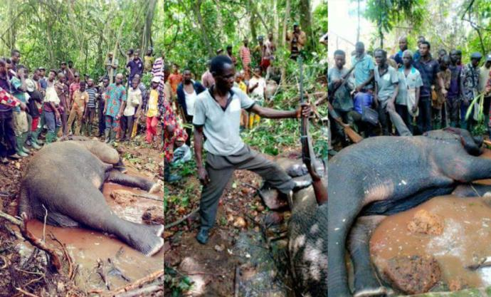

Fig 5. Elephant killed at ondo state

It is very likely this endangered forest elephant wandered from the Oluwa Forest Reserve in Ondo State, Nigeria and rather than informing a government official about the whereabouts of the lost animal, Mr hunter decided to kill it.
It is important to note that the forest elephants in Nigeria found in Ondo, Osun and Ogun states are more threatened by deforestation. Experts fear that about 40 forest elephants (minus one now) are remaining in Omo, Shaha and Oluwa forest reserves. Hunting, logging and farming methods used in the forest have affected them and depleted their population over the years.The elephants in these states could be extinct in five years if the problem of logging and poaching in their natural habitat continues.

The government pays little regard or no attention to it at all.
The illegal killing of African elephants for their ivory seems to have fallen from record peaks but poaching of the animal is still far too high

6.0 Wildlife conservation
There are two main ways of conserving wildlife

6.1 Ex Situ conservation
This is the process of protecting or preserving an endangered species of either plants or animal outside of its natural habitat either by removing whole or part of that population from the threatened habitat and placing it in a new environment which may be a wild area or within human control environment. In ex-situ conservation, species whose life is threatened in a particular habitat is removed and placed in a well-protected habitat and taken care of by man.
6.1.0 Zoos
A zoo is a place where wild animals are kept either for tourism, scientific studies/ research, preservation or breeding purposes. Zoo and botanical garden are the most conventional methods of ex-situ conservation where endangered species are bred for possible reintroduction into the wild. Animals whose life is threatened in the wild is captured and kept in a zoo to ensure its continuous existence. Alao (2008), reported that about 18 endangered species of animal are known to be represented by only captive members since those in the wild have since died off. Animals such as Arabian Oryx, peer David Deer, Northern white Rhinoceros, etc at various points in time were extinct in the wild before their reintroduction into the natural world from captive breeding.
6.1.1 Aquaria
Aquaria are facilities used for captive breeding of fish and other aquatic animals. In the past, aquaria were only used for display (decoration) of environment. However, due to growing threat to freshwater species they are now being used for captive breeding programs. The World Conservation Union (IUCN) is said to be working on captive breeding programs for conservation of fishes in the Lake Victoria in Africa, the desert fishes of North America and Appalachian stream fishes where aquaria are being designed to depict the natural habitats for conservation of these fishes.
6.1.2 Gene bank
These are cryogenic facilities used for the storage of living sperm, eggs or embryos for future reproduction. The eggs or sperms of endangered animal species are preserved through this method. Inter-governmental panel on Climate change, reported that the zoological society of San- Diego has established a frozen zoo for the storage of eggs and sperms where more than 355 species of animals including mammals, reptiles and birds are said to have their reproductive cells stored. Storage of animal reproductive cells in gene bank for future reproduction is applicable even in humans. In 2004 a woman from the United States of America was reported to have given birth to a baby boy through artificial insemination of sperm obtained from her late husband who died since 1973, the man’s sperm was collected while he was alive, frozen and stored in a Cryogenic (Gene Bank) facility for 30 years before it was finally removed, de-frozen and used to fertilize his widow. A plant or animal may become extinct today but if the seed, sperms or eggs of such species are stored in seed or Gene Bank such species can be brought back into existence through reproduction or propagation of the stored reproductive parts.

6.2 In Situ conservation
This involves the conservation and preservation of species in their natural habitat in places where the species naturally occurs. Under this method the entire ecosystem is protected and maintained so that all the constituent species, both known and unknown are conserved.

6.2.0 Games Reserves
Game reserves are areas set aside for the propagation, protection, conservation and management of flora and fauna with fauna species been of main interest. In Nigeria there are several gazetted Games’ reserves spread across the country. However research by Udoh (1999) has shown that most of these reserves have been degraded while quite a number have totally been de-reserved. Game reserves are statutorily owned and managed by state or local governments.

6.2.1 National Parks
These are areas exclusively set aside for the propagation, protection, conservation and management of flora and fauna as well as the protection of site, landscape or geological formation of a particular place for scientific or aesthetic values for the benefit of the general public. National parks are owned by the Federal Government. In Nigeria, there used to be eight National parks spread across the different ecological zones of the country, but now the number has reduced to seven due to the takeover of the Yankari National Park by the Bauchi state government which has made it to lose the status of a national park. The act establishing parks stipulates that it must be owned and managed by the Federal government. According to the Nigeria National Park Service Brochure (NPS) 2010, the remaining seven national parks in Nigeria include:

i. Kainji Lake National Park-New Bussa Niger State
ii. Chad Basin National Park located in Borno and Yobe State.
iii. Cross River National Park-Cross River State.
iv. Old Oyo National Park- Oyo State
v. Gashaka Gumti National park – cut across Adamawa and Taraba State
vi. Okomu National Park – Edo State
vii. Kamuku National Park –Kaduna State.

The above listed parks were operated as either games or forest reserves until 1991 when the General Ibrahim Badamasi Babangida led Military Government promulgated Decree 36 of 1991, upgrading the first five to the status of a Park. In 1999, Okomu and Kamuku were added to the list after Degree 36 of 1991 was replaced with Degree 46 of 1999 (Now Act 46 of 1999) on May 26th 1999 (NPS 2010). Some of the objectives of establishing national parks in Nigeria include: - - - - Conservation of selective representative samples of wildlife communities in Nigeria Protection of endangered vertebrate species. Protection of crucial wetland and water catchments areas. Promotion and provision of education about wildlife and nature conservation etc.

6.3 Cultural conservation
Before the advent of modern conservation methods in Nigeria, some cultural beliefs had helped a lot in conservation of some wild plants and animal species. Not all animals were either killed or eaten by some tribes. For instance, it was forbidden for a Bini man to kill or eat Buffalo, Bushbuck, Leopard, Chimpanzee, Tortoise and black Snake. The tortoise was used for curing of some deadly or terminal illness and as such was believed to be capable of bringing back such disease to the family if eaten. The Buffalo on the other hand was believed to be a harbinger of ill luck. Therefore, anyone who kills or eats it is doomed to ill luck and penury. Similarly, it was a taboo for an Urhobo man or an Itsekiri man to kill or eat Crocodile, monitor Lizard or Bushbucks. The Yorubas despised the Vulture bird. The Tiv people of North Central Nigeria do not kill the green snake locally called “kyarem”. According to them it was the “kyarem” that helped their forefathers to cross a river on their way from Congo to Nigeria by lying across the river hence enabling the people to cross over as bridge. Based on this belief, the green snake was highly protected by the Tivs.

7.0 TECHNOLOGY IN CONSERVING ENDANGERED FAUNA
Technology has been implemented in conserving of endangered species. These methods can be applied in saving Nigeria's endangered fauna.

7.1 Smart Collars for Endangered Species:
We've got smart phones and smart meters and smart grids, and now biologists will have new "smart collars" that use GPS and accelerometer technology to track not only a wild animal's location but also how it is moving, when it is hunting, what it is hunting - in other words, these collars can tell us its every move. Researchers hope that by knowing exactly what certain species of animals are up to, they can understand them much more thoroughly - and possibly even predict behavior and reduce human-animal conflicts, revolutionizing the way we interact with and manage wildlife.

7.2 Remote Control Photography and Video:

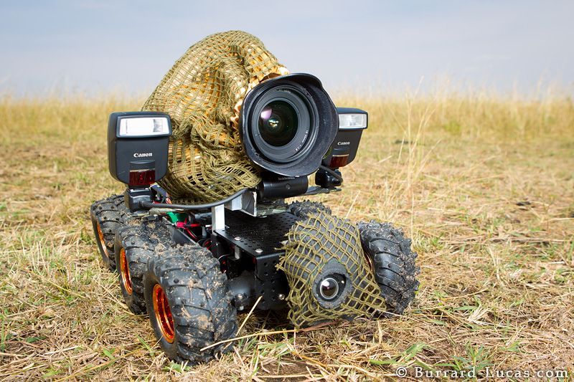

Fig 6
For learning about the needs and risks of endangered species, getting up close and recording the details of wildlife in their natural habitat can be essential - and problematic, due to the difficulty of getting clear access without exposing our own presence. But thanks to ideas like the BeetleCam, observing some kinds of animals is getting easier.

7.3 High-Tech Fish Hooks:

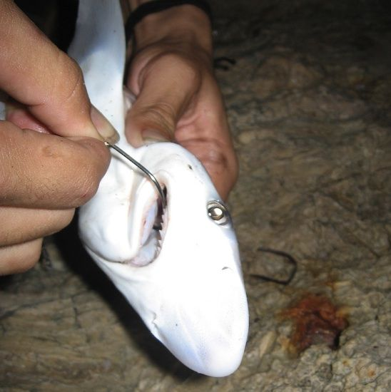

Fig 7
A new high-tech magnetic fish hook, the SMART hook, could help keep sharks safer from fishing lines. The new hooks have a special metal coating that produces a voltage in seawater, and because sharks are highly sensitive to electric fields in the water, the SMART hook (Selective Magnetic and Repellent-Treated Hook), will help keep sharks away from the fishing lines intended for other species of fish.
7.4 Beehive Fences:

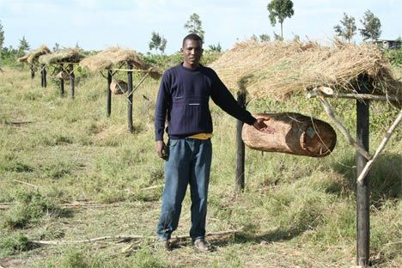

Fig 8

In some places, the interactions between farmers and elephants are getting a little bit easier, thanks to another species, the honeybee, and some innovative thinking. A fence made of beehives, strung together by wires, has been shown to be effective against elephants that have become a nuisance by raiding farmers' crops.

7.5 Conservation Drones:
Not all drones are for the military. An ecologist and a biologist have created a conservation drone complete with cameras, sensors and GPS to map deforestation and count orangutans and other endangered species in northern Sumatra. Their creation can be used for both monitoring and tracking long-term changes as well as providing real-time video and data feeds.

8.0 CONCLUSION

Despite the numerous benefits man derives from wildlife resources, his reckless exploitation of the species remain unceasing and unabated. Human activities such as bush burning, damming of rivers, draining swamps, environmental pollution, hunting and poaching have continued to threaten wildlife existence in every environment. Consequently, many animals are faced with extinction and are classified either as threatened or endangered species. Conservation goals and objectives in the country’s national policy ought to be given more attention as concerned NGOs continue to implore and support the government in integrating them. As man is the chief culprit in interference with the natural environment, the onus is equally on him for sustainable management and use of the resources nature has made available. As the World Wildlife Fund (WWF) states in their slogan for conservation - “we are building a future where humans live in harmony with nature.” It is also imperative that Nigeria take more decisive action and rise up to the challenge of conserving its wild fauna resources if there will be a future where its children will live in harmony with nature.

Scientists, in a recent study said, cows are soon to be the biggest land animals. That's a really bad expectation. This will be as a result of unnecessary and unmonitored human activities.

9.0 RECOMMENDATION

As several plants and animals species continued to go extinct due to loss of habitat, occasioned by environmental degradation and climate change, there is every need for adequate protection and conservation of both the endangered species in their natural habitat to be encouraged. Insitu conservation which involves the protection of species in their natural habitat should be encouraged. In-situ conservation in most cases is carried out by removing the endangered species in question and placing it under human controlled environment which in most cases is more costly, and the species faces the challenges of survival after reintroduction in the wild.
To prevent endangered species from going into extinctions, the following measures should be taken.
1. Some cultural practices which favour conservation of natural resources should be encouraged.
2. Government should develop and encourage the use of alternative resources of energy to discourage most Nigerians from using fuel wood as a source of energy which has caused the depletion of forest resources over the years, (forests serve as habitat to many species).
3. Adequate protection of the existing forest reserves and national parks should be carried out to check activities of illegal timber dealers and poachers.
4. Adequate documentation and publicity of the endangered species should be carried out so that the general public can also help in their protection and conservation.
5. Massive aforestation program by both government and private individuals to check the effect of climate change and environmental degradation which is responsible for loss of biodiversity should be encouraged.

10.0 REFERENCES

Alao, A. O. (2008): Desertification:Eleven Northern States on the danger List.The National newspaper 11th March 2008pp 29.

ANFP (2006): Approved National Forest Policy. Federal Ministry of Environment Abuja, 2006.

Annon, C. (2004): BBC News Science Report www.BBC news.com/sci.co.uk

Barbara, D. W. (2004): Biodiversity and Conservation. British Wildlife conservation and environmental education. www.countrysideinfo.co.uk/index .htm.

Corker, J. (2002): Endangered species conservation. British Wildlife Conservation and Environmental Education.www.countrysideinfo.co.uk/ index.htm.

Glenn, G. H (2006): Earth’s Endangered Creatures: Accessed 9/30/2008.

IPCC (2007): Intergovernmental Panel on Climate Change. Report on Effect of climate change on biodiversity, 2007.

IUCN (2010) International Union for the Conservation of Nature. www.iucn.com.

IUCN (2009): International Union for the Conservation of Nature. Red list statistics www.iucn.redlist.com

Njoku,F. (2009): Nigeria Agriculture and the challenges of the 21st Century. Agro-science Journal of Tropical Agriculture, Food, Environment and Extension University of Nigeria Nsukka.

NPS (2010): National Park Service Brochure, 2010 Edition. Mbakwe, R. (1986): the process of Deforestation in Nigeria and its Ecological consequences. Proceedings of the Annual Conference of Forestry Association of Nigeria Minna, Niger State.

Udoh, L. (1999): Forest Biodiversity Conservation in Nigeria through community Forestry. In proceeding of the 26th Annual Conference of Forestry Association of Nigeria, Borno State

